Listening Lesson Plan

Topic: Do you understand a legal drama in English?

Instructor:  Aeree Chang | Level:  Advanced | Students:  9 | Length:  60minutes

Materials:
- Worksheets I – Vocabulary Comprehension Check
- Worksheet II – Eliciting (Correct the order of Picture story)
- Worksheet III – Dictation (Fill the blank)
- Using a Board, Pens.
- Script – Answer for Worksheet III

Aims:
- To increase listening comprehension in authentic situation
- To introduce specialized vocabulary items
- To provide a format for problem solving
- To familiarize students with one aspect of the American judicial system
- To learn information for understanding the legal terms.
- To practice listening to understand content and solve the cloze.
- To practice speaking by discussing with group members.

Language Skills:
- Reading: Transcript and vocabularies in worksheets.
- Listening: DVD clip, other student’s speeches
- Speaking: discuss answers of outline worksheet within groups.
- Writing: Answering the questions on of the Worksheets. Dictation

Language Systems:
- Lexis: Vocabulary and expression for lawfirm and trial court
- Grammar: Present perfect tenses
- Phonologic: Understanding the argument.
- Function: Giving and receiving opinion, Eliciting, group work
- Discourse: Worksheets, interaction between students

Assumption:

Students already have:
- Experienced listening English legal dramas.
- Enough knowledge of vocabularies
- Heard American torts claims and legal system.
- How the class is set up and run (there will be 3 student groups at each table).
- Most students have not seen this episode of the legal drama .

Anticipated Errors and Solutions:
- Students may not be able to follow the passage easily.
→ Let them listen to the track again until they get the gist of the content.
- Students may not be able to understand content stream.
→ Concentrate on outline work.
- Students may need more time to work on the idioms.
→ If it takes longer than 5 minutes, cut answer-checking short by verbally sharing the answers.

References:
- Black’s law Dictionary
- Http://en.wikipedia.org/
- http://www.boston-legal.org/
- DVD of Boston Legal Season2 Episode 5 Men to boys

Lead-In
Materials: None
Time  5 minute | Set Up  Whole Class | Procedure:  Hi! Everyone. How are you doing today? Great? Before we start today’s class, why don’t we divide the class into pairs? I want each one ha your partner.  Asking a few students their favorite TV drama.  And check them how to watch the program usually.

Pre-Activity
Materials: Worksheet I, Board
Time  3 minutes  7 minutes | Set up  CCQ  A Pair work  T-Ss | Procedure  How do you think about legal drama?  Does anyone know a useful web-site for studying a legal drama in English?  Grouping Ss  (Worksheet I)  Now, I will give you “Worksheet II”. You see eight pictures?  Can you find the correct explanation of these legal terms?  Discussion and share the answers.

Main Activity
Materials: Laptop computer, DVD, Transcript, Board
Time  5 minutes  10 minutes  5 minutes  10 minutes  5 minutes  10 minutes | Set Up  Handout  Play a DVD  Play a DVD  Grouping  Handout  Presentation  Hand out  Separating  Play a DVD  T-Sss | Procedure:  Now, I will give you “Worksheet III”. You see many blank?  Please try to guess the correct answer to fill the blank  CCQ  Please, Watch the DVD clip carefully and try to know what she say, how the lawyer’s tone was? And Mood? And what is she trying to say us?  Activity I  Worksheet I +III  (1st time)  “Do you understand a legal drama in English?”  Have you had any difficulty in completing the blank of Worksheet III?  Could you find the correct word/definition match of Worksheet I?  CCQ  How was her voice? What is the point of her opening statement? And How do you think the argument?  (2nd time)  “Do you understand a legal drama in English?”  CCQ M : Ask strong students  How many tips were provided?  Is the plaintiff’s counsel arguing very well?  Tell us the keywords that you found.  Activity II  Worksheet II  3 people, 3 groups  Ask them to summarize of what they heard from the video.  Now, I will give you “Worksheet II”. You see eight pictures? It is randomly arranged. Can you reorder the pictures? Describe the story line to your partner. And elicit the next story.  Make sure each group has a strong student and he/she can lead the group to summarize it as well.  Each group will present their summary.  CCQ F  You can acquire the full storyline that you just missed by listening of other group spoken.  What was it?  Activity III  Worksheet II  Now, I will give you a transcript of the DVD clip. So check it out by yourself.  Individual work  (3nd time)  “Do you understand a legal drama in English?”  Check up the answers.

Post Activity
Materials: None
Time  5 minutes | Set Up  Whole Class | Procedure:  Conclusion  Elicit the outline verbally.  Give homework  Review the scripts and vocabularies worksheet what you learned today.  I hope you enjoyed this class. See you next class.

Work Sheet I

Vocabulary Comprehension Check

Match the word and adequate definition.

Burden of Proof Defendant Terminal Admittedly
Lawsuit Counsel Juror Practice of law
Defense Recall Opening Statement Product liability
Trial Settlement Verdict Legislator
Damage Courtroom Jury Out of court settlement

1. A group of law-abiding members of a community brought together to give an impartial judgment

2. A room in which a legal court meets
3. A person who is serving on a jury
4. Any party who is required to answer the complaint of a plaintiff or pursuer in a civil lawsuit before a court, or any party who has been formally charged or accused of violating a criminal statute.

5. Institutional damage, unintended consequences to an individual resulting from interaction with an institution

6. It is a formal meeting in a law court, at which a judge and jury listen to evidence and decide whether a person is guilty of a crime

7. It is generally the first occasion that the trier of fact (jury or judge) has to hear from a lawyer in a trial, aside possibly from questioning during voir dire

8. It is the area of law in which manufacturers, distributors, suppliers, retailers, and others who make products available to the public are held responsible for the injuries those products cause.

9. The formal finding of fact made by a jury on matters or questions submitted to the jury by a judge

10. When the parties to a dispute (both disputes that are being litigated before the courts, and disputes where court action has not been started) reach an agreement as to the case, which is said to 'settle' the claim.
11. The party who initiates a lawsuit (also known as an action) before a court
12., A defendant may raise it in an attempt to avoid criminal or civil liability in civil proceedings and criminal prosecutions under the common law

13. It involves giving legal advice to clients, drafting legal documents for clients, and representing clients in legal negotiations and court proceedings such as lawsuits, and is applied to the professional services of a lawyer or attorney at law, barrister, solicitor, or civil law notary.

14. This illness or disease causes death, often slowly, and cannot be cured. fatal, deadly, lethal, killing, mortal, incurable, inoperable

15. A person who gives advice, more particularly in legal matters.

16. You use it when you are saying something which weakens the importance or force of your statement.
17. In law, It is a civil action brought before a court in which a party (plaintiff) has claimed to have received damages from a defendant's actions, the plaintiff, seeks a legal or equitable remedy.

18. It is the obligation to shift the assumed conclusion away from an oppositional opinion to one's own position

19. It is a request to return to the maker a batch or an entire production run of a product, usually due to the discovery of safety issues. It is an effort to limit liability for corporate negligence (which can cause costly legal penalties) and to improve or avoid damage to publicity

20. A person who writes and passes laws, especially someone who is a member of a legislature. Legislators are usually politicians and are often elected by the people.

Work Sheet II
Step1: Reorder the picture & describe the storyline what you’ve understood to your partner.
A.
verdict
B.
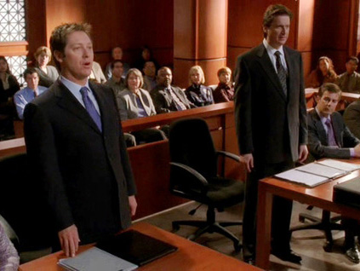
Plaintiff’s counsel Defendant’s counsel
C.
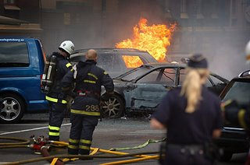
Car explosion in garage
D.
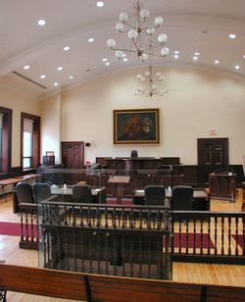Courtroom
E.
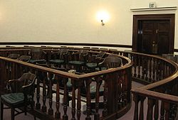 Jury (jurors) listen and discuss

F.
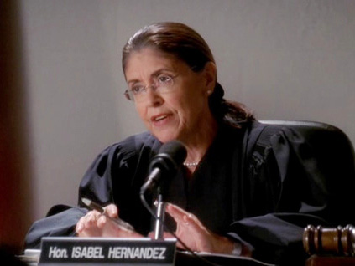
Judge instructs.
G.
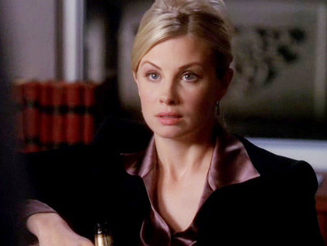A representative lawyer (here, Denise Bauer) takes the “car explosion” case of Plaintiff(Husband; Hose Patino) against Big car manufacturers (Defendants).

H.
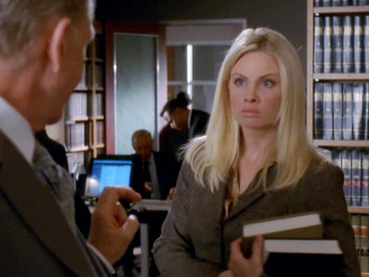Junior Associate gets legal advice from Senior Partners. So, she tries to make an out of court settlement.

Step 2 : Elicit the storyline!
1.Car explosion in garage → 2.Terminal Woman was died. → 3.Husband hired a Lawyer →4. Lawyer tried to settle →5. Out of court settlement failed →6. Trial Court → 7.Opening Statement of Plaintiff’s lawyer → 8.Opening Statement of Defendant’s lawyer → 9. Jurors listen →10. (Settlement) →11. Jury discuss →12. Jury make a unanimous decision→13. Verdict (Judge)
Work Sheet III
Dictation
Fill the Blank

1. Law firm practice- settlement

Denise Bauer: $225000? Are you serious?
Attorney Michael Eaves: You can ( ) the numbers.
It covers all ( ) caused by the fire to both the garage and house. Which insurance already paid by the way?
Denise Bauer: A woman died here
Attorney Michael Eaves: A ( ) woman less than five days to live perhaps
Denise Bauer: Certainly the cost of a ( ) would exceed $225,000.
Attorney Michael Eaves: Perhaps. But the cost of a ( ) could be exponentially bigger if it occasions other to sue.
Denise Bauer: The risk of losing by ( )?
Attorney Michael Eaves: That won’t happen.
Denise Bauer: You think I’m not ready to try this tomorrow. Is that you think?
Attorney Michael Eaves: Denise, you’re no doubt a good lawyer. With a very diverse ( ) you handle… stock fraud, anti-trust, and even some criminal work.
The three of us…Do nothing but ( ) work for car manufacturers. In fact, over the last few years, while you were doing other things, letting this particular file collect dust, we’ve been handling only automobile ( ) ( ) cases, specializing in the sports trucks that catch fire.
Day… after day… after day. It’s what we do.
Denise Bauer: (long pause) your offer of $225,000 is rejected.
(She pushes the paper back to him)
Attorney Michael Eaves: Then, we shall see you for ( )( ).

2. Courtroom- Lawyer’s argument

(In Judge Stephen Bickel’s courtroom)
Judge Stephen Bickel: All right, we will begin with ( ) ( ) starting with the ( ).
Denise Bauer: (She gets up.) Good morning. My name is Denise Bauer.
I along with Sara Holt will be ( ) the plaintiff, Hose Patino, who’s wife Elena died in a fire that started in their garage when their pickup truck, manufactured and sold by the ( ), suddenly burst into flames.
The truck was not running at the time. In fact, it had not been driven all night.
Let me begin by saying that a terrible human tragedy has occurred here.
And of course, nothing that happens in this ( ) will bring Elena Palins back.
(The lawyers at the opposing counsel’s table look as each other)
Lawsuits you see are ultimately about money.
Putting a dollar figure on suffering……
( ) there is some question as to how much Elena even suffered in the fire.
Also ( ) Elena was in the final stage of ovarian cancer.
She had come home from the hospital, in fact that very day, basically to die.
You may ask yourselves, “What ( ) did she really endure?”
Well, you will here from Hose Patino and what you will here is that she had a day.
And another day…… coming after that…… And another one after that.
She had in fact six or seven days to be at home with her family.
She didn’t’t get those days.
She never got the last opportunity to sit with her grand children.
Hose was never able to have his wife of thirty-seven years in his arms hold her in his arms and hum……
If any of you have spent the final days with a loved one dying of cancer of another disease you know those moments are the most precious.
Hose and Elena Patino had those days coming. They didn’t’t get them.
You can’t bring Elena Patino back. But you are in a position to help save others.
Because lawsuits, in addition to money, are about ( ) ( ).
Who is best able to prevent this tragedy from happening again?
Well, you might be inclined to think, “This is just a freak accident.”
But in fact this is a much bigger problem.
This is a very popular sports truck made by a major manufacturer of sports trucks.
And they’re catching fire!
The defendant has recently ( ) almost a million of their vehicles because of these malfunctions.
So you see?
This is potentially your problem.
How do you motivate a corporate conglomerate to fix a ( )?
You make it too expensive for them not to.
At the conclusion of this trial, when it finally comes down to a dollar amount I will be asking you to be ( ) and come back with a number that says to the ( ) and all car manufacturers “ Make your vehicle safe.”
For your sake,.. For your daughters,..For your grandsons...
And I’ll ask you to be human-beings. The conscience of a passionate society and return with a ( ) that somehow reflects everything that was taken from Elena Patino, her family and most of all her high school sweetheart.

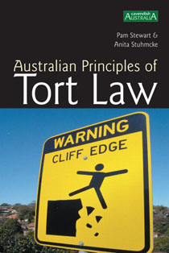 Good Job!! ^^
Work Sheet I Answer

1 Jury 2. Courtroom3 Juror 4 Defendant 5. Damage 6 Trial 7 Opening Statement 8. Products liability 9 Verdict 10 Out of court Settlement 11. Plaintiff 12. Defense 13. Practice of law 14. Terminal 15. Counsel 16. Admittedly 17. Lawsuit 18. Burden of Proof 19. recall 20. Legislator
Work Sheet II Answer

C→G→H→D→F→B→E→A

Work Sheet III Answer
Transcript

1. Law firm practice- settlement
Denise Bauer: $225,000? Are you serious?

Attorney Michael Eaves: You can run the numbers.
It covers all damages caused by the fire to both the garage and house. Which insurance already paid by the way?

Denise Bauer: A woman died here
Attorney Michael Eaves: A terminal woman less than five days to live perhaps
Denise Bauer: Certainly the cost of a trial would exceed $225,000.
Attorney Michael Eaves: Perhaps. But the cost of a settlement could be exponentially bigger if it occasions other to sue.
Denise Bauer: The risk of losing by verdict?
Attorney Michael Eaves: That won’t happen.

Denise Bauer: You think I’m not ready to try this tomorrow. Is that you think?
Attorney Michael Eaves: Denise, you’re no doubt a good lawyer. With a very diverse practice you handle… stock fraud, anti-trust, and even some criminal work.
The three of us…Do nothing but defense work for car manufacturers. In fact, over the last few years, while you were doing other things, letting this particular file collect dust, we’ve been handling only automobile product liability cases. Specializing in fact in the sports trucks that catch fire. Day after day after day. It’s what we do.
Denise Bauer: (long pause) your offer of $225,000 is rejected.
(She pushes the paper back to him)
Attorney Michael Eaves: Then, we shall see you for opening statements.

2. Courtroom- Lawyer’s argument

(In Judge Stephen Bickel’s courtroom)
Judge Stephen Bickel: All right, we’ll begin with opening statements starting with the plaintiff.
Denise Bauer: (She gets up.) Good morning. My name is Denise Bauer.
I along with Sara Holt will be representing the plaintiff, Hose Patino, who’s wife Elena died in a fire that started in their garage when their pickup truck, manufactured and sold by the defendant, suddenly burst into flames.
The truck was not running at the time. In fact, it had not been driven all night.
Let me begin by saying that a terrible human tragedy has occurred here.
And of course, nothing that happens in this courtroom will bring Elena Palins back.
(The lawyers at the opposing counsel’s table look as each other)
Lawsuits you see are ultimately about money.
Putting a dollar figure on suffering…
Admittedly there is some question as to how much Elena even suffered in the fire.
Also admittedly Elena was in the final stage of ovarian cancer.
She had come home from the hospital, in fact that very day, basically to die.
You may ask yourselves, “What damages did she really endure?”
Well, you will here from Hose Patino and what you will here is that she had a day.
And another day… coming after that… and another one after that.
She had in fact six or seven days to be at home with her family.
She didn’t get those days.
She never got the last opportunity to sit with her grand children.
Hose was never able to have his wife of thirty-seven years in his arms hold her in his arms and hum……
If any of you have spent the final days with a loved one dying of cancer of another disease you know those moments are the most precious.
Hose and Elena Patino had those days coming. They did not get them.
You can’t bring Elena Patino back. But you are in a position to help save others.
Because lawsuits, in addition to money, are about allocating burden.
Who is best able to prevent this tragedy from happening again?
Well, you might be inclined to think, “This is just a freak accident.”
But in fact this is a much bigger problem.
This is a very popular sports truck made by a major manufacturer of sports trucks.
And they’re catching fire!
The defendant has recently recalled almost a million of their vehicles because of these malfunctions.
So you see?
This is potentially your problem.
How do you motivate a corporate conglomerate to fix a defect?
You make it too expensive for them not to.
At the conclusion of this trial, when it finally comes down to a dollar amount I will be asking you to be legislators and come back with a number that says to the defendants and all car manufacturers “ Make your vehicle safe.”
For your sake,.. For your daughters,..For your grandsons...
And I will ask you to be human-beings. The conscience of a passionate society and return with a verdict that somehow reflects everything that was taken from Elena Patino, her family and most of all her high school sweetheart.

