Listening Lesson Plan

Countable vs. Non-Countable Nouns

Instructor:
Jenny Lee
Level:
Intermediate
Students:
15
Length:
15 min

Materials:
Some pictures of noncountable objects such as water, rice, cheese
Flash cards (One deck for Countable nouns and another for Non-Countable nouns)
Worksheets
Substitution table
Board & markers

Aims:

- Students will know and practice proper nouns correctly.
- Students will be able to distinguish between countable and noncountable nouns.
- Students will be able to use proper word or expression like some, a lot of, a piece of, a bit of, a great deal of…. with noncountable nouns.

Language Skills:
- Listening: Teacher’s instruction and explanation, classmates
- Speaking: During group works, practice activities
- Reading: Worksheets instructions & questions
- Writing: Worksheet answers

Language Systems:
- Phonology: Listening to instruction & explanation, drilling
- Syntax/Lexis: Using various nouns
- Grammar: Countable, Noncountable.
- Function: Counting objects with proper expression

Assumptions:
- Students know the meaning of the words
- Student are middle school students

Anticipated Errors and Solutions:

- Students may not clearly understand the meaning
* Provide more examples
- Students may have a hard time drilling
* Error correct immediately & give student more chances to practice
- Students may need more time to work on the separating countable and noncountable nouns.
* Cut answer-checking short by verbally sharing the answers instead of having students w

References:
http://www.chompchomp.com/terms/noncountnoun.htm

Lead-In
Materials: Board & markers, Picture of noncountable objects
Time  2 min | Set Up  Whole Class | Procedure:  - Greeting.  Hello, everyone. How are you doing today? Did you have good weekend?  (Show the picture of noncountable objects)  Look at these pictures. Can you guess what today’s lessen is about? What can you see in the picture? It is water. How many glasses can you see? Yes, there are three glasses of water. How about this rice? How many bowls can you see? Yes, there is just one bowl of rice. Last one. What can you see in this picture? How many slice of cheese can you see? There are two slices of cheese.  So now, can you guess what we going to learn?

Pre-Activity
Materials: Flash cards, Board
Time  2 min  3 min | Set Up  Whole Class | Procedure:  Show more pictures. Explain & visual demonstration of categorizing using flash cards.  T: What is it? S: Snow  T: Can you count that? S: No  T: Right. We cannot count snow by itself. Then how can we measure the amount of snow? We can say snow storms, snow flakes, snow drifts.  T: What is it? S: Wine  T: Can you count wine? S: Yes or No  T: We cannot count wine itself because it is liquid. Then how can we say to describe this picture? We say seven bottles of wine.  Practice  T: What is this? S: Meat  T: Now, do not repeat. Only listen.  CCQ) What do you do?  How many cups of coffee do you want?  I want two cups of coffee.  How many loaves of meat do you have?  I have four loaves of meat and four slices of bacon.  T: Now listen and repeat.  CCQ) What do you do?
Main Activity
Materials: Flash cards, Worksheet
Time  3 min  4 min | Set Up  Group of Five people  Group of Pairs | Procedure:  Practice 1.  Categorize these flash cards into two sections. One section is for countable nouns while the other is for noncountable nouns. I’ll give you 2 min. Work with your group members.  CCQ) How much time do you have?  What do you do?  Distribute the deck of flash cards. Monitor and help where needed.  Check answers together. Orally elicit correct answers from students and write on the board.  Practice 2.  (Distribute worksheet.)  Do the worksheet. Use the noncountable nouns we categorized just before, make a short conversation for each word with your partner. For the expressions, you can use ‘a piece of, a loaf of, a puff of, a plume of, a bottle of, a glass of, a bolt of, a yard of, a pile of, a truckload of’ I’ll give you 4 min.  CCQ) How much time do you have?  Who do you work with?  Check answers together. Orally elicit correct answers from student.

Post-Activity
Materials:
Time  2 min | Set up  Whole Class | Procedure:  Error Correction & Feedback  I hope that today’s activity helped you to understand how different countable and noncountable nouns. Also, I hope that you can use proper expression to measure noncountable objects.  Did you enjoy this activity? Was it difficult for you? Is there any question about today’s lesson?  For your homework, write a recipe of your favorite dish using the expressions we learned today. For example, two teaspoons of sugar, five cups of flour. The homework is due until next time.  On Tuesday, we are going to learn about irregular verb form such as ‘get, got, gotten’ , ‘go, went, gone’



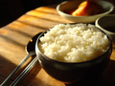
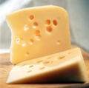


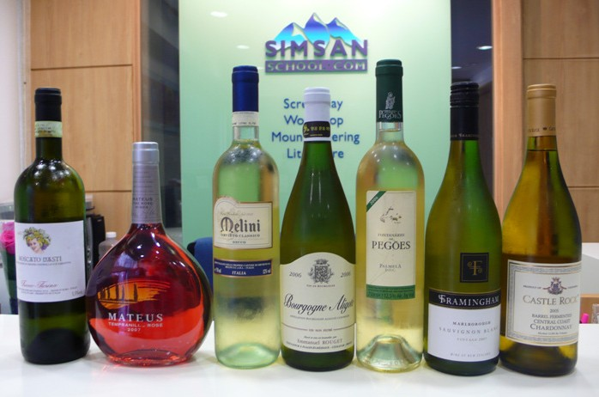

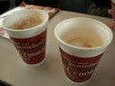
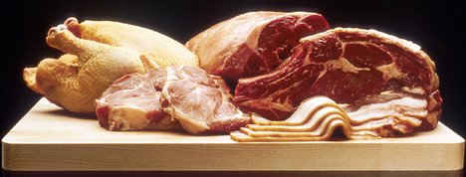

EXERCISE 1.
In each sentence, choose the best phrase to complete the gap from the choices below.

1. The receptionist at the front desk gave me two .

a) informations b) information c) pieces of information d) lots of information

2. My cousin is very beautiful. She has green eyes and .

a) long hair b) long hairs c) a long hair d) a long length of hair

3. have you got in the bank? Is it enough to buy a house?
a) How many moneys b) How many money
c) How much money d) How much moneys

4. On Saturday, my friend Paul went fishing and he caught .

a) three fish b) three fishes c) three items of fish d) three of fish

5. Can I borrow from you? I’ve left mine at home and I want to
write some notes.
a) paper b) a paper c) a slice of paper d) a piece of paper

6. How many did the teacher give us today? He always gives us a lot to do.
a) homework b) homeworks c) a lot of homework d) pieces of homework

7. Every morning before I come to school, I spend thirty minutes doing .
That’s how I stay so slim.
a) exercise b) an exercise c) some exercises d) some pieces of exercise

8. Your sister is a great pianist. She played at the party.
a) a lovely music b) some lovely musics
c) lovely musics d) a lovely piece of music
EXERCISE 2
Fill in the gaps with proper expression

Conversation 1.

Charles: Alice! Have we got ( ) eggs?
Alice: Yes, there are ( ) in the cupboard.
Charles: Have we got ( ) cheese?
Alice: Yes, there’s ( ) in the fridge.
Charles: Can I use ( ) olive oil?
Alice: Yes, of course.
Charles: I need ( ) tomatoes.
Alice: We haven’t got ( ). Charles, would you like ( ) help?
Charles: No, thanks, I’m OK.

Conversation 2.

Tom: Let’s go for a picnic in the park.
Sarah: OK. We’ll make ( ) sandwiches. What do we need?
Tom: We haven’t got ( ) bread. Can you buy ( )?
Sarah: Yes, sure. What about butter?
Tom: We’ve got ( ). I’ll buy ( ) cheese.
Sarah: OK, and is there ( ) orange juice in the fridge?
Tom: No, I’ll get ( ).
Sarah: Good. Do we need ( ) apples or cherries?
Tom: Just ( ) apples.
Sarah: Oh dear! I haven’t got ( ) money to buy bread!
Tom: Don’t worry. I’ll lend you ( ).

Conversation 3

Barbara: Is there ( ) milk left?
Katherine: Yes, there is ( ) in the bottle on the table.
Barbara: Would you like ( ) milk?
Katherine: No, thank you. I don’t think I’ll drink ( ) tonight. Could I have ( ) water, please?
Barbara: Sure. There is ( ) in the fridge.
Catherine: There is ( ) Chinese boy in my English class.
Barbara: That’s interesting! Could you ask him ( ) questions for me?
Katherine: No problem.
Barbara: Could ask him ( ) questions about life in China?
Katherine: I would be happy to do that for you.
Calf | Horse
Man | Shop
Idea | Flower
Cookie | Bus
Leaf | Rainstorm
Chair | Smile
Assignment | Egg
Rice | Money
Furniture | Cheese
Air | Bread
Flour | Chocolate
Meat | Butter
Fish | Paper
Juice | Homework
Some
A piece of

A great deal of

A lot of

A bit of

A slice of

A loaf of

A glass of

A bottle of

A bowl of

A yard of

A pile of

A teaspoon of

A pound of

