If the volcano goes on erupting, we’d really better move away.

Instructor:  Joseph C. | Level:  Intermediate | Students:  15 | Length:  15 minutes
Materials:
- Picture of a volcano with a man and woman standing in front of it (drawn on board)
- Board and markers
- Worksheets for homework (15 copies)
Aims:
- Ss will practice using the ‘first’ and ‘second’ conditionals and collaboratively change one grammatically correct sentence into other grammatically correct sentences, one word at a time.
Language Skills:
- Listening: T instructions and explanation, classmates
- Speaking: Drilling and practice activities
- Reading: Sentence on board, worksheet instructions and items
- Writing: Worksheet answers
Language Systems:
- Phonology: listening to instructions and explanations, drilling
- Grammar: ‘first’ and ‘second’ conditionals. If the volcano goes on erupting, we’d (we+would) really better move away.
- Function: to speak about possible action in the present or future.
Assumptions:
- Ss can fill in empty parts of a sentence with a grammatically correct replacement.
- Ss are intermediate students.

Anticipated Errors and Solutions:
- Ss may not understand the meaning
- Provide more examples
- Ss fill in an empty space with a grammatically incorrect word
- Have S read and inquire if S and the class if they are happy with it. If yes, then move on. If no, then ask for another word.
- The activity takes too long.
- Shorten the post-activity
- There is extra time left in the session.
- Keep rubbing out words and writing new ones in.
References:
- Grammar Games: Cognitive, affective and drama activities for EFL students by Mario Rinvolucri. Cambridge University Press ©1984. Pp. 56-58

Lead-In and Presentation
Materials: Board and markers
Time:  2 min | Set Up:  Whole Class | Procedure:  Good morning. _(S name)_, please draw a volcano, a man, and a woman on the board.  Please draw a speech bubble above for the man.  Now, _(S name)_ please write “If the volcano keeps erupting, we’d really better move away” in the speech bubble.  (Now have the students read) “If the volcano keeps erupting, we’d really better move away.”  Have the students repeat the sentence a few times. (You should stay silent)  (You will stay completely silent for the rest of the lesson.)

Main Activity
Materials: Board and markers
Time:  12 min | Set Up:  Whole Class | Procedure:  Now, erase one word from the sentence, any word you want.  *Note: remember to keep the words necessary for the conditionals (If and …+would)  Prompt the Ss for a word to replace it and write it in.  Have the S that gave the word read the new sentence.  Prompt the S and then all of the Ss if they are happy with the new sentence.  If not, then erase the word and prompt a new word from the unsatisfied S.  Repeat until everyone is satisfied.  If everyone is satisfied, then move on to another word.  The aim is to end up with a new sentence still using the ‘first’ and ‘second’ conditionals.  *Drilling: You will have the students repeating the sentences that they are creating on the board.

Post-Activity
Materials: Board and markers
Time:  1 min | Set Up:  Whole Class | Procedure:  Give the students the worksheets for homework.

Name: ________________________________________
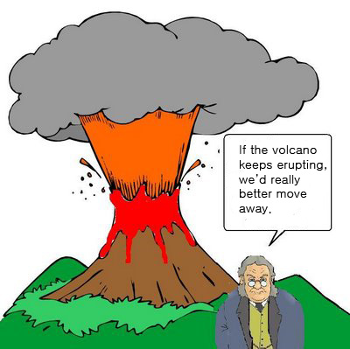
Date: _________________________________________

Conditionals: If the volcano keeps erupting,
we’d really better move away.

Please complete the following sentences with your own words.

- If I won the lottery, _____________________________________________________.

- If dogs had wings, ______________________________________________________.

- If everyone spoke English, _______________________________________________.

- If it snowed in July, _____________________________________________________.

- If my friend were the president, ___________________________________________.

- _______________________________________________, I’d have told you the truth.

- ______________________________________________________, he'd regret it later.

- _________________________________________________, she’d go to the hospital.

- _________________________________________________, they’d read more books.

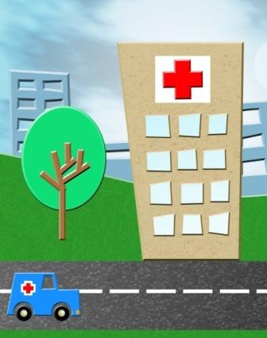
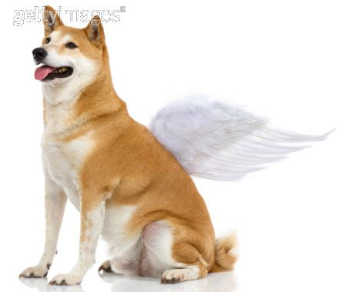
- ___________________________________________________, it’d have to be fixed.

