Reading Lesson Plan
Title: My office
Instructors |  | Yun Minkyong |  |  |  | Level | Pre-intermediate |  | # of Ss: | 14 |  | Length: | 15min
Materials
- 14 copies of reading text “ My office ”
- 14 copies of vocabulary & comprehension exercises worksheet
- Board & markers
- Realia ( Flash cards )
Aims
- Ss can improve and develop reading skill by answering question to understand
- To learn office related vocabulary by flash cards and matching in the worksheet, listening teacher’s explanation, answering CCQ
- To learn about the office equipments and supplies when Ss need to set up their own office in the future
Language Skills
Reading: Comprehension text & questions ( multiple-choice & True/False)
Speaking: Pair work discussion to answering questions
Listening: The teacher’s explanation about new vocabulary
Writing : Teacher will give homework to write an essay
Language Systems
Lexis: (armchair, cabinet, desk, drawer, equipment, furniture, highlighter, laptop, paperclip, stapler)
Phonology: Practice new vocabulary

Assumptions
- Ss have seen office supplies in the stationary
- Ss know what office supplies are such as pen, clip, eraser, stapler
- Ss speak in English with pair work, but not very accurately
- Ss know how to skim and scan through reading text
Anticipated Errors and Solutions
- Ss may not know about office supplies, or how office look like
- Ss will have difficulty in doing the comprehension worksheet, it had better to make pair work to help each other
- Show demonstration ( realia / flash cards ) rather than longer explanation, which can be increased more Student Talk Time ( STT )
- If student have need more time to complete their activity, give them more time to finished their activity and cut off time of post activity
References
- http://esl.about.com
- http://www.google.com
- http://www.executivecenter.com
Lead-In
Materials | Realia
Time |  |  | Set up |  | Procedure
1 minute |  |  | Whole class  Individually |  | Greeting:  T: Hi everyone, how are you today?  Ss: Fine, thanks.  T: We are going to study for reading comprehension with today’s  lesson, but before that I would like to ask some questions.  T: Have you ever planned for a new business?  Ss : Yes / No  T: If you go into a business, what is the most important tools for  preparation?  Ss: Office space, computer, telephone…..
Pre-Activity
Materials | Board & markers, flash cards, worksheet ( Matching vocabulary & Reading text)
Time |  |  | Set up |  | Procedure
5 minutes |  |  | Whole class  (2 minutes)  Pair work  (2 minutes)  Pair work  (1minute) |  | Instruction:  Teacher write on the board about today’s lesson topic  T: Before we read the text, let’s learn some new vocabulary  ( Write on the board new vocabulary)  Vocabulary demonstration  ( T shows the flash cards and ask repeat to the Ss of each word)  T: Repeat after me “armchair”, “cabinet”, “desk”, “drawer”, “equipment”, “furniture”, “highlighter”, “laptop”, “paperclip”, “stapler”  Ss: ( Ss repeat after teacher’s instruction)  T: Very good. Now, we are going to do a matching vocabulary activity.  Instruction  (Distribute vocabulary worksheet of matching activity and monitor each pair of Ss)  Match with the word on the left to the meaning on the right. Draw a line to march and work with your partner. You have 2 minutes.  CCQ:  Are you work alone?  What are you going supposed to do?  How much time do you need?  T: You have 20 second left.  T: Ok, let’s check the answer together.  ( Check all the answers orally with the Ss)
Main Activity
Materials | worksheet ( Matching vocabulary & Reading text, comprehension questions worksheet)
Time |  |  | Set up |  | Procedure
7 minutes |  |  | Whole class  Pair work  Whole class  (2 minutes) |  | T: Ok class, now let’s start reading text “ My office”  ( Distribute the comprehension questions worksheet)  Instruction:  Skim and read the text. After that complete the answer “multiple-choice “ and “True/False” questions. You have 5 minutes & work with pair.  CCQ:  Do you read the text alone?  What should you do now?  How much time do you have?  ( Monitor carefully each pair of Ss )  T: You have 1 minute left.  T: Ok class, now let’s check the answer together  T: Very good.
Post-Activity
Materials | Worksheet ( Reading comprehension questions ), board & markers
Time |  |  | Set up |  | Procedure
2 minutes |  |  | Individually  Whole class |  | Student Talk Time ( STT )  Ask two Ss how was their office look like when they had work experience in the company / as a school teacher  Give homework ( Essay Assignment)  T: Write an essay that If you set up a business, how to decorate your own office. Please give some examples of today’s vocabulary such as office equipment, desk, drawer, cabinet, etc…) and write 250~300 words.  Feedback:  Ask questions before end up an activities:  *How’s the class today?  T: All of you guys did a good job. Bye and see you again on next week.

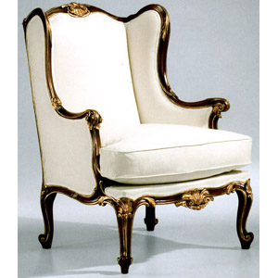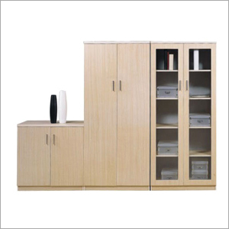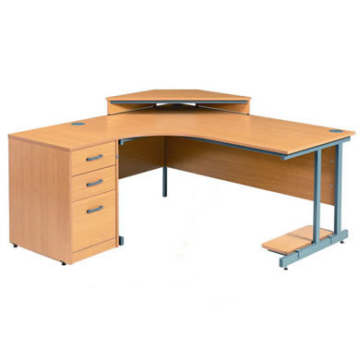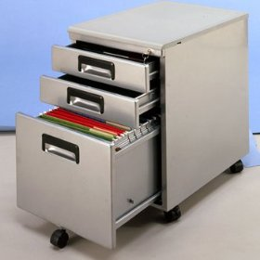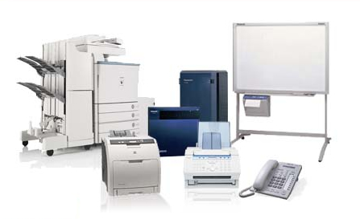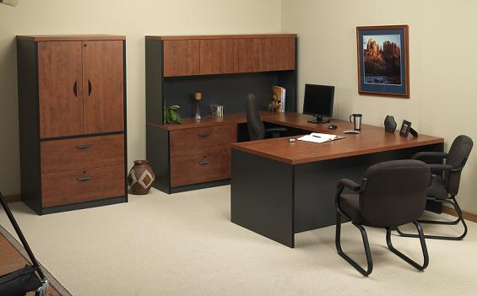
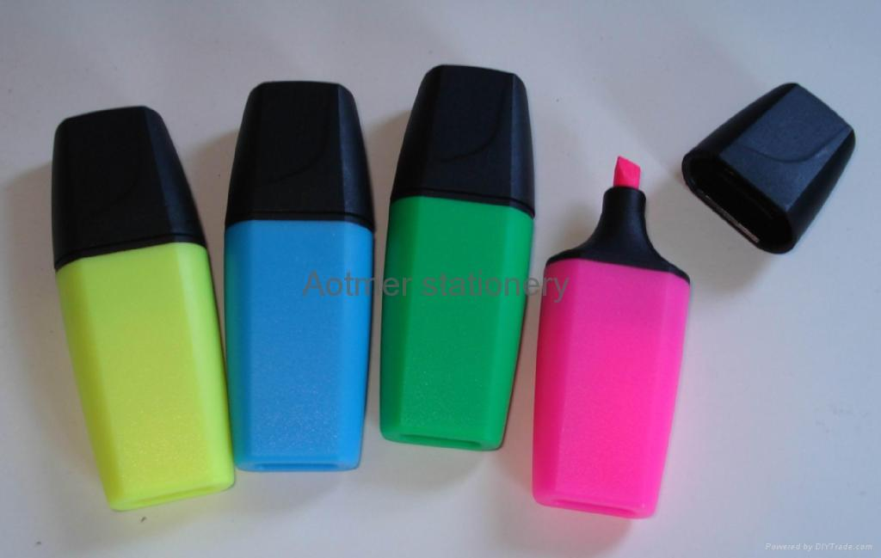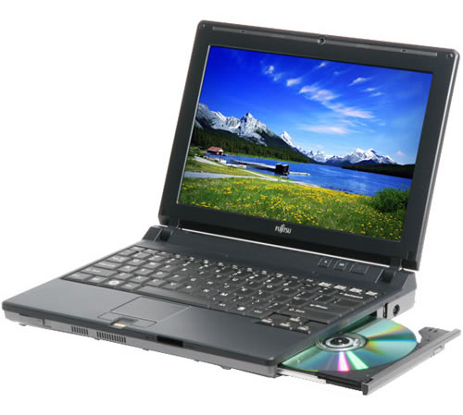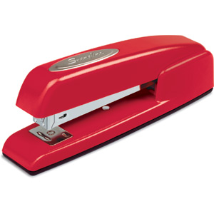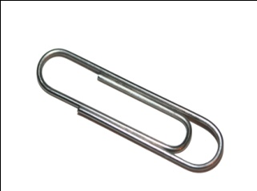

My Office
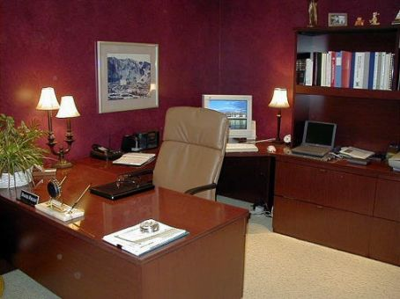
ike most offices, my office is a place where I can concentrate on my work and feel comfortable at the same time. Of course, I have all the necessary equipment on my desk. I have telephone next to the fax machine on the right side of my desk. My computer is in the center of my desk with the monitor directly in front of me. I have a comfortable office chair to sit on and some pictures of my family between the computer and the telephone. In order to help me read, I also have a lamp near my computer which I use in the evening of I work late. There is plenty of paper in one of the cabinet drawers. There are also staples and stapler, paper clips, highlighters, pens and erasers in the other drawer. In the room, there is a comfortable armchair and sofa to sit on. I also have a low table in front of the sofa on which there are some industry magazines.
L

Vocabulary Worksheet:
Match each word on the left with its definition in each box on the right.

armchair
a small metal clip used to hold papers together
cabinet
supplies & tools used to work
desk
a moveable articles for use in the house or office
drawer
a moveable or portable computer
equipment
a small device used to bind papers together
furniture
sliding receptacle in a desk, cabinet, etc...
highlighter
writing table
laptop
paperclip
a comfortable chair often found in a living room
stapler
a small chest used for keeping papers. files, etc
pen used to mark passages in a bright color

I. Multiple-Choice Comprehension Check Questions
: Choose the correct answer based on the reading.

1. What do I need to do in my office? Answer.......
a) relax b) concentrate c) study d) read magazines

2. Which piece of equipment do I NOT have on my desk? Answer.......
a) fax b) computer c) lamp d) photocopier

3. Where are the pictures of my family located? Answer.......
a) on the wall b) next to the lamp c) between the computer and the telephone
d) near the fax

4. I use the lamp to read: Answer.......
a) all day b) never c) in the morning d) in the evening

5. Where do I keep the paperclips? Answer.......
a) on the desk b) next to the lamp c) in a cabinet drawer
d) next to the telephone

6. What do I keep on the table in front of the sofa? Answer.......
a) company reports b) fashion magazines c) books d) industry magazines

II. Decide if the statements are "True" Or "False" based on the reading.

1. I work late every night. T F
2. I use highlighters to help me remember important information. T F
3. I keep reading materials that are not related to my job in the office. T F
4. It is important to me to feel comfortable at work. T F

