Reading Lesson Plan
(Busan TESOL 29th)

Student : Maeng & G
Teacher : Valerie Hamer
Date : 09. 6. 2010

OUT LINE

Lead In -G 1.Greeting
2.Introducing

Pre Activity 1.Voca①-G
2.Voca②-Maeng

Main Activity 1.Skinning-G
2.Scanning-Maeng

Post Active Discussion-Maeng & G

Close - Maeng

Blood types in Japanese Culture
Instructor:  G & Maeng | Level:  Intermediate | Student:  10 | Length:  30 minutes

Materials
-12 copies of the text (10 copies for each student + 2 extra copy)
-Picture A (for introduction) , Picture B (for vocabulary), Picture C (for vocabulary),
-12 copies worksheet A (10 copies for each student + 2extra copy)
-5 copies worksheet B (3 copies for each group + 2 extra copy)
-Whiteboard, markers, eraser
Aims
Ss will be familiar with key vocabulary by eliciting and through T’s explanation
Ss will improve scanning skill by answering true & false questions.
Ss will improve speaking and listening ability by sharing ideas in a group.

Language Skills
Reading : reading text “Blood types in Japanese culture” /worksheet
Writing : answering true & false questions / taking notes of group discussion
Speaking : sharing ideas in a group
Listening : listening to Ts presentation, instruction, / classmates’ ideas

Language Systems
Lexis : zodiac signs, matchmaking
Phonology : repeating new words
Discourse : talking about main Q with group members.

Assumptions
Most Ss know their blood type.
Most Ss are aware of typical characteristic traits of blood types
Ss are used to working individually and in groups of 3-4
Ss know how to skim and scan
Anticipated Errors and Solutions
Ss may not understand some adjectives on worksheet
-Explain by acting or comparing word groups
There may not be enough time to complete the lesson
-Assign the post activity discussion task as a homework assignment
If students finish their tasks earlier than anticipated.
->Have a role-play time to show the features of each blood type as group
References
http://en.wikipedia.org/wiki/blood_types_in_Japanese_culture
http://www.google.co.kr/images?hl=ko&source=imghp&q=matchmaking&btnG
Advanced Learner's English Dictionary p1695
www.cartoonstock.com

Lead-In (G)
Materials : whiteboard & Marker, pictureA
Time  2 min |  |  |  | Set Up  Whole class |  | Procedure  Greeting  Hello, everyone. How are you today?  Introducing  -Eliciting  (show a picture to all)  I bring one picture. Can you guess what this means? How many people are here?  What are they doing?  -Introducing  So, today, we will talk about ‘Blood type’  (Write the topic on the top of the board)
Pre-Activity
Materials: picture B, picture C, whiteboard, markers
Time  2 min (G)  2 min (M) |  |  | Set up  Whole class  Whole class |  | Procedure  Vocabulary  First of all, Let’s learn vocabulary. It will help you to read the text.  1.zodiac signs  (Write the word on the board)  Eliciting  (Show the picture to all) Look at this picture.  Can you guess what this means?  Where can you see this? On the land or in the sky? When can you see this? In the day time or at night?  Instruction  If I’m born on June or July my zodiac signs is like this.  (On the board, write the numbers 6,7 and next to that numbers draw a crab and point that drawing)  If I’m born on February and March my zodiac signs is like this. (On the board, write the numbers 2,3 and next to that numbers draw a fish and point that drawing)  Zodiac signs is the position of the starts.  CCQ  If you are born on February and I’m born on June,  your zodiac signs and mine are same?  (No, It’s different)  (Write ‘zodiac signs’ on the top right corner of the board)  2.matchmaking  Show 1 copy of picture to Ss and make Ss elicit and explain  (First, write down the word “matchmaking” and put a picture then explain, She in the middle is a matchmaker and trying “ ? “…. Then make Ss elicit the word matckmaking)  CCQ  Do you want to get marry by matchmaking?
Main-Activity
Materials:
12copies of the text “Blood types in Japanese culture” whiteboard & markers
12cpies of worksheet #1
Time  7 min (G)  7 min (M) | Set up  Individual  & pair  Whole class  Individual  &Pairs  Whole class |  |  |  |  |  | Skimming activity  (Write the question on the board)  “Does the writer insist that we have to know our blood type certainly?”  Instruction  What did I write?  Let’s read the question together.  At first, think about the question as you read the text individually, and then discuss with your neighbor. I’ll give you 4 min to all task.  ICQ  What will you do at first?  How much time do you have?  (Pass out the text and run the task)  You may begin.  -Feed back  Do you need more time to discuss?  Yes : give 1 min extra time  No : run the next stage  Have 2 or 3 students invite to present their view.  Scanning activity T/F Qs  You will have a worksheet. There are some T/F questions and you will work individually then compare it with your partner. You will have 4mins.  Demonstration  Give one question (Japanese don’t like to talk about blood type) looking worksheet and pretend to check false.  I.C.Q.  What should you do?  Do you work in pairs?  How much time to you have?  (Run Task)  Feedback  Have you all checked the answers?  If yes, check the answers. (T reads out and have Ss say the answer out loud)
Post-Activity
Materials: 5 copies of worksheet#2
Time  7 min  2 min |  | Set up  Groups  Whole class |  |  |  |  |  | Discussion  Instruction  You will have a worksheet with a chart explaining some characteristic traits about blood types.  Share your ideas if you agree or not.  You will work in group for 4min. Make notes if needed.  I.C.Q.  What will you do?  Do you work alone?  How much time do you have?  (Make groups, pass out worksheets and run task)  Feedback  Have you all finished?  (If yes) Share groups idea by having each one student from each group.  Tell the main idea they have.  (If no) give Ss more time to the task.  Closing  It is time to finish. We talked about “Blood types in Japanese culture”. Did you enjoy it?

Blood types in Japanese culture

There is a popular belief in Japan that a person’s ABO blood type is predictive of their personality. As the result, discussion of blood types is widely popular as a way of gauging relationship with a potential or current partner. In addition, a series of four books that describes people’s character by blood type ranked third, fourth, fifth and ninth on a list of best selling books in Japan in 2008. Although there is no proven correlation between blood type and personality, it remains popular with the many matchmaking services that cater to blood type. In this way, it is similar to the use of zodiac signs in the West. Asking one’s blood type is common in Japan, and people are often surprised when a non-Japanese does not know his or her own blood type.

Worksheet#1
TRUE & FALSE

- Japanese think ABO blood type is predictive of their personality.

- In 2008, only one book that describes people’s character by blood was ranked a list of best selling books in Japan

- There is a proven correlation between blood type and personality.

- Most of Japanese know their blood type.

- For matchmaking services, They think they have nothing to do with blood type.

- Asking one’s blood type is extremely rude in Japanese culture.

Worksheet#2

Japanese blood type personality chart

Type A
Best traits Earnest, creative, sensible
Worst traits Fastidious, overearnest,

Type B
Best traits wild, active, doer
Worst traits Selfish, irresponsible

Type AB
Best traits Cool, controlled, rational
Worst traits Critical, indecisive

Type O
Best traits Agreeable, sociable, optimistic
Worst traits Self-important, rude

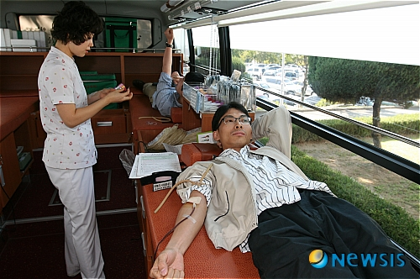
Picture A

Picture B

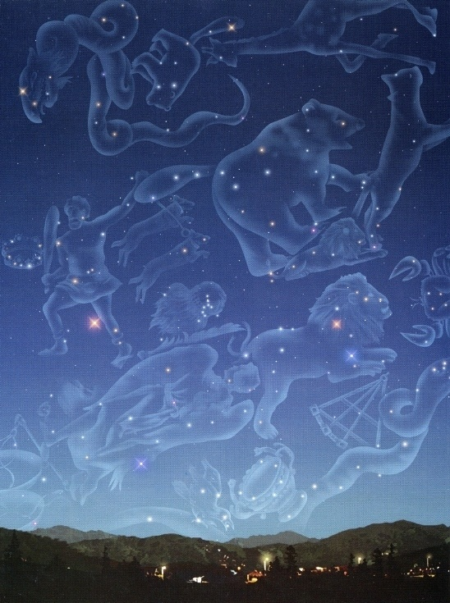
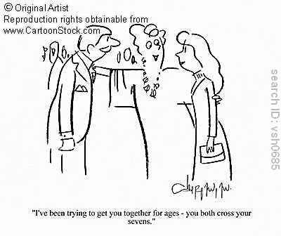

Picture C

