<WORKSHEET #1>

* Please match the words and phrases with the definitions.

- any of various materials that can be used to produce
musical tones or sounds ( )

(2) very special or unusual ( )

- a plant or part of a plant that is eaten as food. ( )

(a) unique (b) vegetable (c) instrument

<WORKSHEET #2>

- Vegetable Orchestra -
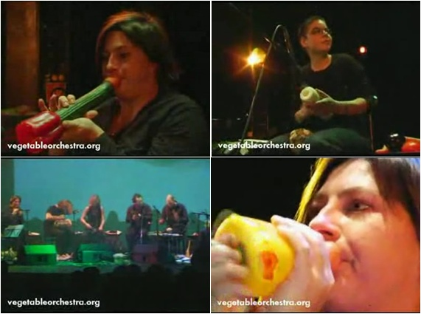

Carrots, peppers, pumpkins – most people use these vegetables to make their dinner. However, for the Vienna Vegetable Orchestra, they are perfect instruments for playing music! Since 1988, this group of 11 men and women has been making music with vegetables and giving concerts around the world.

It is a concert day. The musicians are at the local market. They are looking for good, fresh “instruments” to buy. After shopping, they begin making instruments. With just a knife, a drill, and imagination, soon there will be a carrot flute, a pepper trumpet, and a pumpkin drum! Now, it’s time to play. The concert starts and the audience is surprised: How can the vegetables produce such a calm and comforting sound? It’s a unique sound that no other instruments can make. In addition, fresh smells from the vegetables fill the whole concert hall.

The performance is over, but no one leaves the concert hall. Why?
They’re waiting for some vegetable soup that is made from the instrument! This special orchestra pleases not only your ears, but your nose and stomach, too.
<WORKSHEET #3>

- Comprehension Questions -

# Read the text, and answer the following questions.

1. Where do the musicians get instruments?

2. What kind of tools can the musicians use to make the vegetable instruments?

3. After the concert is over, why do people stay in the hall?

4. Why do the audience enjoy their concert ?

5. If you are a musician , what kind of instrument do you want to play?

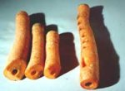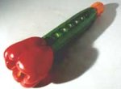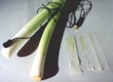

- Homework -
* Class :
* Name :
# An interview with a member of the Vienna Vegetable orchestra
Q: ( A )
A: Vegetables sounds great, and you can also smell and taste them. They’re
nice to look at too, with many different colors and shapes. Most importantly,
you can fine them anywhere.
Q: ( B )
A: Oh, we hear that question too often! No, we’re not.
Q: ( C )
A: Sometimes it’s hard to find the right vegetables. To make a carrot recorder,
for example, you need a special kind of carrot. In some countries, It can be
hard to find.
Q: How do all the members work with each other?
A: There 13 of us and we all have different ideas about music. Therefore, we
talk a lot during practice. In this way, we can respect each other’s ideas.

1. Match the correct question to each blank.

    - (A) ⓐ Are all of vegetarians?
    - (B) ⓑ Is it difficult to prepare for your concerts?
    - (C) What are the reasons you use vegetables as
instruments?

2. The members talk a lot during practice because they (
)

