Lesson Plan - Language Based Template

Topic : Animals In The Zoo.
Instructor:  Lina |  |  | Students Level:  Upper Beginner  7-9 years old. |  | Number of Students:  12 |  | Lesson Length:  50 min
Materials:
1. Velcro Board (setting: front side- zoo animals/ back side – animals & letter flash cards)
2. Pictures of various place (zoo, hospital, fire station, kindergarten)
3. Flash cards of zoo animals (snake, lion, monkey, bear, dolphin, elephant) & zoo sign.
4. Team marker & candies , score board, mike
5. Big bag (Ss put their activity materials in the bag)
* Worksheets : Write and Color the Picture. Match The Puzzles.
* Songs : s1- Daddy’s Taking Us To The Zoo Tomorrow.
s2- Goodbye Song.
Objective/Aims of Lesson: (What students will be able to do during the lesson and as a result of the lesson.)
1. Ss will be able to say “Let’s go to the zoo” & “ I like zoo animals & I don’t like zoo animals
(snake, lion, monkey, bear, dolphin, elephant) by singing a song (s1) and answering T questions.
2. Ss will learn words about animals in the zoo by answering T questions,
participating in classroom activities, playing games.
3. Ss will improve listening skill by T questions, participating in classroom activities,
playing games, singing a song “s1, s2”.
4. Ss will improve speaking skill by answering Ts questions, participating in classroom activities,
playing games, singing a song “s1,s2”
5. Ss will improve reading skill by reading flash cards and worksheet.
6. Ss will improve writing skill by completing a worksheet.
Language Skills: (Lists what language skills students will be using)
1. Speaking: Ss answering T questions, participating in classroom activities, playing games,
singing a song “s1, s2”
2. Reading: Word cards, Worksheet
3. Writing: Worksheet
4. Listening: Ts’ talk, participating in classroom activities, playing games,
a song “s1, s2”, Ss talk..
Assumptions: (What students must already be able to do and what concepts must already be mastered before the lesson.)
1. Ss know words about family. (daddy, mommy)
2. Ss can express their feeling. (good, bad, sad, tired)
3. Ss know words about places. (hospital, kindergarten, fires station, zoo)
4. Ss can follow the song.(S1, S2)
5. Ss can make short sentences with vocabulary used in the lesson.
6. Ss know most of words used in lesson.
Anticipated Errors and Solutions: (What things might go wrong in the lesson and what the solution will be.)
1. Some Ss are too shy to participate -> Ts encourage Ss and give positive feedback.
2. Lesson ends earlier than expected-> Ts ask more questions and play some game with flash cards.
3. If lesson takes longer than expected-> Ts make activity shorten and ask fewer questions.
References:
www.teacherplus.co.kr , http://www.kizclub.com
 | 1. WARM-UP ( 8 min)
Materials:
1. Pictures of various place (zoo, hospital, fire station, kindergarten)
2. Song: Daddy ‘s Taking Us To The Zoo Tomorrow.

 | Time: | Classroom Set Up: |  | Student Activity and Goals: |  | Teacher Procedure:
 | 1 min  3 min  4 min | Whole class |  | Ss greet T.  Ss listen & answer  Ss sing a song.  2times |  | *Greet .  1. Tell the story.  (With Daddy In The Zoo.)  2. Show the places picture cards &  , find the zoo with Ss.  3. Ask “ Do you like the zoo?”  4. Sing a song with Ss.  (Daddy’s Taking Us  To The Zoo Tomorrow)

2. PRESENTATION (20 min)

Materials:
1. Velcro Board, Microphone
2. Flash cards of zoo animals (snake, lion, monkey, bear, dolphin, elephant)
& zoo sign.
Song: “Who Is Sitting Lovely.”
Time: | Classroom Set Up: | Student Activity and Goals: | Teacher Procedure:
1min  14min  5min | Whole class  Individual | Listen and observe.  Ss learn animals  In the zoo.  Ss can say.  (I like _____)  (I don’t like ______)  Ss answer.  Ss can answer in Korean.  T transfer in English  In a positive way. | 1. Show the zoo made  by Velcro board &  flash cards.  2. Ask & Act (zoo animals).  What can you see  In the zoo?  ( I like_____)  ( I don’t like ______)  Song:  Who Is Sitting Lovely.  Ask CCQ.:  What animal do you like?  What animal you don’t like?

3. PRACTICE TO PRODUCTION ( 17 min)

Materials:
1. Velcro Board
2. Flash cards of zoo animals which printed letter & picture together.
Time: | Classroom Set Up: | Student Activity and Goals: | Teacher Procedure:
15 min  2 min | SSSS groups | SS form SSSS groups.  Ss play the game by team.  Ss read the letter,  Listen to the T’s speaking. | 1. Divide 3 teams &  Give the team marker.  2. Explain “Who Is Missing” Game  -During the game,  T shows the letters,  T lets the Ss read the letters.  (The teacher will give extra points to the teams and at the end of the game they will be winners.)  3. Check the score.  4. Congratulate Ss & praise SS.

4. WRAP-UP (5 min)

Materials: Big bag.
worksheet.: Write Word & Color The Picture, Match The Puzzles.

Time: | Classroom Set Up: | Student Activity and Goals: | Teacher Procedure:
1 min  1 min  1min  2 min | Whole class  Whole class. | Ss review today’s lesson  by answering T’s question.  Ss clean up with teacher.  Ss sing.  Ss receive the worksheet.  Ss sing a song.  (Good bye song)  Ss say good –bye. | 1. Review by flashcards.  Show them to the Ss , after that  T ask about the zoo animals.  2. Clean up with Ss.  Take the teaching materials from  the Ss and put them in the big bag.  Ss sing “Clean Up Time “  3. Explain the work sheet and  give it.  4. Tell the Ss, “time is up’”  Sing “Goodbye Song” together.
Worksheet Team markers
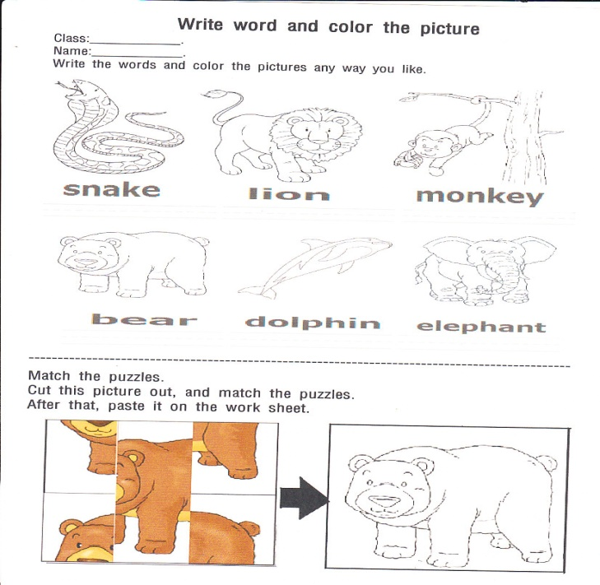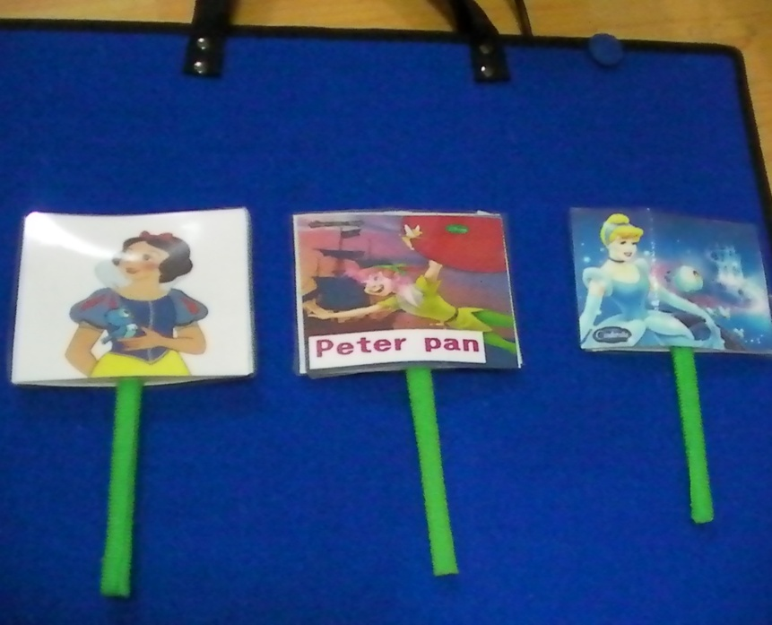

Flash cards & score board
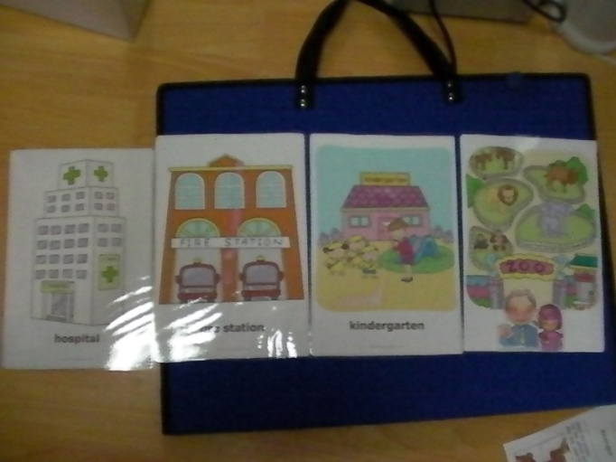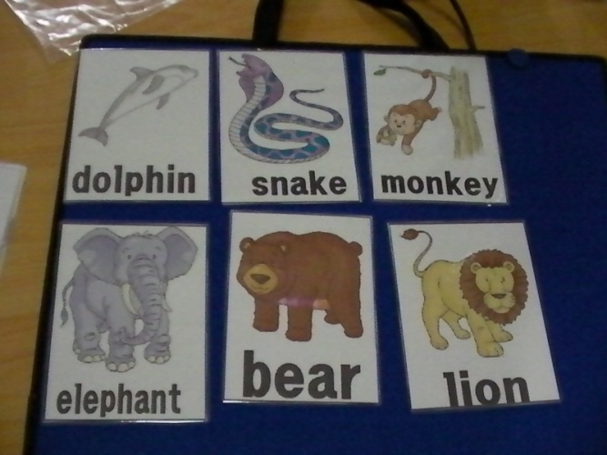

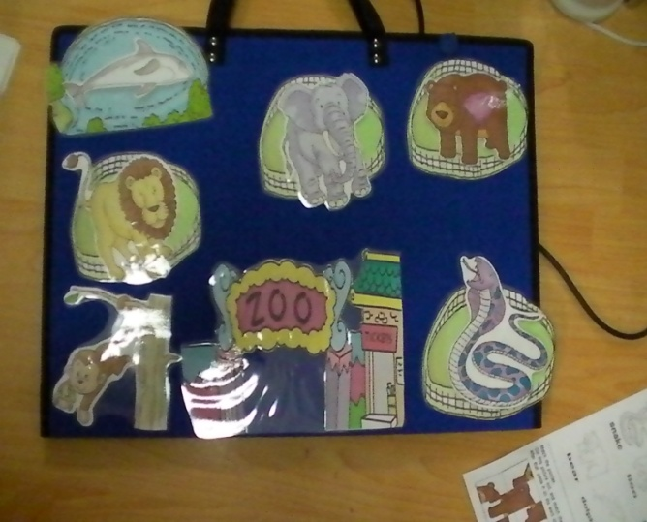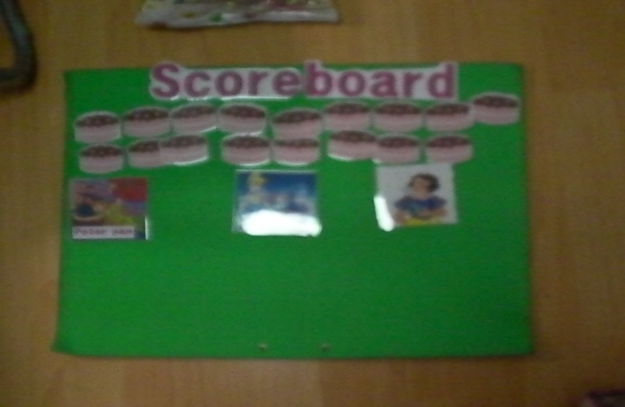
Candies & Mic
