Grammar Lesson Plan

Countable Nouns vs. Uncountable Nouns
Instructor:  Min-jeong, Kim |  | Level:  Low  Intermediate |  | Students:  8 |  | Length:  50 minnutes

Materials:

- Handout
- Beam projector, computer with the Internet connection, PPT(power point)
- White board, board markers, board erasers

Aims:

- Ss will be able to distinguish between countable nouns and uncountable nouns.

Language Skills:

- Reading: reading handouts
- Writing: answering the worksheet.
- Listening: listening to teacher’s instruction, explanations.
- Speaking: drilling, answering questions, and talking individually or in pairs.

Language Systems:

- Phonology: listening to the lecture, drilling.
- Grammar: countable nouns and uncountable nouns
- Function: making a sentence with countable nouns and uncountable ones.
- Discourse: working in pairs using the grammar we learn

Assumptions:

-Ss already learnt the grammar ‘a’ and ‘an’.
-Ss are around 13years old.
-Ss are visual learners.(Visual/Spatial Intelligence)
-Ss feel comfortable with an enabler teacher.

Anticipated Errors and Solutions:

- If class is going faster than I thought, I will give students more time practicing in pairs.
-If class is short of time, I will give Ss handouts as homework.

References:

- English Grammar Third Edition by Betty Schrampfer Azar
- Grammar in use Second Edition by Raymond Murphy
- Englishclub.com
Lean-In
Materials: Whiteboard, markers, Projector & computer
Time  2min | Set Up  Whole class | Procedure:  <Greeting>  Hello, everyone.  How are you today?

Pre-activity
Materials: white board, board markers, board erasers, beam projector, computer w/ Internet, ppt
Time  8 minutes | Set Up  Whole class | Procedure:  <Eliciting>  Showing some pictures of countable nouns and uncountable nouns.  “Among those, which of them can we count? Is there anything we can not count?”  <Introduction>  “We will learn about countable nouns and uncountable nouns today.”
Main-activity
Materials: handouts, white board, board markers, board erasers, beam projector, computer w/ Internet, PPT
Time  30 min | Set Up  Whole class | Procedure:  1.<Definition ; the two types of nouns>  “A countable noun can be singular or plural.  Countable nouns are things we can count.”  “An uncountable noun has only one form.  Uncountable nouns are things we cannot count.”  <CCQ>  What are countable nouns?  What are uncountable nouns?  Can you count countable nouns?  Can you count uncountable nouns?  2.<Distinguish the two types of nouns>  Teacher will give a lecture.  3. <Practice>  ~Giving handouts to Ss  Ss will be paired off and practice distinguishing the two types of nouns, countable nouns and uncountable nouns.

Post-Activity
Materials: white board, board markers, board erasers, beam projector, computer w/ Internet, PPT
Time  8 min  2min | Set Up  Whole Class  Whole class | Procedure:  <Feedback>  Go over the answer sheet together and correct Ss’ answer.  <Homework>  Handouts: Fill in the blank  <Closing>  “I hope you enjoyed the class today.  If you have any question while doing your homework, please email me or call me. I’ll try to help you out. Have a good day!”

<< Contents of the lecture>>

Countable Nouns
Countable nouns are easy to recognize. They are things that we can count. For example: "pen". We can count pens. We can have one, two, three or more pens. Here are some more countable nouns:
- dog, cat, animal, man, person
- bottle, box, litre
- coin, note, dollar
- cup, plate, fork
- table, chair, suitcase, bag
Countable nouns can be singular or plural:
- My dog is playing.
- My dogs are hungry.
We can use the indefinite article a/an with countable nouns:
- A dog is an animal.
When a countable noun is singular, we must use a word like a/the/my/this with it:
- I want an orange. (not I want orange.)
- Where is my bottle? (not Where is bottle?)
When a countable noun is plural, we can use it alone:
- I like oranges.
- Bottles can break.
We can use some and any with countable nouns:
- I've got some dollars.
- Have you got any pens?
We can use a few and many with countable nouns:
- I've got a few dollars.
- I haven't got many pens.

Uncountable Nouns
Uncountable nouns are substances, concepts etc that we cannot divide into separate elements. We cannot "count" them. For example, we cannot count "milk". We can count "bottles of milk" or "litres of milk", but we cannot count "milk" itself. Here are some more uncountable nouns:
- music, art, love, happiness
- advice, information, news
- furniture, luggage
- rice, sugar, butter, water
- electricity, gas, power
- money, currency
We usually treat uncountable nouns as singular. We use a singular verb. For example:
- This news is very important.
- Your luggage looks heavy.
We do not usually use the indefinite article a/an with uncountable nouns. We cannot say "an information" or "a music". But we can say a something of:
- a piece of news
- a bottle of water
- a grain of rice
We can use some and any with uncountable nouns:
- I've got some money.
- Have you got any rice?
We can use a little and much with uncountable nouns:
- I've got a little money.
- I haven't got much rice.
Uncountable nouns are also called "mass nouns".
Here are some more examples of countable and uncountable nouns:
Countable | Uncountable
dollar | money
song | music
suitcase | luggage
table | furniture
battery | electricity
bottle | wine
report | information
tip | advice
journey | travel
job | work
view | scenery

Nouns that can be Countable and Uncountable
Sometimes, the same noun can be countable and uncountable, often with a change of meaning.
Countable |  | Uncountable
There are two hairs in my coffee! | hair | I don't have much hair.
There are two lights in our bedroom. | light | Close the curtain. There's too much light!
Shhhhh! I thought I heard a noise. | noise | It's difficult to work when there is too much noise.
Have you got a paper to read? (= newspaper) | paper | I want to draw a picture. Have you got some paper?
Our house has seven rooms. | room | Is there room for me to sit here?
We had a great time at the party. | time | Have you got time for a coffee?
Macbeth is one of Shakespeare's greatest works. | work | I have no money. I need work!

Drinks (coffee, water, orange juice) are usually uncountable. But if we are thinking of a cup or a glass, we can say (in a restaurant, for example):
- Two teas and one coffee please.

<Exercise>
Learn countable nouns and uncountable nouns with the picture of fridge.
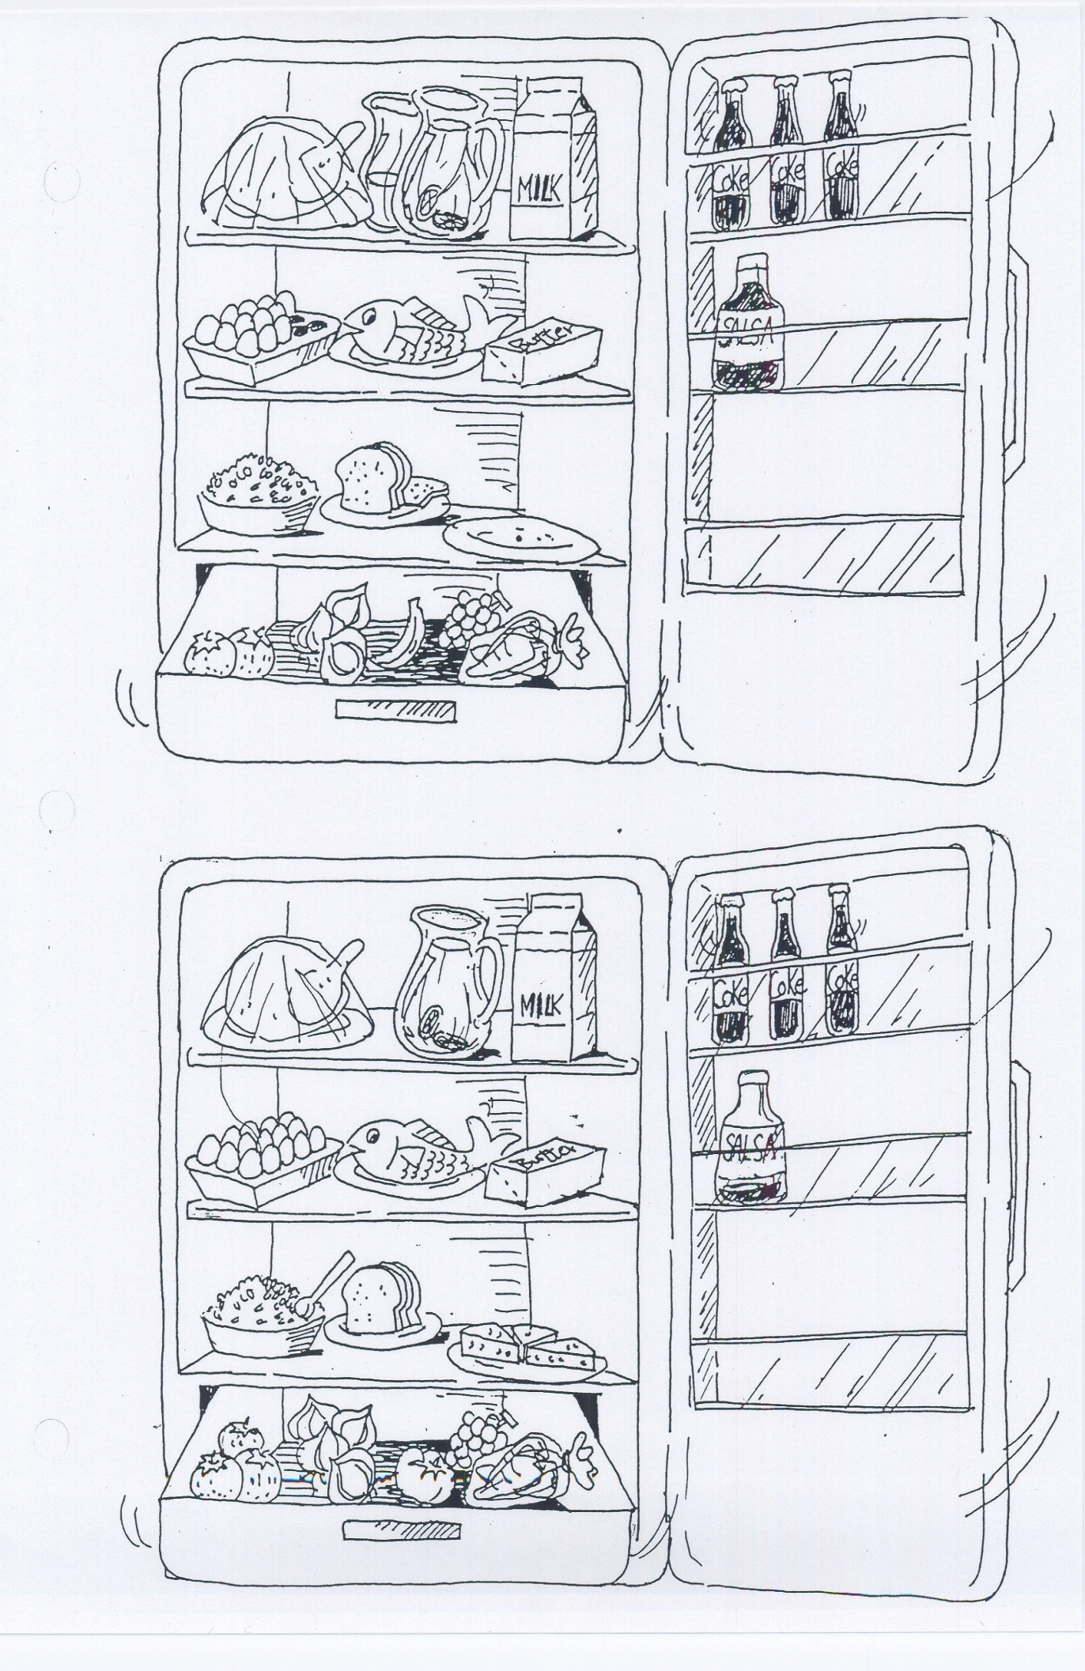
<Exercise: Home work>

Complete the sentences using one of the following words. Sometimes the word needs to be Plural (-s). Use a/an if necessary.

country day friend language

letter line meat

picture space umbrella

1. I had my camera, but I didn’t take many pictures.

2. There are seven _________________ in a week.

3. A vegetarian is a person who doesn’t eat ___________________.

4. Outside the movie theater there was _____________________ of people waiting to see the movie.

5. I’m not very good at writing ____________________.

6. Last night I went out with some ____________________ of mine.

7. There were very few __________________ in the stores today. They were almost empty.

8. I think it’s going to rain. Do you have ___________________ I can borrow?

9. George always wants things quickly. He has no _________________.

10. Do you speak any foreign ____________________?

11. Jane travels a lot. She has been to many ___________________.

12. Our apartment is very small. We don’t have much _____________________.

<Answer>

1. I had my camera, but I didn’t take many pictures.

2. There are seven days in a week.

3. A vegetarian is a person who doesn’t eat meat.

4. Outside the movie theater there was a line of people waiting to see the movie.

5. I’m not very good at writing letters.

6. Last night I went out with some friends of mine.

7. There were very few people in the stores today. They were almost empty.

8. I think it’s going to rain. Do you have an umbrella I can borrow?

9. George always wants things quickly. He has no patience.

10. Do you speak any foreign languages?

11. Jane travels a lot. She has been to many countries.

12. Our apartment is very small. We don’t have much space.

