Reading Lesson Plan

How to make an origami crane

Instructor:  Min-jeong, Kim |  | Level:  Intermediate |  | Students:  8 |  | Length:  50 minutes

Materials:

- Handout, colored paper
- Beam projector, computer with the Internet connection, PPT(power point)
- White board, board markers, board erasers

Aims:

- Ss will be able to understand the instruction by practicing reading.
- Ss will enhance reading skills.
- Ss will be able to make an origami crane. (Task-based lesson)

Language Skills:

- Reading: reading handouts
- Writing: answering the worksheet.(fill in the blank)
- Listening: listening to teacher’s lecture and partner’s instruction or explanation.
- Speaking: answering questions, and talking in pairs.

Language Systems:

- Phonology: listening to the lecture.
- Grammar: learning idioms, new expressions
- Function: reading an instruction.
- Discourse: making an origami crane, following to the given instruction

Assumptions:
-Ss feel comfortable with a task-based lesson.
-Ss are around 18years old.
-Ss are visual learners.(Visual/Spatial Intelligence)
-Ss feel comfortable with an enabler teacher.

Anticipated Errors and Solutions:

- If class is going faster than I thought, I will give students more time practicing making an origami crane in pairs.
-If class is short of time, I will give Ss handouts for a post activity as homework.

References:

http://monkey.org/~aidan/origami/crane/crane6.html
http://video.about.com/familycrafts/How-to-Make-an-Origami-Crane.htm

Lean-In
Materials: Whiteboard, markers, Projector & computer
Time  3min | Set Up  Whole class | Procedure:  <Greeting>  Hello, everyone.  How are you today?  <Eliciting>  Showing the picture of origami cranes.  “What is this?  This crane is made of paper.  We call this origami.  Origami is the craft of folding paper to make models of animals, people, and objects.”  <Introduction of the topic>  “We will learn how to make an origami crane today.”

Pre-activity
Materials: white board, board markers, board erasers, beam projector, computer w/ Internet, PPT
Time  7minutes | Set Up  Whole class | Procedure:  <Studying the vocabularies >  Teacher will go over some vocabularies Ss need to know to read an instruction.  <Giving handouts ; about vocabularies >  Teacher will give Ss the handouts of vocabularies so Ss can review and study more after class.
Main-activity
Materials: handouts, white board, board markers, board erasers, beam projector, computer w/ Internet, PPT
Time  15 min  15 min | Set Up  Whole class  Whole class | Procedure:  1.< Individual work>  Teacher will give Ss handouts containing the instruction of making an origami crane.  Ss will read the instruction thoroughly and make an origami crane, followed to the instruction, as Ss understood from the instruction.  <CCQ>  “What should we do?  How long do we have a time to finish this?”  2.<Group work; pair work >  ~One student has a handout; the other student will not have a handout but have a colored paper.  Ss will be paired off.  One student ,A, will read the instruction out to the other student, B,  Student B has to make an origami crane step by step as she is listening.  <CCQ>  “Who is ‘A’?  Who is ‘B’?  What should ‘student A’ do?  What should ‘student B’ do? ”

Post-Activity
Materials: white board, board markers, board erasers, beam projector, computer w/ Internet, PPT
Time  8 min  2min | Set Up  Whole Class  Whole class | Procedure:  <Feedback>  Teacher will check if Ss understood the instruction correctly or not.  Teacher will show Ss the video clip of making an origami crane.  <Homework>  Handouts: Fill in the blank.  <CCQ>  What is your homework?  When is the due date for this homework?  <Closing>  “I hope you had a fun with making an origami crane today.  If you have any question while doing homework, please email me.  I will do my best to help you out.  Have a good day! See you next week”

<< Contents of the lecture>>

★Vocabulary

- Side: Noun) the side of something is a position to the left or right of it, rather than in front of it, behind it, or on it.
- Both: DET) you use when you are referring to two people or things and saying that something is true about each of them.
- Fold: Verb) If you fold something such as a piece of paper or cloth, you bend it so that one part covers another part, often pressing the edge so that it stays in place.
- Edge: Noun) (usu with supp) the edge of something is the place or line where it stops, or the part of it that is furthest from the middle.
- Outward: ADJ) the outward features of something are the ones that you can see from the outside.
- Lay: Verb) If you lay something somewhere, you put it there in a careful, gentle, or neat way.
- Flat: ADJ) flat means horizontal and not upright.
- Diagonal: ADJ) A diagonal line or movement goes in a sloping direction, for example, from one corner of a square across to the opposite corner.
- Line up: to be, or to put something , in the correct position in relation to something else
- Flap: Noun) A flap on the wing of an aircraft is an area along the edge of the wing that can be raised or lowered to control the movement of the aircraft.
- Flip: Verb) if something flips over, or if you flip it over or into a different position, it moves or is moved into a different position.
- Opposite: ADJ) the opposite side or part of something is the side or part that is furthest away from you.
- Lift: Verb) if you lift something, you move it to another position, especially upwards.
- Upwards: ADJ) if someone moves or looks upwards, they move or look up towards a higher place.
- Crease: Noun) Crease are lines that are made in cloth or paper when it is crushed or folded.
- Invert: Verb) if you invert something, you turn it the other way up or back to front.

★How to make an origami crane

1. Start with a perfectly square sheet of paper
Paper made specifically for origami can be found
at most craft stores. It is usually colored only on
one side. I used a sheet that was colored on both sides.
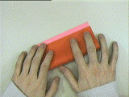 | 2. Begin by folding one edge to meet to other,  with the colored side outward...
 | ...to get this.
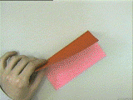 | 3. Open up the paper and lay it flat.  Now repeat step 2 in the other direction,  and open up it up again.
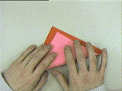 | 4. Fold it diagonally with the white side out (pink here).  Line it up corner to corner...
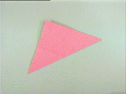 | ...to get this.
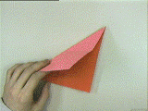 | 5. Open up the paper, repeat  step 4 in the other direction, and  open up the paper again.

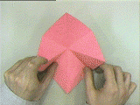 | 6. Lay the paper with the white side up. (pink here)  Bring in the side corners, while bringing  the top corner down...
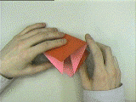 | ...like this...
 | ...to get this.
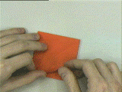 | 7. With the open side pointing towards the left  in this picture, fold one corner of the square  so that the edge is lined up with the center line...
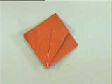 | ...to get this.
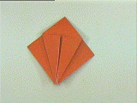 | 8. Repeat step 7 with the other flap.
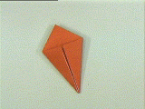 | 9. Flip the paper over and repeat step 7 for  the other two flaps.

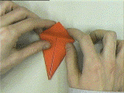 | 10. Fold the top flap down and crease hard...
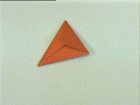 | ...to get this. Now fold it the same way in the  opposite direction.
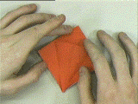 | 11. Open up one side, and lay it flat.
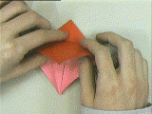 | 12. Lift the top flap on the open end (the lower  end in this picture) and fold it upwards, bringing  in the sides...
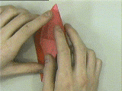 | ...like this...
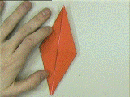 | ... and lay flat to get this.
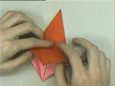 | 13. Flip the paper over and repeat steps 11 & 12  for the other side...

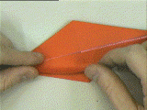 | 14. With the open end towards the left in the  picture, fold in one flap in so that the edge  lines up with the center line...
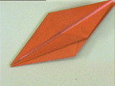 | ...to get this.
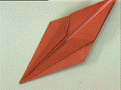 | 15. Repeat step 14 for the other flap.
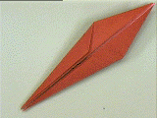 | 16. Flip the paper over and repeat steps 14 & 15  for the flaps on the other side.
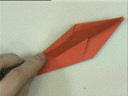 | 17. Fo ld over one side, like this...
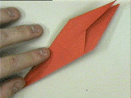 | ... and lay flat to get this.

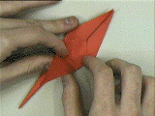 | 18. Fold up the top flap on the open end, so that  the tip of the lower flap reaches the tip of upper  flap...
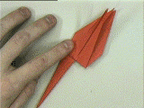 | ...like this.
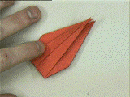 | 19. Fold two of the flaps over and repeat step 18  for the other lower flap.
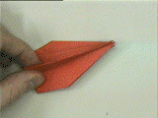 | 20. Fold one flap over and lay flat...
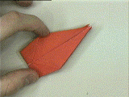 | ...to get this.
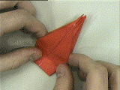 | 21. Fold the top flap down...
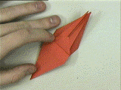 | ...to get this.
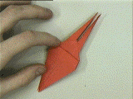 | 22. Flip the paper over and repeat step 21 for  the other side.

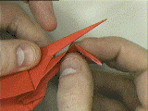 | 23. Invert fold one of the upper tips like this...
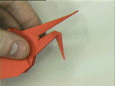 | ...to form the head.
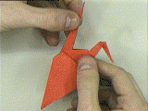 | 24. Pull back the other tip like this...
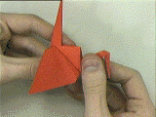 | ...to form the tail.
 | 25. Gently pull the wings apart to form the body.
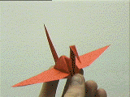 | And now it is complete!

★Homework

*Fill in the blank with a proper word
(Choose from the box blow)

Side Both Fold Edge Outward Lay Flat

Diagonal Line up Flap Flip Opposite Lift

Upwards Crease Invert

1. Verb) you turn it the other way up or back to front. ( )
2. ADJ) the side or part that is furthest away from you.
( )
3. Noun) is the place or line where it stops, or the part of it that is furthest from the middle.
( )
4. ADJ) the ones that you can see from the outside. ( )
5. Verb) you put it there in a careful, gentle, or neat way. ( )
6. ADJ) means horizontal and not upright. ( )
7. Noun) a position to the left or right of it, rather than in front of it, behind it, or on it. ( )
8. DET) you use when you are referring to two people or things and saying that something is true about each of them. ( )

