Olympic champion duo holds wedding ceremony on the ice
09-05-2010 12:25 BJT
Text:A A A |Email
Share |

Watch Video
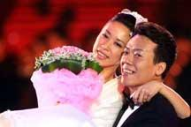Play Video

Retired Olympic champion duo Shen-Xue and Zhao-Hong-bo fulfilled a long-time dream by holding a wedding ceremony on the ice on Saturday at the Capital Indoor Stadium in Beijing. The exhibition also featured several top international skaters.
The couple had a romantic wedding in front of 20,000 spectators.
With the wedding march performed by their coach Yao Bin, wearing white wedding dress Shen-Xue skated to the man she fell in love with 18 years ago.
The couple devoted themselves on figure skating during that period. They gained China's first figure skating gold medal at the Winter Olympics and decided to devote themselves to each other.
The audience were impressed by their happiness，the moment of skating on their wedding day will last with them for their lifetime.
The gala, "Artistry on Ice", also featured American skater Johnny Weir, Swiss former World Champion Stephane Lambiel China's current pairing Pang-Qing and Tong-Jian World champion and Olympic silver medalist Mao Asada and Russia's Olympic singles champion Alexei Yagudin also brought down the house with Russia's ice king Evgeni Plushenko's performance the final highlight of the show.

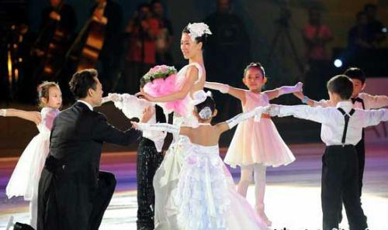

Retired Olympic champion duo Shen-Xue and Zhao-Hong-bo fulfilled a long-time dream by holding a wedding ceremony on the ice on Saturday at the Capital Indoor Stadium in Beijing.

A spectator said,"It's unbelievable! I can watch the performance by the skaters that I love." A spectator said, "Simply wonderful! Very Excellent!"
Shen-Xue and Zhao-Hong-bo appeared on the ice again at the end of the two-hour performance.
They performed Turandot which won them the 2003 World Championship. The spectator's applause rang out for ages in support of what the pair have achieved in their lives. Shen-Xue said,"I am very happy that all the spectators stand to applaud us. I want to say thanks to the support of the spectators. This gala is for the audience We want them to know more of the sport and love it like we do."

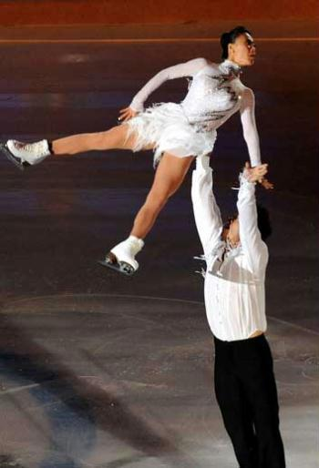

Share |
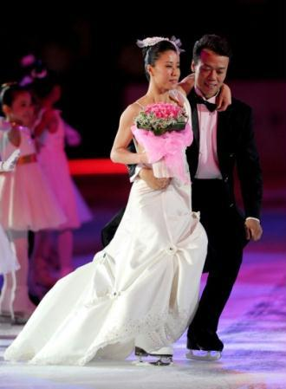

Retired Olympic champion duo Shen-Xue and Zhao-Hong-bo
fulfilled a long-time dream by holding a wedding
ceremony on the ice on Saturday at the Capital Indoor
Stadium in Beijing.

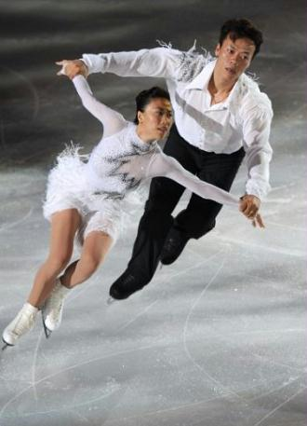

Retired Olympic champion duo Shen-Xue and Zhao-Hong-bo fulfilled a long-time dream by holding a wedding ceremonyon the ice on Saturday at the Capital Indoor Stadium in Beijing.

The follow pages is the class lesson work-sheets:
- Comprehension Task

Check true ,false or no information as you read the text “Olympic champion duo holds wedding ceremony on the ice……”

About Wedding Ceremony Dress & Clothes Code | True | False | No information
- In wedding ceremony on ice, they can wear anything.
- Are the champion couple skating together with children on the stage?
3. Shen-Xue skated to the man she fell in love with 18 years ago？

4. They gained China's first figure skating gold medal at the Winter Olympics

Teacher Comments:

2.The“Olympic champion duo holds wedding ceremony on the ice…”worksheet.
Writing Task *Writing some clothing do’s and don’ts wear in a wedding ceremony of Korean or other country *Writing at least 2 things.

Situation | Do | Don’t
In cities or
in countrysides
In*traditional
*wedding
*ceremony settings
Comments by teacher:

3.The“Olympic champion duo olds wedding ceremony on the ice……”Worksheet.
What’s your personal wedding ceremony especially code?
Circle “agree “or “disagress” for each statement about wedding ceremony dress disagree.

I’ts OK to wear shorts on the wedding ceremony? | agree | disagree
It’s OK for bride to wear wedding ceremony gown in church wedding? | agree | disagree
It’s OK for groom to wear the tailcoat in a church wedding? | agree | disagree
It’s OK the bride must to cover a veil on her head? | agree | disagree
Comments of teacher:

How would you rate yourself that relate the wedding ceremony
dress &clothes when you hold a wedding ceremony in the future?
*Will you be wearing the wedding gown on your
wedding ceremony? Yes/no/why

*Will you be wearing the casual clothes on your
wedding ceremony? yes/no/why

4.Vacabulary:
*.Winter Olympics
- devote
- Audience
- spectator'
- Impressed
- Skating
- Gala
- Artistry on Ice
- support
- Featured
- American skater Johnny Weir
- Swiss former World Champion Stephane Lambiel.
- China's current pairing Pang Qing and Tong Jian
- World champion and Olympic silver medalist Mao Asada
- Russia's Olympic singles champion Alexei Yagudin
- Russia's ice king Evgeni Plushenko's performance
- brought down the house
- highlight
- fulfilled
- wedding ceremony
- unbelievable
- the Capital Indoor Stadium
- international skaters.
- spectators.
- wedding march
- coach
- Olympic champion duo Shen Xue and Zhao Hongbo
- Excellent
- Simply wonderful
- Turandot
- World Championship
- applause rang out for ages
- applaud
- figure skating
- gold medal
- medalist
- medalist
- tailcoat
- groom
- bride
- wedding ceremony
- casual clothes
- veil

Appendix- especially wedding ceremony photoes in this world:

爆竹, firecracker
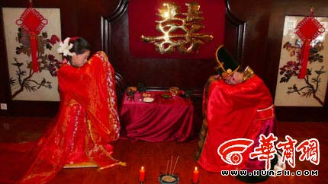

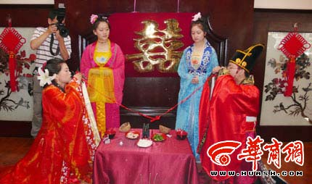

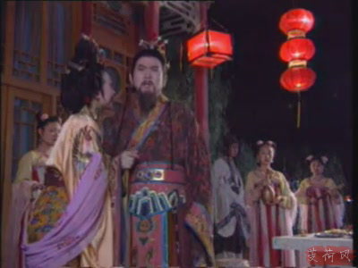

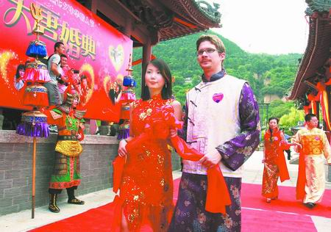
http://www.youtube.com/watch?v=K0DmtmmFEVo

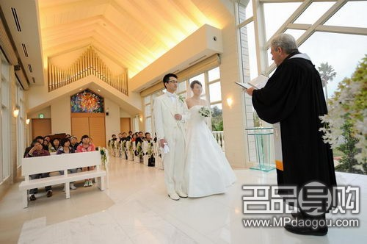

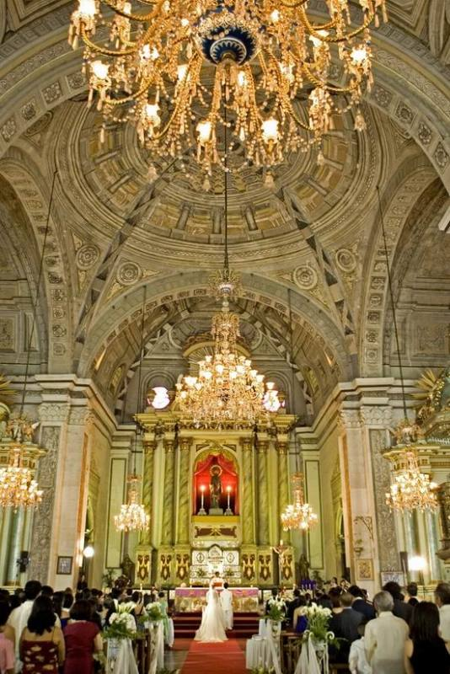



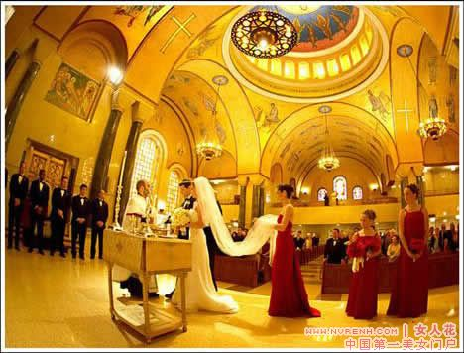

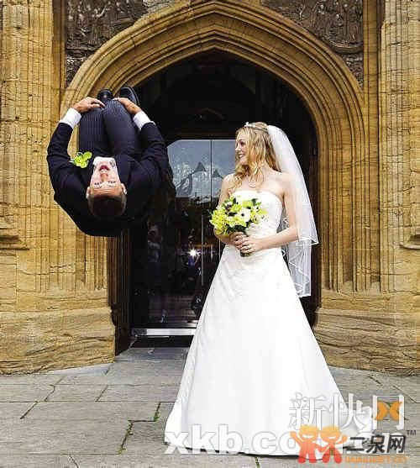

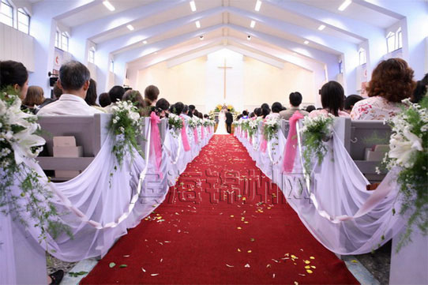

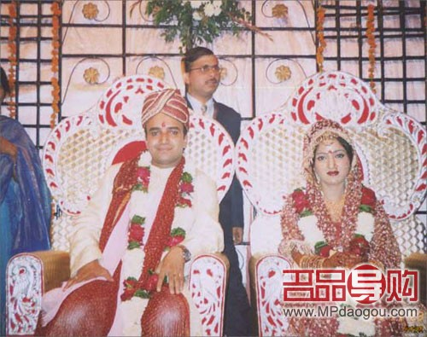

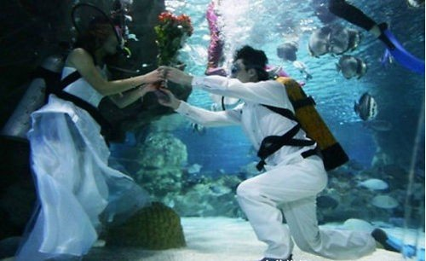

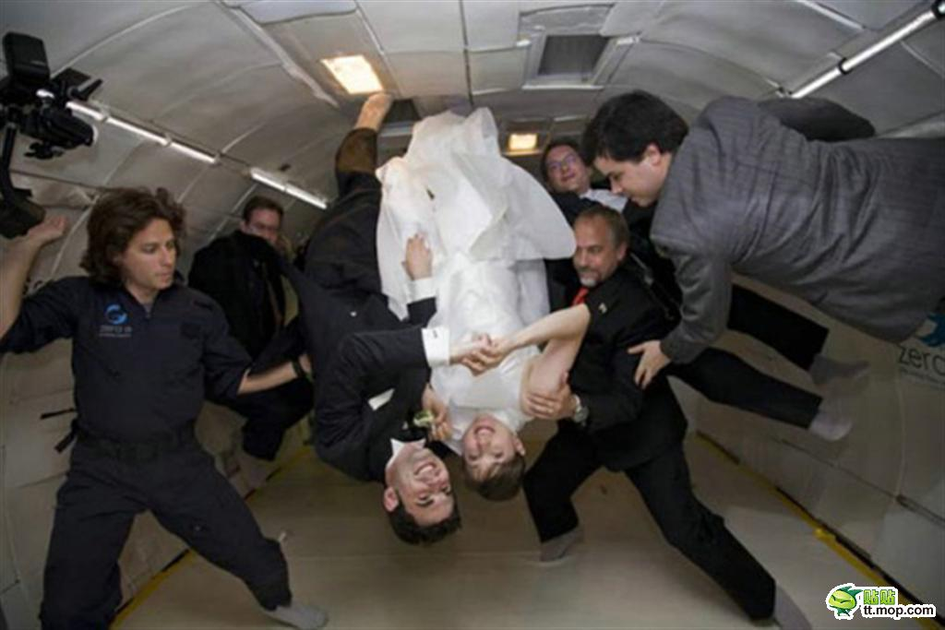
Spaceship wedding

Wedding eremony photoes:

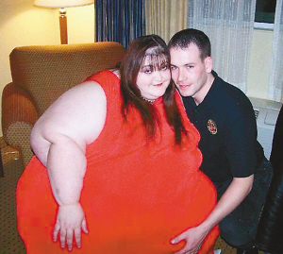

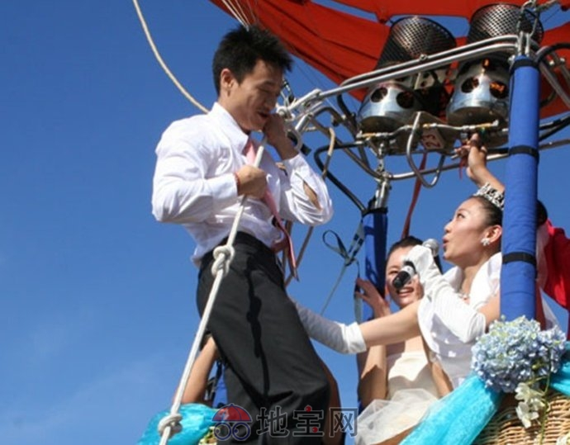
hot-air balloon.wedding

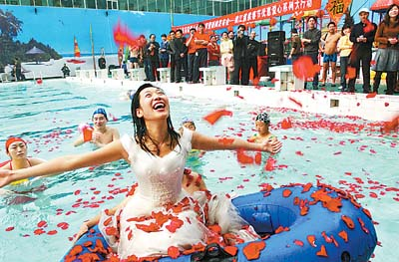

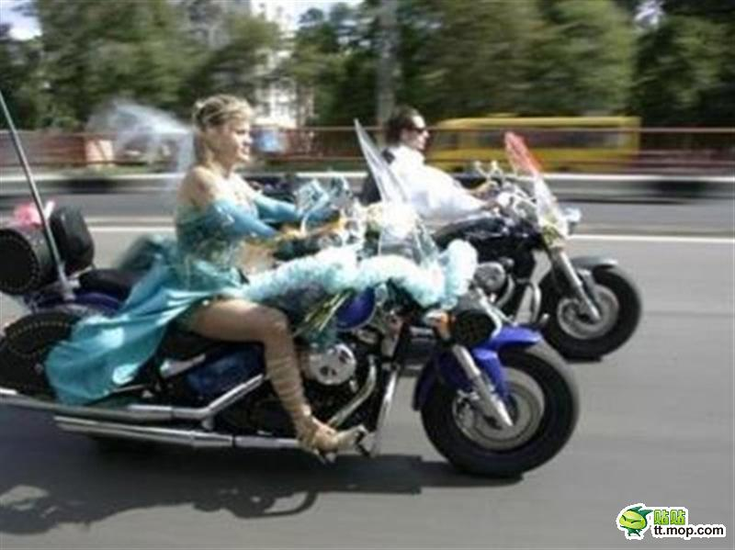
motorcycle wedding

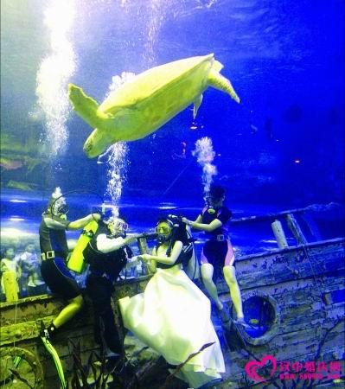

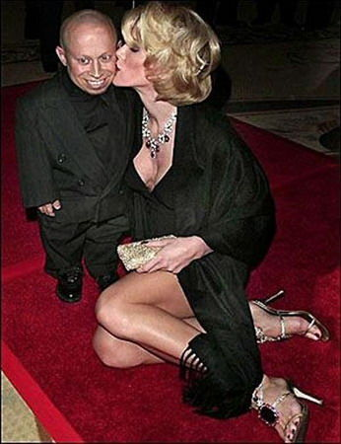

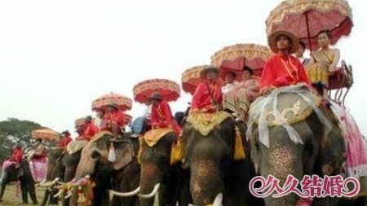

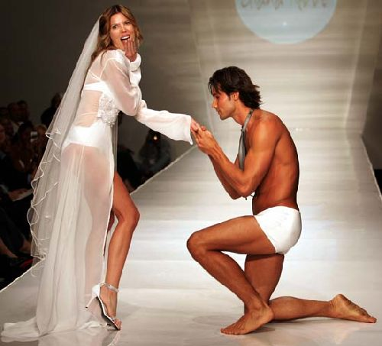

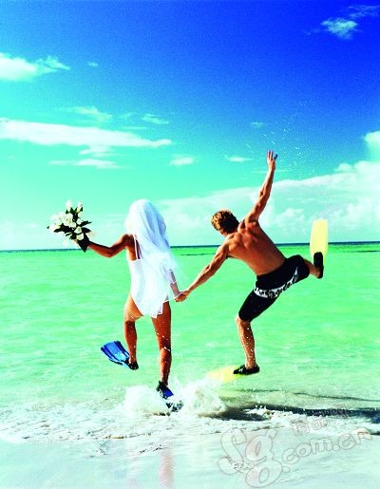frogman wedding



