Listening Lesson Plan

The Birthday Present
Instructor:  kyung-ok Kwon (Diane) |  | Level:  Lower Intermediate |  | Students:  9 |  | Length:  50 minutes

Materials:

- Worksheet #1 for vocabulary: 10 copies (9 copies for each Ss + 1 extra copy)
- Worksheet#1-1 Pictures for prediction: 5 copies(4copies for each pair + extra one copy)
- Worksheet#2 for comprehension(general things & details): 10 copies (9 copies for each Ss + 1 extra copy)
- Worksheet#3 for Instruction of discussion & writing letters: 10 copies (9 copies for each Ss + 1 extra copy)
- Worksheet#3-1:20 half pieces of paper to writing letters (18 pieces for Ss + 2 extra pieces, 2pieces for each Student)
- 10 small pieces of paper for naming (9 pieces for each Ss + 1 extra piece) & a small box
- Wall chart for demonstrations(including examples from WS#1~#3)
- Worksheet#4 for extra time or homework (about plural nouns)
- Listening CD & CD player (a short story with a length of 100 seconds)
- Whiteboard, board markers, board erasers, tape, scissors

Aims:

- To remind vocabulary related to an interesting subject (Birthday Presents) by talking with brain storming
- To learn vocabulary from a short story by listening and answering questions on the worksheet#1
- To predict a story might be happened by speaking with pictures (It is okay even incorrect prediction.)
- To practice comprehension of context by listening to a short story(The Birthday Present) several times and answering questions on the worksheet#2
- To be able to learn the way of writing a letter to someone else by writing letters for classmates in doing an activity
- To practice expressions by speech with letters for classmates in doing post activity

Language Skills:

- Listening: listening to the recording, the teacher and students
- Speaking: talking to each other through the pair/group work for brain storming and predicting stories
- Reading: reading the new words’ definition on the worksheet #1, reading worksheet#2 for comprehension and reading letters after post activities.
- Writing: writing vocabulary on the worksheet#1, gap-filling to write letters with students’ own sentences through worksheet #3

Language Systems:

- Lexis: Vocabulary used to define, figure out details and make a list of presents doing discussion.
- Function: Words and sentences used to complete the letters (short notes) on the worksheet#3.
- Structure: The rule of making plural nouns with putting “ –es” used to make plural nouns for words that end with s, x, z, ch, sh consonants, consonant + y and f or fe on the worksheet#4.
- Discourse: discussing to make a list of presents people like to give and receive and speeches after writing letters to each other

Assumptions:
Students already know:
- Seats have already been arranged in a horseshoe.
- How the class is set up and run (there will be 3 groups 3 Ss together.)
- Ss already know each other well. (e.g. someone’s hobbies, preference and sometimes family members)
- Ss are familiar with group work and discussion.

Anticipated Errors and Solutions:

- Ss may not be able to follow the passage easily
→ Follow the task-feedback circle: let them listen to the track again until they get the gist of the content.
- Ss may not be able to pick up details from listening
→ Chunk the listening (pause-play-pause-play)
- Ss may need more time to work on the vocabulary
→ Give any other questions easer to find the answer by her/him self when monitoring them or let them to work in pair or group. But if it takes longer than 5minutes, cut answer-checking short by verbally sharing the answers instead of having Ss write them on the board.
- If time is short
→ Skip or cut the predict of main activities shortly.
Cut writing letters of the main-activity2 and skip to pick a person from a box.
(Just speech to someone instantly looking the list of presents on the board and given situation on the worksheet#3)
- If students finish their tasks earlier than anticipated
→ Ask as many Ss as possible about their idea or experience of birthday presents what they want to give and receive.
Give Ss extra worksheets (WS#4; easy to solve) to take the task themselves, when Ss couldn’t finish them, they would be homework.

References:

- TESOL 05 Teaching Listening of the binder
- All New Easy TRUE STORIES UNIT18 “The Birthday Present” (p. 70~ 73) by Sandra Heyer
- Worksheet#1,2,3 adapted by kyung-ok Kwon(Diane) from All New Easy TRUE STORIES UNIT18
- http://lovetolearnplace.com/Grammar/singular%26pluralnouns.html

Lead-In
Materials: board ,markers and board erasers
Time | Set Up | Procedure
3 min | Whole Class | <Greeting>  Good morning everyone. How was yesterday?  How are you today?  <Eliciting>  Could you read the date today? (Written the date on the board) Thank you.  Today would be a special day for someone who was born in same date. What kind of a day would it be? (Ss say Birthday)  (Drawing a big box looking like a present on the middle of the WB)  When you think about a birthday, what comes in your mind? Could you tell me?  Do you remember any birthday presents that you received?  (Elicit Ss’ ideas or thoughts about a birthday and write them in the present on the board.)  Thank you, everyone has good ideas. We’re going to listen to a short story someone who prepares a birthday present for his close person. Before listening, we will learn some vocabulary the speakers use.

Pre-Activity
Materials: board ,markers, board erasers, tape, wall chart and worksheet#1, worksheet#1-1 of pictures
Time | Set Up | Procedure:
8 min  4min | Whole Class  Individually  Whole Class  Whole Class  In Pairs  Whole Class | Ⅰ. Vocabulary  < Instructions>  Work in individually. Draw a line to match the words and their definitions.  After the matching part A, then use the words from the box above and write the correct word on the line to complete sentences in part B. You have 4minutes.  <Demonstrations>  Look at the board, here is an example for Part A.  (Draw a line) Read definitions first, you are clear the word’s meaning then draw a line from the word to its definition.  Read these sentences, what word from the box do you need to fill the blanks? Think about the context! (e.g. “Present” -fill this word in the blank on the WB)  <Concept Check Qs>  What should you do first?  What do you fill in the blanks with?  How much time do you have?  (Distribute the worksheet#1)  Monitor discreetly while Ss take the WS. If students ask some questions, answer them. If students don’t do well, help them with some more examples. Give time warning: 1minute left. Be flexible with time. Ask students if they are done then check up the answers when they say yes.  Check the answers: verbally check for part A  What does mean the word “dump”?  In part B, let Ss write the correct vocabulary (not the letters) on the board.  Go through the vocabulary one by one: let each S who wrote the answer read the sentences including the answer loudly. Explain the meaning if necessary.  Ⅱ. Prediction  <Instruction>  Look at theses pictures. Can you make a story in order and use a simple sentence for each picture? You could remind the worksheet#1. Get in pairs 2 or 3. Share your ideas with your partner. Write the numbers on the pictures in order that you think of a story. There is no right answer. Just predict. I give 2minutes.  <Concept Check Qs>  Who are you working with?  What should you do?  How make a story with picture?  (Distribute worksheet#1-1 of pictures)  Give time warning: 30seconds left Elicit vocabulary on the WS#1. Encourage to speak using sentences what characters are doing in the pictures in pair work.  Ok, now Compare your predictions yourselves as you listen to the short story.

Main Activity -1
Materials: CD & CD player, wall chart , worksheet #2, board, marker, tape and eraser
Time | Set Up | Procedure:
5 min  10 min | Whole Class  Individually  Whole Class  Individually  In Pairs  Whole Class | Ⅰ. Listening for the main idea (general understanding)  <Instruction>  Put your pens down. Close your eyes. Listen to the whole story. Think about what this story about. Try to figure out the main idea.  <Concept Check Qs>  What are you supposed to think about?  Can you take notes?  (Play the CD player without stopping)  Would you like to listen again?  - Yes →Have them listen one more time.  - No →Have them share their thoughts.  What do think this story about?  Which genre do you think does this story belong?  Whose birthday is it?  (Give clear feedback to every response of students.)  Identify the pictures.  Compare with their thoughts from the prediction (if done.)  Just notice the differences.  Ⅱ. Listening for details  <Instruction>  Now, let’s listen to the story again. This time you should focus on finding out details. Answer the questions on the worksheet#2 as you listen. The recording will be played three times without stopping. Work individually.  <Concept Check Qs>  Are you working alone?  What should you do while listening?  How many times will the recording be played?  <Demonstrations>  Look at the board, here is an example for comprehension part. (using wall chart#2) Which # would be an answer to complete the question correctly? (e.g. circle the answers)  (Distribute worksheet#2)  (Play the recording three times without stopping)  Let Ss write answer as they listen.  Do you want to listen again?  - Yes →Have them listen one more time.  - No →Have them compare their answers in pairs of two or three.  If students don’t do well, play and pause the play.  Compare the answers with your partner. If you don’t know anything well, ask other students or me.  When you have an agreement, you will read your answer aloud to whole class.  Listen to the tracks one last time.  Check the answers as a person in each pair read the whole sentence of each question after another by turn on WS#2.(4pairs from #2 to #5 on the WS#2) Speak up answer together about the other parts on WS#2.

Main Activity-2
Materials: worksheet #3, worksheet#3-1, wall chart, small pieces of paper, a small box, board, marker, scissors, tape and eraser
Time | Set Up | Procedure:
6 min  8min | Whole Class  In Groups  Whole Class  Whole Class  Individually  Whole Class  Individually | Ⅰ. Discussion to make a list of present  <Instruction>  Make three groups of three students. Make a list of presents people like to give and receive.  <Concept Check Qs>  How many people are working together?  What should we make?  What is the topic of the discussion we will have?  Monitor activity and participate within each group. Give time warning: 1 minute left. Let them fill the list in each group on the WB.  Check the lists as reading and ask about some items why people want to give and receive them.  Ⅱ. Writing letters  <Instruction-1>  Write your name on a small piece of paper. You all put it in a box. Then take a name. You are going to give that person a “present.” Choose a present from the list on the board.  <Concept Check Qs>  What should you write?  (Distribute small pieces of paper)  Let Ss put the paper written their names into the box and pick a piece of other folded paper.  <Instruction-2>  Then copy the letter of on the WS#3 on your own paper and complete it. Then fold your letter and deliver it to your classmate. When you return to your desk, you will find a “present” from a classmate. Write a thank-you note to the person who gave you the present. Copy the thank-you note and complete. You will have 8 minutes.  <Concept Check Qs>  Are you working alone?  What are you supposed to do first?  Where do you write your letter & thank-note?  What will give your friend?  For how long?  (Distribute the worksheet#3 & #3-1)  Monitor writing. Answer the questions. Let Ss know where their names and friends’ name are written in a letter.

Post Activity-2
Materials: N/A, Worksheet#4
Time | Set Up | Procedure:
6 min | Whole Class  Whole Class | Ⅰ. Free Production  <Instruction>  You present a letter what you receive to speech.  Then you tell the friend who gave you the letter a thank-you note.  <Concept Check Qs>  Will you read the letter?  What will you do next?  How are you going to say?  Share Ss’ thoughts and their relationship.  Take 2~3 volunteers if running out of time. Let Ss give their friends the thank-you notes.  (Give positive feedback to every Ss’ thoughts)  Ⅱ. Conclude Lesson  Elicit today’s vocabulary for Ss  <Give Homework>  Take this homework and read the rules of plural noun first. Those can help you to get the answers. Homework is due tomorrow.  <Concept Check>  How can you get the answer?  Do you have to do it now?  By when do you have to finish your homework?  (Distribute HW)  Good job today. See you guys tomorrow!

The script of the listening passage

The Birthday Present

Joe is shopping. He is looking for a present for his wife. Her birthday is in two days. He sees a coat. It is a warm coat, and it is beautiful. It is also expesive-$1,000. Joe is not a rich man. But he loves the coat, and he loves his wife, so he buys the coat.
Joe doesn’t want his wife to see the coat, so he puts it in a black plastic bag. Then he takes the coat to his brother’s house.
When Joe arrives at his brother’s house, his sister-in-law is outside shoveling snow. “I’ll help you.” Joe says. He puts the black plastic bag down on the snow.
While Joe is shoveling snow, a garbage truck comes. The men see the black plastic bag on the snow. They pick it up and throw it into the truck.
When Joe finishes shoveling the snow, he looks for the black plastic bag. It is gone! Then Joe remembers the garbage black plastic bag is in the garbage truck!”
The garbage truck takes garbage to the dump. So Joe drives to the dump. There are thousands of black plastic bags at the dump. Which one has the coat in it? For hours, Joe opens black plastic bags.
He finds empty boxes and cans. He finds old shoes and clothes. He finds old potatoes and onions. Finally, he finds the coat.
Joe gives the coat to his wife on her birthday. “It’s beautiful!” she says. “I love it! But…”
“But what? ” Joe asks.
“It smells like onions.”

All New Easy TRUE STORIES UNIT18 “The Birthday Present” p. 71
Worksheet#1
__________________________________________________________________________________
Vocabulary
___________________________________________________________________________________
Part A: Word definition
Draw a line to match the words and their meanings.

dump * a. a thing that you give to somebody a s a gift
present * b. with no people or things inside
gone * c. a place where waste or rubbish/garbage is taken and left
shoveling snow * d. the sister of your husband or wife
empty * e. used to say that a particular situation no longer exists
sister-in-law * f. moving snow with shovel that is a tool with a long handle and broad blade

Part B: Complete Sentences
Use the words or idioms from the box to complete sentences correctly.

dump present gone
shoveling snow empty sister-in-law

1. Joe wants to give his wife something. He is looking for a ___ _present_ ___ for her.

2. Joe’s brother is married. When Joe arrives at his brother’s house, his brother’s wife is outside working. Joe helps his _____________________________.

3. It is a cold winter day, and Joe’s sister-in-law is ______________________________.

4. Joe looks everywhere for the black plastic bag, but he can’t find it. The bag is __________________.

5. The garbage trucks take all the garbage to the ______________________.

6. Joe finds boxes and cans with nothing in them. They are _____________________.

Worksheet#1,2,3 adapted by kyung-ok Kwon(Diane) from All New Easy TRUE STORIES UNIT18
Worksheet#1 Answer sheet
__________________________________________________________________________________
Vocabulary
___________________________________________________________________________________
Part A: Word definition
Draw a line to match the words and their meanings.

dump * a. a thing that you give to somebody a s a gift
present * b. with no people or things inside
gone * c. a place where waste or rubbish/garbage is taken and left
shoveling snow * d. the sister of your husband or wife
empty * e. used to say that a particular situation no longer exists
sister-in-law * f. moving snow with shovel that is a tool with a long handle and broad blade

Part B: Complete Sentences with context
Use the words or idioms from the box to complete sentences correctly.

dump present gone
shoveling snow empty sister-in-law

1. Joe wants to give his wife something. He is looking for a ___ _present_ ___ for her.

2. Joe’s brother is married. When Joe arrives at his brother’s house, his brother’s wife is outside working. Joe helps his _____sister-in-law_______.

3. It is a cold winter day, and Joe’s sister-in-law is _______shoveling snow_______.

4. Joe looks everywhere for the black plastic bag, but he can’t find it. The bag is ____gone_____.

5. The garbage trucks take all the garbage to the ___ _dump_ _ __.

6. Joe finds boxes and cans with nothing in them. They are _____empty_____.
Worksheet#1,2,3 adapted by kyung-ok Kwon(Diane) from All New Easy TRUE STORIES UNIT18
Worksheet#1-1
__________________________________________________________________________________
Pictures for Prediction

Write the number in the box in order

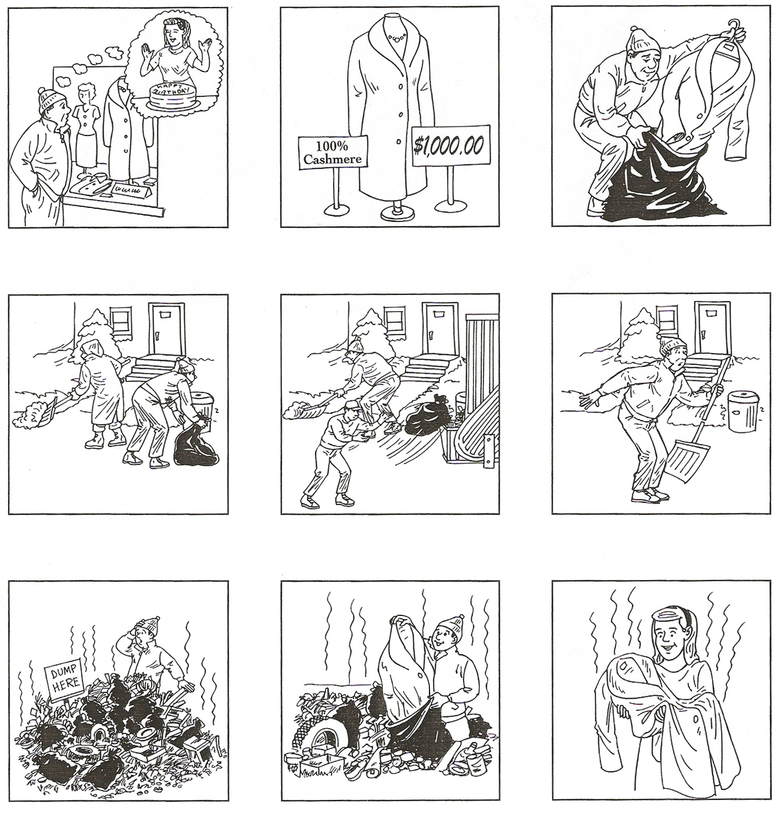

Worksheet#2
__________________________________________________________________________________
Comprehension
___________________________________________________________________________________
Understanding the main ideas
Complete the sentences. Circle a or b.
1. Joe is looking for a present for his wife because
a. she is in the hospital.
b. her birthday is in two days.

2. Joe buys the expensive coat because
a. he loves his wife.
b. he is a rich man.

3. Joe puts the coat in a black plastic bag because
a. he doesn’t want the coat to get dirty.
b. he doesn’t want his wife to see it.

4. Joe doesn’t see the garbage truck because
a. he is watching TV.
b. he is shoveling snow.

5. The coat smells like onions because
a. it was at the garbage dump.
b. Joe’s wife is cooking onions.
Remembering Details
What does Joe find at the dump? Draw a circle around seven words.

empty boxes old shoes an old chair
old onions empty cans old clothes
an old bicycle old potatoes the coat

Worksheet#1,2,3 adapted by kyung-ok Kwon(Diane) from All New Easy TRUE STORIES UNIT18
Worksheet#2 Answer sheet
__________________________________________________________________________________
Comprehension
___________________________________________________________________________________
Understanding the main ideas
Complete the sentences. Circle a or b.
1. Joe is looking for a present for his wife because
a. she is in the hospital.
b. her birthday is in two days.

2. Joe buys the expensive coat because
a. he loves his wife.
b. he is a rich man.

3. Joe puts the coat in a black plastic bag because
a. he doesn’t want the coat to get dirty.
b. he doesn’t want his wife to see it.

4. Joe doesn’t see the garbage truck because
a. he is watching TV.
b. he is shoveling snow.

5. The coat smells like onions because
a. it was at the garbage dump.
b. Joe’s wife is cooking onions.
Remembering Details
What does Joe find at the dump? Draw a circle around seven words.

empty boxes old shoes an old chair
old onions empty cans old clothes
an old bicycle old potatoes the coat
Worksheet#3: Post Activity Instruction
__________________________________________________________________________________
Discussion / Writing letters
___________________________________________________________________________________
Give a “present” to someone in your class.
- With your classmates, make a list of presents people like to give and receive. Your teacher will write your list on the board.

- Write your name on a small piece of paper. Put the piece of paper in a box. Your classmates will put their names in the box, too. Then reach into the box and take a name. You are going to give that person a “present.”

- Choose a present from the list on the board. Then copy this letter on your own paper. Complete the letter as you copy it. Then fold your letter and deliver it to your classmate.

Dear________________________,
I want to give you __________________________________ for a present because
___________________________________________________________________.
Your friend,
________________________
Write a thank-you note for your present.
- When you return to your desk, you will find a “present” from a classmate on your desk. Write a thank-you note to the person who gave you the present.

- Copy the thank-you note below on your own paper. Complete the note as you copy it.

- Then fold your note and deliver it to the person who gave you the present.

Dear _______________________,
Thank you very much for ______________________________. I like the present because ____________________________________________________________.
Your friend,
______________________
Worksheet#1,2,3 adapted by kyung-ok Kwon(Diane) from All New Easy TRUE STORIES UNIT18
Worksheet#3-1: Writing letters to your classmates
__________________________________________________________________________________
Writing letters

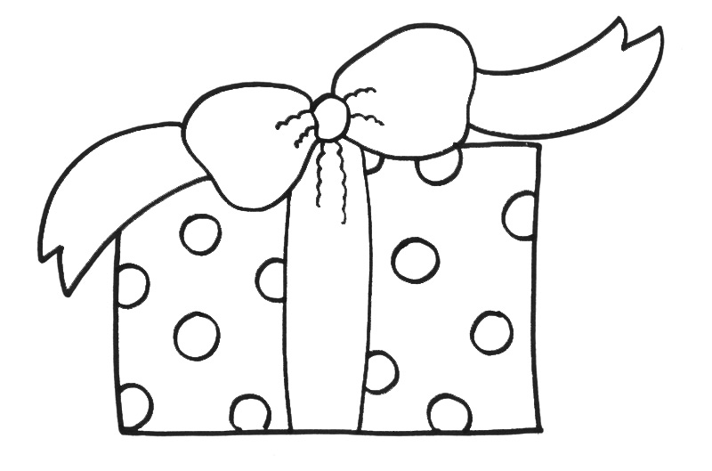

a giving note with present
a thank-you note
Worksheet#1,2,3 adapted by kyung-ok Kwon
Worksheet#4: for an Extra work or Homework
__________________________________________________________________________________
Grammar Practice [Plural nouns]
___________________________________________________________________________________
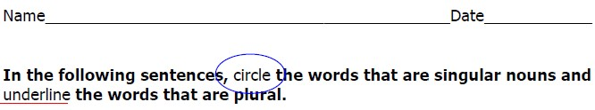
- The leaves are falling off the maple tree outside.
- The ladies were drinking tea and eating sandwiches.
- The foxes are chasing a hen on the farm.
- He finds empty boxes and cans at the dump.
- She gives her sons-in-law some food to eat.
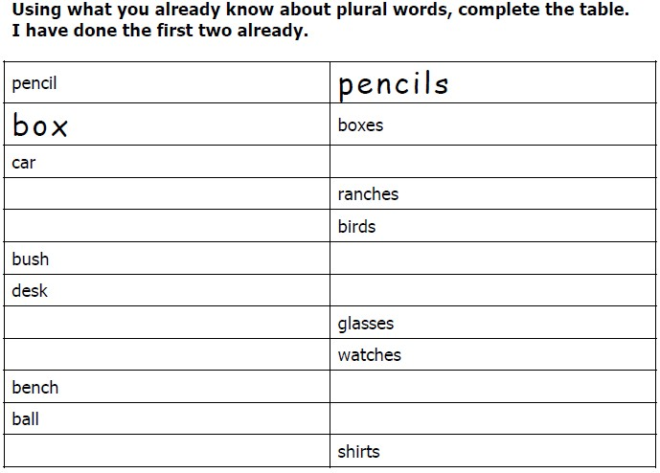
Adapted by kyung-ok Kwon http://lovetolearnplace.com/Grammar/singular%26pluralnouns.html
Please read carefully “The rules of Plural Noun” below!
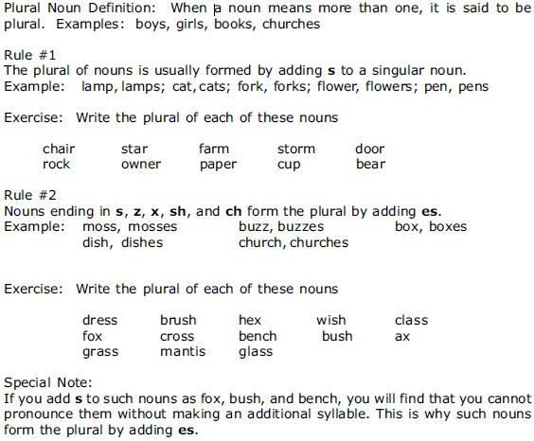
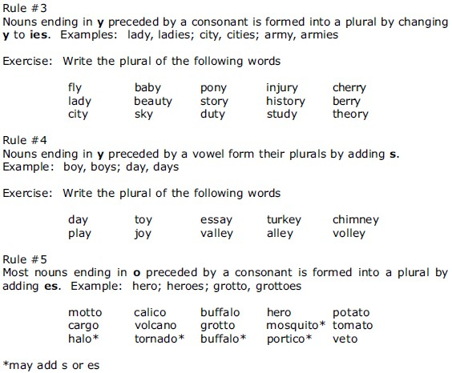
http://lovetolearnplace.com/Grammar/singular%26pluralnouns.html
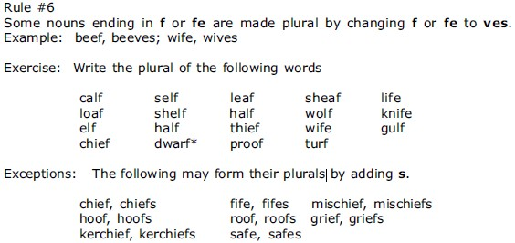
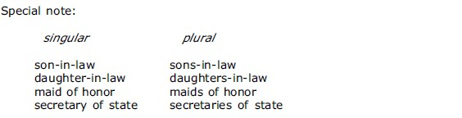

http://lovetolearnplace.com/Grammar/singular%26pluralnouns.html

