Listening Lesson Plan

Waste and Recycle
Instructor:  Su Jin Kim (Jinny) |  | Level:  Intermediate |  | Students:  10 |  | Length:  50 minutes

Materials:
- White board, board markers
- Realia- Recycling sign board, paper, can, glass bottle, plastic, plastic bag
- Listening CD & CD player (Track 1 : about 1minute 45 seconds)
- Worksheet #1 Word check 12copies(10 copies each, 2 extra copies)
- Worksheet#2 Consumer Quiz 12copies(10 copies each, 2 extra copies)
- Worksheet #3 Table & put the sentences in order: 12 copies (10 copies each, 2 extra copies)
- Script 12copies(10 copies each, 2 extra copies)
- Worksheet#4 for speaking: 6 copies (5 copies each pairs, 1 extra copy)
- Worksheet#5 for writing : 12copies(10 copies each, 2 extra copies)

Aims:
- To learn about the importance of recycling by listening to the article.
- Ss predict the topic by looking at the realia.
- To guess the amount of waste and recycling by consumer quiz.
- Ss learn words by checking what they are made of.
- Ss are able to know the amount of collection for recycling by completing the table.
- Ss practice speaking by discussing about recycling with partner.
- Ss practice writing through the survey result.

Language Skills:
- Listening: listening to the short story, a recycling project
- Speaking: comparing the answers with partner
- Reading: words worksheet
- Writing: choose the best introduction

Language Systems:
- Lexis: words used in waste and recycling
- Discourse: discussing about recycling is important in our living.
- Function : Usage of some and any
- Phonology : the pronunciation of words and sentences.
- Structure : Quantity- a lot of, many, much with countable and uncountable nouns

Assumptions:
Students already know:
- how the class is set up and run(there will be 2 Ss group at each table)
- the teacher’s style of teaching and the pace of the course
- all students are single (Age 20 ~25, 5males and 5females)
- pair work and discussion

Anticipated Errors and Solutions:

- Ss may not be able to understand detail from listening
Chunk the listening (pause-play-pause-play)
- Ss may need more time to do worksheets
Cut answer-checking short by verbally sharing the answers instead of having students write down them on the paper.
- If time is short
Cut post-activity discussion short and only ask 2~3 Ss to share their opinions about the importance of recycling.
- If students finish their tasks earlier than anticipated
Ask as many Ss as possible about their opinions of waste and recycling, and charity with some money we can get from recycling.

References:

Adapted from American adventures/Ben Wetz, Unit 10 Material world
10b Waste and 10c Recycle
Worksheet#1,#3,#4 made by me, worksheet#2,#5 adapted from American adventures/Ben Wetz,

Engage
Materials: board and markers
Time | Set Up | Procedure
5 min | Whole Class | <Greeting>  Hello everyone. How are you today? Are you good? I hope everyone is good. How was your weekend? I was recycling in my apartment on weekend and there were lots of wastes. When do you recycle?(students answer)  <Eliciting>  OK, You know waste. What is recycling? (students answer)  Look at this recycling sign board. How often do you recycle?  (students answer)  Look at these materials. Here are plastic, paper, can, glass bottle, plastic bag. You can save some money with them. How?  (Elicit Ss’ thoughts and write them on the board.)  Ok, so today we will listen to some people who are recycling. But first, we will learn about words the speakers use.

Presentation
Materials: board and marker, consumer quiz worksheet, word check worksheet
Time | Set Up | Procedure:
8 min | Whole class  Individually  Whole class | I. Words Check  <Instruction>  Work individually. Match the each the word with the second part pictures. Write the materials what they are made of. You have 2 minutes.  (Distribute the word worksheet)  <Demonstration>  Look at the word box and pictures. What are they made of? for example you can write ‘paper’ with ‘paper plane’.  <CCQs>  Who are you working with?  How much time do you have?  What do you write below the pictures?  Monitors discreetly.  Answer students if they ask questions.  Give time warning: 30 second left.  Be flexible with time. Give 1 more minute if they need it.  Check answers  Let students write the correct words on the paper.  Elicit the meaning from the students.  Explain the meanings if needed.  Ⅱ. Prediction  <instruction>  Look at this consumer quiz worksheet. How many garbage does American family produce in a year? You can choose 1 among ‘a’ and ‘b’.  Compare your answers with your partner.
4min | Pair

Practice
Materials: CD & CD player, Table worksheet , listening script, board and marker
Time | Set Up | Procedure:
10 min  13 min | Whole class  Whole class  Individually  Whole class | Ⅰ. Listening for the main idea(general understanding)  <Instruction>  Put your pens down. Close your eyes. Listen to the whole story. Think about the main idea.  <CCQ>  What are you supposed to think about?  Can you take notes?  (Play the CD player without stopping)  Do you want to listen again?  - Yes - Have them listen one more time.  - No - Have them share their thoughts.  What is the speaker talking about?  How related to recycling?  What is the result of the study?  (Give clear feedback to every response of students)  Did you get some vocabulary what we learned?  Ⅱ. Listening for details  <Instruction>  Now, let’s listen to the story again.  Draw the chart on the worksheet as you listen. Work individually.  <CCQ>  What should you do while listening?  Are you working alone?  (Distribute the table and put the sentence in order worksheet )  Play the CD player. Let students write answers as they listen.  Do you need to listen again?  - Yes -> Play track again.  - No -> Have them share their thoughts.  Complete the table and put the sentences in order.  Did you finish? OK, compare your worksheet with my notes looking at the board.  Listen to the story one last time. If there is anything missing : pause the CD right there and let Ss say it our loud.

Production
Materials: recycling survey worksheet, writing introductions worksheet
Time | Set Up | Procedure:
10 min | Whole class  pair  Whole class | Ⅰ. Free Production  <Instruction>  Do you know recycling is worthwhile thing in your life? How much are you planning to recycle now? Let’s talk about your plan for recycling with your partner. You have 5 minutes.  <CCQ>  Are you working in pairs?  For how long?  (distribute recycling survey worksheet )  Monitor actively and participate within each group.  Share student’s opinions.  Each pair presents their answers.  (Give clear feedback to every opinion of students)  Ⅱ. Conclude Lesson  Elicit today’s words for Ss.  <Give Homework>  (distribute the writing worksheet)  Look at the text about Jinny’s answers to the survey. Then choose the best introduction, a, b, or c.  Write your survey results and Bring your homework next time.  Good job today. See you guys next time!

(Script)
A recycling project
Last year, we decided to plan a recycling project at our school. We called a recycling company in a city near here and we talked about the project. They said that they were interested in our plans, so we started the project.
We designed some posters and we delivered leaflets to every house in our village. Every four weeks, we collected paper, glass, cans, and old clothes from the houses in the village. A lot of parents helped us. We went by car to the houses. Then we took the materials to our school. At school, we put the materials into different containers.
Last year, we collected 8,000 glass bottles, 6,750 aluminum cans, 5,000 kilos of paper, and a lot of clothes. We sold the materials and we used the money for different things.
Last year, we gave some money to a charity for poor people in Africa. We also gave some money to a hospital near our village.

Worksheet #1

Words Check

Choose one material in the word box and write below the picture what they are made of.

-word box-

Paper | Plastic bag | plastic | can | Glass

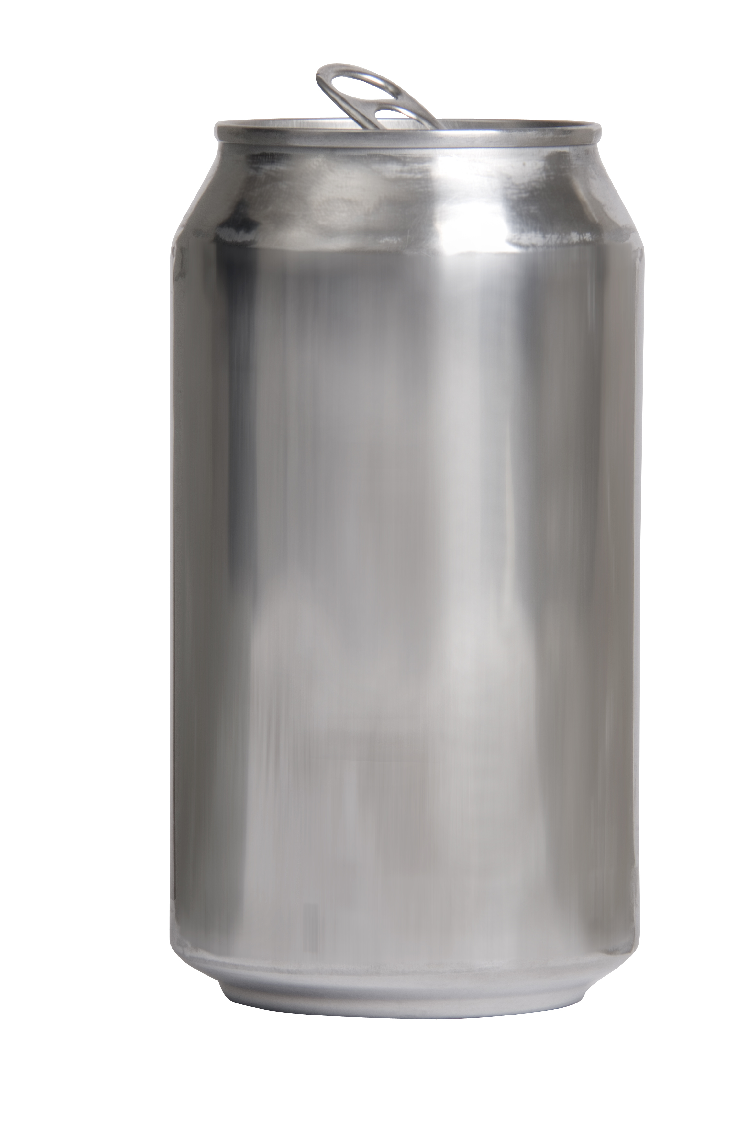 | 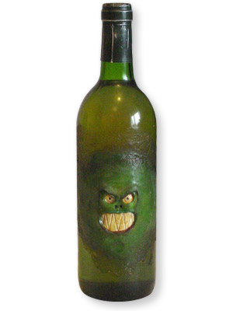 | 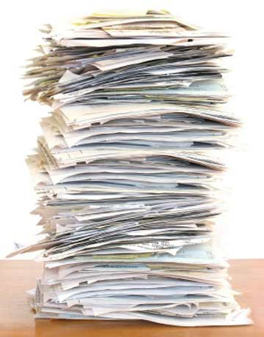 | 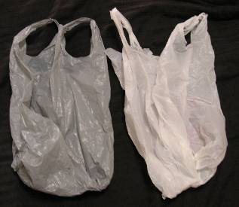 | 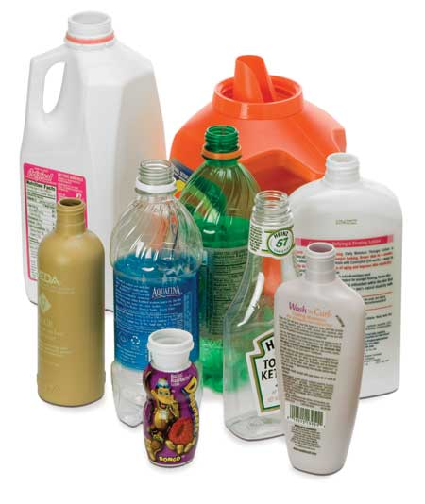

Worksheet #2
Consumer quiz
Recycling is when we reuse materials or garbage. Do people in U.S. recycle much garbage? Do people in the U.S. recycle much garbage? Read the quiz and guess the answers.
- How much garbage does each American family produce in a year?
a 730kilos b 73kilos
- How much paper does the average American family throw away in a year?
a 30kilos b 300kilos
3. How many glass bottles does each family use in a year?
a 5000 b 500
4. How many beverage cans does the average American use in a year?
a 380 b 830
5. How many cans do people in the U.S. recycle?
a 25% b 52%

Worksheet #3
Table and put the sentence worksheet

- Listen to the story and complete the table
- How much quantity do they collect?

Item | Glass bottle | Aluminum can | paper | clothes
Q’ty
2. Put the sentences a-e in order.
a. They gave money to some charities.
b. They delivered leaflets.
c. They sold the materials
d. They collected paper, glass, cans, and old clothes.
e. They spoke with people at a recycling company.

Worksheet #4
For speaking

In pairs, do the recycling survey. Make a note of your partner’s answers.

Recycling survey
How much do YOU recycle?
*Questions
- Are there many recycling containers in your area?
- Do you recycle many cans?
- Do you recycle much glass?
- Do you recycle much paper?
- Do you re-use many plastic bags?
* Answers Score
No, none 0
Not much/ Not many 1
Yes, some 2
Yes, a lot 3

Worksheet #5
For writing

1. Look at the text about Jinny’s answers to the survey. Then choose the best introduction, a, b, or c.

Survey results

  - These are Jinny’s answers to the recycling survey.
  - In this survey, I asked Jinny five questions about recycling. These are her answers.
  - I asked Jinny the questions and she said this. It was a survey about recycling.

There are some recycling containers near her home. She doesn’t recycle many cans and she doesn’t recycle much glass, but she recycles a lot of paper. She also reuses a lot of plastic bags.
Her score was ten.

2. Write your survey results. Include a introduction.

Worksheet #1 answers

can | glass | paper | Plastic bag | plastic

Worksheet #2 answers

- a
- b
- b
- a
- b

Worksheet #3 answers
1.
Item | Glass bottle | Aluminum can | paper | clothes
Q’ty | 8,000 | 6,750 | 5,000kilos | A lot of

2. e-b-d-c-a

Worksheet #4, #5 answers

Depending on individuals

