Listening Lesson Plan

Which country do you want to visit..?
Instructor:  Ahn Eun Jin (Ann) |  | Level:  Intermediate |  | Students:  6 |  | Length:  50 minutes

Materials:
- Whiteboard, board markers
- Listening CD & CD player (a story with a length of 1 minute 20 seconds)
- Worksheet #1 (words check): 9 copies (1 copy for each student + 3 extra copy)
- Work sheet#2(fill in the blanks):9 copies (1 copy for each student + 3 extra copy)
- Worksheet #3(brain storming): 6 copies (1 copy for 1 pair + 3 extra copy)
- World map, pictures for eliciting

Aims:
- SS improve their listening skills by listening to the article.
- Ss to know the vocabulary about places around the world
- Ss practice understanding article by answering the questions.
- Ss learn new words through matching the words and fill-in-blank.
- Ss practice speaking through presentation

Language Skills:
- Listening: listening to the recording, the teacher and students
- Speaking: discussing &comparing answer to each other through the pair/group work
- Reading: reading the word check
- Writing: writing the answers on the worksheet and dictation

Language Systems:
- Phonology: Listening to the sound of the speaker, practicing new vocabulary
- Lexis: words & idioms about countries and famous things, key vocabulary in the text
- Discourse: discussion in pairs, expressing opinion

Assumptions:

Students already know:
- how the class is set up and run(Desks have already been arranged in a circle)
- Ss know the teacher’s style of teaching and the pace of the course
- Ss have traveled around the world or want to travel
- Ss are familiar with group work and discussion
- Ss know some nicknames of the cities in the states
- Ss know they should speak only English in the class

Anticipated Errors and Solutions:

- Students may not be able to understand detail from listening
- Chunk the listening (pause-play-pause-play)
- If Ss finish their activity early
- Give Ss extra comprehension question worksheet
- If Ss may not know vocabulary words in the story
- Encourage Ss to guess from context
- If time is short
- Reduce the number of Ss sharing their opinions

References:

http://www.ebs.co.kr/index.jsp
http://www.naver.com (“Think & talk” in Kids Times)
heep://mapsofworld.com/world.political.map
photo by me(my photograph)

Lead-in
Materials: board and markers
Time | Set Up | Procedure
5 min | Whole Class | <Greeting>  Hello everyone. How are you today? Today’s weather is good!  What a beautiful day! I’d like to go somewhere in this weather!  Do you like to travel? .. Which country do you want to visit?  Is there anybody who has traveled overseas?  (Ss answers)  Today we’re going to listen to some people who are talking about places where they want to go.  <Eliciting>  Could you read the date today?(written the date in the board)  Winter vacation is coming soon. Do you have any plan for winter vacation? If you are planning to go to overseas, which country do you want to visit? Could you tell me?  (Elicit Ss’ thoughts and write them on the board.)  Ok, so today we’re going to listen to a short interesting story.  Before listening, we will learn some vocabulary the speakers use.

Pre-Activity
Materials: board and marker, worksheet#1 ,world map, pictures of beautiful countries
Time | Set Up | Procedure:
10 min | Whole class | - Words Check  <Instruction>  Work individually.  Present Ss the new words.  Explain the meaning by definition or synonyms  <Demonstration>  (write the words check on the board)  Fascinate: if something fascinates you, interests and delights you so much that your thoughts tend to concentrate on it.  Q1. Choose the right words to fill in the blank.  You have 3minutes.  <Concept Check Qs>  Are you working alone?  How much time do you have?  What are you supposed to do?  (Distribute the worksheet #1)  If students don’t do well, help Ss with some more examples.  Monitors discreetly.  Answer students if they ask questions.  Give time warning: 1 minute left (be flexible with time)  .  Check answer with the Ss  Let students pronounce it correctly.  Elicit the meaning from the students.  Go through the vocabulary one by one.  Explain the meaning if necessary.  <Eliciting>  Now, here is a world map.  Which country do you want to go?  Here are some pictures about beautiful countries.  (Explain the pictures and put each picture on the map)  Think about where you would like to go & why you want to go there? You have 1 minute.
5min | Whole class
Main Activity
Materials: CD & CD player, worksheet #2, board and marker
Time | Set Up | Procedure:
15 min  5min | Whole class  Pair | Ⅰ. Listening for the main idea  <Instruction>  Let’s listen to the conversation between Eric and Janet.  Please focus on what they are talking about.  <CCQs>  Where do Eric and Janet want to go?  What did they talk about?  (Play the CD player without stopping)  Ⅱ. Listening for details  <Instruction>  Now, let’s listen to the story again. Fill the blanks on the worksheet as you listen. Work individually.  Listen to the conversation reading script page by page.  (explain the pictures on the map)  <CCQs>  What should you do while listening?  Are you working alone?  (Distribute the worksheet #2)  Play the CD player. Let students write answers as they listen.  Have you done it? OK, Compare the notes with your partner.  Read loudly one sentence after another by turns.  Let’s role play.  Get into pairs. One is Eric, the other is Janet.  After you’re done, change the roles  I’ll give you 5minutes.  What time do you have?  -monitor & be flexible with time.

Post-activity
Materials: worksheet #3
Time | Set Up | Procedure:
10 min | pair  Whole class | Ⅰ. Free Production  Now, you thought about where you want to go, before listening.  Do you remember? If you decide, make a brain storming..  Topic is… “I want to go…”  Think more as Wh-Qs.  Let’s talk with your partner. You have 5 minutes.  <CCQ>  Are you working in pairs?  How much time do you have?  What is the topic?  (distribute worksheet #3)  Monitor actively and participate with in each group.  Share student’s opinions.  Think about one’s brainstorming.  Ⅱ. Conclude Lesson  Did you have fun today with this topic?  What do you think the most interesting was?  Good job today!

(Script)

Which Country Do You want to visit?
Eric: I’m sick of staying at home all day during winter vacation. I want to go somewhere very interesting and fun.
Janet: Where do you want to go?
Eric: Ah, it’s hard to pick one place. There are so many nice places to choose from. Hmm…
where should I go?
Janet: I know it’s hard to choose. Then, try to think about the place you want to visit the most in your lifetime.
Eric: Egypt! I really want to visit the country some day. I’m fascinated by Ancient Egyptian civilization. I want to see the amazing pyramids with my own eyes. I would also like to ride a camel! That would be fantastic.
Janet: As for me, it’s Dubai. I really want to climb to the top of the tallest building in the world, the Burj Khalifa! It is 828 meters tall. The amazing thing is that it takes less than a minute to get to the observatory! The elevators are so fast.
Eric: Yeah, I heard that it has the fastest elevators in the world. Visiting the world’s tallest building would be a very special memory. But I’m afraid to go up to the top of the building! I have a fear of heights.
Janet: Really? Then, how will you be able to ride a camel? Camels are pretty tall and it will be very shaky. You may even get motion sickness.
Eric: I know. But animals are different and I hope to give it a try. Hey, thinking about visiting Egypt makes my heart beat. I should start saving money to visit the country some day.
Janet: Me too. I guess I’ll have to save a lot of money because I want to visit as many countries as possible in my lifetime and not just Dubai!

Worksheet #1

Words Check
Vocabulary Study

A. Choose the right words to fill in the blank.
fascinate civilization fantastic observatory

1. The private lives of movie stars never fail to .

2. I went to an astrophysical last weekend.

3. The design of the individual rooms is .

4. The Orient closed the door against to Western .

B. Choose the right words or phrase that has the same meaning as the underlined words.
fascinate civilization fantastic observatory

1. The hotel is known for its excellent cuisine.
2. Her beauty and intelligence have captivated many men.
3. The children are taught to respect different cultures.
4. She called the weather laboratory where he worked.

Answer Keys for Vocabulary Study

Question A : 1. fascinate
2. observatory
3. fantastic
4. civilization
Question B : 1. fantastic
2. fascinate
3. civilization
4. observatory

Worksheet #2
Fill in the blanks

Which Country Do You want to go?
Eric: I’m staying at home all day during winter vacation. I want to go somewhere very and fun.
Janet: Where do you want to go?
Eric: Ah, it’s hard to pick one place. There are so many nice places to choose from.
Hmm… where should I go?
Janet: I know it’s hard to choose. Then, try to think about the place you want to visit the most in your lifetime.
Eric: Egypt! I really want to visit the country some day. I’m by Ancient Egyptian . I want to see the amazing pyramids with my own eyes. I would also like to ride a camel! That would be .
Janet: As for me, it’s Dubai. I really want to climb to the top of building in the world, the Burj Khalifa! It is 828 meters tall. The amazing thing is that it takes less than a minute to get to the ! The elevators are so fast.
Eric: Yeah, I heard that it has the fastest elevators in the world. Visiting the world’s tallest building would be a very special memory. But I’m go up to the top of the building! I have a fear of heights.
Janet: Really? Then, how will you be able to ride a camel? Camels are pretty tall and it will be very shaky. You may even get motion sickness.
Eric: I know. But animals are different and I hope to give it a try. Hey, thinking about visiting Egypt makes my heart beat. I should start saving money to visit the country some day.
Janet: Me too. I guess I’ll have to save a lot of money because I want to visit as many countries as possible in my lifetime and not just Dubai!

Worksheet #3
Brain storming

America 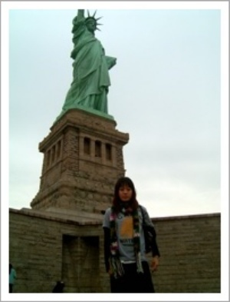 Egypt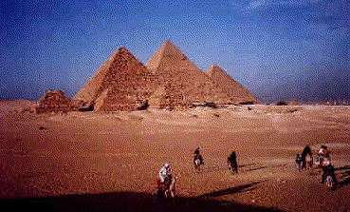
Dubai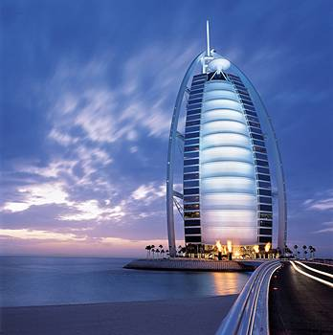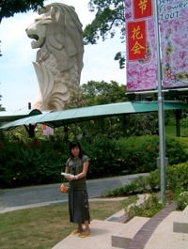

Singapore

Japan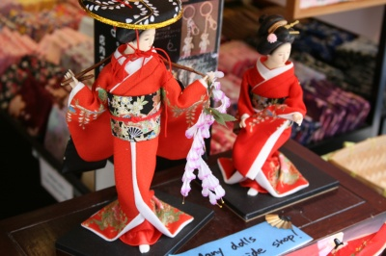Indonesia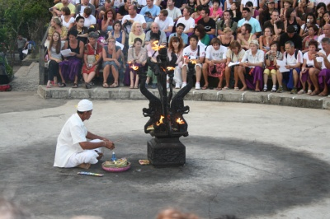

World map

