Listening Lesson Plan

Men& women
Instructor:  Kang Aeri(Meg) |  | Level:  Lower Intermediate |  | Students:  12 |  | Length:  50 minutes

Materials:

- Whiteboard, Board markers, board eraser, CD & CD Player
- Picture( a woman in superman’s clothes )
- Worksheet # 1 (Vocabulary)-> 12 copies for each Ss + 3 extra copies)
- Worksheet # 2 ( True& False by listening) -> 12 copies for each Ss + 3 extra copies)
- Worksheet # 3 (Fill in the blanks) ->12 copies for each Ss + 3 extra copies)
- Homework -> 12 copies for each Ss + 1 extra copy)
- Extra worksheet (12 copies for each Ss + 2 extra copies)

Aims:

- To learn listening skills.(To understand by listening the topic issue)
- To get hints the topic from the picture which display on the board.
- To learn some vocabularies related to the topic.
- To understand the instruction by Demo & ICQ’s.
- To comprehend what the text saying by listening, reading ,speaking.
- To practice speaking & share with others.
- To suggest their own idea.
- To manage the time be given.
- To be able to learn how to deal with interviewer.

Language Skills:

- Listening: Listening to the recording, teacher and students.
- Speaking: Speaking own thought & new vocabularies , discuss with others through the pair/
group working .
- Reading: Reading all worksheets to understand the tasks.
- Writing: Writing new vocabularies(worksheet#1), Writing ideas on the poster &
questionnaire, Filling the blanks(worksheet#3)

Language Systems:

- Grammar: An irregular conjugation. e. g) man->men(woman->women)
- Function: Know the word’s clear meaning in the task. e. g) operate.
- Lexis: Learn new vocabularies.
- Discourse: Discuss about men& women’s role. Interview with adults for questionnaire.

Assumptions:

Students already know:
- Today’s topic (men& women), because teacher told them yesterday.
- How the class is set up and run. (Desks have already been arranged in horseshoes.)
- The teacher’s style & Ss each other well enough.
- Ss are familiar with group work and discussion.
- (They also know that they are going to work in pairs and group today)

Anticipated Errors and Solutions:

- When Ss elicit they can make a wrong guess the focus that mom can do everything like superman. ->(Teacher leads Ss focus on the person, mom, first . not superwomen)
- Ss may not be able to pick up details from listening.
->(Chunk the listening , Pause- Play – Pause – Play, when it need.)
- Ss may need more time to work on each tasks and
-> (Give any other questions easer to find the answer or give extra time )
- Ss can finish their tasks earlier than anticipated.
-> ( Give Ss extra worksheet)

References:

- EXPRESS YOURSELF 1 “ Men and Women” (p. ) written by LIS KOREA EDITORIAL STAFF & DUAME VORHEES.
- Worksheet # 1,2,3 & Questionnaire are made by Kang aeri (Meg)
- Picture adapted by Kang aeri (Meg) from the story book “ My mum” written by Anthony Brown.

Lead-In
Materials: board, markers, board erasers, picture.
Time | Set Up | Procedure
2 min  4 min | Whole Class  Work in pairs | <Greeting>  - How are you everyone? (Ss answer)  - How was yesterday, anyone have a story for us?  One student raise her hand and talk a story she has. This is special rule of this class. Teacher starts the class giving a chance to Ss talk anything to encourage them for speaking to others.  - Good talking & good listening. Excellent. Let’s move on today’s topic  <Eliciting>  - Do you see the picture? (Teacher put the picture on the board)  - Can you guess who is this? (Ss answer)  - Who does she wear like ?(Ss answer)  - Whom do you say “superman, superwomen”? Work with in pairs.  After work in pairs, Teacher writes Ss thoughts on the board.  - Thank you for share your idea. We’re going to listen to a story about Men & Women. Before listening, we will learn some vocabulary the speakers use.

Pre-Activity
Materials: board ,markers, board erasers, worksheet #1
Time | Set Up | Procedure:
7 min  8min | Individually  Whole Class  Work in pairs  Whole Class | Ⅰ. Vocabulary  <Instruction>  - Draw a line to match the words and their definitions(Part A).  - Write suitable word to complete the sentence(part B).  - Work in individually. You have 4minutes.  <Demonstration>  Write “ overworked” & its definitions on the board.  - Look at the board, here is an example for Part A.  - What does “overwork” mean? (Ss)  Teacher draw a line to “ to work too hard” for its definition meaning.  Write word “ supermarket, cinema, school” on the board.  - I’m going to ( ) to study. Which word should be in the blank?( Ss)  <ICQ’ s>  - Who are you work with?  -What should you do first?  - How to match with words and definitions?  - What do you fill in the blanks with?  - How much time do you have?  (Distribute the worksheet #1)  Teacher monitor Ss to check if they understand or not with WS.  If Students don’t do well, give them with easy example.  Give time warning. (e. g 1minute left)  Be flexible with time when it really need.  Check the answers: verbally check for part A.  -What does the word “burden” mean? (Ss answer)  In part B, Ss read right sentence one by one.  Teacher gives feedback about the difficult word to hear & explain the meaning of the word.  Ⅱ. Prediction  “Are men and women equal in our society?”  <Instruction>  - Are men and women equal in our society?  -Share your opinions with your partner.  - Give 4mins.  <ICQ’s>  -What should you do?  -Who are you work with?  - How much time do you have?  Teacher is monitoring the students and inspires students who hesitate to speak out.  After work in pairs Ss share with others and teacher writes their opinions on the board so that Ss may guess the topic in advance.

Main Activity
Materials: CD & CD player, worksheet #2 & 3, board, marker, eraser
Time | Set Up |  | Procedure:
8min  8min | Individually  Whole class  Whole Class  Individually  In pairs |  | Ⅰ. Listening for the main idea  <Instruction>  -Put your pens down. Close your eyes. Listen to the whole story. Think about what this story about. Try to figure out the gist. After listen to the story do worksheet #2 –T/F through the story. Work in individually.  <Demonstration>  Write the sentence and ask Ss to read the sentence.(Ss read)  “Is the story about modern family? ”? If it is true, write the letter T. If it is not write the letter F.  <ICQ’s>  - Can you listen to the story with your eyes open?-  - What are you supposed to think about?  - Can you take notes while you listen?  - What should you do after listening?  - What should you do the sentence is true??  Teacher distribute the worksheet #2  Play the CD 2times.  Teacher let students do worksheet  - Would you like to listen again?  Yes →Have them listen one more time.  No →Have them share their thoughts.  Ss write T/F the script by themselves first, and compare with partner.  Ⅱ. Listening for details  <Instruction>  - Listen and fill the blanks on the worksheet#3 as you listen.  - Don’t guess the word and fill the blanks from listening.  -Work individually. After do it, compare with your partner to complete.-  -You’ll listen the story 3Times  -You have 4mins.  <Demonstration>  Teacher demos with worksheet # 3.  <ICQ’s>  - What should you do while listening?  - Are you working together at the start?  - What do you do to complete the worksheet?  - How many times are you going to listen the story?  - How much time do you have?  Teacher…  Handout the worksheet #3 & demonstrate how to do it.  Play the CD 2times with out stop.  Distribute the script to Ss and Ss check what they  misunderstood.  Play the CD one more to complete.
Post Activity
Materials: Paper board, crayons, color markers, questionnaire , plastic tape
Time | Set Up | Procedure:
13 min | Group with  4Ss each | Ⅰ. Free Production.  Make a poster  <Instruction>  - Read the story by oneself and make a poster about the topic.  - Make a poster coincide with this story.  Teacher gives question to Ss to get some idea for task  - What does society expect to Men& women to perform?  - Are women enjoy their housekeeping burden?  - When you finish, display on the wall.  - Work in groups with 4. You have 10 min  <Demonstration>  - Figure out the picture from the story. E .g ) Men and Women insist they are overworked. You draw some picture you can imagine from this sentence. Use your imagination & make a poster.  <ICQ’s >  - Who are you work together?  - What do you suppose to do?  - Share Ss’ thoughts and start to make poster.  - What do you do when you finish?  Ⅱ. Conclude Lesson  Elicit today’s vocabulary for Ss  <Give Homework>  - Make solution ideas on this questionnaire with interview 2 adults  around you.. Homework is due tomorrow  < ICQ’s >  - What do you suppose to do?  - Do you have to do it now?  - By when do you have to finish your homework?  - Who do you need to do homework?  Teacher distributes HW and close the class.  - Good job today. See you guys tomorrow!
(script)

Men & Women

The traditional roles of men and women are changing. Even though men have not been freed from being the principal breadwinners, they are also expected t help with household chores. Women too are making money outside the home, but they still operate under the assumption that childrearing is primarily their function. Men and women alike cry under the load and insist they are overworked and underappreciated. Both are probably right. But women still have more to complain about than men. More of the housekeeping burden falls on their shoulders than on their husband’s and at work they are paid less and promoted less often. What may be worse, the stress being placed on them may be taking its toll on their children and spouses: society needs to understand that women are just human, not superwomen.

Picture for eliciting.
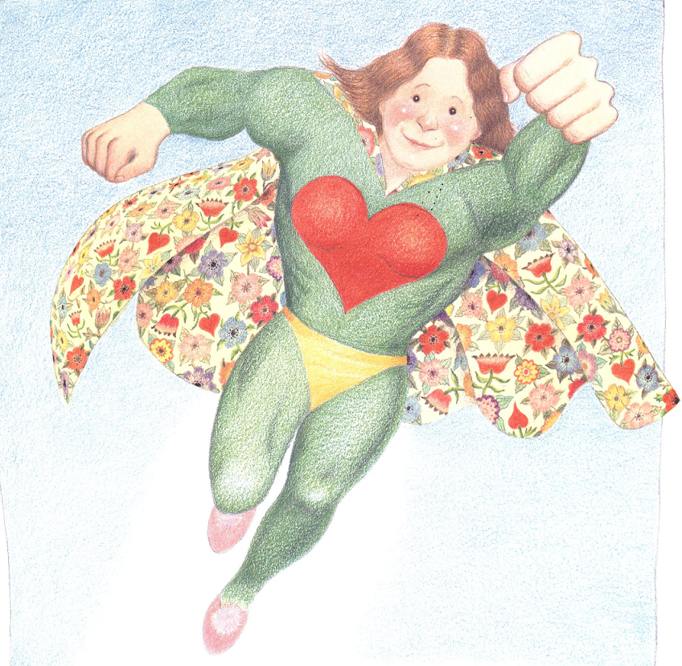
Worksheet # 1 vocabulary
Date __________ Name:
A . Draw the line to match the letter & meaning

1. Breadwinner ● a ● To perform a function: work
2. Operate ● b ● . Sexual identity
3. Assumption ● d ● . a source of great worry or stress
4. Burden ● e ●. an idea or a statement accepted as true
5. Gender ● without proof
f ● .a person supporting a family with his/her earnings

B . Write the suitable word to complete the sentence.

breadwinner assumption gender
operate burden

- Women are sometimes denied opportunities solely because of their __________.
- He was the _____________ of his family at age five.
- The __________of organizing the campaign fell to me.
- This machine _______________ night and day.
- They are wrong in their _______________that we are all alike.

Worksheet # 1 vocabulary
(answer sheet)
Date __________ Name:
A . Draw the line to match the letter & meaning

1. Breadwinner ● a ● To perform a function: work
2. Operate ● b ● . Sexual identity
3. Assumption ● d ● . a source of great worry or stress
4. Burden ● e ●. an idea or a statement accepted as true
5. Gender ● without proof
f ● .a person supporting a family with his/her earnings

B . Write the suitable word to complete the sentence.

breadwinner assumption gender
operate burden

- Women are sometimes denied opportunities solely because of their gender.
- He was the _breadwinner_ of his family at age five.
- The burden of organizing the campaign fell to me.
- This machine operates night and day.
- They are wrong in their assumption that we are all alike.

Worksheet # 2 True & False
Date __________ Name:
Answer the following sentence (T) for true or (F) for false.

- Men and Women’s role are not changed nowadays.
- Are modern Men have been freed from being the principle breadwinners.
- Are Men expected to help with household chores.
- Modern Women’s main function is making money.
- Men are Women insist they are underappreciated.
- Men have more to complain about housekeeping burden.
- Men and Women are equal in modern society.
- Women work less than Men at work.
- Women’s stress at work may be taking its toll on their family.
- Society needs to understand that women work like superwomen.

Worksheet # 2 True & False
(answer sheet)
Date __________ Name:
Answer the following sentence (T) for true or (F) for false.

1. Men and Women’s role are not changed nowadays. F
2. Are modern Men have been freed from being the principle breadwinners. F
- Are Men expected to help with household chores. T
- Modern Women’s main function is making money. F
- Men are Women insist they are underappreciated. T
- Men have more to complain about housekeeping burden. F
- Men and Women are equal in modern society.F
- Women work less than Men at work. F
- Women’s stress at work may be taking its toll on their family. T
- Society needs to understand that women work like superwomen. F

Worksheet # 3 Fill the blanks
Date __________ Name:
Listen and fill the blanks.

The traditional roles of men and women are ( 1 ). Even though men have not been freed from being the principal breadwinners, they are also expected
to ( 2 ) with household chores. Women too are making ( 3 ) outside the home, but they still operate under the assumption that ( 4 ) is primarily their function. Men and women alike cry under the load and insist they are overworked and underappreciated. ( 5 ) are probably right. But women still have more to complain about than ( 6 ). More of the housekeeping ( 7 )falls on their shoulders than on their husband’s and at work they are paid less and promoted less ( 8 ). What may be worse, the ( 9 being placed on them may be taking its toll on their children and spouses: society needs to understand that women are just human, not ( 10 )

Worksheet # 3 Fill the blanks
(answer sheet)
(Date __________ Name:
Listen and fill the blanks.

The traditional roles of men and women are ( changing ). Even though men have not been freed from being the principal breadwinners, they are also expected
to ( help ) with household chores. Women too are making ( money ) outside the home, but they still operate under the assumption that ( childrearing ) is primarily their function. Men and women alike cry under the load and insist they are overworked and underappreciated. (Both) are probably right. But women still have more to complain about than ( men ). More of the housekeeping ( burden )falls on their shoulders than on their husband’s and at work they are paid less and promoted less ( often ). What may be worse, the ( stress ) being placed on them may be taking its toll on their children and spouses: society needs to understand that women are just human, not ( superwomen )

Questionnaire

1. Do you agree with your role at home and work?

Person1 | Person2
Gender : | Gender:
Response: | Response:

2. Which is the most unequal part in Men& Women’ role
in your life?

Person1 | Person2
Response: | Response:

Extra worksheet

What is your ideal style with roles at home?
- Make a cartoon with dialogue.

