Listening Lesson Plan

Amusement Parks
Instructor:  HwaSeon Kim (Molly) |  | Level:  Intermediate |  | Students:  9 |  | Length:  50 minutes

Materials:

- Worksheet #1 for vocabulary: 10 copies (9 copies for each Ss + 1 extra copy)
- Worksheet#2 fill in the blanks: 10 copies(9copies for each Ss + 1 extra copy)
- Worksheet#3 for comprehension check-up: 10 copies (9 copies for each Ss + 1 extra copy)
- Worksheet#4 for discussion & write on: 10 copies (9 copies for each Ss + 1 extra copy)
-worksheet#5 for grammar round-up : 10 copies (9 copies for each Ss + 1 extra copy)
- Worksheet#6 for extra time or homework (9 copies for each Ss + 1 extra copy)
- Listening CD & CD player (a short story with a length of 100 seconds)
- Whiteboard, board markers, board erasers

Aims:
- SS improve their listening skills by listening to the article.
- Ss practice listening to the details by filling the blank.
- Ss practice understanding article by answering the questions.
- Ss learn new words through matching the words and fill-in-blank.
- Ss practice speaking through discussing with partner.

Language Skills:

- Listening: listening to the recording, the teacher and students
- Speaking: talking to each other through the pair/group work
- Reading: reading the new words’ definition on the worksheet #1, reading worksheet#3 for comprehension check-up.
- Writing: writing vocabulary on the worksheet#1, gap-filling to write letters with students’ own sentences through worksheet #4

Language Systems:

- Lexis: Vocabulary used to define, figure out details.
- Function: Words used to complete the sentences on the worksheet#4.
- Structure: the rule of using subordinate conjunctions on the worksheet#5
- Discourse: discuss about what your favorite theme park ride is?

Assumptions:
Students already know:
- Seats have already been arranged in a horseshoe.
- How the class is set up and run (there will be 3 groups 3 Ss together.)
- Ss already know each other well. (e.g. someone’s hobbies, preference and sometimes family members)
- Ss are familiar with group work and discussion.

Anticipated Errors and Solutions:

- Ss may not be able to follow the passage easily
→ Follow the task-feedback circle: let them listen to the track again until they get the gist of the content.
- Ss may not be able to pick up details from listening
→ Chunk the listening (pause-play-pause-play)
- Ss may need more time to work on the vocabulary
→ Give any other questions easer to find the answer by her/him self when monitoring them or let them to work in pair or group. But if it takes longer than 5minutes, cut answer-checking short by verbally sharing the answers instead of having Ss write them on the board.
- If students finish their tasks earlier than anticipated
→ Ask as many Ss as possible about their idea or experience of amusement parks where they want to go.
Give Ss extra worksheets (WS#6; easy to solve) to take the task themselves, when Ss couldn’t finish them, they would be homework.

References:

- TESOL 05 Teaching Listening of the binder
- http : applenews.co.kr

Lead-In
Materials: board ,markers and board erasers
Time | Set Up | Procedure
3 min | Whole Class | <Greeting>  Good morning everyone. How was yesterday?  How are you today?  <Eliciting>  Have you ever been to Everland or Lotte world? Which ride is the most scary?  (Elicit Ss’ ideas and write them on the board.)  Thank you. So today we’ll listen to an interesting article which is about the amusement park. But first we will learn words the speaker use.

Pre-Activity
Materials: board ,markers, board erasers, worksheet#1
Time | Set Up | Procedure:
8 min  4min | Whole Class  Individually  Whole Class  In Pairs | Ⅰ. Vocabulary built-up  < Instructions>  Work in individually. Draw a line to match the words and their pictures.  After the matchingQ1, then use the words from the box above and write the correct word on the line to complete sentences in Q2. You have 4minutes.  <Demonstrations>  Look at the board, here is an example for Q2  (Draw a line) Read definitions first, you are clear the word’s meaning then draw a line from the word to its definition.  Read these sentences, what word from the box do you need to fill the blanks? Think about the context! (e.g. “regret” -fill this word in the blank on the WB)  <Concept Check Qs>  What should you do first?  What do you fill in the blanks with?  How much time do you have?  (Distribute the worksheet#1)  Monitor discreetly while Ss take the WS. If students ask some questions, answer them. If students don’t do well, help them with some more examples. Give time warning: 1minute left. Be flexible with time. Ask students if they are done then check up the answers when they say yes.  Check the answers: verbally check for Q1  What does mean the word “landmark”?  In Q2, let Ss write the correct vocabulary (not the letters) on the board.  Go through the vocabulary one by one: let each S who wrote the answer read the sentences including the answer loudly. Explain the meaning if necessary.  Ⅱ. Prediction  <Instruction>  Look at the picture on the cover page.  What is your favorite theme park ride?  Compare your thought with your partner.  <Concept Check Qs>  Who are you working with?  What should you do?  How make a story with picture?

Main Activity
Materials: CD & CD player, worksheet #2, board, marker
Time | Set Up | Procedure:
5 min  10 min | Whole Class  Individually  Individually  In pair | Ⅰ. Listening for the main idea (general understanding)  <Instruction>  Put your pens down. Close your eyes. Listen to the whole story. Think about what this story about. Try to figure out the main idea.  <Concept Check Qs>  What are you supposed to think about?  Can you take notes?  (Play the CD player without stopping)  Would you like to listen again?  - Yes →Have them listen one more time.  - No →Have them share their thoughts.  What do think this story about?  Which genre do you think does this story belong?  Did you get some vocabulary what we learned?  Ⅱ. Listening for details  <Instruction>  Now, let’s listen to the story again. Fill in the blanks on the worksheet as you listen. Work individually.  <Concept Check Qs>  Are you working alone?  What should you do while listening?  How many times will the recording be played?  (distribute the worksheet #2)  Play the CD player. Let students write answers as they listen.  Do you want to listen again?  - Yes →Have them listen one more time.  - No →Have them compare their answers in pairs of two or three.  If students don’t do well, play and pause the play.  Compare the answers with your partner. If you don’t know anything well, ask other students or me.  When you have an agreement, you will read your answer aloud to whole class.

Main Activity-2
Materials: worksheet #3, worksheet#3-1, wall chart, small pieces of paper, a small box, board, marker, scissors, tape and eraser
Time | Set Up | Procedure:
6 min  8min | Whole Class  In Groups  Whole Class  Whole Class  Individually  Whole Class  Individually | Ⅰ. Discussion to make a list of present  <Instruction>  Make three groups of three students. Make a list of presents people like to give and receive.  <Concept Check Qs>  How many people are working together?  What should we make?  What is the topic of the discussion we will have?  Monitor activity and participate within each group. Give time warning: 1 minute left. Let them fill the list in each group on the WB.  Check the lists as reading and ask about some items why people want to give and receive them.  Ⅱ. Writing letters  <Instruction-1>  Write your name on a small piece of paper. You all put it in a box. Then take a name. You are going to give that person a “present.” Choose a present from the list on the board.  <Concept Check Qs>  What should you write?  (Distribute small pieces of paper)  Let Ss put the paper written their names into the box and pick a piece of other folded paper.  <Instruction-2>  Then copy the letter of on the WS#3 on your own paper and complete it. Then fold your letter and deliver it to your classmate. When you return to your desk, you will find a “present” from a classmate. Write a thank-you note to the person who gave you the present. Copy the thank-you note and complete. You will have 8 minutes.  <Concept Check Qs>  Are you working alone?  What are you supposed to do first?  Where do you write your letter & thank-note?  What will give your friend?  For how long?  (Distribute the worksheet#3 & #3-1)  Monitor writing. Answer the questions. Let Ss know where their names and friends’ name are written in a letter.

Post Activity-2
Materials: Worksheet#4, worksheet#6
Time | Set Up | Procedure:
6 min | Whole Class  Whole Class | Ⅰ. Free Production  <Instruction>  Do you know what kinds of amusement park are there in America?  And Where is your favorite theme park?  Let’s talk with your partner. You have 5 minutes.  <Concept Check Qs>  Are you working in pairs?  How much time do you have?  (distribute worksheet # 4)  Monitor actively and participate with in each group.  Share student’s opinions.  Each group presents their interesting answers.  (Give positive feedback to every Ss’ thoughts)  Ⅱ. Conclude Lesson  Elicit today’s vocabulary for Ss  <Give Homework>  Fill in the blanks on the paper.  Homework is due tomorrow.  <Concept Check>  How can you get the answer?  Do you have to do it now?  By when do you have to finish your homework?  (Distribute HW)  Good job today. See you guys tomorrow!

The script of the listening passage

Amusement Parks
Disneyland. Anaheim, California.
Created in 1955, Disneyland was designed to be the “happiest place on Earth.” Disneyland employs men and women to wear suits that look like Disney characters. These fantastic “real-life cartoons” walk around the park all day and entertain visitors. Rides at Disneyland include Space Mountain and Mr. Toad’s Wild Ride. Even if you can’t go to California, you can still ride these rides at another Disney parks around the world - Disneyworld in Florida, Paris Disneyland in France, and Shanghi Disneyland in China.
Schlitterbahn. New Braunfels, Texas.
Schlitterbahn is in Texas, an American state that is known for being oversized. Like other things in Texas, Schlitterbahn is big - it’s more than 36 hectares! Schlitterbahn has been voted the “Best Waterpark in the World” for twelve years in a row. The park gets its funny name from the Germans who immigrated to New Braunfels in the 1840s. The town likes to celebrate its German heritage, and it chose a German - sounding name for its famous water park. Yet “Schlitterbahn” isn’t actually German - it’s completely nonsensical, although it sounds similar to the words for “slippery road.”
The Wizarding World of Harry Potter. Orlando, Florida.
The Wizarding World of Harry Potter is based on the best-selling Harry Potter book series that was written by J.K. Rowling. Visitors can ride several different rides, including the Dragon Challenge and the Forbidden Journey. There are also restaurants in the Wizarding World that are meant to be like the restaurants in the book series. At the Three Broomsticks Restaurant, for example, visitors can eat traditional British food like Fish and Chips. At the Hog’s Head Tavern, they can try Harry Potter’s favorite drink: butterbeer! While the Wizarding World has a lot of shops, the items sold there aren’t actually magic. In the books, Harry can buy magic wands and spellbooks that actually work! At the Wizarding World, however, you can only buy pins, mugs, stuffed animals, and candy.
Amusement Park Safety
If you go to an amusement park, it’s important to keep these safety tips in mind. Parks are fun, but an injury could sour your enjoyment. Always be careful! A. Stay in a group.
If you’re old enough to go to a park without your parents, make sure that you have one or two friends with you. It’s no fun to be lost by yourself in a large crowd of people!
B. Read all of the signs. Amusement Parks have many rules in place to help keep you safe. Always read the signs before going on a ride. C. Wear sunscreen. In many amusement parks, it is hard to find shade. A bad sunburn can make you regret spending so much time outside! Apply sunscreen before going to an Amusement Park, so that your skin doesn’t hurt afterward.

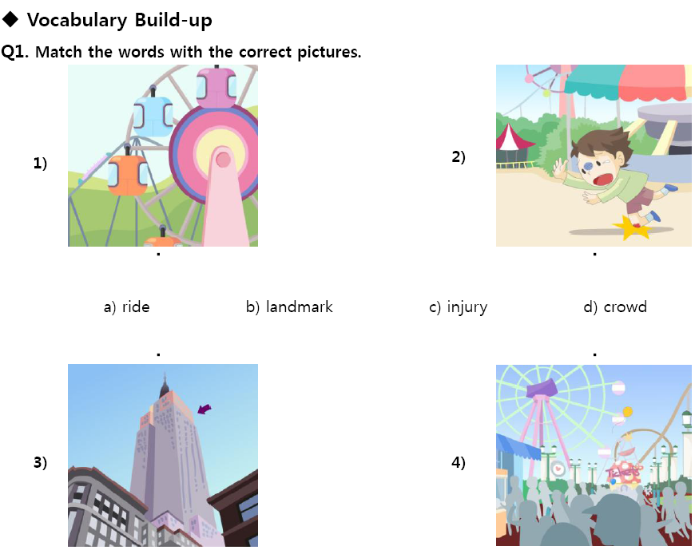
Worksheet#1

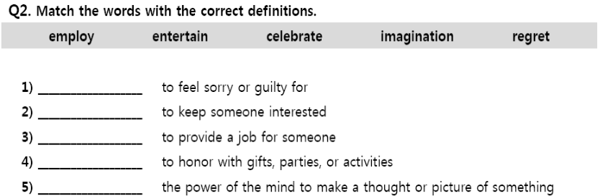

Worksheet#2

Fill in the blanks

Disneyland. Anaheim, California.
Created in 1955, Disneyland was ______________ to be the “happiest place on Earth.” Disneyland employs men and women to wear suits that look like Disney characters. These fantastic “_______-_______ cartoons” walk around the park all day and entertain visitors. Rides at Disneyland include Space Mountain and Mr. Toad’s Wild Ride. Even if you can’t go to California, you can still ride these rides at another Disney parks around the world - Disneyworld in Florida, Paris Disneyland in France, and Shanghi Disneyland in China.
Schlitterbahn. New Braunfels, Texas.
Schlitterbahn is in Texas, an American state that is known for being ______________. Like other things in Texas, Schlitterbahn is big - it’s more than 36 hectares! Schlitterbahn has been voted the “Best Waterpark in the World” for twelve years ___ __ ______. The park gets its funny name from the Germans who ______________ to New Braunfels in the 1840s. The town likes to celebrate its German heritage, and it chose a German - sounding name for its famous water park. Yet “Schlitterbahn” isn’t actually German - it’s completely nonsensical, although it sounds similar to the words for “slippery road.”
The Wizarding World of Harry Potter. Orlando, Florida.
The Wizarding World of Harry Potter is based on the _______-___________ Harry Potter book series that was written by J.K. Rowling. Visitors can ride several different rides, including the Dragon Challenge and the Forbidden Journey. There are also restaurants in the Wizarding World that are meant to be like the restaurants in the book series. At the Three Broomsticks Restaurant, for example, visitors can eat traditional British food like Fish and Chips. At the Hog’s Head Tavern, they can try Harry Potter’s favorite drink: butterbeer! While the Wizarding World has a lot of shops, the items sold there aren’t actually magic. In the books, Harry can buy _________ __________ and spell books that actually work! At the Wizarding World, however, you can only buy pins, mugs, ___________ animals, and candy.
Amusement Park Safety
If you go to an amusement park, it’s important to keep these safety tips in mind. Parks are fun, but an __________ could sour your enjoyment. Always be careful!
A. Stay in a group.
If you’re old enough to go to a park without your parents, make sure that you have one or two friends with you. It’s no fun to be lost by yourself in a large crowd of people!
B. Read all of the signs.
Amusement Parks have many rules in place to help keep you safe. Always read the signs before going on a ride.
C. Wear sunscreen.
In many amusement parks, it is hard to find shade. A bad ___________ can make you regret spending so much time outside! Apply sunscreen before going to an Amusement Park, so that your skin doesn’t hurt afterward.

Worksheet#3
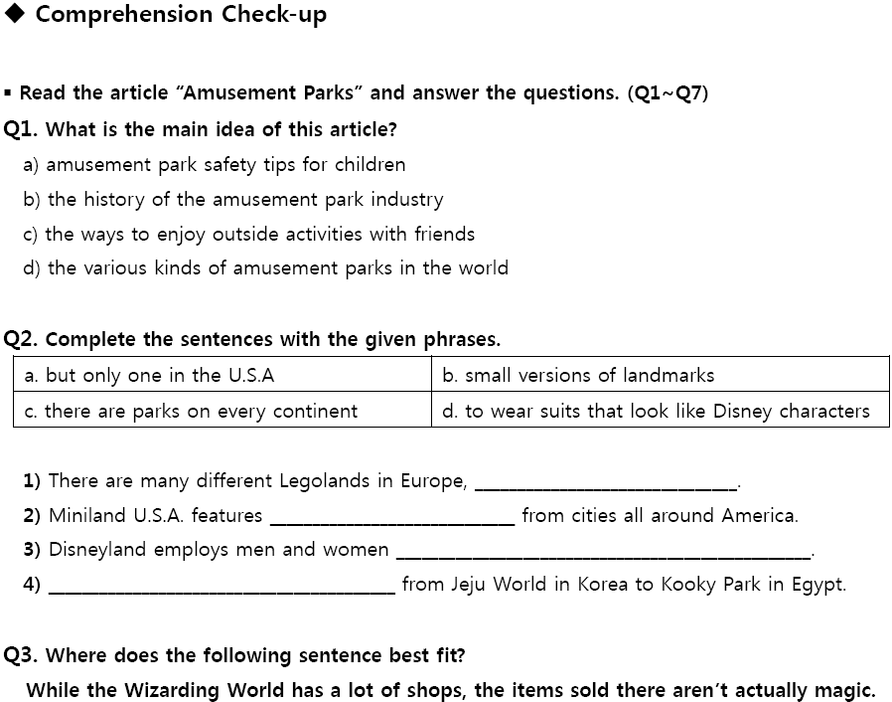

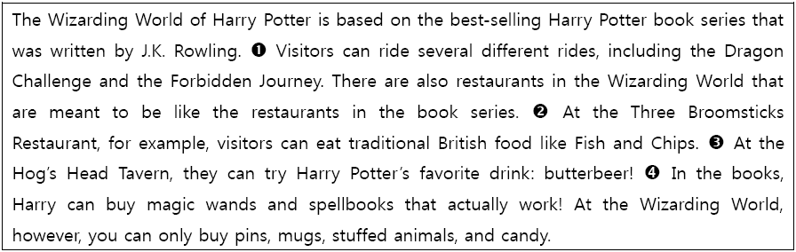

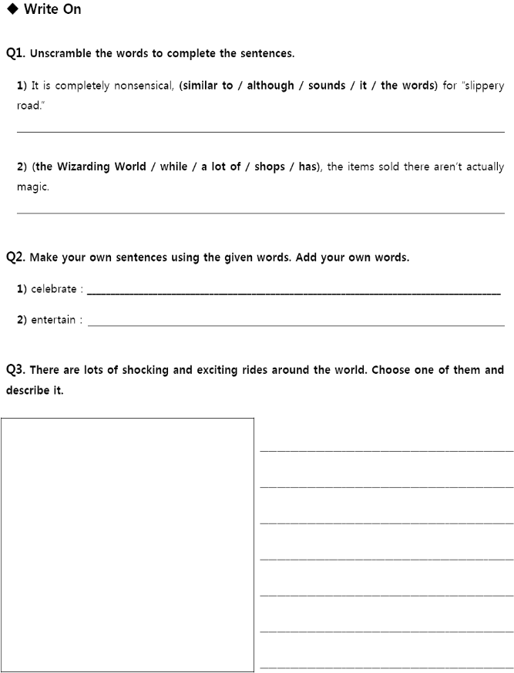
Worksheet#4
Q4. What is your favorite theme park ride?
Worksheet#5
◆Grammar Round-up
While most parks have water rides and other games for you to play, all parks have coasters.

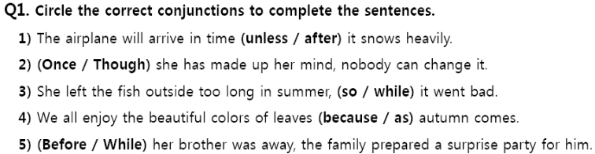

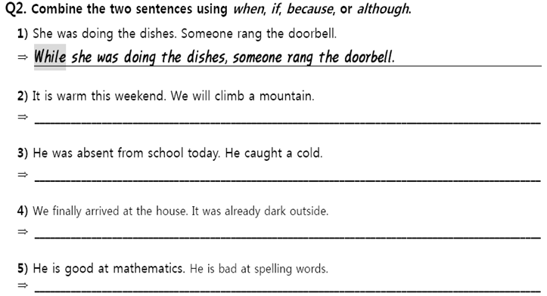

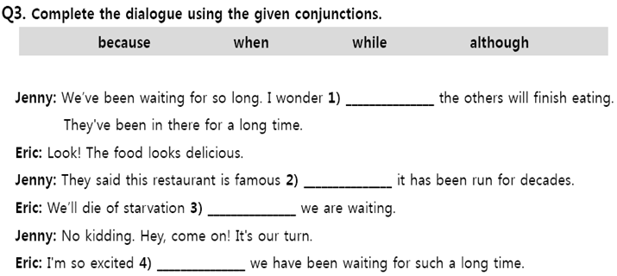

Worksheet#6 homework
Vocabulary review

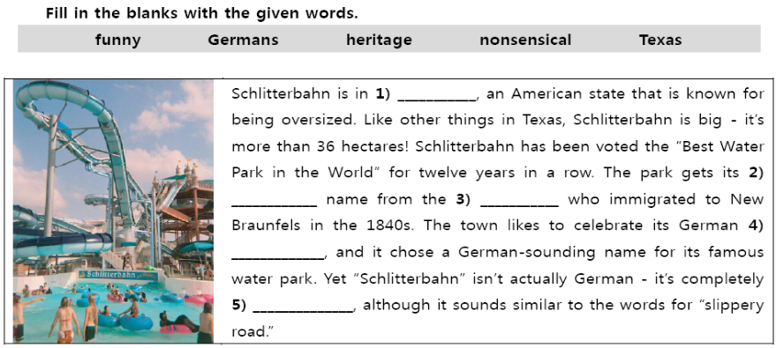

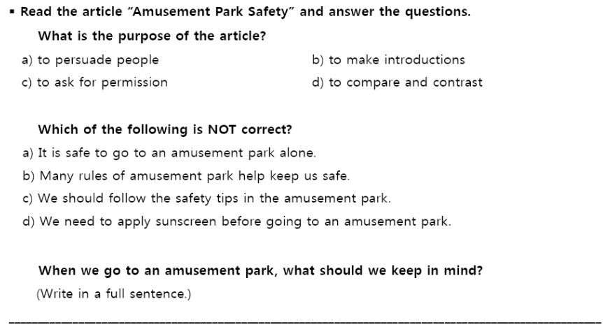

Worksheet#6 for extra time

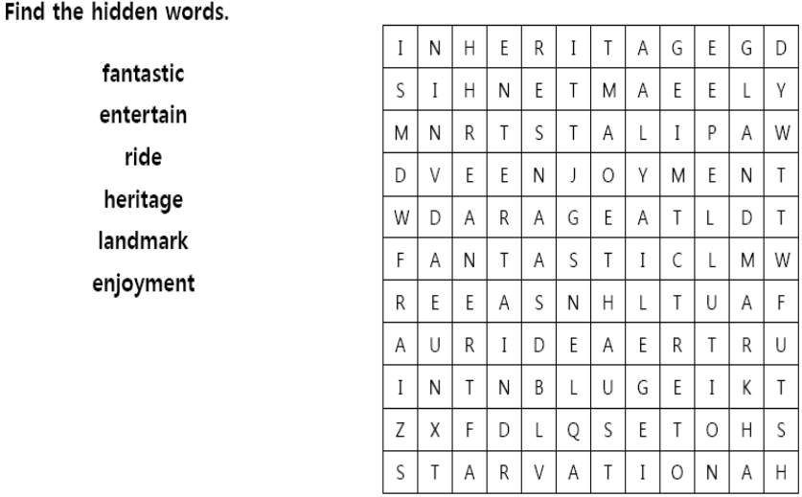

Answer sheet for answer sheet

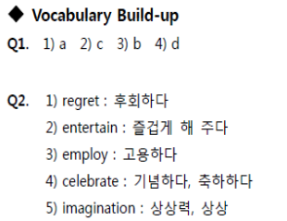

- Comprehension check-up
Q1. D
Q2. 1) a 2) b 3) d 4) c
Q3. 4



