Grammar Worksheet #1

[1] Choose and write. Use a/an with the count noun

Homework | Dog | Cup | Child
Pen | House | Juice | Potato
Milk | Bread | Water | Baby
cookie | Dish | Cheese | Money

Count noun non-count noun

_________ _________

_________ _________

_________ _________

_________ _________

_________ _________

_________ _________

_________ _________

_________ _________

_________ _________

_________ _________

[2] Choose whether each sentence needs an indefinite article (a, an), a definite article (the), or no article.

1. He asked me _________ very hard question.
2. _________ question that he asked me was easy.
3. Have you seen _________ my scarf?
4. Could you please pass me _________ salt?
5. Is there _________ good restaurant around here?
6. _________ restaurant that my friend owns is very good.
7. I have several _________ good friends.
Grammar Worksheet #2
Look and write a, an, the or x
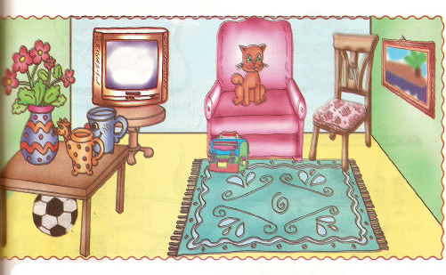

1. Look at the picture. What do you see?
I see _________ table, _________ chair, _________ ball, _________ television and _________ cups.

2. Where is _________ ball?
It is under _________ table.

3. Do you see _________ sofa?
Yes, I see.
What color is it?
_________ sofa is pink.

4. Do you see any animals?
Yes, I see _________ cat.

5. Where is _________ cat?
_________ cat is on _________ sofa.
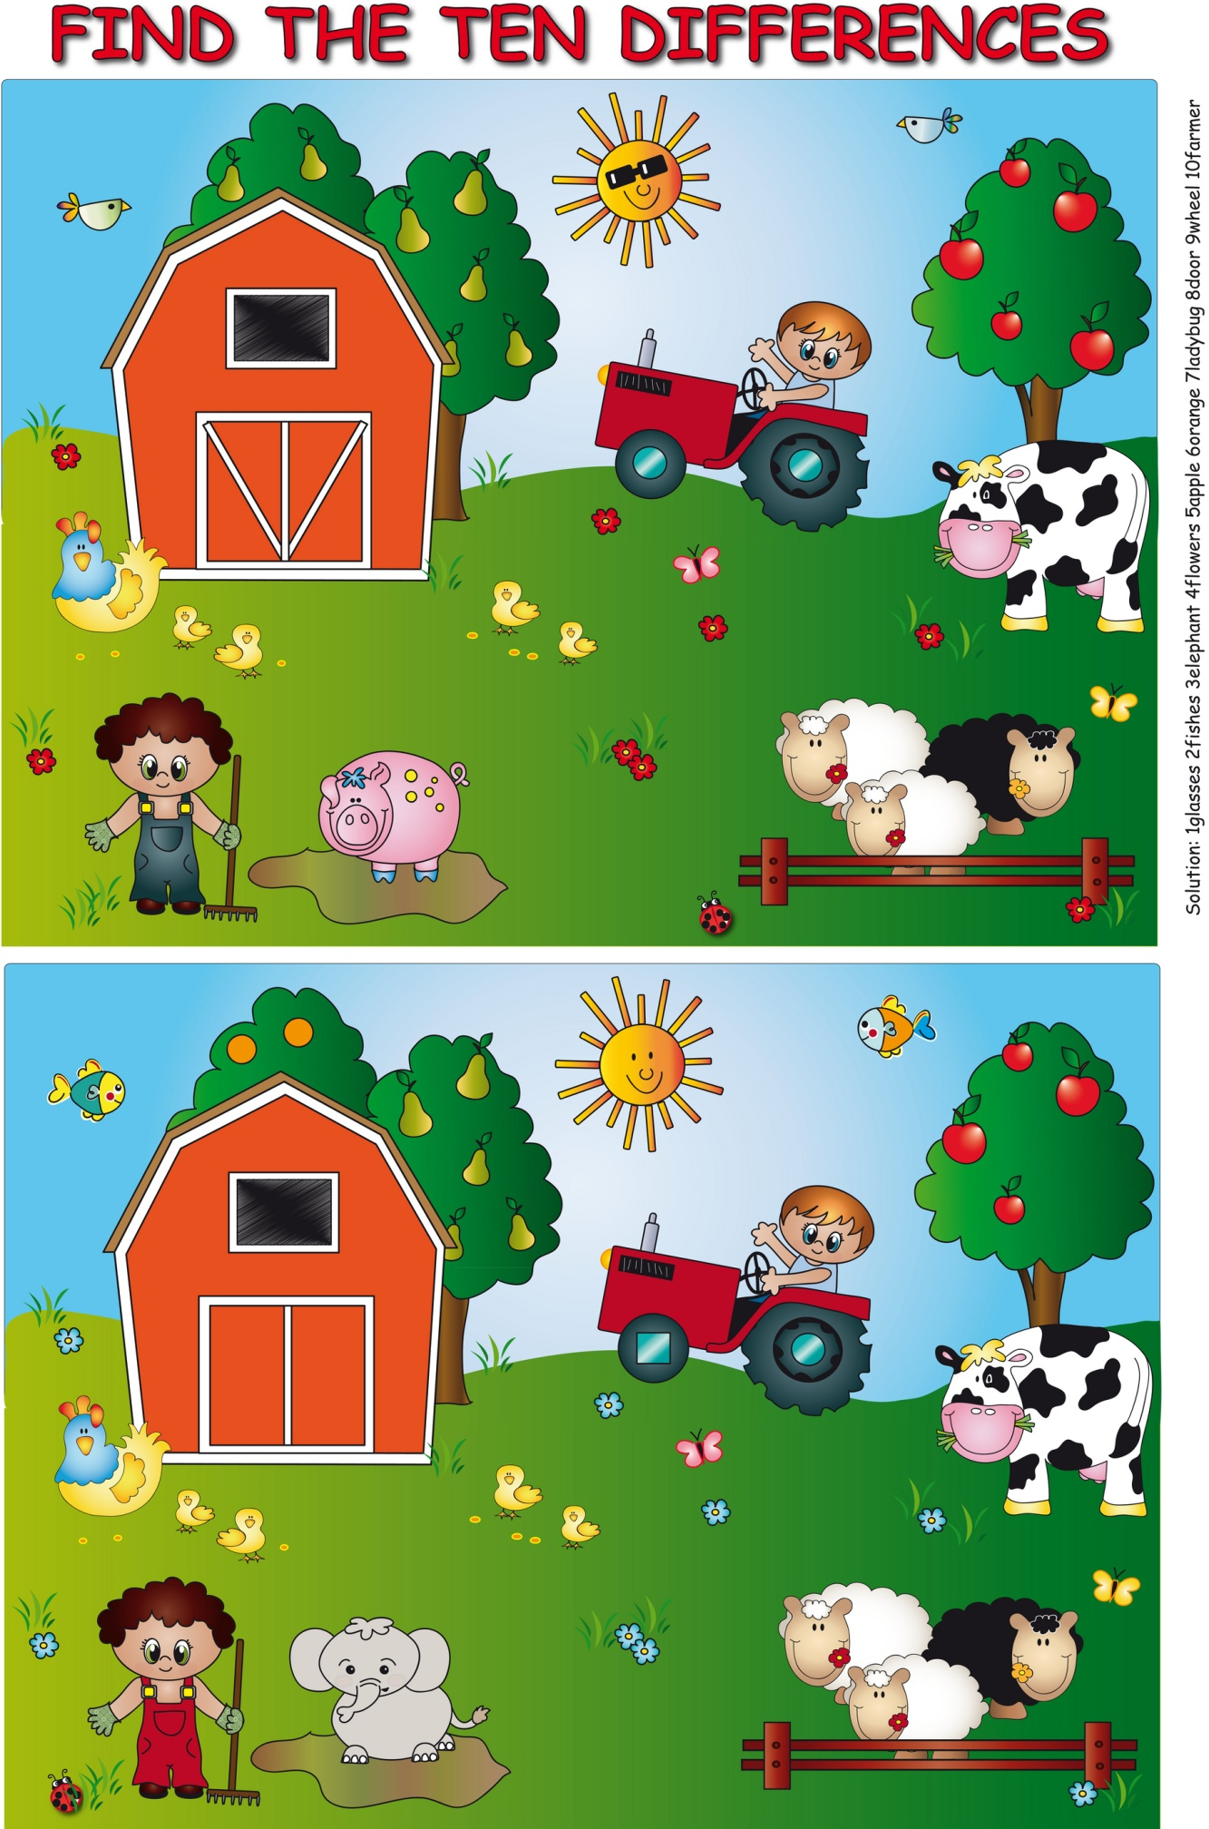
PAIR WORK PICTURE DIFFERENCE

Students being given two pictures that are similar but not the same and being asked to find the differences without looking at each others’ pictures is also an activity that prompts lots of articles, and this can be reinforced by having one picture where “The cat is under the table” and the other where “A cat is under the table” (there being more than one cat in the picture in the second case).

