Lesson Plan Template – Presentation Practice Production Based
Listening Speaking Reading Grammar Writing
Topic: The Love Letters

Instructor:  Rachel (Dayeon) Yang | Level:  High Beginner | Students:  10 | Length:  45 Minutes

Materials:
- Worksheets #1~#5 (10 copies each)
- Picture
- White board, board markers

Aims:
- To learn vocabulary relating to topic-the love letters
- To predict the events through looking and sharing the pictures.
- To practice speaking by discussing with classmates and pairs.
- To express students’ own ideas of empathy with Ming-fu and Lee
- To remember the details of the story.
- To improve scanning skill by answering the detail question

Language Skills:
- Reading: comprehension and reading worksheet
- Listening: the students’ short speech about themselves
- Speaking: prediction, comparing and sharing ideas within classmates and pairs
-Writing: writing letters to Lee

Language Systems:
- Phonology: pronunciation related to vocabularies in the story
- Lexis: vocabulary used in the story
- Function: self expression and share ideas about the love at first sight and prediction of the story.
- Discourse: sharing experiences about writing letters to others and being rejected by others.
- Grammar: N/A

Assumptions:
- Ss already know the Ts style of teaching and how the classroom works
- Ss are high-beginner level
- Ss have already experienced writing letters and being rejected by others
- Ss have already known some vocabulary in the story
- They are mostly active.
- Familiar with sharing ideas and group work.

Anticipated Errors and Solutions:
- Ss don’t understand key vocabulary
→T tells example sentences using the key vocabularies.
- Ss may not be able to pick up details from the reading
→Chunk the story and give them more time to read
- If time is short
→Cut post-activity discussion short and only ask 2~3 Ss to share their opinions about activities when they love at first sight/being rejected by others
- If Ss finish their tasks earlier than anticipated,
→ Ask as many Ss as possible about their idea about the story and let them read the letter to Lee out loud. Also give enough time to think to answer to the worksheets

References:
-True Stories in the News ③ Unit 4- The Love Letters
- www.dic.naver.com

Lead-In
Materials: White Board & Markers
Time | Set Up | Student Activity | Teacher Talk
3min | Whole Class | Answer and listen to the teacher | Procedure:  •Greeting  - Do you believe in love at first sight? Raise your hands and tell us if it’s possible or not and why.  - Have you ever written letters to others? To whom?  - Have you ever rejected someone’s proposal? Or have you ever been rejected by someone? What situation was it?  - If you have to make someone who rejects your proposal accept yours, what action would you use, how will you do it?  <Introducing today’s topic>  Today, we will talk about “The Love Letters”

Pre-Activity
Materials: Worksheet #1(Vocabulary), Picture, Board, Markers
Time | Set Up | Student Activity | Teacher Talk
15min | Whole Class  Individually  Whole Class  Whole Class | Listen to the teacher  Answer on the vocabulary worksheet  Answer and make sentences  Listen to the teacher and answer the questions. | Procedure:  1. Vocabulary  Instruction  Work individually. Write each vocabulary word next to its meaning. You have 5 minutes.  [Distribute the worksheet #1]  Demonstration  Look at #1.... “Right, a building where a large number of interesting and valuable objects….” So put the word “museum” in the blank.  CCQ  Who are you working with?  How much time do you have?  What do you write on the worksheet?  Monitor carefully. Answer students if they ask questions.  Give time warning: 30 seconds left.  Be flexible with time. Give 1 more minute if they need it.  Check answers:  ① When the teacher read the question #1, let students answer the correct vocabulary out loud. Point out one each student to answer the questions.  ② Point out one each student to answer the questions  (Making sentences).  - Go through the vocabulary one by one  - Explain the meaning if necessary  2. Prediction  Instruction  <Eliciting>  Look at the picture (Show Ss the picture). And you can guess what is going on in this picture.  -What do you see in the picture?  - In what language is the letter?  -What do you think this story is about?  - Can you guess what happens?  Pick each S and let them answer the questions.

Main Activity
Materials: Worksheet #2(Reading), Worksheet #3(Comprehension)
Time | Set Up | Student Activity | Teacher Talk
12min | Whole Class  Individually  Individually  Whole Class | Listen to the teacher.  Read the material individually and remember the details  Put answers on the worksheet #3  Speak the answer sentences out loud. | Procedure:  •Guiding Question  - Does this story believe in love at first sight?  ② Is this a happy ending?  1. Reading  Instruction  Read worksheet #2 individually. I will give you 3 minutes to read. While you read, try to remember the details.  [Distribute the worksheet #2]  CCQ  How much time do you have?  Do you get worksheet #2?  Do you work alone?  Monitor carefully. Answer students if they ask questions.  Give time warning: 30 seconds left.  Discuss your answers to guiding questions with a partner.  Share responses with class.  2. Comprehension check  Instruction  Read again for detail and answer the questions on the worksheet #3.  If you don’t remember the details, you can read the material one more time. Work individually. I will give you 5 minutes to do this.  [Distribute the worksheet #3]  CCQ  What are you going to do?  Do you work with partners?  Check answers:  Let students answer the correct answers out loud. Pick one each student to answer the questions.  (Instead of saying answers only, let Ss make sentences using the answer words- not just saying ‘party is the answer’, ‘Ming-fu and lee met at a party.’)  Monitor carefully. Giving some tips to Ss if they have no ideas.

Post Activity
Materials: Board, Worksheet #4(Discussion), Worksheet #5(Homework)
Time | Set Up | Student Activity | Teacher Talk
15min | Whole Class  Individually  Pair work  Whole Class  Whole Class | Do the worksheet #4  Compare ideas with your pair  Vote and share ideas  Listen to the teacher | Procedure:  1. Discussion  Instruction  Although Lee rejected Ming-fu’ propose, he really loved her so he wrote many letters to her. But in the end, Lee got married with the mail carrier who sent Ming-fu’s letters.  Instead of writing letters, what can Ming-fu do? Look at worksheet #4 and check the actions what you think are good for him. And think about the reasons. I will give you 5 minutes to do it individually.  [Distribute the worksheet #4]  CCQ  How much time do we have?  What should we do?  Is it ok to check several options?  Monitor Ss and give some tips to help them.  Ok, let’s share your ideas with the pairs. The pair will be combined with one man and woman. And tell your partner why you think these are best option for Ming-fu? Compare the answers with your partner. I will give you 3 minutes.  Demonstrate  If I were Ming-fu, I will sing for her. Writing letters is also good but it would be better if I can deliver my feeling of sincere love through singing. Of course in that case, I would be good in singing…..  CCQ  Do you work with your pair?  What should you do?  Share responses  Let’s vote among the girls, who choose option number 1? Raise your hand. (check it on the board)  How about boys? …. Ok let’s talk about it. Why do you think men and women’s answers are different?  2. Closing  It’s time to wrap up. We talked about ‘the love letters’. Did you  enjoy it?  Give homework  What do people write in a love letter? Make a list of possible  sentences with your classmates.  Ming-fu and Lee lived in Taiwan, so Ming-fu wrote his letters in  Chinese. On your own paper, write a love letter from Ming-fu  to Lee in English.  [Distribute the worksheet #5]  Ok, you did a great job today. Try to love others so much and be loved by others. Have a great day and see you tomorrow!

<Picture>

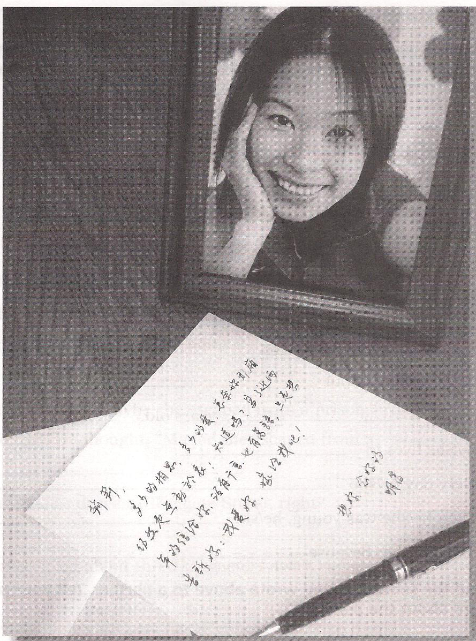

<Worksheet #1-Vocabulary>
① FILL IN THE BLANKS
can’t believe it museum love at first sight weekend
ready deliver carrier marry

1. ______________: a building where a large number of interesting and valuable objects,
such as works of art or historical items, are kept, studied, and displayed
to the public
2. ______________: If you do this something somewhere, you take it there
3. ______________: legally become husband and wife in a special ceremony
4. ______________: Someone who deliver the letter
5. ______________: falling in love with somebody the first time you meet them
6. ______________: Saturday and Sunday
7. ______________: they are properly prepared for something
8. ______________: you can’t accept that they are telling the truth.

② MAKING SENTENCES
1.__________________________________________________________________
2. __________________________________________________________________
3. __________________________________________________________________
4. __________________________________________________________________
5. __________________________________________________________________
6. __________________________________________________________________
7. __________________________________________________________________
8. __________________________________________________________________
<Worksheet #2-Reading>
The Love Letters

Ming-fu and lee met at a party. For Ming-fu, it was love at first sight. “Hello,” he said to Lee. “I’m Ming-fu.” Lee looked at him and smiled. “Hi,” she said. “I’m Lee.” Ming-fu and Lee laughed and talked all evening. When they left the party, it was 2am.
For the next year, Ming-fu and Lee were together every weekend. They went everywhere together- to movies, to parks, to museums, and to restaurants.
One night, at a romantic restaurant, Ming-fu asked Lee, “Will you marry me?” “No,” Lee answered. “I’m not ready to get married.”
“I can’t believe it!” Ming-fu thought. “Lee doesn’t want to marry me! But I love her! What can I do?” Ming-fu began writing love letters to Lee. Every day he wrote a letter and mailed it to her. “I love you,” he said in his letters. “Marry me.”
Every day the same mail carrier delivered Ming-fu’s letter to Lee. The mail carrier always smiled when he gave Lee a letter. “Another letter from your boyfriend,” he said.
Ming-fu sent Lee a love letter every day for two years -700 letters altogether. Finally Lee said, “I’m ready to get married now.”
Did Lee marry Ming-fu? No, she didn’t. She married the mail carrier who delivered Ming-fu’s letters.

<Worksheet #3-Comprehension>

◎UNDERSTANDING WORD GROUPS
Read each group of words. One word in each group doesn’t belong. Find the word and cross it out
smile  run  laugh  talk |  | parks  museums  labels  restaurants |  | marry  romantic  love  soccer |  | mail carrier  doctor  letters  send

◎ REMEMBERING DETAILS
-One word in each sentence is not correct. Find the word and cross it out. Write the correct word.
party
1. Ming-fu and Lee met at a concert.
2. When they left the party, it was 2pm.
3. For the next year, Ming-fu and Lee were together every morning.
4. They went everywhere together- to movies, to parks, to museums, and to schools.
5. One night, at a romantic restaurant, Ming-fu asked Lee, “Will you write me?”
6. Ming-fu began writing postcards to lee.
7. Ming-fu sent Lee a love letter every day – 70 letters altogether.
8. Lee married the mail carrier who wrote Ming-fu’s letters.

◎ UNDERSTANDING QUOTATIONS
- Find the best way to complete each sentence. Write the letter of your answer on the line.
1. When Ming-fu met Lee, he said, _c_ | a. “Another letter from your boyfriend.”
2. When Ming-fu asked Lee,  “Will you marry me?” she said, ____ | b. “I love you. Marry me.”
3. When Ming-fu wrote love letters to Lee,  he told her, ____ | c. “Hello. I’m Ming-fu.”
4. When the mail carrier delivered Ming-fu’s letters, he smiled and said, ____ | d. “No. I’m not ready to get married.”
<Worksheet #4-Discussion>

When Lee told Ming-fu, “I’m not ready to get married,” Ming-fu thought, “What can I do?”

What can Ming-fu do? Give him some ideas. First, read the list below and choose the five best ideas. Check them.

Ming-fu wants Lee to marry him. What can he do? He can…
□ 1. write love letters to her.
□ 2. call her on the phone every day.
□ 3. sing to her.
□ 4. buy her presents(flowers, dandy, jewelry.
□ 5. take her to restaurants for dinner.
□ 6. cook for her.
□ 7. take her dancing.
□ 8. wear nice clothes.
□ 9. be clean and smell good.
□ 10. listen to her when she talks.
□ 11. always tell her the truth. Never lie to her.
□ 12. remember important days- her birthday, for example.
□ 13. be polite; say “please” and “thank you.”
□ 14. tell her she is beautiful.
□ 15. be faithful to her. (No other girlfriends!)
□ 16. _______________________________________________________________________
(Write your own idea.)
<Worksheet #5-Homework>
What do people write in a love letter? Make a list of possible sentences with your classmates.

Ming-fu and Lee lived in Taiwan, so Ming-fu wrote his letters in Chinese. On your own paper, write a love letter from Ming-fu to Lee in English.

Dear Lee,

