Lesson Plan – Reading

Title – Free running(outdoor sports)

Instructor:  Jaeyun Cho  (Jake) | Level:  Intermediate | # of Students  10 | Length  30 minutes

Materials:
- White board, markers, erasers
- A laptop
- An article
- Worksheet for main activity
- Worksheet for pre-activity
- Pictures for lead-in

Aims:

Main Aim: Students will be able to know what is the free running and various lexical items through reading the article and the definitions sheet.

Secondary Aim: Students will be able to get the main idea by skimming the reading text and answering questions.

Personal Aim: I want to reduce my TTT and increase STT.
I want to improve my ICQ’s and CCQ’S.
I hope students will know more lexical items related to outdoor sports.

Language Skills:

- Speaking: Group discussion, small talking
- Listening: Listen to the teacher’s instruction and other classmates’ talking
- Reading: Reading text, worksheet
- Writing: Worksheet

Language Systems:

- Discourse: discussion
- Phonology: Expressions
- Lexis: vocabularies in the article
- Grammar: None to discuss.
- Function: Answer to the questions in worksheet

Assumptions:

Students already know:
- They have experienced at asking the way they didn’t know.
- They have to speak English in the classroom
- They should follow teacher’s instruction.
- How to discuss their ideas with a partner

Anticipated Errors and Solutions:

- If they hesitate what to say about outdoor sports
->Let a teacher do the first
- If Ss have difficulties in doing activities
-> Try to clear with instruction and monitor them
- If Ss don’t understand vocabulary in reading text
-> Explain the vocabulary in easy words
- If Ss finish their task earlier than expected
-> Have Ss compare their answers with their partners
- If Ss need more time to read text or solving the questions
-> Give them a little more time to read carefully and work on it

References:
- www.oup.com/elt/headway
- http://www.usingenglish.com/handouts/336.html

Lead-in
Materials: white board, markers, erasers, pictures
Time  1 minute  3 minutes | Set up  Whole Class | Procedure  Greeting:  Greet students: “Hello everyone! How are you today?”  Eliciting and Prediction:  Show pictures (tape pictures to the board)  Inside sports(left side on the board)  Outside sports(right side)  Ask questions to Ss  “What do you come into your head looking at these pictures?”  Elicit ‘indoor sports’ and ‘outdoor’ from Ss.  After that, ask a couple of sports to Ss what sports they usually do in their free time.  (Brainstorming)

Pre-activity
Materials: Sheets for pre-activity, white board, markers, erasers, A laptop
Time  3 Min.  2 minutes  3 minutes  1 minute | Set up  In pairs  Whole class | Procedure Hand in quiz sheets. Make Ss pair up and figure out what the answers are.  “This is a sheet for a variety of sports term.  Talk to your partner. I will give you 3minutes to do.”  Monitor and give time warning(1 minute left)  ICQs 1) How much time do you have?  2) Will you work alone?  After 3 minutes, let the pairs tell the answers.  If they don’t know why the correct answers are, give a definition sheet for Ss.  And have a student who don’t know the meaning of the word speak loudly  Write ‘Free running’ on the board.  And show ‘free running’ video to Ss.  “Now, we are going to watch a clip for understanding in the next reading. This outdoor sports name is ‘free running’. Free running is one of the out-door sports. It’s not popular in Korea. It looks dangerous but exciting.  First of all, let’s watch.”  http://www.youtube.com/watch?v=v5iQWY6AITY  After watching,  “How was it? Was it interesting to you? I can assure that it’ll be popular in Korea. Someday, I might join the competition. You will be able to watch me in TV.
Main activity
Materials: sheets for reading, white board, markers, erasers

Time  2 minutes  3 minutes  3 minutes  3minutes | Set up  Individual  Individual  In pairs | Procedure  Hand sheets for reading out to Ss  “Ok, before starting with reading, we are going to check for words you don’t know well.”  (If they don’t know the words,  -suburb: an area where people live that is outside the center of a city  -street light: a light at the top of a tall post in the street  -waste of time: to use more time than is necessary or useful  -outdoor: used, happening or located outside rather than in a building  -rude: having or showing a lack of respect for other people and their feelings  -flowerbed: a piece of ground in a garden/yard or park where flowers are grown  “Now, we are going to read this article.  Brian, can you read a sentence loudly?  And then the next student read  After finishes reading, make them pair up to figure out the answers.  “I will give you 3minutes to check the answers.  Talk to each other.”  Monitor. And give time warning.  ICQ’s: How much time do you have?  Tell them the right answers.  If they can’t understand, let Ss know where is the line a teacher found a clue.

Post-Activity
Materials: the second page of the sheet for reading, board, markers, erasers
Time  5 minutes  1 minute | Set-up  In pairs  Whole class | Procedure  Let Ss do the role play(no.5) in pairs  “Ok, guys! You will do the role play in pairs. A students sitting on the left is A, another is B.  All A students say this information loudly. And All B students say your information. You don’t need to do presentation. Just feel free to talk to your partner. I’ll give you 5 minutes.  Monitoring and giving time warning  ICQ’s: How much time do you have?  Review & CCQ  “Free running is an indoor sport?”  “If the score is 0-0, the game is a …?  “Today’s lesson is finished. I hope you enjoyed the lesson. See you tomorrow!!”

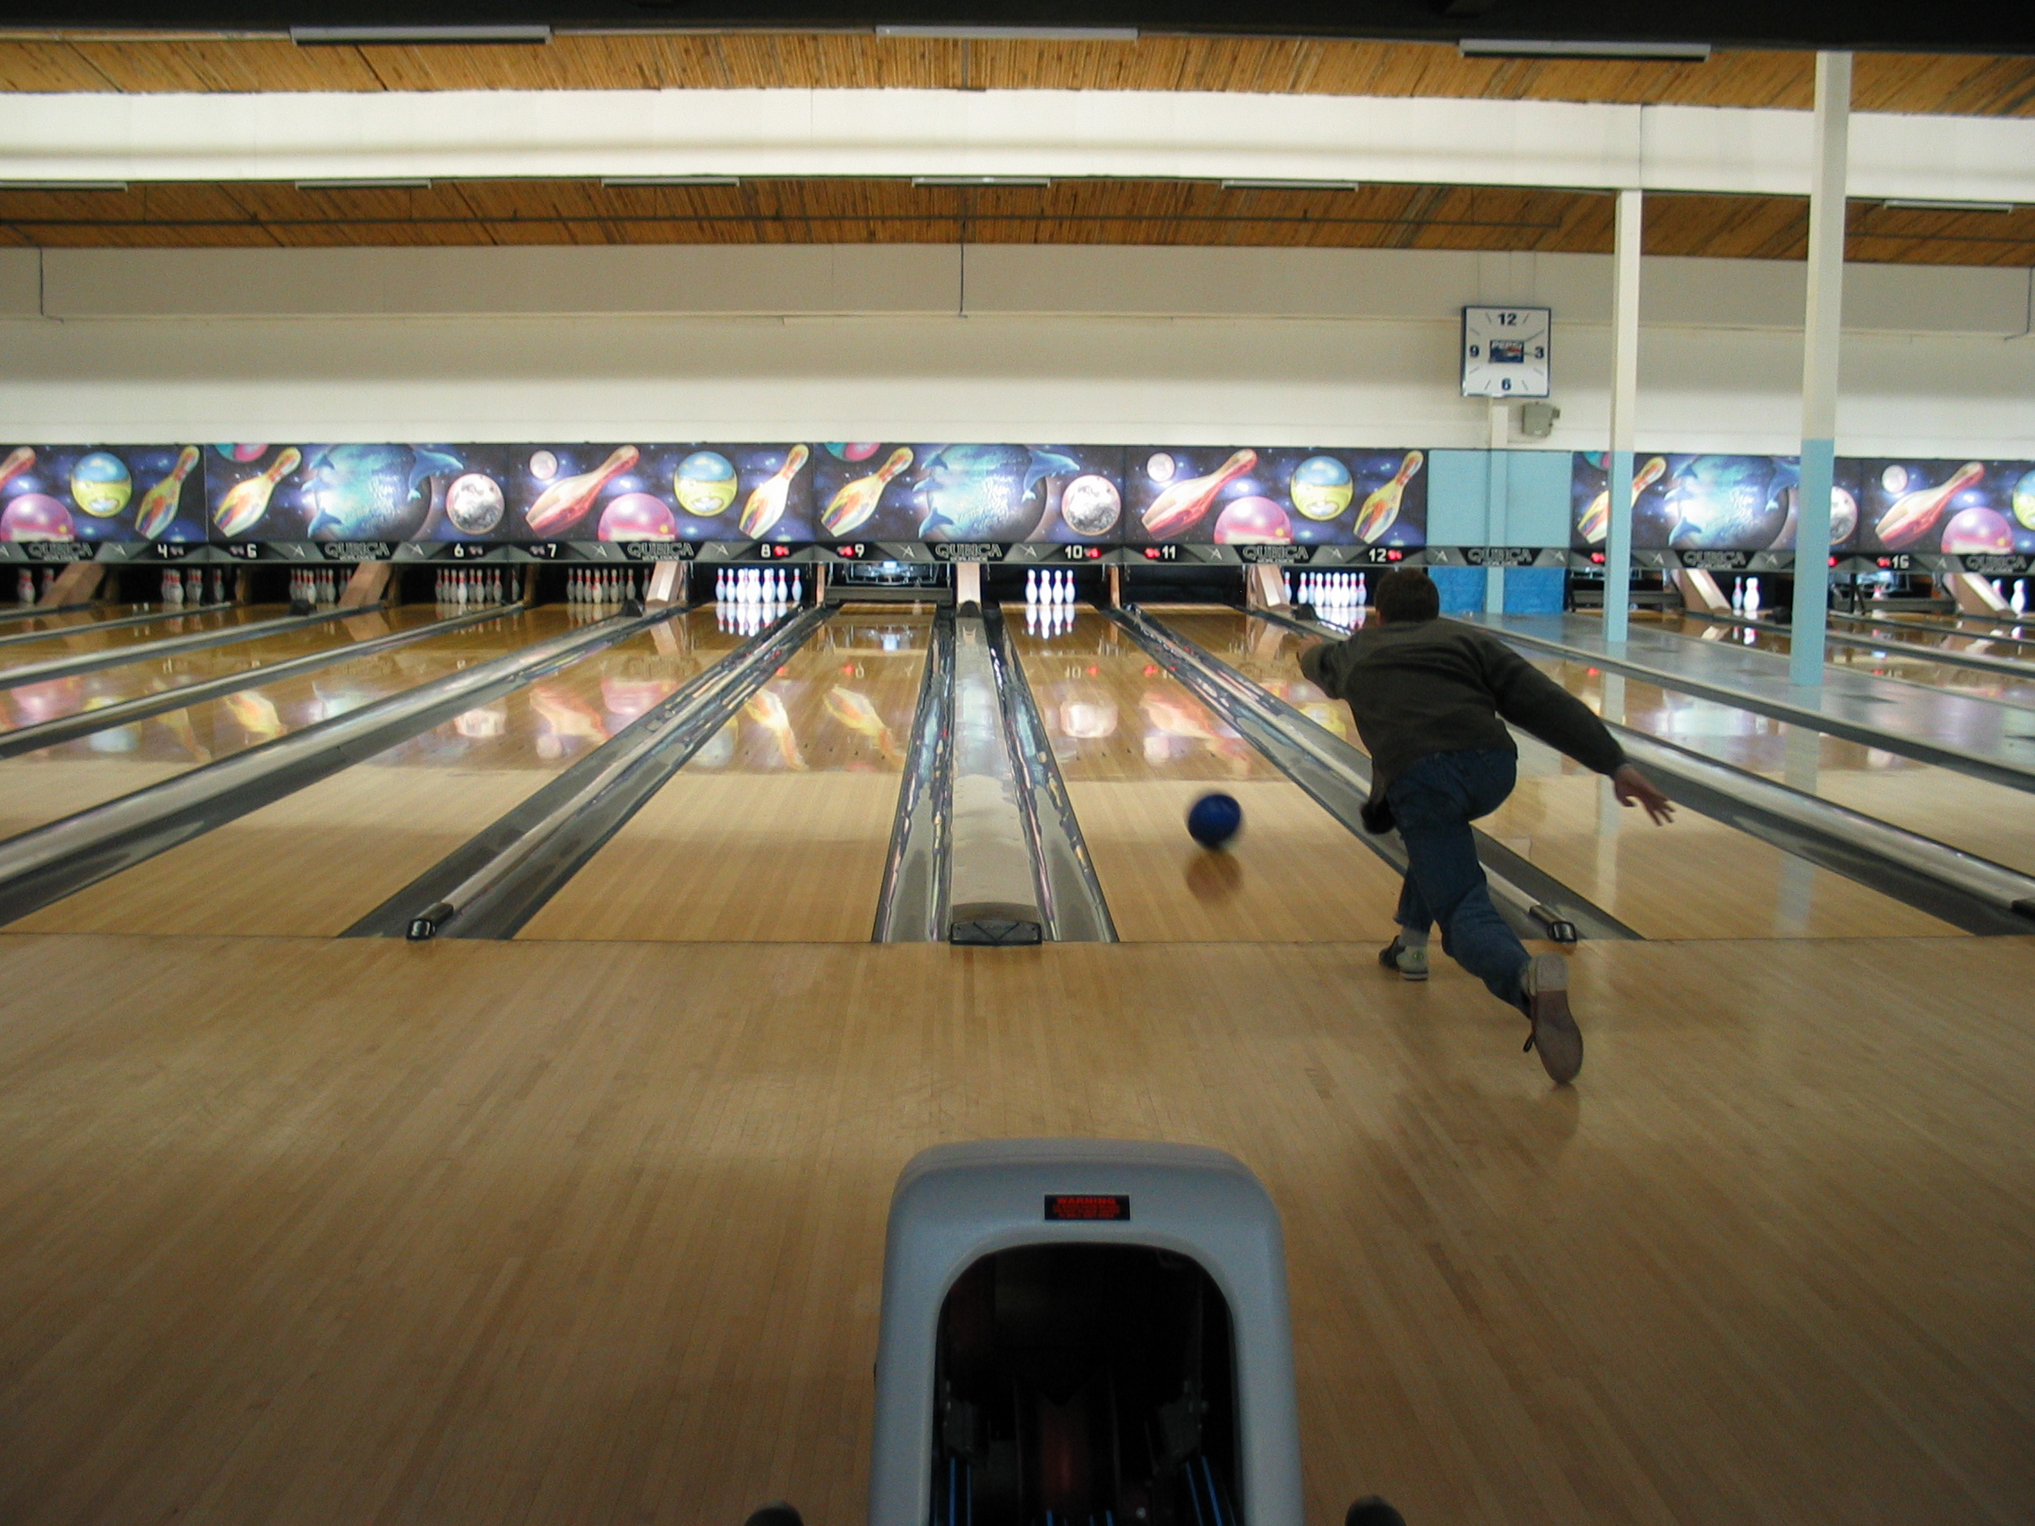

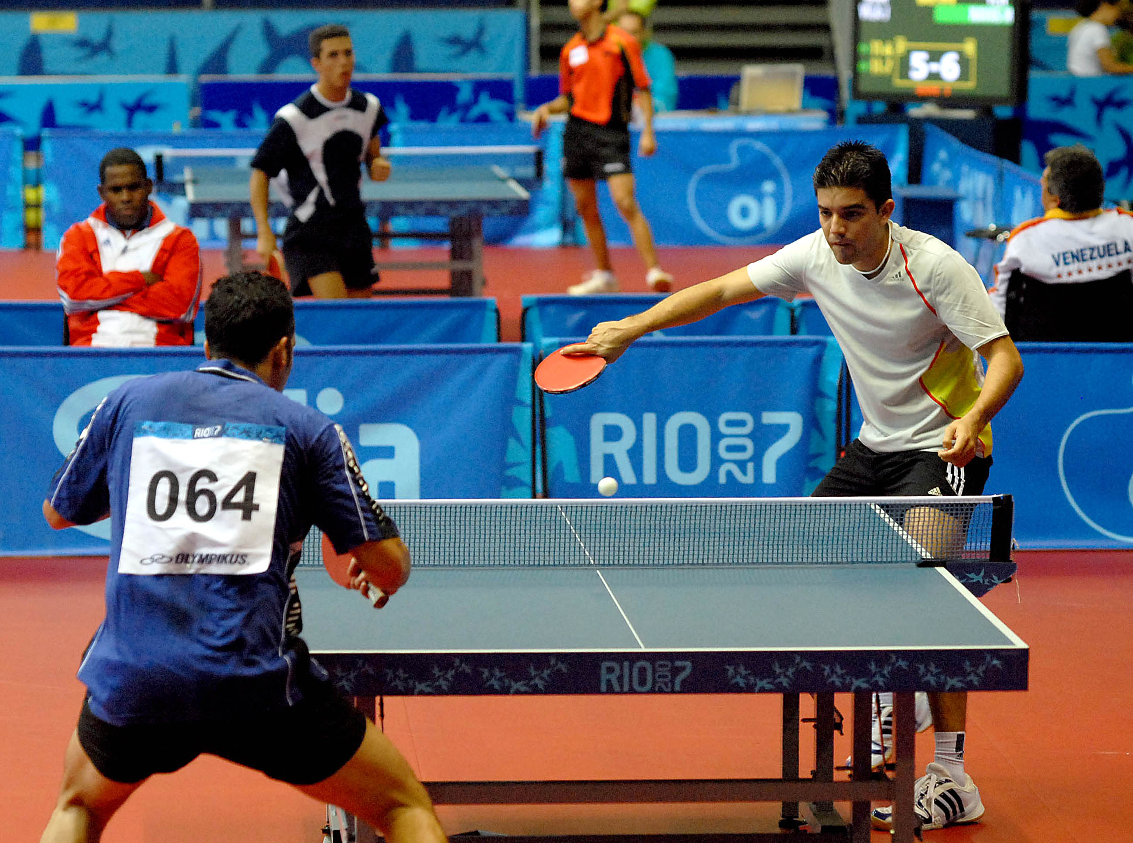

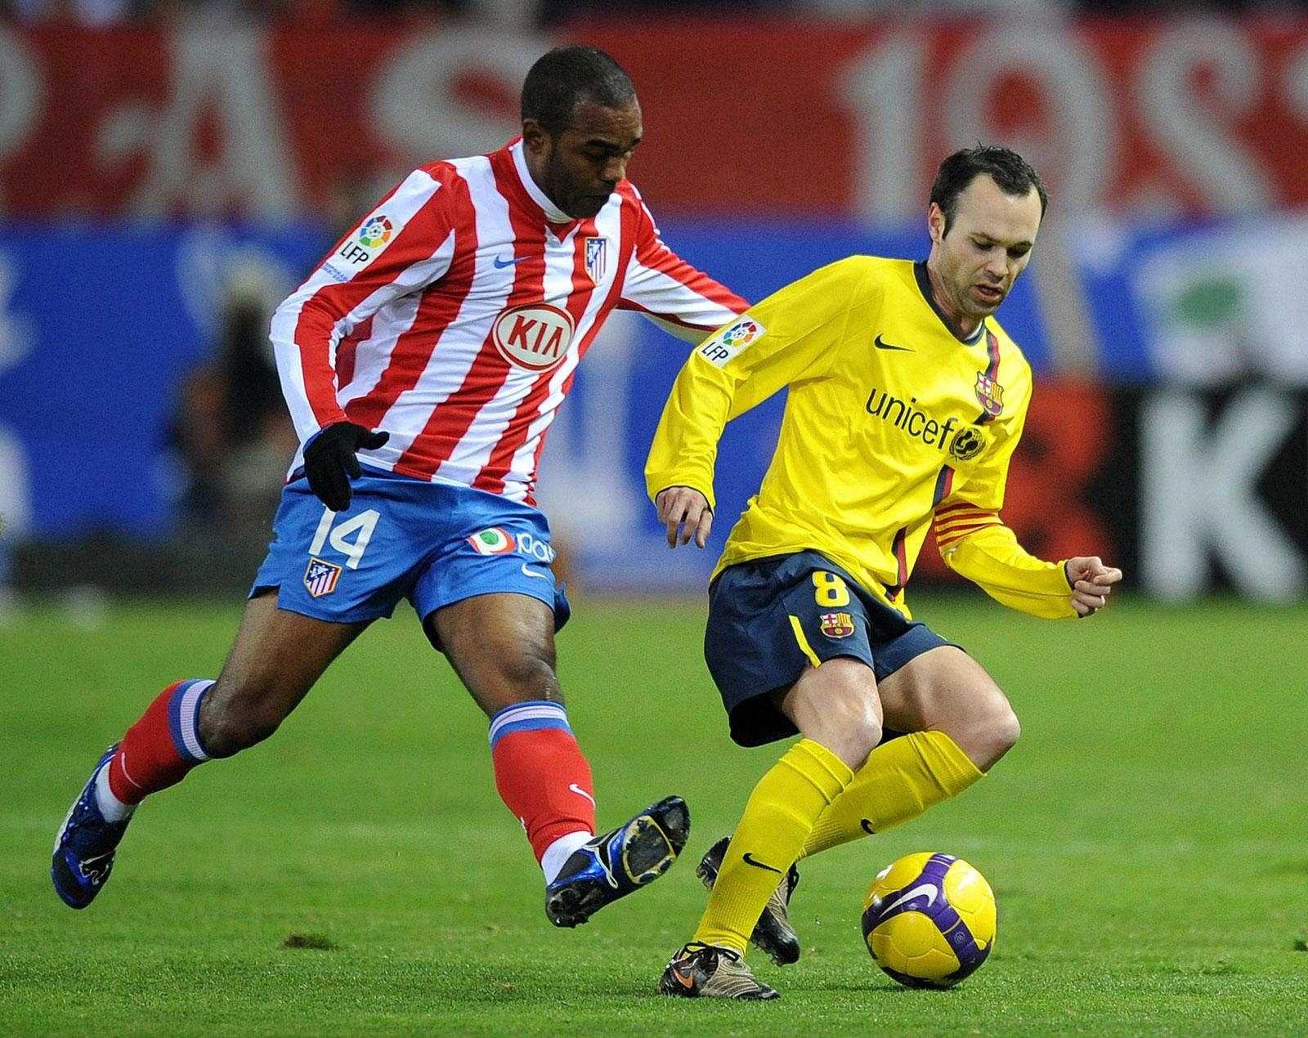

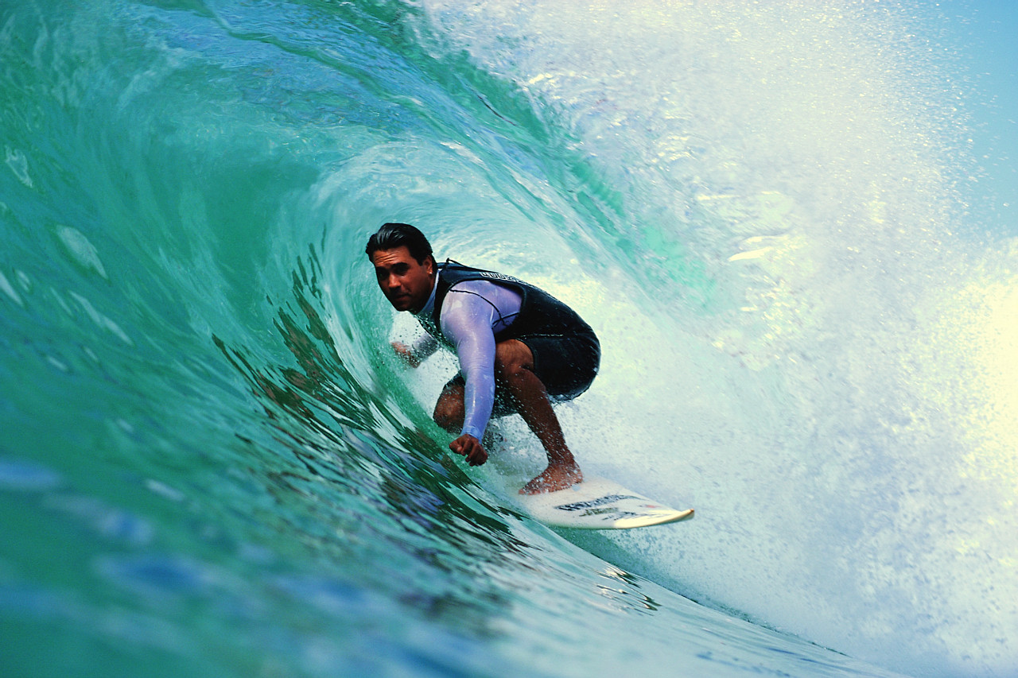

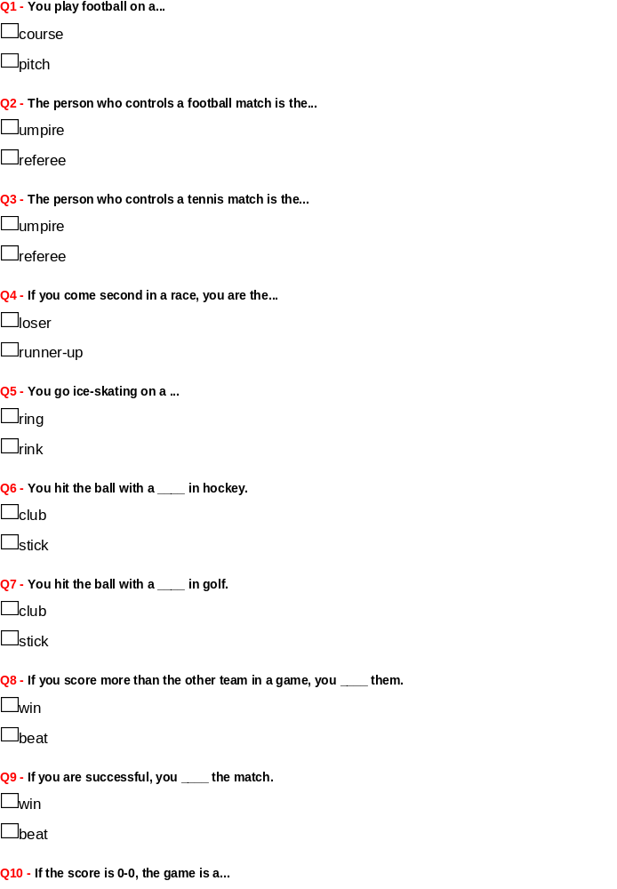win
loss
draw
beat

Definition (in pre-activity)

1 .Course: (for races) an area of land or water where races are held
(for golf)

2. pitch: an area of ground specially prepared and marker for playing a sports game

3. umpire: in sports such as tennis and baseball a person whose job is to watch a game and make sure that rules are not broken

4. referee: the official who controls the game in some sports

5. loser: a person who is defeated in a competition

6. runner-up: a person or team that finishes second in a race or competition

7. ring: (for performance/competition): a confined area in which animals or people perform or compete, with seats around the outside for the audience

8. rink: a specially prepared flat surface of ice, where you can ice- skate

9. club: (in golf) a heavy stick with a thick end

10. stick: (in hockey, polo, and other games) a long, thin tool, typically made of wood, with a curved head or angled blade that is used to hit or direct the ball or puck

11. win: acquire or secure as a result of a contest, conflict, bet, or other endeavour

12. beat: defeat (someone) in a game or other competitive situation

13. loss: a failure to win a contest

14. draw: finish with an even score

