Lesson Plan
 |  | Listening
 |  | To get accepted into college…
Instructors | Candice |  |  | Level | intermediate |  | # of Ss: | 12 |  |  | Length: | 55
Materials
- 15 copies of each vocabulary, dictation, comprehension worksheets (added 3 extra sheets of each)
- 4 copies of group worksheets (added 2 extra sheets)
- White board and markers
- DVD player and DVD, Screen or TV, Remote, lap top ( if necessary)
Aims
- To improve listening comprehension by watching a film without subtitle.
- Ss will be accustomed of watching a film by listening in English directly.
- Ss will be able to learn informal or more common words spoken in real life by watching a film.
- Ss will get a chance to watch a film and learn listening skill at the same time.
Language Skills
- listening : Watching a film without subtitle, group discussion
- writing : Dictation, comprehension check, group discussion
- reading : Vocabulary, dialogue
- speaking : Answering the questions individually, group discussion
Language Systems
- Lexis : Vocabulary worksheet
- Phonology : Vocabulary worksheet
- Function : Comprehension check worksheet
- Discourse : Group discussion
Assumptions
- Ss already know how to dictate in dialogue and what to do in this class.
- Ss have more than a basic knowledge of something but not yet advanced.
- Ss have different style of dictation and listening skill while watching a film.
- This class for listening dictation by watching a film is once a week every Friday.
Anticipated Errors and Solutions
Overtime : Give an assignment for Comprehension check worksheet or reduce the time on group discussion .
Undertime: Allow Ss to watch the film until the class finished or give more time to discuss in groups.
References
- Times media student workbook
- Learning Teaching by Jim Scrivener
- http://www.google.co.kr (research for story line on this film and photos)

Lead-In
Materials | Board and marker
Time |  |  | Set up |  | Teacher Activity |  | Student Activity
2 min |  | Whole class |  | How are you today? It’s getting warmer these days, however inside the class is cool with air conditioner, isn’t it?  Okay, as you know you’re going to watch new DVD named ‘Accepted’ and is there anyone who’ve watched it before?  Write the title of the film on the board  Let you know about the whole story line briefly. A high school slacker who's rejected by every school he applies to opts to create his own institution of higher learning. |  | Talking to teacher  No one answers  Listening to what teacher says
Pre-Activity
Materials | Board and marker, Vocabulary check worksheet
Time |  | Set up |  | Teacher Activity |  |  | Student Activity
3 min  5 min |  | Whole class  Whole class |  | <Instruction>  First off, you’ll watch the film for 5 minutes shortly and then dictate the words in the blanks individually. Focus on listening carefully not watching the film and try to write what you listen promptly if possible.  <ICQ>  - What are you going to do after watching the film?  - How long does it take to watch it?  - Are you going to work in groups?  - What are you asked to do during watching it?  Before watching the film, let’s check on the vocabulary which you’re going to learn today in advance.  Hand out Vocabulary check worksheet to Ss and write the words on the board with pronouncing them clearly so that Ss repeat them again. Let Ss choose the answers as possible, however say the answers directly if no one knows the answers. |  |  | Ss say: Dictation  say: 5 min  say: No, individually  say: Listening carefully not watching the film.  Pronouncing the words follows teacher’s speaking and taking notes.
Main Activity
Materials | DVD player and DVD, Remote, Board and marker, Dictation and Comprehension check sheet
Time |  | Set up |  | Teacher Activity |  |  | Student Activity
5 min  30 min |  | Whole class  Individually  Whole class  Individually  Whole class  Individually |  | Hand out Dictation worksheet and stand in front of Ss by giving a warning not to sleep or chat with others while watching the film.  Turn on DVD and check time for 5 min  Have you enjoyed watching it for a moment?  <CCQ>  - If you are in such situations what will you do?  - What do you think you should go to college?  Okay, well done. Im already starting wondering what’s gonna happen next on the film and what about you?  <Instruction>  - Raise up your hand to speak with an answer.  - Do not hesitate to ask for repeat again if there’re some missing blanks you couldn’t fill in.  <ICQ>  - What are you supposed to do to speak with answers?  - Am I going to give you more chances to listen again?  <Instruction>  - Try to write whatever you listen even if  you think it’s a wrong.  - Correct the errors with colored pen.  <ICQ>  - Are you asked not to write down that you think it’s a wrong answer ?  - How will you correct the errors ?  <Demonstration>  Show Ss how to use colored pen to correct errors.  Get the film back to 5 min ago and start the class again from there. Play the first paragraph and then pause in order to give Ss time to dictate(Repeat this step 3 times)  If no one appears to know the answer, repeat the way(as far as time permits) or give some CCQ to Ss in order to elicit what they think.  Do not wait by Ss speak out and involve weaker or shyer as well.  Follow the same cycle until the worksheet I prepared for the day is totally finished.  Before I check out what you have done so far, there’s one point I want to go over.  What’s the meaning of the word “Cut the crap“ ?  Well done, Den and you exactly know what the word means.  <CCQ>  - What situation do you usually use that word?  - How do you feel if someone uses the word to say to you?  I’m going to check your worksheet one by one from now on.  <Instruction>  - If there’re any blanks you missed to fill out, circle on them with red pen.  - Put the worksheet on the left at the desk.  - Answers the questions in Comprehension check worksheet I’m gonna give you soon.  <ICQ>  - What will you do with a blank you couldn’t fill in ?  - Which side at the desk will you put the worksheet I’m going to check out?  - What are you going to do while I’m checking each of your worksheet?  Hand out Comprehension check worksheet and give Ss 3 min to write.  After 3 min, let some of them proceed to the board to write an answer and then let them know the right answer directly. |  |  | Looking straight ahead for DVD  Some of them are dictating what they listen from the film.  Eric: I would tell my parents honestly and ask them help me.  Su:I think it’s also good getting a job instead of gointg to college but I actually want to go to college.  Gen: yes, I’m same with you and I want you to let us watch more it right now.  Listening to what teacher says.  Ss say: Raising up hand  Say: yes  Ss say: Yes, we have to try to write.  say: We need colored pen to revise them.  Dictating what they are listening and some seem to make it ,some look like confusing though.  Involving in Speaking, reading, listening,writing.  Den: used to tell somebody in an impolite way to stop talking about unimportant things or talking nonsense and get to the main point  Some of them answer the questions  Listening to teacher talking.  Ss say: Making a circle with a red pen.  Say: On the left.  Say: Answering the questions in Comprehension worksheet.  Ss are engrossing in their work.  Some write an answer on the board.
Post-Activity
Materials | Group discussion worksheet
Time |  | Set up |  | Teacher Activity |  |  | Student Activity
10 min |  | Whole class  Groups |  | Okay, well done everyone. I’m proud you guys have involved in the class positively today and from now on you’ll have discussion in a short period of time.  <Instruction>  - Discuss what the next story on the film will be in groups.  - Do so by moving desks to form 4 groups with 3 people.  - You’ll have 10 min for discussion.  <ICQ>  - Are you working individually ?  - How many people will be there in a group?  - How long time do you have ?  Give time warning and walk around in the class to monitor how well the group discussion work.  5 min later, Let Ss present what they’ve discussed.  Okay, well done everybody and I can see most of you are getting better in listening skill on watching a film without subtitle with time.  I’m going to give you a homework to make compositions with 5 vocabularies that we’ve learned today and can be chosen whatever you want.  Let’s call it a day. Have a nice weekend and see you next Monday. |  |  | Ss say: No  Say: 3 people  Say:10 min  Ss make a seat facing each other in groups and start discussion.  Participating in presenting their results from group discussion.
- Dictation worksheet(for Ss)

BARTLEBY: "I regret.. can't believe I didn't ( ) State!.I wasn't even ( ) high with that one. That was my fallback! It was my safety school, my ( )!
Sister : Maybe you're just too ( ).
BARTLEBY: Hey, time out. Too average? Okay. Okay. Excuse me, Lizzie. R-R-Remember who you're talkin' to here. I didn't have to go to gym class for a whole year cause I ( ) to be allergic to sweat. Or what about the time I got the note from my doctor saying I was ( ) and I ( )( )( ) study in my dreams? I got the school ( ),Frank Daley,( )( ) for two years because he was sexually (harassing) me by pushing me up against the locker and I said I felt something.I mean, come on.That was ( ) genius.
Sister : Maybe if you didn't write an essay called "I Don't Have a Clue."
BARTLEBY: Well, it's true. You know? I don't have a ( ) what I want to do with the ( )( )( )( ).
Sister : Mom and Dad are ( ) kill you.
BARTLEBY: O ye of little ( . They're not gonna kill me.
Sister : Uh-huh.
BARTLEBY: I just have to ( ) it and put it in ( ) they can understand.
Father: I don't understand.
Mother: I don't understand, ( ).
BARTLEBY: Okay, I figure it like this. The ( ) cost of college is, what, $20,000 a year? Now, according to these ( ) that I got off the Web...You can pass those around. Someone with no education ( ) high school can expect to make
about $20,000 a year in the ( ) job market. Now, that being said, over the next four years, you could either ( ) $80,000 or I could make $80,000.
Father: Are you saying you don't want to go to ( )?
BARTLEBY: No. I'm saying that it is fiscally ( ) for me to go to college. You know?
Mother: Are you ( )?
BARTLEBY: Oh, God. No.
Mother: Are you ( )?
Father: You're ( ) grass?
BARTLEBY: No. I'm not ( ), Mom. I'm not stoned. I'm completely fine. In fact, I'm more clear and ( ) than I've ever been.
Father: Okay, cut the crap, Bartleby. Society has rules. And the first rule is you go to college.
Mother: Mmm-hmm.
Father: You want to have a happy and ( )( )? You go to college. If you want to be ( ), you go to college. If you want to ( )( ), you go to college.
BARTLEBY: Well, you know what? Maybe I didn't ( )( ) college.
Father: What do you mean?
BARTLEBY: I didn't get ( ) anywhere.
Mother: Oh, Bartleby.
Father: Damn it.
Mother: I knew he ( )( )( ) for college in junior high like his sister.
Father: Now, she's got a ( ).
Sister: I've got a shot.
Mother: She's got a shot.
BARTLEBY: Listen, guys. There are ( ) of successful people ( ) didn't go to college. Albert Einstein, you know. Pocahontas never went to college. Corey Feldman
and Corey Haim. They had a great ( ). Both Lewis and Clark. Suzanne Somers. Bono.
Mother: I need to go check on the ( ).
BARTLEBY: "Check the cobbler." Glug, glug, glug.
Father: You know, I really don't care ( ) Sonny Bono did or didn't do. You're ( ) ( )college.
Sister: I told you ( ).
BARTLEBY: You were ( ).
MRS. SCHRADER: Everyone, I would like to ( ) a ( ) to our graduates. To the Class of 2006, may the next four years of college ( ) the best years of your life.
HANDS: Hey.
BARTLEBY: Hey, man, what's up?
HANDS: What's up, B?
BARTLEBY: How you doin'? What's up?
HANDS: Dude, I ( ), if one more person tells me ( )( ) they are to go to college, I'm gonna ( ) it.
BARTLEBY: Oh, man, I heard about the ( ). That's insane. You're one of the best ( ) in the state.
HANDS: Uh, the best. And, uh, no knee, no football, man.
BARTLEBY: That sucks. What are you gonna do now?
HANDS: I have no idea.
BARTLEBY: That ( ) two of us, pal.
RORY: It's fine, it's fine,it's fine, it's fine,it's fine.
BARTLEBY: Hey, Rory. What's goin' on?
RORY: Oh, hey. What? Fine. Nothing. Um, I--I didn't ( )( ) Yale. I did-- I didn't, I didn't get into Yale. I didn't... I didn't get into Yale.
BARTLEBY: What? ( )( )( ) that!
RORY: Well, there's no room for Rory at Yale. Too many ( ) kids with ( ) grades and ( ) parents this year, I guess. No room for Rory, who's been working ( ) first grade to get into Yale. Rory, who only ( ) to Yale and nowhere else. I had it all ( )! It was perfect, B! Perfect! And now it's nothing! Nada! It's a goose egg!
BARTLEBY: Okay. Well. God, Rory! Rory!
HANDS: She's ( ) that really well.
RORY: College is for pussies!
BARTLEBY: All right. I ( )( ) get out of here, pal.
HANDS: ( )( )( ).
BARTLEBY: All right, man. You, too.
Mr. Schrader : Bartleby! Hey!
BARTLEBY: Oh, hey, Mr. Schrader. I was ( ) just...
Mr. Schrader : Did you have any cake?
BARTLEBY: No, you know, ( )( )( )( ) a cake guy.
Mr. Schrader : Oh, it is a hell of a cake. It is the same cake we ( ) for Scotty and Seth when they( ) into Harmon.
BARTLEBY: Oh, ah, everything comes full ( ).
Mr. Schrader : Jay! How are ya, bud? Oh, I really don't... Hey, Stu.
Stu : Hey. I can't imagine your ( ), knowing your youngest is ( )( ) to a good college. Must take a ( )( ).
Mr. Schrader : Yeah, well, not to mention the load it ( )( ) my bank ( ).
BARTLEBY: Dad. Nothin' like gettin' a load off!
Stu : What about you, Bartleby?
BARTLEBY: That's a good question, Mr. Harkin. What's with the questions, Mr. Trebek?
- Dictation worksheet(for T)

BARTLEBY: "I regret.. can't believe I didn't (get)(into) State!.I wasn't even (aiming) high with that one. That was my fallback! It was my safety school, my (fail-safe)!
Sister : Maybe you're just too (average).
BARTLEBY: Hey, time out. Too average? Okay. Okay. Excuse me, Lizzie. R-R-Remember who you're talkin' to here. I didn't have to go to gym class for a whole year cause I (claimed) to be allergic to sweat. Or what about the time I got the note from my doctor saying I was (nocturnal) and I (was)(allowed)(to) study in my dreams? I got the school (bully),Frank Daley,(kicked) (out) for two years because he was sexually (harassing) me by pushing me up against the locker and I said I felt something.I mean, come on.That was (pure) genius.
Sister : Maybe if you didn't write an essay called "I Don't Have a Clue."
BARTLEBY: Well, it's true. You know? I don't have a (clue) what I want to do with the (rest)(of)(my)(life).
Sister : Mom and Dad are (gonna) kill you.
BARTLEBY: O ye of little (faith). They're not gonna kill me.
Sister : Uh-huh.
BARTLEBY: I just have to (spin) it and put it in (terms) they can understand.
Father: I don't understand.
Mother: I don't understand, (either).
BARTLEBY: Okay, I figure it like this. The (average) cost of college is, what, $20,000 a year? Now, according to these (estimates) that I got off the Web...You can pass those around. Someone with no education (beyond) high school can expect to make
about $20,000 a year in the (current) job market. Now, that being said, over the next four years, you could either (spend) $80,000 or I could make $80,000.
Father: Are you saying you don't want to go to (college)?
BARTLEBY: No. I'm saying that it is fiscally (irresponsible) for me to go to college. You know?
Mother: Are you (huffing)?
BARTLEBY: Oh, God. No.
Mother: Are you (high)?
Father: You're (huffing) grass?
BARTLEBY: No. I'm not (huffing), Mom. I'm not stoned. I'm completely fine. In fact, I'm more clear and (level-headed) than I've ever been.
Father: Okay, cut the crap, Bartleby. Society has rules. And the first rule is you go to college.
Mother: Mmm-hmm.
Father: You want to have a happy and (successful)(life)? You go to college. If you want to be (somebody), you go to college. If you want to (fit)(in), you go to college.
BARTLEBY: Well, you know what? Maybe I didn't (get)(into) college.
Father: What do you mean?
BARTLEBY: I didn't get (accepted) anywhere.
Mother: Oh, Bartleby.
Father: Damn it.
Mother: I knew he (should've) (started)(preparing) for college in junior high like his sister.
Father: Now, she's got a (shot).
Sister: I've got a shot.
Mother: She's got a shot.
BARTLEBY: Listen, guys. There are (plenty) of successful people (who) didn't go to college. Albert Einstein, you know. Pocahontas never went to college. Corey Feldman
and Corey Haim. They had a great (run). Both Lewis and Clark. Suzanne Somers. Bono.
Mother: I need to go check on the (cobbler).
BARTLEBY: "Check the cobbler." Glug, glug, glug.
Father: You know, I really don't care (what) Sonny Bono did or didn't do. You're (goin')(to) college.
Sister: I told you (so).
BARTLEBY: You were (adopted).
MRS. SCHRADER: Everyone, I would like to (propose)a (toast) to our graduates. To the Class of 2006, may the next four years of college (be) the best years of your life.
HANDS: Hey.
BARTLEBY: Hey, man, what's up?
HANDS: What's up, B?
BARTLEBY: How you doin'? What's up?
HANDS: Dude, I (swear), if one more person tells me (how)(excited) they are to go to college, I'm gonna (lose) it.
BARTLEBY: Oh, man, I heard about the (scholarship). That's insane. You're one of the best (receivers) in the state.
HANDS: Uh, the best. And, uh, no knee, no football, man.
BARTLEBY: That sucks. What are you gonna do now?
HANDS: I have no idea.
BARTLEBY: That (makes) two of us, pal.
RORY: It's fine, it's fine,it's fine, it's fine,it's fine.
BARTLEBY: Hey, Rory. What's goin' on?
RORY: Oh, hey. What? Fine. Nothing. Um, I--I didn't (get)(into) Yale. I did-- I didn't, I didn't get into Yale. I didn't... I didn't get into Yale.
BARTLEBY: What? (I)(can't)( believe) that!
RORY: Well, there's no room for Rory at Yale. Too many (rich) kids with (mediocre) grades and (well-connected) parents this year, I guess. No room for Rory, who's been working (since) first grade to get into Yale. Rory, who only (applied) to Yale and nowhere else. I had it all (planned)! It was perfect, B! Perfect! And now it's nothing! Nada! It's a goose egg!
BARTLEBY: Okay. Well. God, Rory! Rory!
HANDS: She's (handling) that really well.
RORY: College is for pussies!
BARTLEBY: All right. I (got)(to) get out of here, pal.
HANDS: (Hang)( in)( there).
BARTLEBY: All right, man. You, too.
Mr. Schrader : Bartleby! Hey!
BARTLEBY: Oh, hey, Mr. Schrader. I was (actually) just...
Mr. Schrader : Did you have any cake?
BARTLEBY: No, you know, (I'm)(not)( much)( of) a cake guy.
Mr. Schrader : Oh, it is a hell of a cake. It is the same cake we (got) for Scotty and Seth when they( got) into Harmon.
BARTLEBY: Oh, ah, everything comes full (circle).
Mr. Schrader : Jay! How are ya, bud? Oh, I really don't... Hey, Stu.
Stu : Hey. I can't imagine your (pride), knowing your youngest is (headed)( off) to a good college. Must take a (load)( off).
Mr. Schrader : Yeah, well, not to mention the load it (takes)( off) my bank (account).
BARTLEBY: Dad. Nothin' like gettin' a load off!
Stu : What about you, Bartleby?
BARTLEBY: That's a good question, Mr. Harkin. What's with the questions, Mr. Trebek?

- Vocabulary check worksheet(for Ss)

※ Choose right answer in a table and then fill in the blank

fallback | cobbler | insane | bud | accepted
hang in there | nocturnal | level-headed | high | swear
toast | fit in | bully | mediocre | adopted
pal | huff | scholarship | harass | plenty
fiscally | nada | lose | estimate | spin

1. A plan or course of action that is ready to be used in an emergency if other things fail. ( )

2. Happening during the night. ( )

3. A person who uses their power to frighten or hurt weaker people. ( )

4. To annoy or worry sb by putting pressure on them. ( )

5. To present information or a situation in a particular way. ( )

6. To form an idea of the cost, size, value but without calculating it exactly.( )

7. Connected with government or public money, especially taxes. ( )

8. To say sth or make a noise in a way that shows you are offended or annoyed.( )

9. Behaving of in an excited way because of the effects of alcohol or drugs.( )

10. Calm and sensible:able to make good decisions even in difficult situations.
( )

11. Go along with or harmonize with. ( )

12. To be allowed sb to join an organization , attend an institution .( )

13. A large amount, as much or as many as you need. ( )

14. If you describe something that someone has just said as it, you mean that you think it is nonsense. ( )

15.A child has legally become part of a family which isn’t the one in which he or she was born. ( )

16. The act of a group of people wishing sb happiness, success by drinking sth. ( )

17. To make a serious promise to do sth. ( )

18. To have less and less of sth, especially until you no longer have any of it. ( )

19. An amount of money given to sb by an organization to help pay for their education. ( )

20. Seriously mentally ill and unable to live in normal society. ( )

21. A friend or used to address a man in an unfriendly way. ( )

22. Not very good: of only average standard. ( )

23. Nothing. ( )

24. Try harder, persist, not give up. ( )

25. Buddy. ( )

- Vocabulary check worksheet(for T)

※ Choose right answer in a table and then fill in the blank

fallback | cobbler | insane | bud | accepted
hang in there | nocturnal | level-headed | high | Swear
toast | fit in | bully | mediocre | adopted
pal | huff | scholarship | harass | plenty
fiscally | nada | lose | estimate | Spin

1. A plan or course of action that is ready to be used in an emergency if other things fail. (fallback )

2. Happening during the night. (nocturnal)

3. A person who uses their power to frighten or hurt weaker people. ( bully)

4. To annoy or worry sb by putting pressure on them. (harass)

5. To present information or a situation in a particular way. (spin )

6. To form an idea of the cost, size, value but without calculating it exactly.(estimate)

7. Connected with government or public money, especially taxes.(fiscally)

8. To say sth or make a noise in a way that shows you are offended or annoyed.(huff)

9. Behaving of in an excited way because of the effects of alcohol or drugs.(high)

10. Calm and sensible:able to make good decisions even in difficult situations.
(level-headed)

11. Go along with or harmonize with. ( fit in)

12. To be allowed sb to join an organization , attend an institution .(accepted)

13. A large amount, as much or as many as you need. (plenty)

14. If you describe something that someone has just said as it, you mean that you think it is nonsense.(cobbler)

15.A child has legally become part of a family which isn’t the one in which he or she was born.(adopted)

16. The act of a group of people wishing sb happiness, success by drinking sth. (toast)

17. To make a serious promise to do sth. (Swear)

18. To have less and less of sth, especially until you no longer have any of it. (lose)

19. An amount of money given to sb by an organization to help pay for their education. (scholarship)

20. Seriously mentally ill and unable to live in normal society. (Insane)

21. A friend or used to address a man in an unfriendly way. (pal)

22. Not very good: of only average standard.(mediocre)

23. Nothing. (nada)

24. Try harder, persist, not give up.( hang in there)

25. Buddy. (bud)

- Comprehension check worksheet

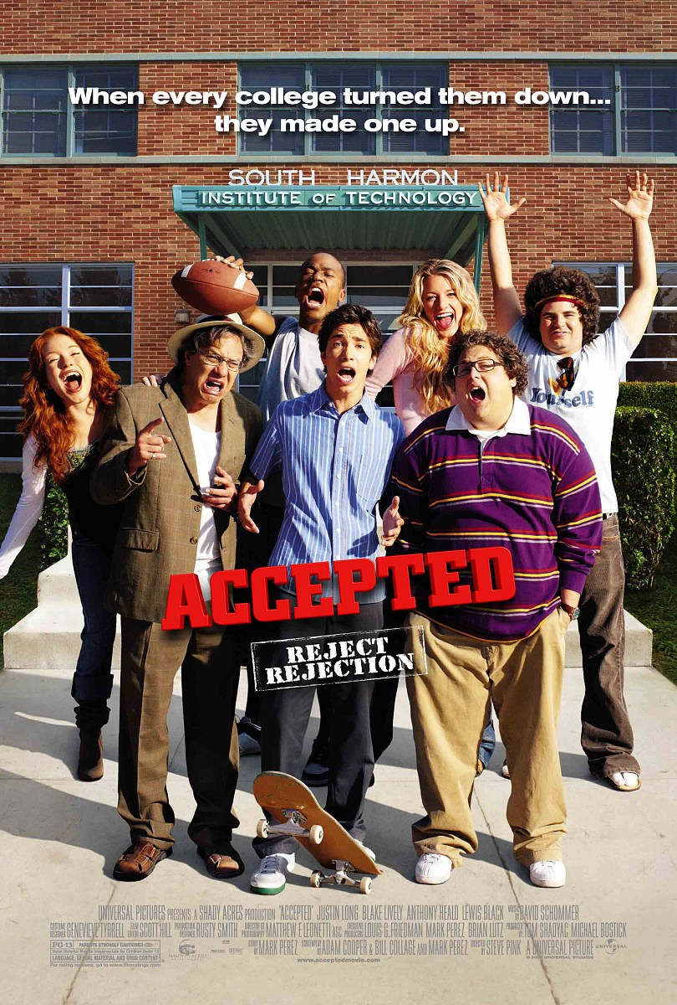


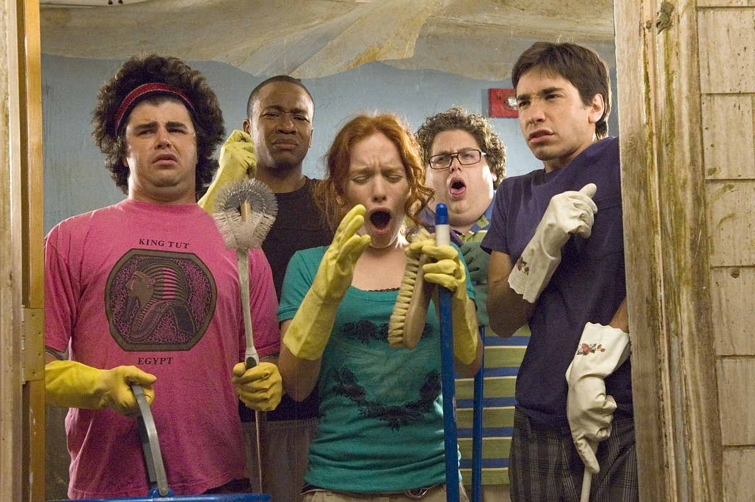

Q1. Did Bartleby get into any college ?
A:

Q2. What did his parents want Bartleby to do for his future?
A:

Q3. What college did Rory hope to go and how did she look like ?
A:

Q4. What did Bartleby attempt to do in order to persuade his parents ?
A:

Q5. Did his sister show Bartleby enthusiasm to help him ?
A:

Q6. If you are in such a situation what will you do ?
A:

- Group discussion worksheet

※ Discuss in groups what the next story in the film will be…….

Group # 1  a.  b.  c. | Group # 2  a.  b.  c.
Group # 3  a.  b.  c. | Group # 4  a.  b.  c.

