Lesson Plan Template – Presentation Practice Production Based
Listening Speaking Reading Grammar Writing
Topic: Laptops for the Classroom

Instructor:  Mjay | Level:  Intermediate | Students:  10 | Length:  50 Minutes

Materials:
- Reading article
- Enlarged picture of a student who is using a laptop
- White board, board markers
- Worksheets for true or false, skimming, scanning ,comprehension check and discussion

Aims:
- Ss will be familiar with key vocabulary through T’s explanation and CCQ
- Ss will be able to get the main idea by skimming the reading text and answering a guiding question
- Ss will improve scanning skill by answering true & false questions
- Ss will improve speaking and listening skills by sharing ideas with a group

Language Skills:
Reading : reading article about ‘laptops for the classroom / worksheets
Listening: listening to T’s presentation, explanation and other Ss ideas and opinions
Speaking: Prediction, Comparing answers within groups , Express opinions during discussion activity
Writing: answering worksheets(true or false, scanning and discussion)

Language Systems:
Lexis : workable / portable
Function : express the necessity of laptops in the classroom
Discourse : talk with Ss about laptop use in school

Assumptions:
Students already know:
- How the classroom is set up and run
- The teacher’s style of teaching and pace of the class
- All students have experience using computers
- Ss know how to skim and scan

Anticipated Errors and Solutions:
- Students may not be able to follow the passage easily
→ explain more words and context
- Students may not able to pick up details from the reading
→ give Ss more time to read
- If time is short
→cut post-activity discussion short
If students finish their tasks earlier that expected,
→ give them the supplementary worksheet

References:
- http://www.google.co.kr/ - for pictures
- Webster’s Dictionary
- Reading Insights – 2^{nd.} Edition

Lead-In
Materials: Board ,Board Marker, Picture 1
Time | Set Up | Procedure :  Greeting  Hello everyone. How was your weekend?  Eliciting  Can you look at the picture. What is the student doing? Do you have one? What are the advantages of such a device? Who might use this? How would they use it?  - Try to elicit the use of laptops in schools and universities.  Introduce today’s topic  Today, we will talk about “Laptops for the Classroom”
  People | How would they use it?
5min. | Whole Class

Pre-Activity
Materials: White Board & Markers
Time | Set Up | Procedure :  - Vocabulary  - Let’s learn vocabulary that will help you to read the text  Portable PC  - Presentation  (write ‘portable PC’ on the board)  When you go to school, you take your bag and books. Right?  Can you carry your bag? Yes, you can carry it. Can you carry your books? Yes, you can. Your bag and books are potable.  - Repeat after me. Portable PC.  - CCQ  - Are portable PCs home computers? Laptops? Think pads? Can you carry them around? Yes, they are portable.  Workable  - Presentation  (write ‘workable’ on the board)  You have a laptop, but it is not working properly. Is it possible to use it? No. it doesn’t work. It is not workable. You have a plan, but it didn’t go or work as you planned? Is the plan workable?  - CCQ  Do you have a goal? What is your goal? Do you think it is workable? You are going to Canada during the winter. Can you wear short pants? Is it workable?
5min. | Whole class  Whole Class

Main Activity
Materials: Reading article , White board & board marker, , Worksheets for true or false, skimming and scanning
Time | Set Up | Procedure :  - Guiding Questions  (write the question on the board)  What is the benefit of having the laptop in the classroom?  Instruction  What did I write? Let’s read the question together. Think about the answer as you read this article. I will give you 3 min. to read.  Read silently and individually.  CCQ  What will you read as you read?  Do you read with your partner?  How much time do you have?  (Distribute the article and run the task)  You may begin.  Feedback  Do you need more time?  (Yes → give extra 30 seconds / No → have Ss share their ideas)  What do you think about the question?  ( let all the Ss talk about their ideas about the question)  - Task A - Skimming(search for the main idea)  Instruction  Skim through the passage. Then read the statement saying Task B. Choose the one that is the correct main idea of the reading. You have 2 minute.  CCQ  What should you do?  How much time do you have?  Feedback  Do you need more time?  (Yes → give extra 30 seconds / No → check answers with Ss)  - Task B – Scanning(search for details)  Instruction  Scan through the passage. Work with a partner to fill in the flowchart below with the information from the reading. You have 4 minutes.  CCQ  What should you do?  Will you do it alone?  How much time do you have?  Feedback  Do you need more time?  (Yes → give extra 30 seconds / No → check answers with Ss)  - Task C  Instruction  You will have a worksheet. There are true or false questions. Check true or false, and if a statement is false, change the statement so that it is true. I will give you 3 min. to read and answer the questions. Find the line that supports your answer.  Demonstrate question #.1  CCQ  What should you do?  Will you put underline to support your answer?  Are you going to change the statement if it is false?  How much time do you have?  (Run Task)  Feedback  Do you need more time?  (Yes → give extra 30 seconds / No → check answers with Ss)
5min.  3min.  7min.  5min. | Whole Class  Whole Class  Whole Class  Whole Class

Post Activity
Materials: Worksheet for comprehension check and Discussion
Time | Set Up | Procedure :  - Brainstorming  Needless to say, we all have laptops. I will pair you up and talk about 3 benefits (or advantages) and disadvantages of having them in classroom. You have 4minutes.  (Distribute the worksheet to write down their opinions)  CCQ  Are you working in pairs?  How much time do you have?  Monitor actively and participate within each group.  Feedback  Do you need more time?  (Yes → give extra 30 seconds / No → discuss and share  opinions among Ss)  - Discussion  Instruction  We can easily find many Ss with laptop in a lecture hall. Do Ss really need that? If yes, why do you think so? If not, why do you think so? Discuss that with your partner and fill the blanks on a worksheet. You have 7 minutes.  (Distribute the worksheet to write down their opinions)  CCQ  Are you working in pairs?  How much time do you have?  Monitor actively and participate within each group.  Feedback  Do you need more time?  (Yes → give extra 30 seconds / No → discuss and share  opinions among Ss)  Homework  Summarize the reading article. It should be more than 5 sentences.  - Closing  Today, we learned the e-trend in a campus. I think you better get ready for cutting-edge technology for yourself.  Good job today!! See you guys on Wednesday!!!
  Needed | Not needed
  Because ~ | Because~
18min.  13min. | Whole class  & Groups  Groups

Picture 1


Task 1

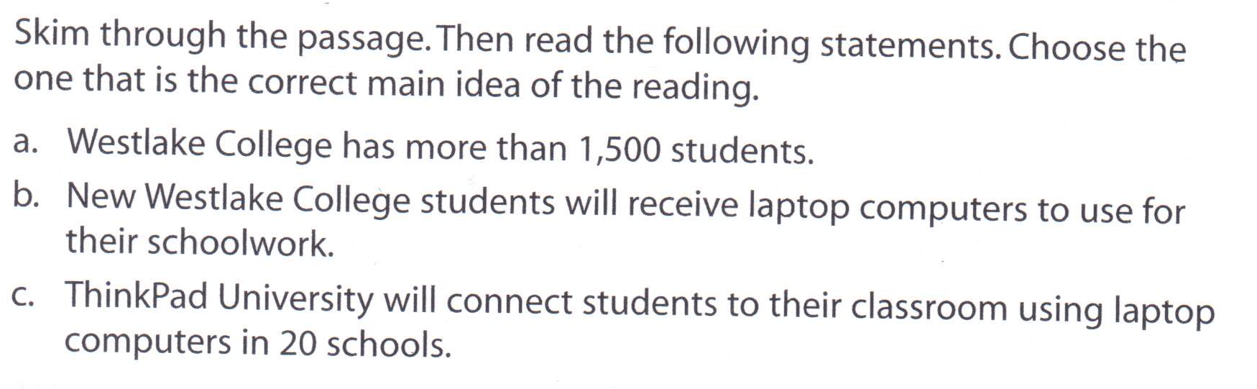

Task B
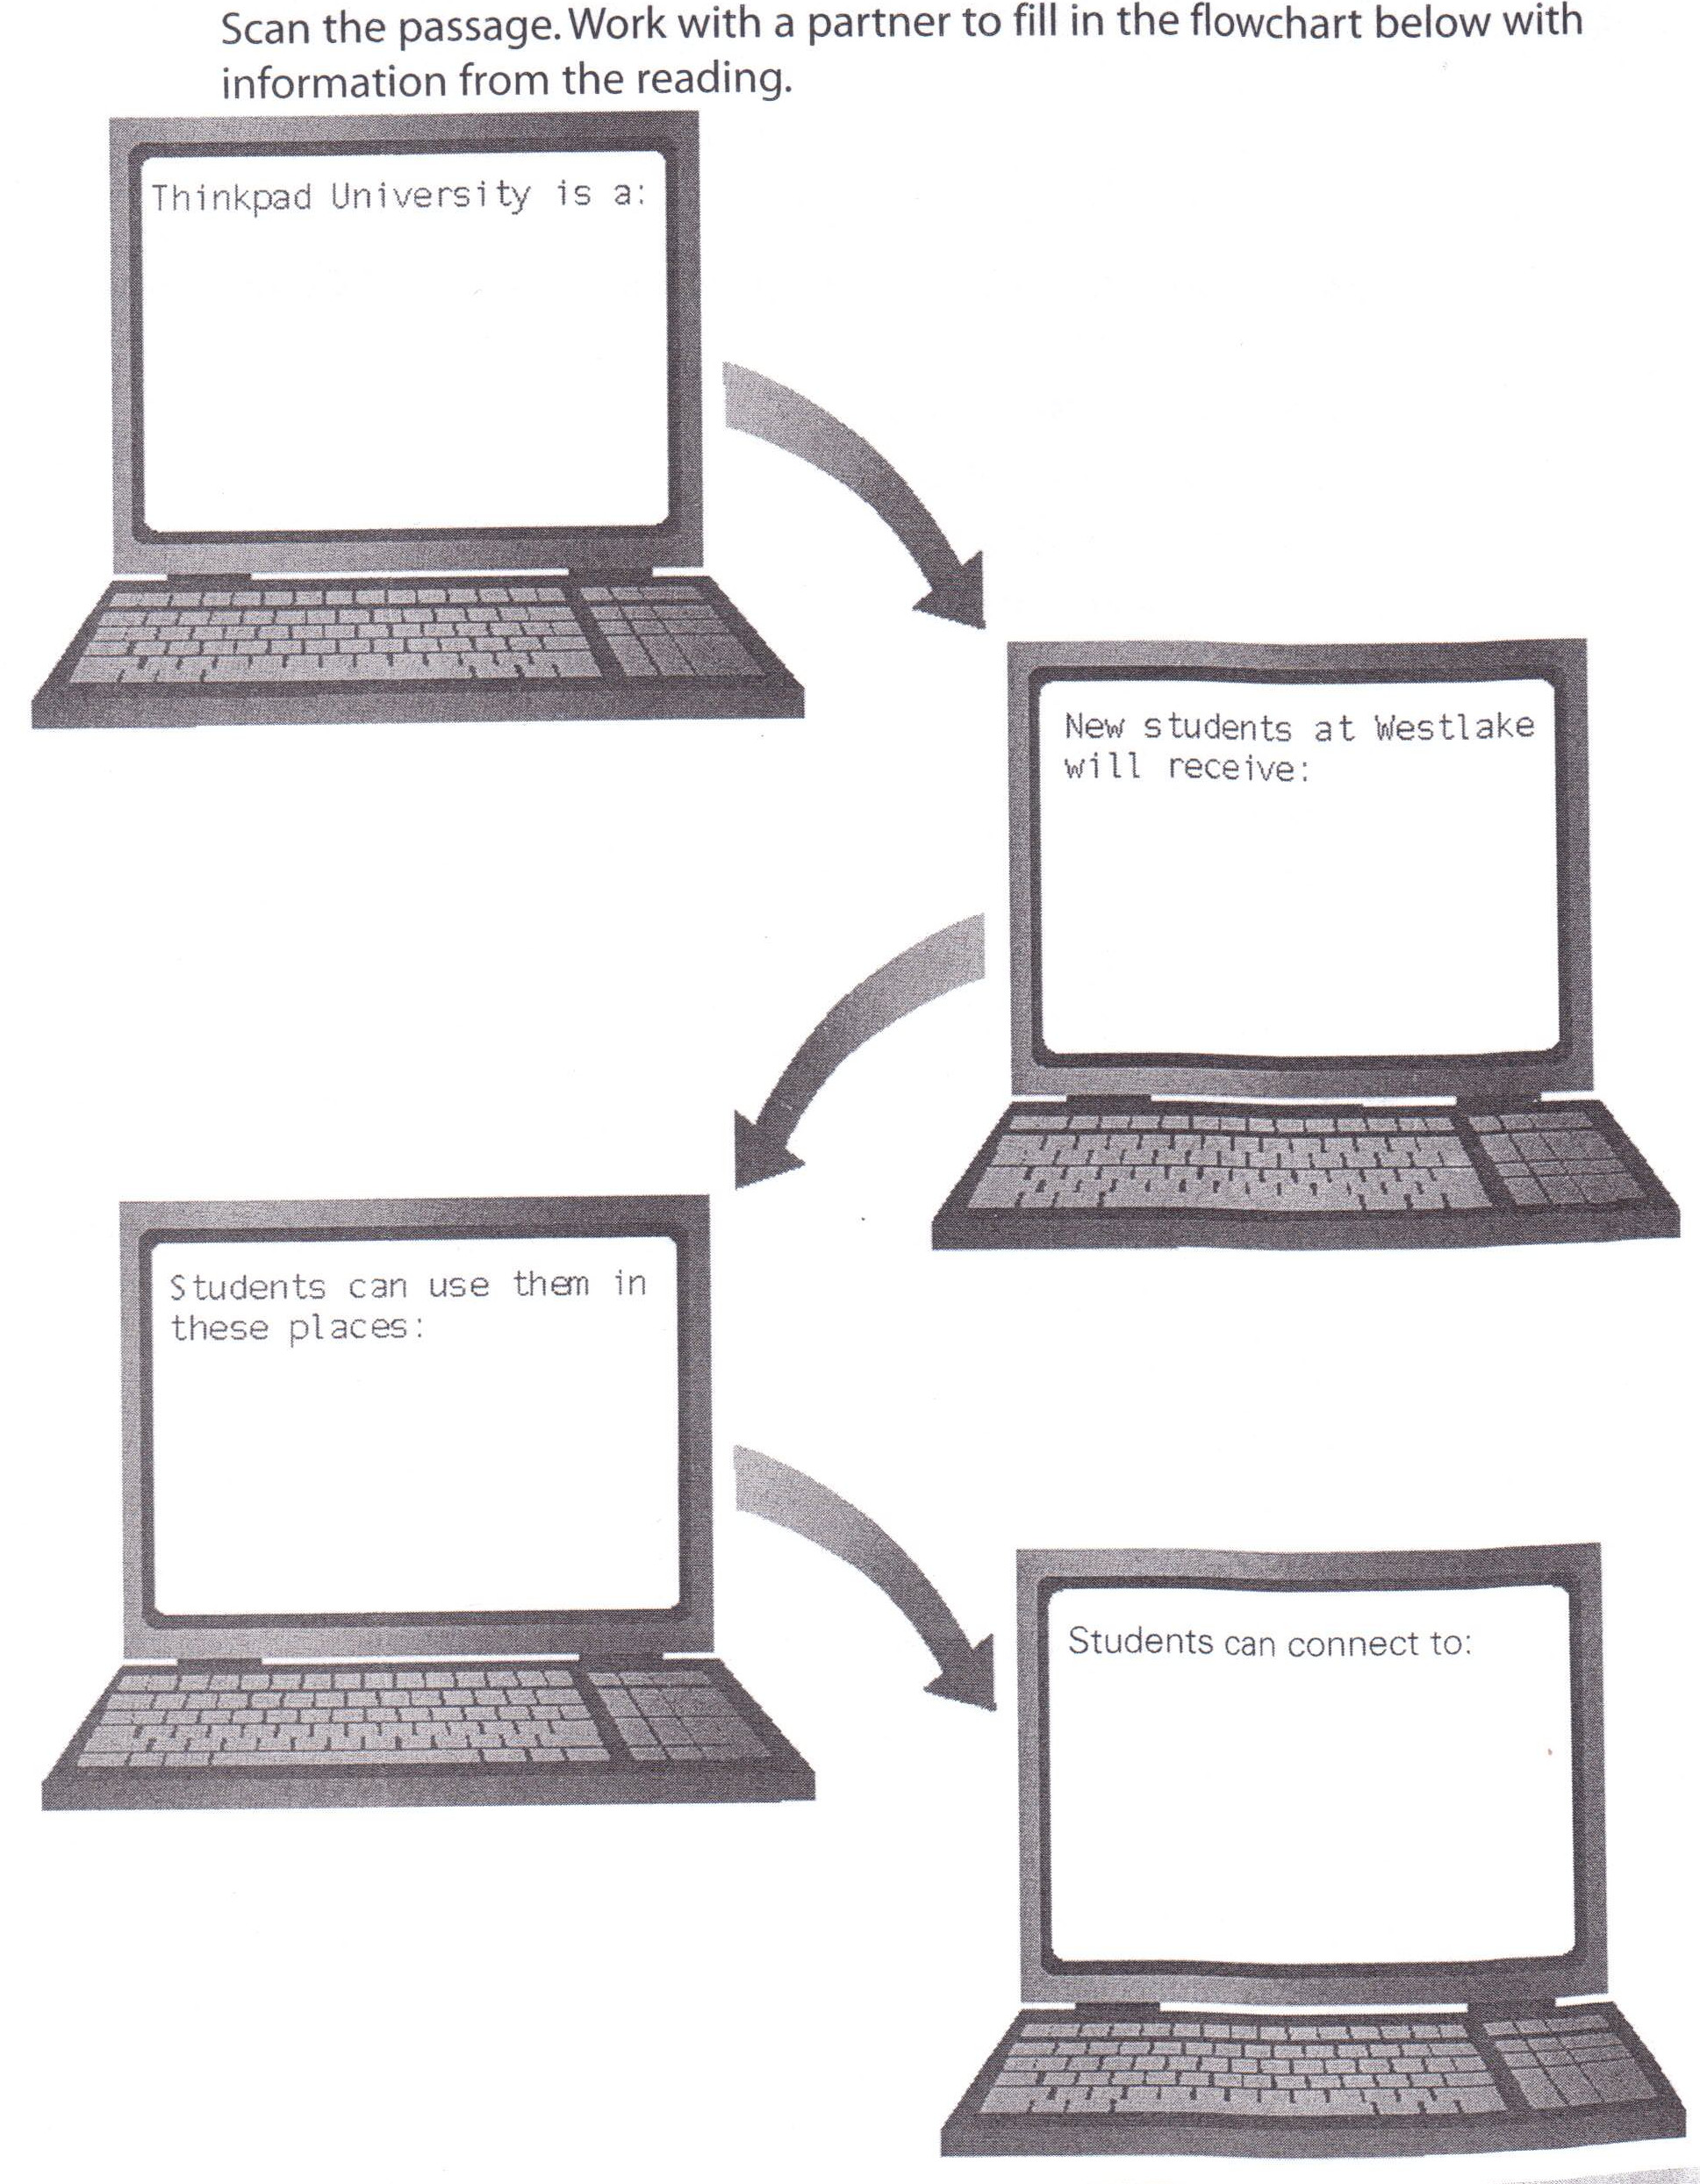

Reading Article
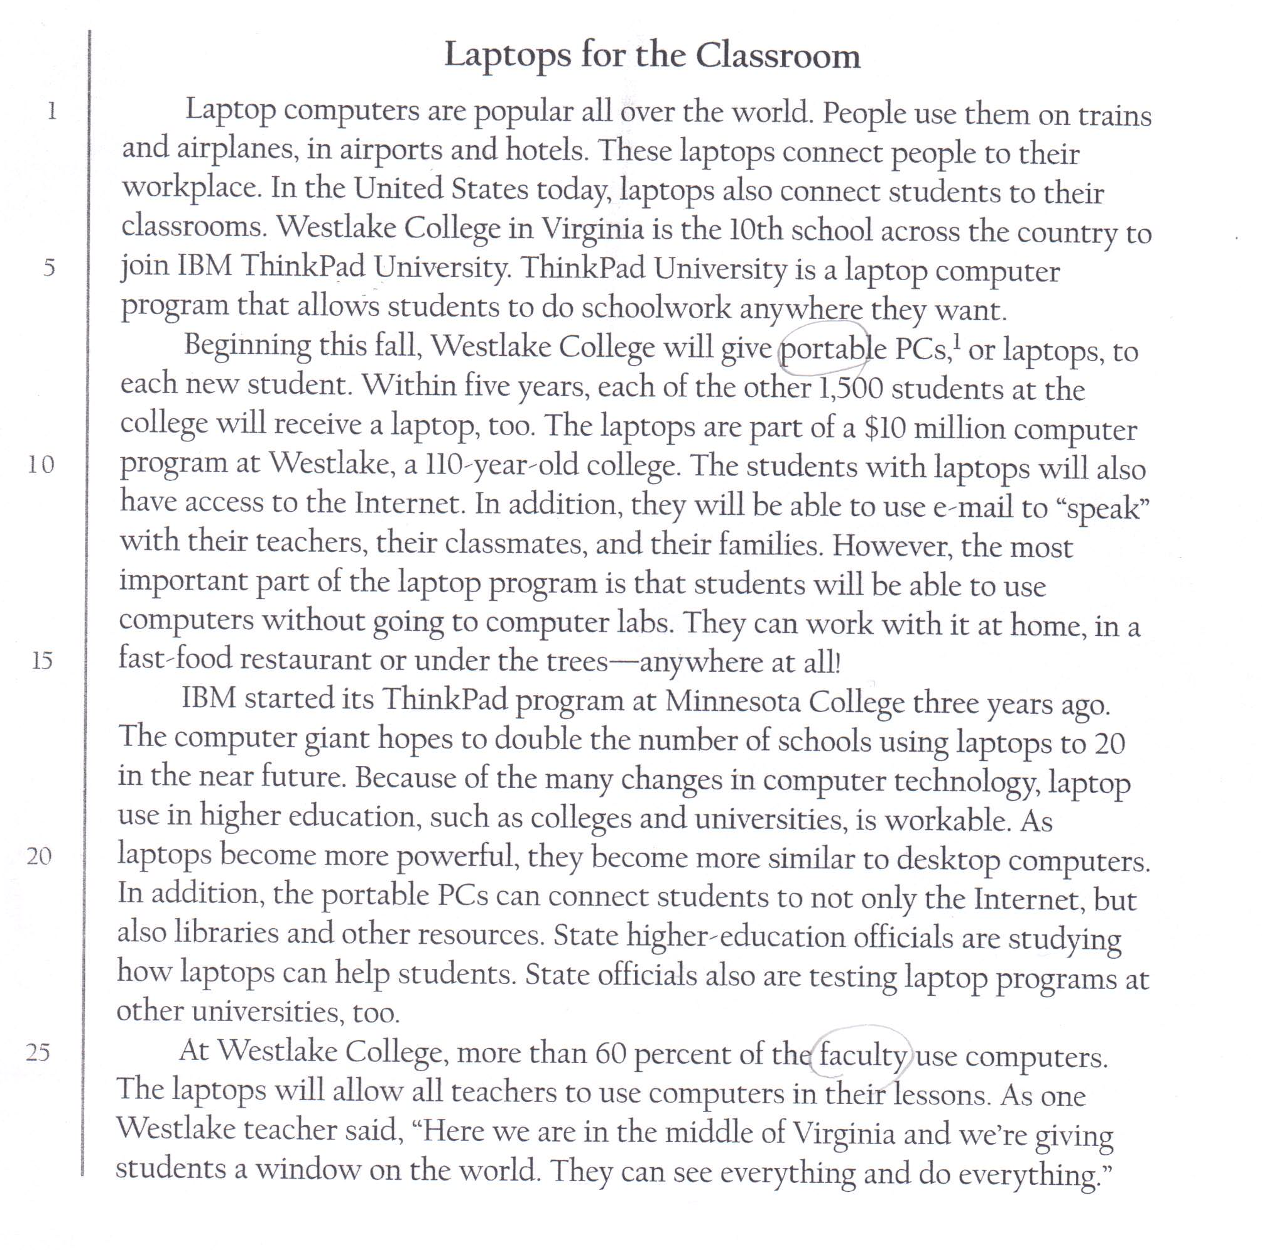

Task C
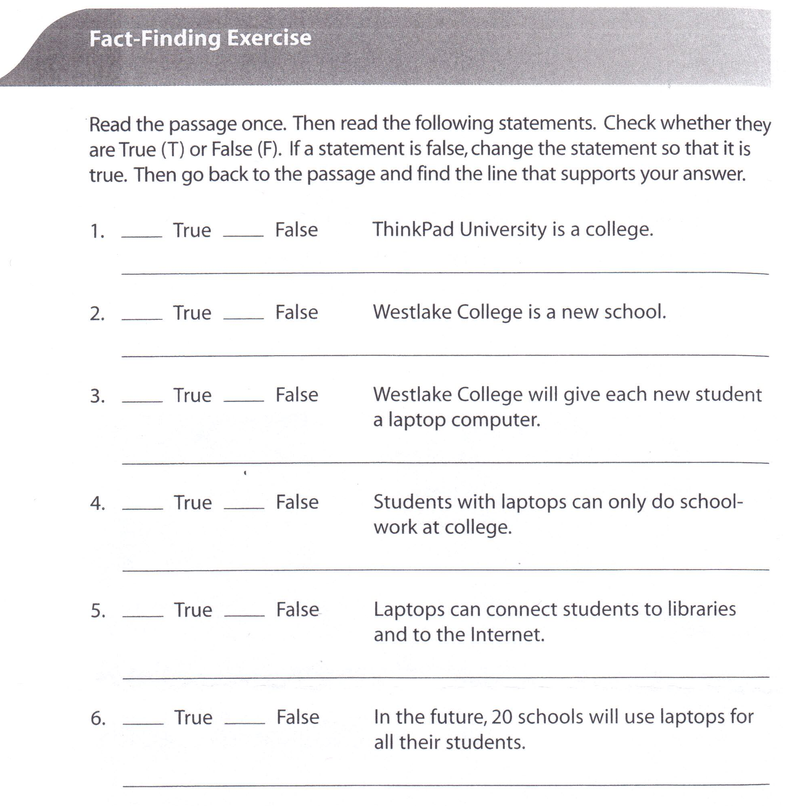

Brainstorming
Benefits | Disadvantages

Discussion
Needed | Not needed
Because ~ | Because~

