Grammar Lesson Plan

Used to / Be used to
Instructor:  Hyongmin Kim  (Claire) |  | Level:  Intermediate |  | Students:  14 |  | Length:  20 minutes

Materials:

- Classroom equipment: Whiteboard, board markers, board erasers, laptop, speakers, projector, screen
- Materials:
a. Presentation slides for grammar teaching (Sample sentences & Test sentences)
b. Worksheet #1 & #2 for main activity: 15 copies (14 copies for Ss + 1 copy for Claire)

Aims:
- Main aim: To develop Ss’ grammar skill by learning confusable idioms “used to” and “be used to”
-Secondary aim: To help Ss distinguish different usage of two idioms by listening to the conversation.
-Personal aim: I want to move back and forth to use both board and screen to reduce my boarding time and make the lesson more productive.

Language Skills:

- Listening: Ss will listen to the teacher’s instructions and recorded conversation to fill out the dialogue
- Speaking: Ss will answer questions, read the sample sentences
- Reading: Ss will read worksheet #1 and screen
- Writing: Ss will check the right answer on the worksheet #2.

Language Systems:

- Lexis: Learn words used in the worksheet. - mummify
- Phonology: Learn different sound of “used to” and “be used to” from the dialogue.
- Grammar: Used to / Be used to
- Function: Learn several usages of “use”
- Discourse: Discussion for group activity

Assumptions:

- All Ss are well aware of the past tense and present.
- All Ss have common experiences to attend the TESOL course.
- Ss have good listening skill to figure out the meaning of the dialogue.

Anticipated Errors and Solutions:

Anticipated Errors | Solutions
1. Ss might not know some lexical words related to today’s lesson. | 1. Teacher will elicit the meaning of the words from students and give explanation
2. Ss might still confuse about proper usage of 2 idioms after the pre-teach. | 2. Teacher will drill Ss by practicing with several sentences.
3. Activities might go longer than expected. | 4. Teacher will ask Ss to do homework for the 2nd worksheet and check it at the next lesson.
5. Activities might end earlier than expected | 5. Teacher will show some websites where Ss can practice themselves after the lesson.

References:

- http://www.eslbase.com/grammar/used-to
- http://www.myenglishpages.com/site_php_files/grammar-lesson-used-to.php
- http://www.englishpage.com/verbpage/usedto.html
- http://www.envid.com
- Book “Boost! Grammar #3” by Jason Renshaw
- http://www.englishclub.com/grammar/verbs-m_used_quiz.htm
- http://www.learn-english-today.com/lessons/lesson_contents/used-to_to-be-used-to_ex..htm
- http://www.englishgrammarsecrets.com/usedto/menu.php

Stage: Lead-In
Materials:
Time | Set Up | Procedure
2 min | Whole Class | <Greeting & Warm up>  Hello everyone, How are you today? (Ss answer)  It has been over a month since we meet in this class to study Tesol. That means… we only have 3 weeks to go to be released!  What did you usually do during the weekend before you start the Tesol course? (Ss Answer)  I can see you sacrificed a lot to take this class. But we already have studied Tesol more than a month. So I’m sure now you are all familiar with this situation meeting our classmates and studying during the weekend. Right?  Well, then… let me sum up our conversation like this.  [Turn on the monitor]  Can you read?  I used to go out with my friends during the weekend.  go camping  climb mountains  But now I’m used to studying Tesol during the weekend.  Can you guess what today’s lesson topic is?  Yes, it’s used to / be used to.

Pre-Activity
Materials:
Time | Stage | Procedure:
1.5min  1.5min  2 min | Pre-teach  Meaning  Structure  Whole Class | Grammar  - S + used to + Verb base  - S + be used to + Noun or Verb~ing (Gerund)  [Write on the board]  I used to (past)  I’m used to (not new or not strange)  They look similar but they have different meaning and different structure. So let’s find out the meaning first.  When I say I used to do something. It’s the past. It means some regular actions or states in the past. But not any more.  When I say, I’m used to doing something. Actually it means, it’s not new or not strange to me.  For example, As you said earlier,  I used to go out with my friends during the weekend.  That means, In the past, you usually met your friends during the weekend. But what do you still meet friends during weekend? (CCQ)  Not any more.  And you can say,  Now I’m used to studying Tesol during the weekend.  Does it mean that studying during the weekend is new or strange? (CCQ) It means that you are already familiar with this situation.  Now let’s look at the structure and then we can figure out how we can use it properly. Let’s start up with the first one.  I used to (past)  As you can see on the end, we got “to” so we are going to make this in infinitive form.  It is Subject + used to + Verb base (infinitive form)  When I’m saying this. It means,  In the past I regularly did something but not any more.  If you are still doing it, you cannot use this form because it only can be used for past sentence.  Let’s make a sample sentence.  I used to wear skinny pants.  This means, in the past I wore skinny pants, but not any more because I’m fat now.  And let’s tweak it a bit,  I’m used to wearing skinny pants.  This is not the past any more. It’s just something not new or strange to me.  And we gotta change it in continuous form.  It is Subject + be + used to + Ving or Noun  It is not new or strange for me.  CCQ  What do we call this form Verb+ing? It’s gerend  So let’s practice some sentences together.  [Showing the sample sentences on the screen.]  CCQ  I say, “I used to listen to music with a walker-man.”  “Do I still use a walker-man?” (Ss answer No.)  I say, “I am not used to teaching English yet.”  “Am I talking about my past habit?” (Ss answer No.)
Main Activity
Materials:
Time | Stage | Procedure:
1 min  3 min  2 min  0.5min  1.5min  1.5min | Instruction  Listening  STT  Whole Class  Instruction  Reading  STT | Now I want you work in pairs for our main activity. (Make 7 teams 2 each) We are going to listen to a conversation. From the conversation you will find how the “use” can be used in several forms. And you need to complete the dialogue. And also find the truth and false in 1 minute.  [Distribute worksheet #1]  ICQs  What are we doing?  Are we working individually?  [Play the mp3. Listen to the conversation]  You want to listen to the conversation one more?  - Ss say Yes → Play again.  - Ss say No → Check the answer with Ss.  Can we read the sentence?  Good job! Let’s compete again at the next stage.  [Elicit]  mummify  [Distribute worksheet #2]  Now we are going to find the grammatical mistakes and correct it. I will give you 1min 30sec.  ICQs  How many minutes do we have?  Ss read the worksheet.  We have 20 seconds left. “Time is up!”  “How many errors did you find?”  Ok, let’s find it. (Ask Ss to read the email.)

Post activity
Materials:
Time | Stage | Procedure:
3 min  0.5min | Whole Class  STT  Closing  comment | Ok. Let’s work individual to check if we all understand the usage of used to and be used to properly.  [Share the screen with the test page.]  Any questions or feedbacks?  Now are you used to using “Used to” and “Be used to”?  “Good job, everyone. Let’s call it a day! Have a good one and see you next week!”
Worksheet #1.
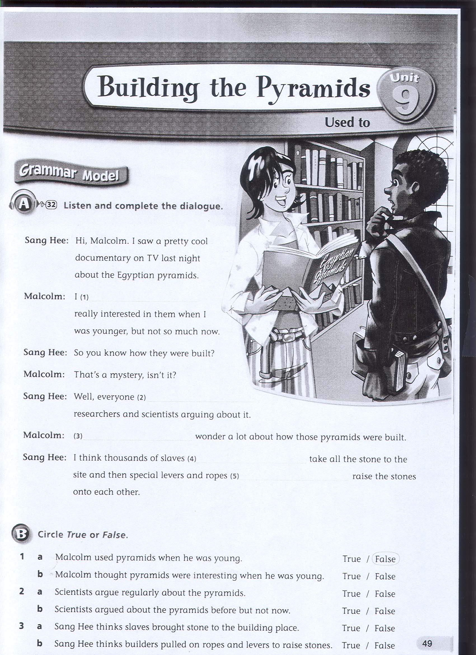
Worksheet #2.


