Listening Speaking Reading Grammar Writing

Topic: How to make Cupcake Cone?

Instructor:  Raina | Level:  High-Intermediate | Students:  10 Adult Students | Length:  50 Minutes

Materials:
- Listening CD(Chapter 10; 70 sec) and CD player
- Picture of Cupcake, cupcake cone, dollop, frosting, spatula, sprinkle(1 copy each)
- Picture Worksheets(12 copies)
- Fill-in-the blank Worksheets(12 copies)
- Tongue Twisters (12 copies)
- Board, board markers & tape

Aims:
- Main aim : To enable Ss improve their listening comprehension about spoken instructions by listening to “Making Cupcake Cone”
- Secondary aim : Ss practice understanding instructions in order by lining up pictures.
- Personal aim : I want to have more confidence.
I want to have more ideas to elicit words.

Language Skills:
- Listening : Ss will listen to recording, teacher’s instructions and their classmates’ speaking.
- Speaking : Ss will answer questions, discuss with their partners and describe pictures.
- Reading : Ss will read worksheets and vocabularies on a board.
- Writing : Ss will write down new vocabularies and take dictation.

Language Systems:
- Phonology: Linking sound. ex) fill it [filit]
- Lexis: Words used in making Cupcake cone
- Grammar: None to discuss
- Function: Understand instruction in order.
- Discourse: Teacher-student interact, Student-student interact

Assumptions:
- Students know Cupcake but don’t know Cupcake Cone.
- Students don’t know how to make Cupcake cone.
- Students know vocabularies related to taste.
- Students are interested in cooking.

Anticipated Errors and Solutions:
Students may not be able to answer the eliciting questions.
---> Give hints of spelling, Play jumbled word
CD or CD player may not be able to use.
---> Lead the script by a teacher
Students may not be able to divided into pairs.
---> one group will have 3 members.
Students may feel difficulty of dictation
---> Show written samples and make students chose one of them.
There is more time than expected
---> Practice tongue twist

References:
Hee-jin Kim, All Ears(2010), Saram In

Lead-In
Materials: Picture of Cupcake, Cupcake Cone & tape
Time | Set Up | Student Activity | Teacher Talk
3 min | Whole class | Ss will respond to T and  grasp today’s lesson topic. | Good morning, everyone.  Did you have enough breakfast today?  Today’s topic would make you hungry.  (Show picture of Cupcake.)  Do you know what this is?  (Show picture of Cupcake cone.)  Then, can you guess what this is?  This is Cupcake Cone and we will learn how to make this.

Pre-Activity
Materials: Picture of dollop, frosting, spatula, sprinkle & tape
Time | Set Up | Student Activity | Teacher Talk
12 min | Whole Class | Ss will think and guess.  Ss will speak some vocabularies they know.  Ss will think and guess.  Ss will see the picture and read spelling .  Ss will answer Y/N.  Ss will think and guess.  Ss will see the picture and read spelling .  Ss will answer Y/N.  Ss will think and guess.  Ss will see the picture and read spelling .  Ss will answer Y/N.  Ss will think and guess.  Ss will see the picture and read spelling .  Ss will answer Y/N. | Vocabulary  Instruction  What ingredients need to make Cupcake cone?  When you scoop a spoon of cream, how do we call it?  (Show picture of “dollop” and write spelling on a board)  CCQ  Is ‘ a dollop of cream’ a huge amount?  Is ‘dollop’ for soft and sticky food?  When you make a cake, what can we do with a dollop of cream?  (Show picture of “frosting” and write spelling on a board)  CCQ  Is ‘frosting’ covering and decorating cake?  Is ‘frosting’ salty and hot?  What appliance we need for frosting?  (Show picture of “spatula” and write spelling on a board)  CCQ  Do you see a spatula in a bathroom?  Is spatula for cooking?  On the top of the cupcake is decorated by what?  (Show picture of “sprinkle” and write spelling on a board)  CCQ  Is ‘sprinkle’ light and soft motion?  Do you sprinkle stones to sky?  Do you have any question so far?

Main Activity
Materials: CD, CD player, Board, 5 board markers, Picture Worksheet, Candies
Time | Set Up | Student Activity | Teacher Talk
3 min  10 min  8 min | Whole class  Groups  Groups | Ss will listen to recording.  Ss will look at the worksheet.  Ss will seat in pair.  Ss will answer the question.  Ss will listen to recording.  Ss will discuss with a partner.  Ss will listen to recording.  Ss will discuss with a partner.  Ss will write on a board and back to seat.  Ss will look at the pictures.  Ss will speak about a picture to class. | 1. Listening to the recording  Instructions  You will listen to recorded instructions. Close your eyes and imagine the scene of instructions.  (Play track 10 once)  What kind of sweets did you hear from the record?  (Distribute the worksheet)  Instructions  Find your partner who seat next of you. There are 6 pictures on the sheet.  You will listen to the recording twice. Line up the pictures according to the order. After each listening I will give you time to discuss with your partner.  ICQ  Are you working individually?  How many times you would listen to?  (Play track 10 once)  Give 2 min and monitoring  (Play track 10 once)  Give 1 min and monitoring  Time warning 15 sec left  Let Ss come out to a board and write their answer.  Check the right answer.  Give candies to all students  2. Describing pictures  Instruction  Each group will describe one picture in the right order. I will start first.  Demonstration  Picture ‘D’ is the first step, there are candies in a cone. Group 1. would you explain the picture for next step?

Post Activity
Materials: CD, CD player, Board, 5 board markers, Fill-in-the blank Worksheet
Time | Set Up | Student Activity | Teacher Talk
12 min  3 min | Whole Class  Whole  Class | Ss will read the worksheet.  Ss will listen to recording.  Ss will take dictation.  Ss will write down on a board and back to seat.  Ss will look at a board.  Ss will listen to recording.  Ss will answer and recall today’s class. | 1. Listening for details  (Distribute the worksheet)  Instruction  Now listen to recording again and fill in the blank. You will listen to the record twice . Second time you will listen to the sentences one by one.  (Play track 10 once without stop)  (Play track 10 and stop for each sentence.)  Do you want to listen again?  Yes → Have them listen one more  No → Let Ss come out to a board and write their answer.  Check the right answer and correct error  (Play track 10 once.)  2. Conclude lesson  Can you make Cupcake Cone by yourself?  For frosting what appliance do you need?  What is the last step of making Cupcake cone?
SOS Activities
Materials: Tongue twister worksheet
Time | Set Up | Student Activity | Teacher Talk
10 min | Whole Class  Individually | Ss will read and practice Tongue Twister | Tongue twister  Instruction  Do you enjoy buttered bread?  Let’s practice “B” sound from tongue twister.  (Distribute the worksheet)  Let Ss read and practice the worksheet.  Demonstrate myself to Ss.  Let Ss read individually to class and correct error.

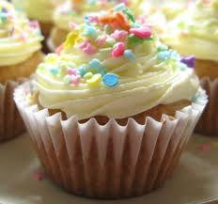
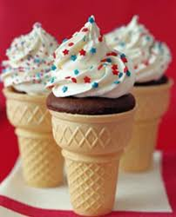

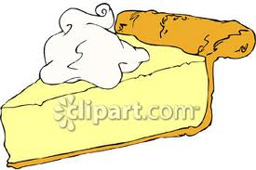
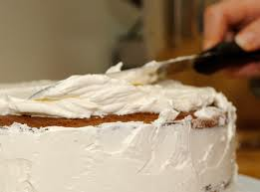

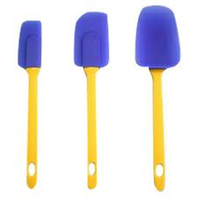

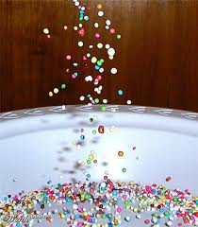
<Recorded Script> 70 sec
I’m going to take my cone and fill it with candy. Just about halfway. So now, remove the cupcake liner. Take a dollop of frosting, and place it on top and spread it evenly. Then, invert the cupcake into the cone. Place another dollop of frosting on top of this cupcake. Then, take a mini cupcake and invert it right on top.
Now, it’s time to frost our ice cream cone. We want it to look like a soft-serve cone. I’m just going to cover the entire surface with frosting. I hold the cone in my hand, I think that’s the easiest way. And once we have it all covered, we’ll give it a little texture to imitate the soft-serve look. So to do that, I’m just going to run my spatula around. The final touch? Sprinkles. And there you have your cupcake cone!
<Picture Worksheet>
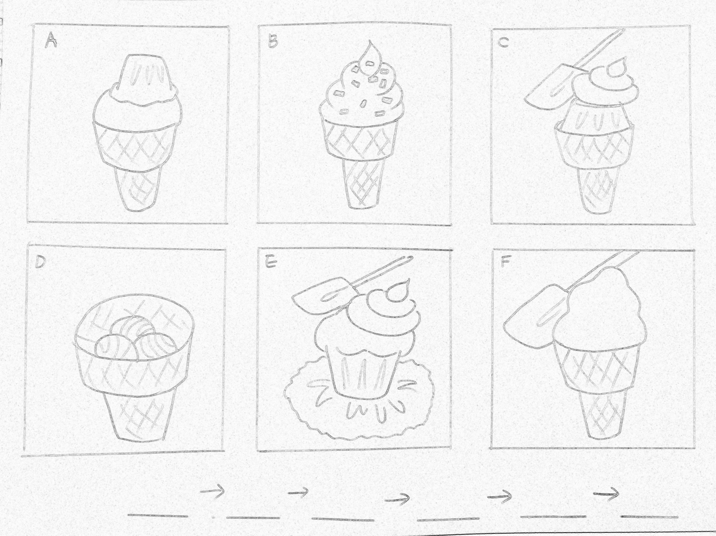
Answer : D → E → C → A → F → B
<Fill-in-the blank Worksheet>

I’m going to take my cone and 1._________________. Just about halfway. So now, remove the cupcake liner. Take a dollop of frosting, and place it on top and 2._________________. Then, invert the cupcake into the cone. Place another dollop of frosting on top of this cupcake. Then, take a mini cupcake and 3.________________ on top.
Now, it’s time to frost our ice cream cone. We want it to look like 4._____________ _____. I’m just going to cover the entire surface 5._____________. I hold the cone in my hand, I think that’s the easiest way. And once we have it all covered, we’ll 6.__________________ to imitate the soft-serve look. So to do that, I’m just going to run my spatula around. The final touch? Sprinkles. And there you have your cupcake cone!

<Tongue Twister>

Betty Botter bought a bit of butter. “But,” she said,
“This butter’s bitter! If I put it in my batter, it will make my batter bitter!”
So she bought a bit of butter better than her bitter butter,
and she put it in her batter, and her better was not bitter.
So it was better Betty Botter bought a bit of better butter.

