Name: Seung Hun Kim Date: 8/13/11 Length of lesson: 20/30/ 40/ 50

Topic or Title: Health & Nutrition
Class Profile: There are 10 advanced level adult English learners. Mixed ages.  L1 language is Korean. | Lesson Fit: This is the Reading lesson which students will improve their reading skills by exercising activities and learning new vocabularies.
Materials: Board, markers, worksheets, photos.

Main Aim: To enable Ss to read and learn new knowledge about nutrition and health through the activities.

Secondary Aims: To enable students to learn new vocabularies and to use in daily life through the activities.

Personal Aims: I want to reduce TTT and I will have louder voice for students’ clear understanding of lesson.

Anticipated Problems:  Students may have hard time to understand meanings of new vocabularies.  Students may have hard time to fill in the worksheets.  Activities may take longer time than I expected.  Language Skills:  - Listening: Ss will listen to the teacher’s instruction and classmates speaking.  - Speaking: Ss will share their recipe with classmates.  - Reading: Ss will read worksheet and explanation.  -Writing: Ss will take notes while doing post-activity.  Language Systems:  - Phonology: None to discuss  - Lexis: nutrients, malnutrition, immunity, etc.  - Grammar: None to discuss  - Function: None to discuss  -Discourse: None to discuss | Solutions:  Teacher will elicit and explain the words’ meaning and demonstrate how to use the words.  Teacher will make students to work in pairs for doing worksheet activity.  Teacher will manage time flexibly depends on the students’ demanding.  Assumptions:  - Ss already have basic knowledge of nutrition and health.  - Ss may not have any recipe (Then, just sharing partner’s one).

References
http://www.rd411.com/index.php?option=com_content&view=article&id=1171:crossword-puzzle-basic-nutrition&catid=97:healthful-eating&Itemid=391
Time  Interaction  1 Min  T-Whole Class  or T-WC  1 Min  T-WC  1 min  T-WC  4 min  T-WC  1 min  T-WC  12 Min  T-WC  2 Min  1 Min  3 Min  3 Min  1 Min | Stage  Lead-in  (Pre-Activity)  Pre-teach  Controlled Practice  Controlled Practice  (Main-Activity)  Controlled Practice  Controlled Practice  Controlled Practice  (Post-Task)  Clarification  Controlled Practice  Feedback | Objective  Ss will feel relaxing and induce interesting about the topic  Eliciting the topic to introduce to the class.  Explaining new words related to the nutrition and health.  Exercising activity of matching photos to the nutrients.  Teacher will correct errors on the worksheet.  Ss will answer on the crossword puzzle worksheet.  Ss will write their answers on the board  Teacher will correct errors on the worksheet.  Ss will practice making sentences using new words related to the nutrition and health.  Ss will share their recipes.  Teacher will provide feedback | Procedure  Seung greets everyone. Hello, how are you doing today?  Seung will lead Ss to the topic by asking some questions. (e.g. What did you eat for dinner?  Is anyone on diet? etc.)  Seung will elicit the topic and introduce it to the class. (CCQ’s: Does chocolate have vitamins?)  Seung will explain new words related to the nutrition and health.  (e.g. nutrients, malnutrition, immunity)  Seung will pass out worksheet for easy understanding of what foods contain nutrients. Ss will work individually.  (ICQ’s: Do you work in group? = No)  Seung will correct errors on the worksheet.  (e.g. Explain differences bet. Carbohydrate and glucose)  Seung will give worksheet and Ss will answer on the worksheet. Ss will work in pairs.  (ICQ’s: Do you work in group? = No)  Ss will write their answers on the board to share with classmates.  Seung will correct errors on the worksheet.  Ss will share their best recipe using words of nutrition and health with partner.  (ICQ’s: How many minutes do you have? = 3 min.)  Ss will present partner’s recipe with the classmates.  Seung will provide any error correction and/or feedback. Seung will give homework to Ss and ask the class “Do you have any questions about today’s lesson? If there are no further questions, this concludes my presentation. I’ll be followed by ____.”  End of lesson.

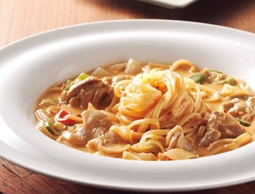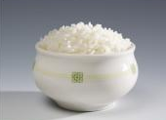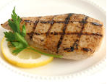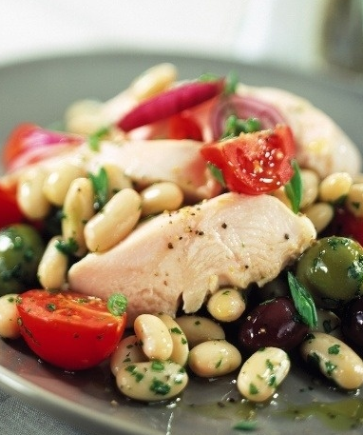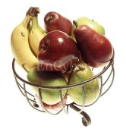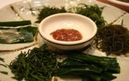
Nutrients
Carbohydrate
Glucose
Protein
Vitamins
Fiber
WORKSHEET

Nutrients
Carbohydrate
Glucose
Protein
Vitamins
Fiber
ANSWER SHEET

Crossword Puzzle: Basic Nutrition

Test your knowledge of basic nutrition principles with this crossword puzzle.

 |  |  |  |  |  |  | ¹ |  |  |  |  |  | ⁹
 |  |  |  |  |  |  |  | ² |  |  |  |  |  |  |  |  |  | ¹⁰
 |  |  |  |  | ¹³ |  |  |  |  |  |  |  | ³
 | ¹¹
 |  |  | ¹² |  |  |  |  |  |  |  |  |  |  |  | ¹⁶
 |  |  |  |  |  |  |  | ¹⁴ |  |  | ¹⁵
 |  |  |  |  |  |  |  |  |  |  | ⁴
⁵ |  | ¹⁷
 |  |  |  |  |  |  |  |  |  |  |  |  | ¹⁸
 |  |  |  |  |  |  | ⁶
 |  |  |  |  |  |  |  |  |  |  |  |  |  |  | ¹⁹
 |  |  |  |  |  |  | ⁷
 |  |  |  |  |  |  |  |  |  |  | ⁸
²⁰

ACROSS
- Units by which energy is measured
- The physiological drive for food
- The body’s ability to recognize and eliminate foreign invaders, such as bacteria
- Altered glucose regulation and utilization
- Higher than normal blood pressure
- Providing enough—but not too much—of a substance
- Sometimes known as “blood sugar”
- The characteristics that enable to body to perform physical activity
20. It means any food that is particularly rich in the complex “_______” starch (such as cereals, bread, and pasta) or simple “_______”, such as sugar

DOWN
5. Sudden tissue death caused by blockages of vessels that feed the heart
- The addition to a food of nutrients that were lost during processing
- Organic, essential nutrients required in small amounts by the body for health
- Providing all of the essential nutrients, fiber, and energy in amounts sufficient to maintain health
- Providing foods of a number of types in proportion to each other
- Condition caused by excess or deficient food energy or nutrient intake, or by an imbalance of nutrients
- Food is broken down into absorbable units
- Physically inactive
- Eating a wide selection of foods within and among the major food groups
- Found in meat, poultry, fish, eggs, milk, nuts, and seeds
- Chemical substances obtained from food and used in the body
- A form of carbohydrate found in plant foods that is not digested by the human digestive enzymes

Word bank

Adequacy | Fitness | Moderation
Balance | Glucose | Nutrients
Calories | Heart attack | Protein
Diabetes | Hunger | Sedentary
Digestion | Hypertension | Variety
Enriched | Immunity | Vitamins
Fiber | Malnutrition | Carbohydrate

Answer key

 |  |  |  |  |  |  | ¹C | A | L | O | R | I | ⁹ E | S
 |  |  |  |  |  |  |  |  |  |  |  |  | N
 |  |  |  |  |  |  |  | ²H | U | N | G | E | R |  |  |  |  | ¹⁰ V
 |  |  |  |  | ¹³M |  |  |  |  |  |  |  | ³ I | M | M | U | N | I | T | Y
 | ¹¹A |  |  |  | A |  |  |  |  |  |  |  | C |  |  |  |  | T
 | D |  | ¹² B |  | L |  |  |  |  |  |  |  | H |  | ¹⁶V |  |  | A
 | E |  | A |  | N |  |  |  |  |  |  |  | E |  | A |  |  | M
 | Q |  | L |  | U |  |  | ¹⁴ D |  |  | ¹⁵ S |  | D |  | R |  |  | I
 | U |  | A |  | T |  |  | I |  |  | E |  |  |  | I |  |  | N
 | A |  | N |  | R |  |  | G |  |  | ⁴D | I | A | B | E | T | E | S
 | C |  | C |  | I |  |  | E |  |  | E |  |  |  | T
⁵H | Y | ¹⁷ P | E | R | T | E | N | S | I | O | N |  |  |  | Y
E |  | R |  |  | I |  |  | T |  |  | T |  | ¹⁸N
A |  | O |  |  | O |  |  | I |  |  | A |  | U
R |  | T |  |  | N |  | ⁶M | O | D | E | R | A | T | I | O | N
T |  | E |  |  |  |  |  | N |  |  | Y |  | R
 |  | I |  |  |  |  |  |  |  |  |  |  | I |  | ¹⁹ F
A |  | N |  |  |  |  | ⁷G | L | U | C | O | S | E |  | I
T |  |  |  |  |  |  |  |  |  |  |  |  | N |  | B
T |  |  |  |  |  |  |  |  |  |  | ⁸F | I | T | N | E | S | S
A |  |  |  |  |  |  |  |  |  |  |  |  | S |  | R
²⁰C | A | R | B | O | H | Y | D | R | A | T | E
K

