Listening Speaking Reading Grammar Writing

Topic: Let’s make our own icecream!

Instructor:  Yuri Jeong(Yuri) | Level:  Advanced | Students:  12 | Length:  30 Minutes

Materials:
Whiteboard, markers, 3 wall charts, my own wall chart, color pens, and
13 worksheets #1

Aims:
1. Main aim- To enable students to improve their speaking skills by giving a presentation on making icecream.
2. Secondary aim- Students will practice delivering a presentation.
by creating their own icecream brand and marketing it.
3. Personal aim- I want to reduce my T.T.T.(teacher talking time) and increase S.T.T.(student talking time)
I want to practice CCQs and ICQs.
S.S will get more comfortable to speak English.

Language Skills:
Listening- S.S will listen to their classmates’ speaking and presentations.
Reading- S.S will read their notes that they wrote down.
Speaking- S.S will keep telling their ideas and speaking to each other.
Writing- S.S will write down their opinions.

Language Systems:
Phonology- Practice pronouncing /l/, /r/ and all other words fluently.
Grammatical- Present and Present progressive tense.
Lexical- Idioms used in inventing new icecream.
Function- Suggestion, Persuasion.
Discourse- Group discussion (presentation)

Assumptions:
S.S like to eat icecream.
S.S have their favorite flavors of icecream
S.S are familiar with group discussion.
S.S are advanced level.
Teacher can speak at normal speed.

Anticipated problems: Solutions:
S.S might not understand key vacabularies. -> Teacher will give them synonyms and antonyms.
S.S might have trouble giving presentations. -> Teacher will make them write short sentences to speak.
S.S might not pronounce some words. -> Teacher will make them repeat those words several times.
S.S might get nervous to give presentations. -> Teacher will encourage them to try their best.

References:
www.google.com
www.naver.com
www.baskinrobbins.co.kr (pictures)

Lead-In
Materials: none to discuss

Time | Set Up | Student Activity | Teacher Talk
2min | Whole class | Greeting | -Hello, everyone. How are you??  (s.s answer) Good.  Today we are going to create our own brand of something and introduce it.

Pre-Activity
Materials: Whiteboard, markers, 3 wall charts, color pens, and my own chart.

Time | Set Up | Student Activity | Teacher Talk
3min  3min  1min | Whole class  Group  Whole class | Try to guess what it is.  Create and draw icecream.  Show their drawings. | -Eliciting: During hot summer, what do you usually eat to cool down?  -Guiding question: what is the coldest thing to eat in summer? (If needed)  ( -> icecream s.s answer)  That’s correct.  -CCQs  Is icecream cool? -> yes  Is it good when icecream is melt? -> no  <instruction>  Let’s draw your creative icecream that you want to sell to people.  And make a special name of it.  <Demonstaration>  -Show my own wall chart.  “ you can do like this!”  -Make a group of 4 and work in groups  for 3mins.  (Give them the wall charts and color pens.)  -ICQs  What are we doing? -> Drawing new icecream and making a name.  Are you working individually? -> no  How many minutes do we have? -> 3mins  -Monitor: wait  Give time warning: 1min left.  Time is up.  Let’s check out your icecream.  Encourage them “good job”

Main Activity
Materials: whiteboard, markers, and 3 wall charts.

Time | Set Up | Student Activity | Teacher Talk
1min  5min  6min | Whole  class  Group  Group | Discuss the way of marketing for their products.  Deliver their presentations. | <Instruction>  Now you have your own icecream.  It’s time to sell it to people.  -Let’s talk about the marketing to sell your icecream!  -CCQs  Is marketing commercial? -> yes  Can you touch marketing? -> no  Ok. Good job! Well, work in same group and you have 5 mins.  -ICQs  How many mins do we have? -> 5mins  Are we working in group? -> yes  What are we doing? -> talking about the marketing  Begin!  -Monitor discreetly  Give time warning: 1 min left  Time is over.  <instruction>  Next you are going to give a presentation to market your icecream.  Stay with your group and you have 6 mins.  -ICQs  How many mins do we have? -> 6min  Are we working in group? -> yes  What are we doing? -> giving a presentation.  -Let’s start from this group. I will give 2 mins to each group.  (Make them come to the front.)  -Monitor discreetly (listen to their presentations)  Give time warning: 30sec left.  Time is up!  After all presentations,  That was great!!

Post Activity
Materials: Whiteboard, markers, 13 worksheets#1

Time | Set Up | Student Activity | Teacher Talk
2min  2min  3min  2min | Whole class  Group  Whole class  Whole  class | .  Play the matching game.  Share their answers.  Ask some questions if they have. | <Instruction>  Now we are going to have some  matching game.  (Distribute worksheets)  Let’s think about what kind of icecream  from the paper will be good with one of  the food.  Match the icecream with the food!  <Demonstrarion>  (put my worksheet on the board)  I will do first. “I think this one is good  with this food.”  -Stay with your group. You have 2  mins.  -ICQs  What are we doing? -> matching game  How many mins do we have? -> 2min  Are we working individually? -> no  Begin!  -Monitor: wait. Give time warning:  30sec left.  Time is up!  Let’s listen to your choice..  (point out group by group)  Good job!  Feedback (Error correction)  “Do you have any question?  If no, close the lesson.  Well done! See you later!
SOS Activities

Materials: Whiteboard, markers, and wall charts.

Time | Set Up | Student Activity | Teacher Talk
1min  2min  6min  2min | Whole  Class  Group  Group  Whole class | Decide the roles.  Prepare for it.  Advertising their product. | Let’s have role play!  <Instruction>  Now you are on the street. You are  going to sell your icecream in person.  Decide who is going to be sellers and  customers.  Prepare for it with same groups for 2mins.  -ICQs  What are we doing? Preparing to advertise icecream  How many min do we have? 3mins  Are we working in group? -> yes  Are we going to role play? -> yes  -Monitor discreetly.  Give time warning: 1min left.  Time is up!  Let’s start role playing!  (Give 2 min to each group)  Finish it and encourage them  “good job”  Feedback (Error correction)

Worksheet #1
Match this icecream to the food!
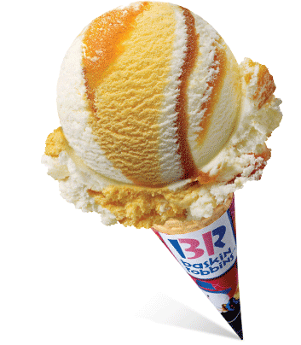1.chessecake+pumkin 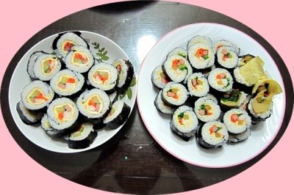a.kim bob
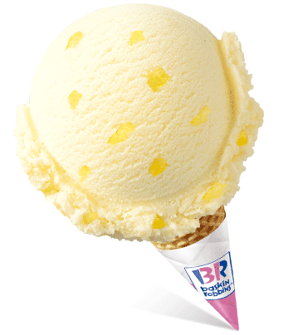2.pineapple 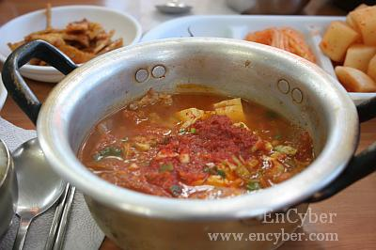b.kimchi soup
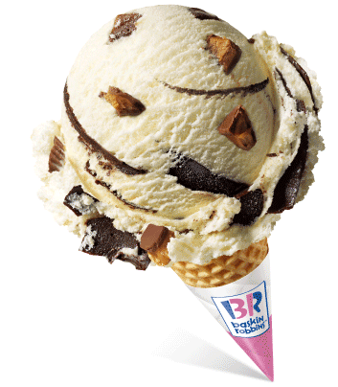3.peanut 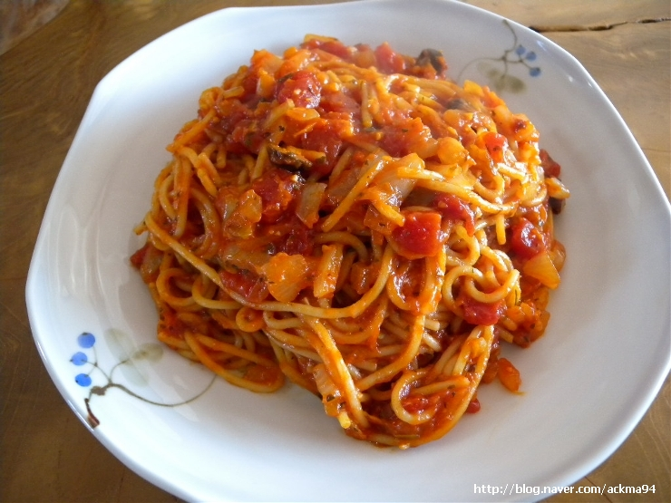c.spagetti
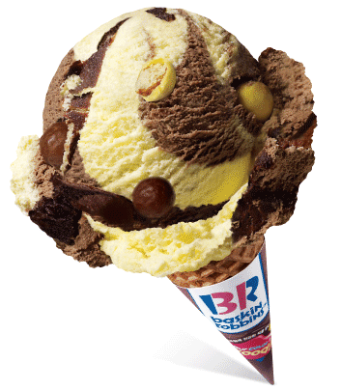4.banana 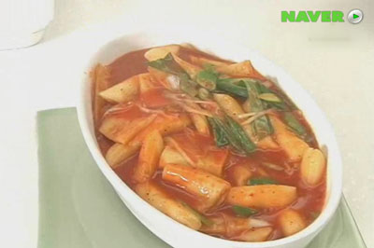d.spicy ricecake
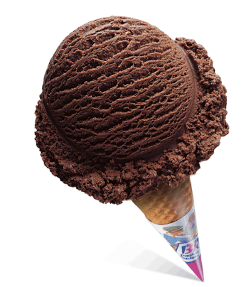5.chocolate 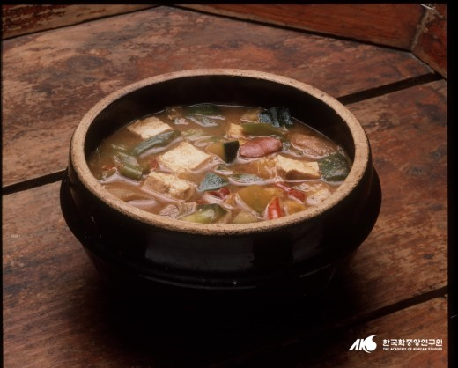e.soybean soup
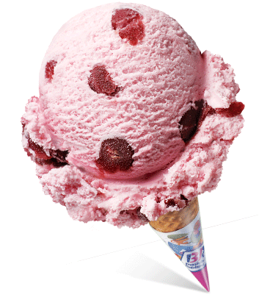6.cherry 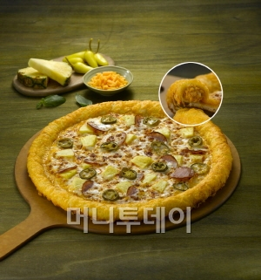f.pizza
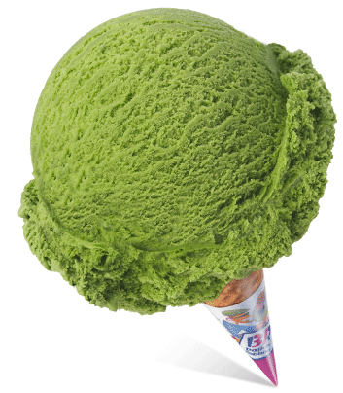7.green tea 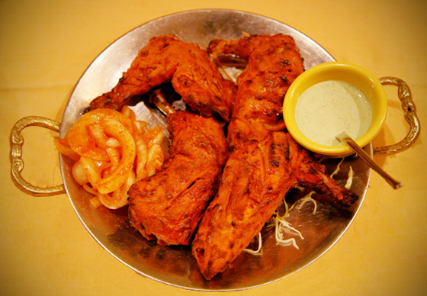g.chicken

