Simple Present | Simple Past | Simple Future
I study English every day. | Two years ago, I studied English in England. | If you are having problems, I will help you study English.  I am going to study English next year.
Present Continuous | Past Continuous | Future Continuous
I am studying English now. | I was studying English when you called yesterday. | I will be studying English when you arrive tonight.  I am going to be studying English when you arrive tonight.
Present Perfect | Past Perfect | Future Perfect
I have studied English in several different countries. | I had studied a little English before I moved to the U.S. | I will have studied every tense by the time I finish this course.  I am going to have studied every tense by the time I finish this course.
Present Perfect Continuous | Past Perfect Continuous | Future Perfect Continuous
I have been studying English for five years. | I had been studying English for five years before I moved to the U.S. | I will have been studying English for over two hours by the time you arrive.  I am going to have been studying English for over two hours by the time you arrive.

Simple Present | Simple Past | Simple Future
I English every day. | Two years ago,  I English in England. | I to study English next year.
Present Continuous | Past Continuous | Future Continuous
I English now. | I English when you called yesterday. | I English when you arrive tonight.  I English when you arrive tonight.
Present Perfect | Past Perfect | Future Perfect
I English in several different countries. | I a little English before I moved to the U.S. | I every tense by the time I finish this course.  I every tense by the time I finish this course.
Present Perfect Continuous | Past Perfect Continuous | Future Perfect Continuous
I English for five years. | I English for five years before I moved to the U.S. | I English for over two hours by the time you arrive.  I English for over two hours by the time you arrive.
Worksheet #2

Simple Present - [VERB] + -s/-es in third person. Ex) I play tennis.
Simple Past - [VERB + -ed] or irregular verbs. Ex) I saw a movie yesterday.
Simple Future - [will + verb]. Ex) You will help him later.
Future Continuous - [will be + present participle]. Ex) You will be waiting for her when her plane arrives tonight.
Past Continuous - [was/were + present participle] Ex) You were studying when she called.
Present Continuous - [am/is/are + present participle] Ex) You are watching TV.
Present Perfect - [has/have + past participle] Ex) You have seen that movie many times.
Past Perfect - [had + past participle] Ex) You had studied English before you moved to New York.
Future Perfect - [will have + past participle] Ex) You will have perfected your English by the time you come back from the U.S.
Future Perfect Continuous - [will have been + present participle] Ex) You will have been waiting for more than two hours when her plane finally arrives.
Past Perfect Continuous - [had been + present participle] Ex) You had been waiting there for more than two hours when she finally arrived.
Present Perfect Continuous - [has/have + been + present participle] Ex) You have been waiting here for two hours.
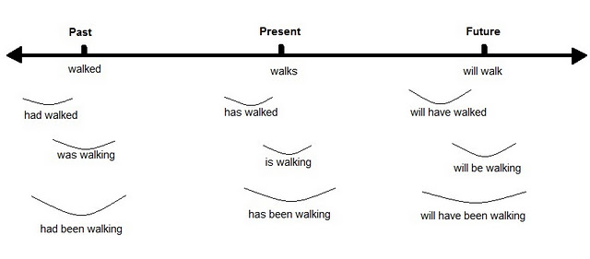
Example | Past tense | Present tense | Future tense
Rule | Add –d or -ed | Add –s or -es | Add will before the verb
Word: play | played | plays | will play
Worksheet #1

Verb | Past tense | Present tense | Past tense
 |  | uses
watch
 | wrote
 |  |  | will read
 |  | says

Worksheet#2
1. am going
2. am going to be studying
3. am studying
4. will have studied
5. am going to have been studying
6. have been studying
7. will have been studying
8. study
9. will help
10. studied
11. will be studying
12. was studying
13. have studied
14. had studied
15. am going to have studied
16. had been studying

