A. 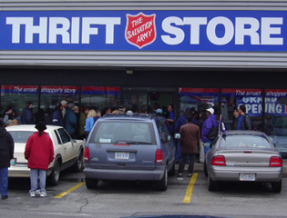 B. 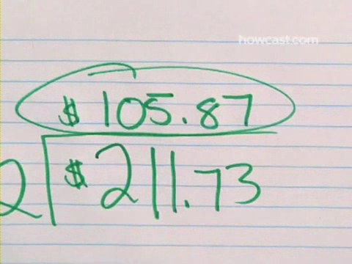
C. D. 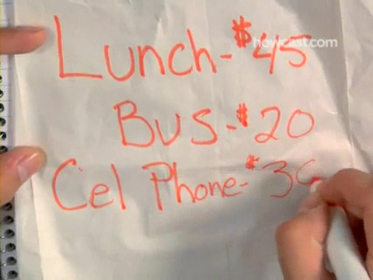
E. 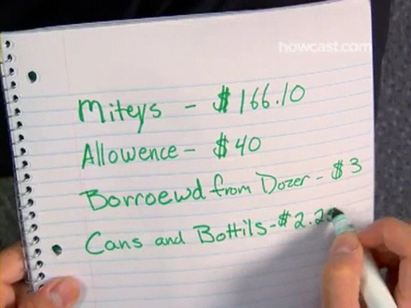 F.
G. 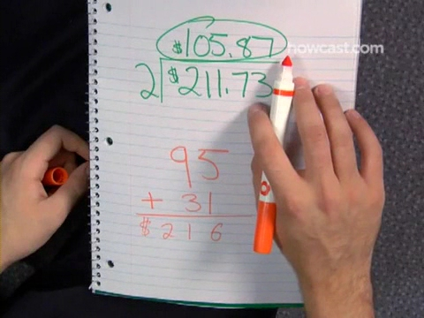 H.
I .
Answer

Key words

add up add together, sum up

monthly income wage, pay, salary, earning

monthly spending rent, food, gas, cloths, cable, internet, drink, cigarette,

essential expenses rent, food, transportation,

personal necessities gym, coffee, supplement

nonessential spending nail shop/ starbucks/ fancy dinner/snack/ party

exceed to surpass, outdo, outgo

cut back to decrease

stick to to stay

discipline self control

savings institution bank

frugal thrifty, economical

thrift store charity shop, hospice shop, resale shop

How To Live on a Budget

They don’t call it minimum wage for nothing.
How’s a guy supposed to get ahead, breaking his back 24-7, when all it gets you is chicken scratch?
My friend, you need a budget.

You Will Need

•Discipline

•Ability to add, subtract, multiply, and divide

•Bank or credit union

Step 1: Add up income
Add up all your income.

Step 2: Divide by months it took to
Divide the total by the number of months it took you to earn it. The result is your monthly income.

Step 3: Add up monthly expenses
Add up your essential monthly expenses, like food, rent, transportation, and personal necessities.

Step 4: Add up nonessential
Next add up your nonessential monthly spending.

Step 5: Add up expenses
Now add up your expenses, and pray the total is lower than your monthly income.
If your expenses exceed your income, you’ll need to cut back on nonessential items.

Step 6: Stick to numbers
Once your numbers are set, stick to them! Discipline is the key to living on a budget.

Tip: Try to set aside a small portion of your income on a regular basis—make sure to deposit it in a secure savings institution.

Step 7: Take public transportation
Take public transportation, or carpool with friends to save on gas. Walking is free, and it’s great exercise!

Step 8: Be frugal
Be frugal. Stop buying brand name clothes and fancy foods. Stop drinking lattes. Don’t order takeout.

Tip: Instead of buying napkins, wipe your mouth on your sleeve.

Step 9: Buy secondhand
Buy anything you can secondhand. Thrift stores often sell household goods and perfectly good used clothing.

According to the Department of Education, more than 80% of undergrads have at least one credit card, and nearly 50% have four or more.
How To Live on a Budget

They don’t call it minimum wage for nothing.
How’s a guy supposed to get ahead, breaking his back 24-7, when all it gets you is chicken scratch?
My friend, you need a budget.

You Will Need

•Discipline

•Ability to add, subtract, multiply, and divide

•Bank or credit union

Step 1: Add up income
Add up all your income.

Step 2: Divide by months it took to earn
Divide the total by the number of months it took you to earn it. The result is your monthly income.

Step 3: Add up monthly expenses
Add up your essential monthly expenses, like food, rent, transportation, and personal necessities.

Step 4: Add up nonessential spending
Next add up your nonessential monthly spending.

Step 5: Add up expenses
Now add up your expenses, and pray the total is lower than your monthly income. If your expenses exceed your income,
you’ll need to cut back on nonessential items.

Step 6: Stick to numbers
Once your numbers are set, stick to them! Discipline is the key to living on a budget.

Tip: Try to set aside a small portion of your income on a regular basis—make sure to deposit it in a secure savings institution.

Step 7: Take public transportation or carpool
Take public transportation, or carpool with friends to save on gas. Walking is free, and it’s great exercise!

Step 8: Be frugal
Be frugal. Stop buying brand name clothes and fancy foods. Stop drinking lattes. Don’t order takeout.

Tip: Instead of buying napkins, wipe your mouth on your sleeve.

Step 9: Buy secondhand
Buy anything you can secondhand. Thrift stores often sell household goods and perfectly good used clothing.

According to the Department of Education, more than 80% of undergrads have at least one credit card, and nearly 50% have four or more.

