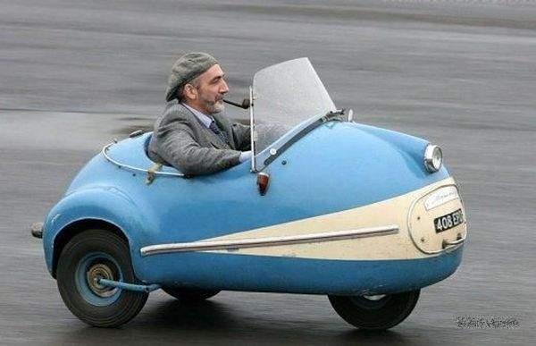

<Example 1>

I’m hungry.
He is hungry.
I’m hungry, and he is too.
I’m hungry, and so is he.

She has an I-phone.
He has an I-phone.
She has an I-phone, and he does too.
She has an I-phone, and so does he.

I liked the movie.
They liked the movie.
I liked the movie, and they did too.
I liked the movie and so did they.

John can play the guitar.
I can play the guitar.
John can play the guitar, and I can too.
John can play the guitar, and so can I.

<Board race example>
Team A |  |  | Team B
Can had go does took |  |  | could eat love like have may
met would was runs got |  |  | will see been keep make
main verbs | Helping verbs |  | main verbs | Helping verbs

Simple variable substitution drill sheet

- "So" and "Too" in Positive Agreement

Drill 1 (Be /too)
 | singular |  | plural
MJ is happy, and | I am | too | we are | too
 | you are |  | you are
 | he is |  | they are
 | she is

Drill 2 (Be/so)
 | singular |  | plural
MJ is happy, and | so | am I | so | are we
 |  | are you |  | are you
 |  | is he |  | are they
 |  | is she

Drill 3 (Do/too)
 | singular |  | plural
Ella likes pizza, and | I do | too | we are | too
 | you do |  | you are
 | he does |  | they are
 | she does

Drill 4 (Do/so)
 | singular |  | plural
Ella likes pizza, and | so | do I | so | do we
 |  | do you |  | do you
 |  | does he |  | do they
 |  | does she

Here are some more examples:
He likes to cook, and she does, too.  or  He likes to cook, and so does she. | 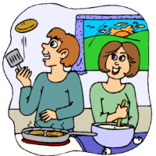
Bobby went swimming yesterday,
and so did Tom.
or
Bobby went swimming yesterday,
and Tom did, too.
He has gotten all wet, and she has, too.  or  He has gotten all wet, and so has she. | 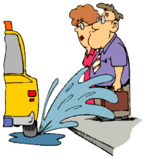
<Simple Variable Substitution drill >
- Match the items with the items in the box.

So am I / So was I / So do I / So did / I so will I / So have I / So can I

A
- I have two hamsters.
- I can make almond cookies.
- I’m in the mood for Italian food.
- I love you so much.
- I enjoyed the meal.
- I'm going to be at the party.
- I was pleased to hear the news.
- I've met Yuna Kim.
- I saw him at Burger King.
- I'm thirsty.

B
- I'll give him 5,000 won.
- I was crazy about chocolate.
- I'm in the mood for Big-Mac.
- I drank So-ju last night.
- I've seen 'Avatar'.
- I have a galaxy tab.
- I can play the cello.
- I've had enough of this exercise.
- I'm going to save up my money.
- I feel tired.

<Simple Variable Substitution Drill - Game>
Relay game – Each ss has 2 sentences. S1 Read one sentence to the S2. S2 give S1 positive agreement using So. And then read one sentence to S3. 2cycles.The team that has the less number wins the game.
You will need : Stop watch / copy this sheet, and cut along the line. (Give each ss two)
Rule: 1 wrong answer : +5sec
Once ss said wrong answer, it is counted +5 sec even if they change it.
e.g.) Team A total relay time 50 + 2wrong answers (+10sec) = Total 60sec
Team B total relay time 53 + 1 wrong answer (+5sec) = Total 58 sec Winner!

1. I have two hamsters. | 1. I'll give him 5,000 won.
2. I can make almond cookies. | 2. I was crazy about chocolate.
3. I’m in the mood for dancing. | 3. I'm in the mood for Big-Mac.
4. I love you so much. | 4. I drank So-ju last night.
5. I enjoyed the meal. | 5. I've seen 'Avatar'.
6. I’d like a T-bone steak. | 6. I have a new galaxy tab.
7. I was pleased to meet you. | 7. I can play the cello.
8. I've met Yuna Kim. | 8. I've had enough of this exercise.
9. I saw him at Burger King. | 9. I'm going to save up my money.
10. I'm thirsty. | 10. I feel tired.
Answer
A |  | B
1. So do I | 6. So am I | 1. So will I | 6. So do I
2. So can I | 7. So was I | 2. So was I | 7. So can I
3. So am I | 8. So have I | 3. So am I | 8. So have I
4. So do I | 9. So did I | 4. So did I | 9. So am I
5. So would I | 10. So am I | 5. So have I | 10. So do I

<Simple Variable Substitution drill >
- Notice that the helping verb is used in the second part of the sentence.
Now it's time for you to practice. Be sure to pay attention to the verb tenses that are used. They have to match in both sentences. After you do this exercise, you should understand. Use the subject and the connecting word in parenthesis (this sentence is in parenthesis). Write this out by hand.

1. Mary can ride a bike, and ______________________________. (John / so)
2. You like to study English, and ___________________________. (she / too)
3. They lived in Mexico a long time ago, and __________________. (I / so)
4. I have been to New York, and ____________________________. (you / so)
5. She's a student, and ___________________________________. (he / too)
6. We were late to class, and ________________________. (the teacher / so)
7. I eat lots of vegetables, and __________________________. (my kids / too)
8. My computer has a power cord, and __________________. (my printer / so)
9. Bob has finished his homework, and _____________________. (Mary / too)
10. Jerry will go to the party, and __________________________. (Sue / so)

Homework
Directions: Choose "so" or "too" for each sentence and the correct helping or modal verb for each sentence.

1. I like to watch the news in the evening, and __________ __________ my friends.

2. Veronica went to the University of Illinois, and John __________ __________.

3. He's a student, and _________ __________ you.

4. My kids are tired, and I __________ __________.

5. The train is going to be late, and __________ __________ the bus.

6. Our teacher is interesting, and yours __________ __________.

7. This coat was made in India, and __________ __________ hers.

8. They have been to New York, and we __________ __________.

9. I'll try to help you, and __________ ___________ they.

10. He should start looking for a new job, and __________ __________ they.
Homework
Directions: Complete the second part of each sentence with the correct auxiliary verb.
1. He wanted to go to the movies, and so _________ she.
2. I like to eat Vietnamese food, and you _________ too.
3. Martha knows how to make a really good pizza, and Robert _________ too.
4. We have had the same car for over 10 years, and so ____________ they.
5. You can play guitar really well, and so ___________ I.
6. They decided to barbeque outside last night, and we ___________ too.
7. She had been to that restaurant before, and so __________ he.
8. Sara and Oscar might get married next year, and Oscar's brother ___________ too.
9. The teacher was late to class this morning, and so ____________ the students.
10. Tobin is going to be at the party, and so __________ Roger.

