Listening Speaking Reading Grammar Writing

Topic: TV or Not TV

Instructor:  Irynn | Level:  Intermediate | Students:  11 | Length:  45 Minutes

Materials:

- Board & Markers
- 11 copies of worksheet #1, 2, 3, 4, 5
- 8 pictures of 4kinds of Television, information, education, fun, couch potato

Aims:

- To develop their reading of story
- To learn vocabularies related to the story
- To practice expressing what they read
- To practice and improve speaking & listening through some conversation

Language Skills:

- Listening: Teacher explanation, Conversation, Explaining information
- Speaking: Conversation with people, Explaining information
- Writing: Fill in the blank, writing answer of the questions
- Reading: Worksheet

Language Systems:

- Lexis:
- Function: Asking/ Explaining information
- Grammar:
- Phonology:
- Discourse:

Assumptions:
- Students already know how the class is set up and run
- Students are familiar with each others.
- Students know most of words in the worksheet.
- Students are familiar with doing activities both individually and in groups

Anticipated Errors and Solutions:

If students need more time to work
~ give some time
If students have trouble with introduction of the activity
~ explain about the instruction easily and slowly
If there is not enough time for all students to present their answer
~ ask any volunteers or pick 2-3 teams

References:

Lead-In
Materials: Worksheet #1, Board & markers
Time | Set Up | Procedure
10min | Whole Class | Greetings  Good morning/afternoon, everyone.  How are you today?  Now, we make a plan on the weekend of December. Isn’t it interesting?  (Distribute the paper)  Eliciting  Look at the list and write some other things you would like to do.  Then put the numbers in the pie chart!  Take about 3 minutes.  CCQ  Do you make a plan on the weekday or weekend?  What do you put in the pie chart? (put the number, not words)  How many times do you have?  (Monitor them while they make plans)  (Give time warning)  I know that you make great weekend plan.  In your plan, how many hours a day do you watch TV?  (Students answer)  Can you guess today’s our topic?  Today, we talk about ‘TV or Not TV’

Pre-Activity
Materials: Pictures, Board & markers
Time | Set Up | Procedure
5min | Whole class | (Show picture 5 kinds of TV)  What are these?  Yes, these are TV. We can meet TV very easily in our life.  On the street, in the airplane, in the car, in your hand, and at home.  We know that there are 2 sides to everything.  Of course, TV has two sides.  Let’s talk about TV’s strength and weakness.  (Listening their opinion)  Okay, everybody agree with your friends’ opinion?  As we talk,  TV’s good points are getting fun, a lot of information and education for children.  TV’s bad points are making people lazy, violence and so on.  (Attaching pictures on the board.)  Vocabulary  Let’s learn vocabulary that will help you to read the text.  (invent, imitate violence, overweight, obesity)  Is there any words you don’t understand?

Main Activity
Materials: Board & markers, Worksheet # 2, 3
Time | Set Up | Procedure
10min  10min | Whole Class  Pairs  Groups | Guiding Questions  (Write the question on the board)  “What Is Television?”  What did I write? Let’s read the question together.  Think about the answer as you read this story. I’ll give you 1min to read. Read individually and silently.  CCQ  What will you do as you read?  Do you read with your partner?  How much time do you have?  (Pass out the text)  Do you need more time to read?  Did you get some new information?  What is it?  Q.  Who create the TV?  The words of Television have a meaning or it just a proper noun?  Now we know about television exactly what it is.  Guiding Question  (write the question on the board)  “What are good and bad things about TV”  What did I write?  Let’s read the question together.  Think about the answer as you read the story.  Let’s make a pair.  You have different story.  If you have good points about TV then your partner have bad points.  After reading our part, then you explain to your partner what you read.  Okay, now read the story silently for 2minutes and explain to your partner for 3minutes. So, we have 5minutes.  CCQ  Are you working alone?  What are you supposed to do after reading?  How many times do you have?  Begin.  (Monitor them while they read and explain)  (Give time warning)  Okay. Are you done?  Did your partner explain to you well?  Please remember well what your partner said.  Now we move to the next page.  There are 3 questions.  Let’s make a group of 3.  For the sake of time, Question No.1 is for Group A, No.2 is for Group B, No.3 is for Group C.  These questions don’t need to correct answer. Please answer the questions with your creative brains.  Take about 3minutes.  CCQ.  How many times do you have?  Are you working alone?  (Monitor discreetly)  (Give time warning)  (If students need, give them 1 or 2 more minutes)  Are you done?  Which group wants to go first?  (If there are not any volunteer then start Group B first)  Thank you for sharing your good ideas to us.

Post Activity
Materials: Worksheet #4
Time | Set Up | Procedure
10min | Individually | Let’s move to the next page.  Do you remember what your partner said about good and bad things of TV?  Okay. Complete the diagram below using the help box.  Take about 5minutes.  CCQ  How many times do you have?  What can you use for completing the diagram?  Begin.  (Monitor discreetly)  Are you done?  Let’s answer the questions together.  Error correction and feedback  Give chance to answer the questions in order.  (If there are errors, facilitate peer correction.)  <Closing>  It’s time to finish. Did you enjoy the lesson?  You did a great job today.  Next our topic is “Instead of TV”. Think about it.  Bye! See you next week!
SOS Activities
Materials: Board and Markers
Time | Set Up | Procedure
3min | Whole class | We have 3 more minutes.  Let’s think about something to do instead of TV.  If you have any ideas, please share together.  (write the answer of students)  That’s great.

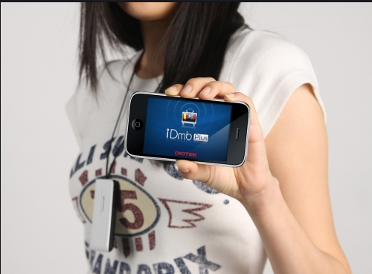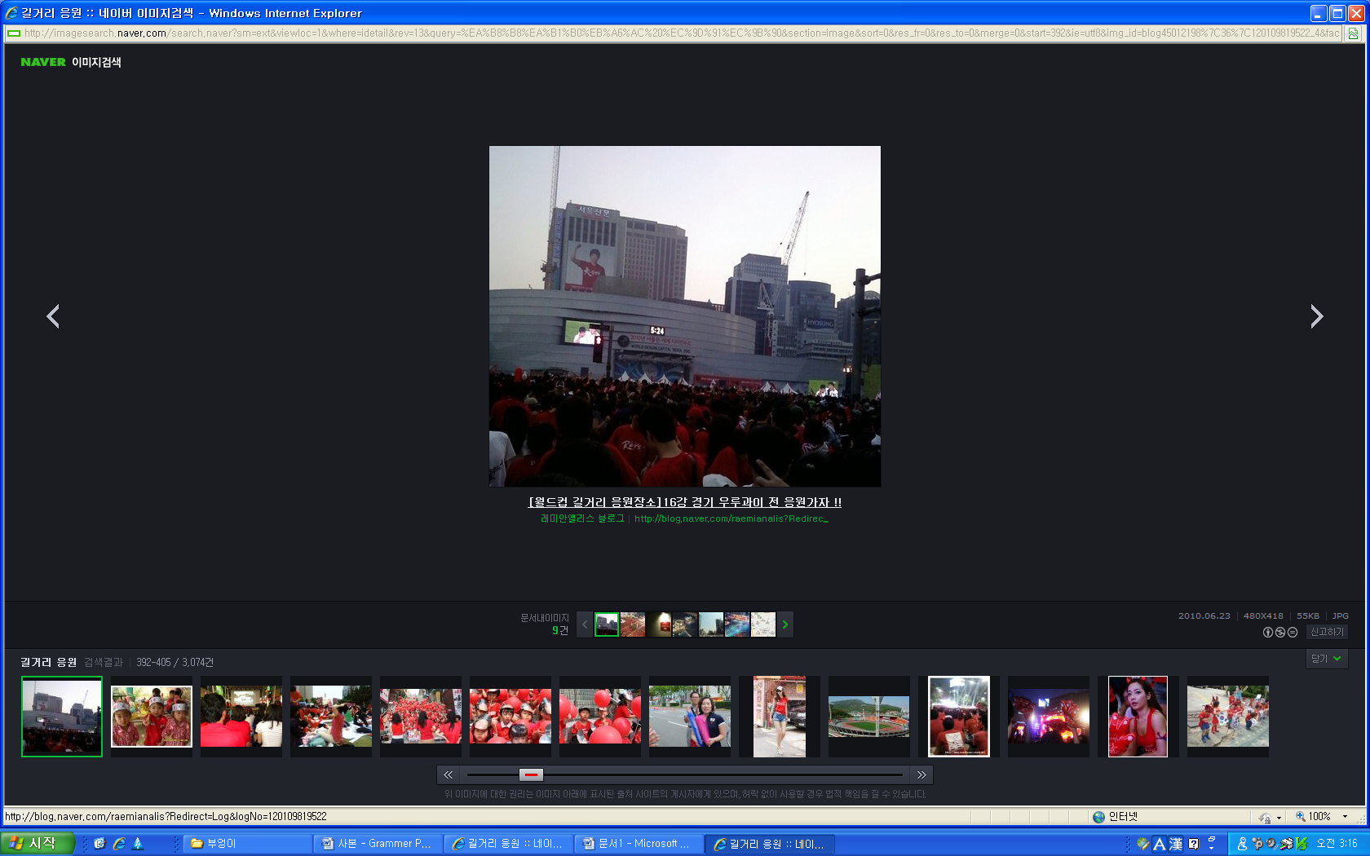

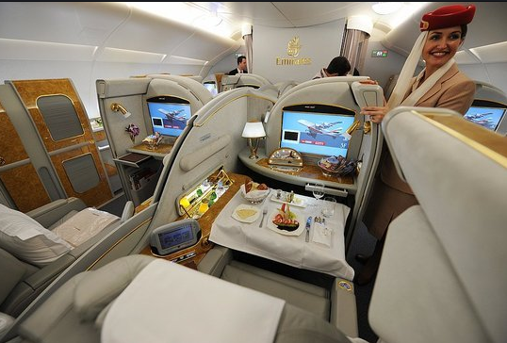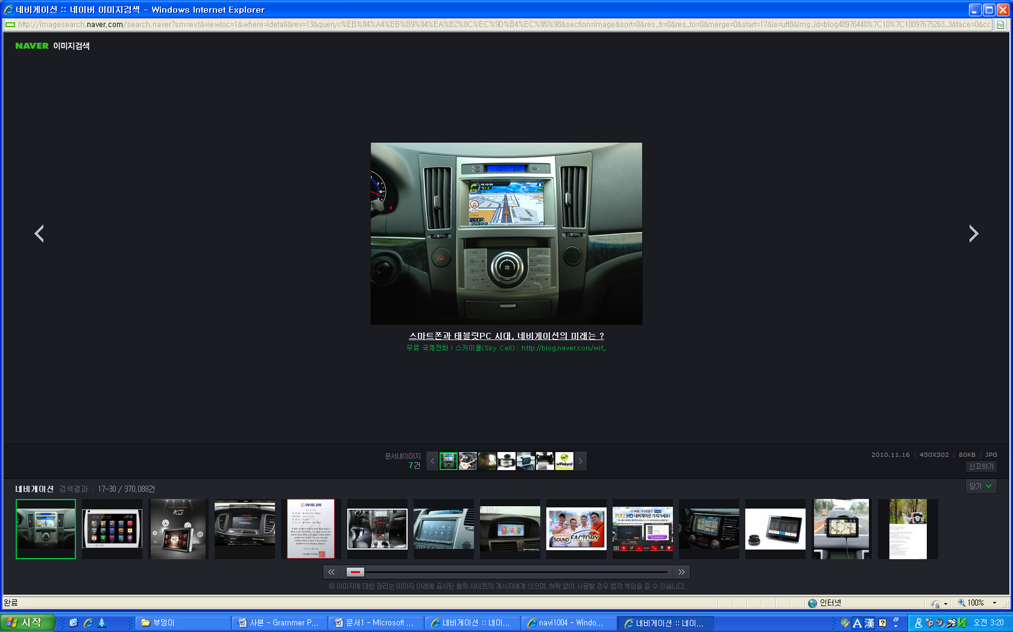

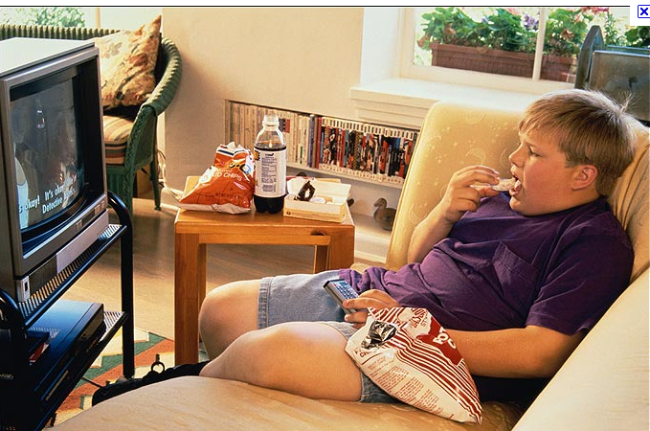

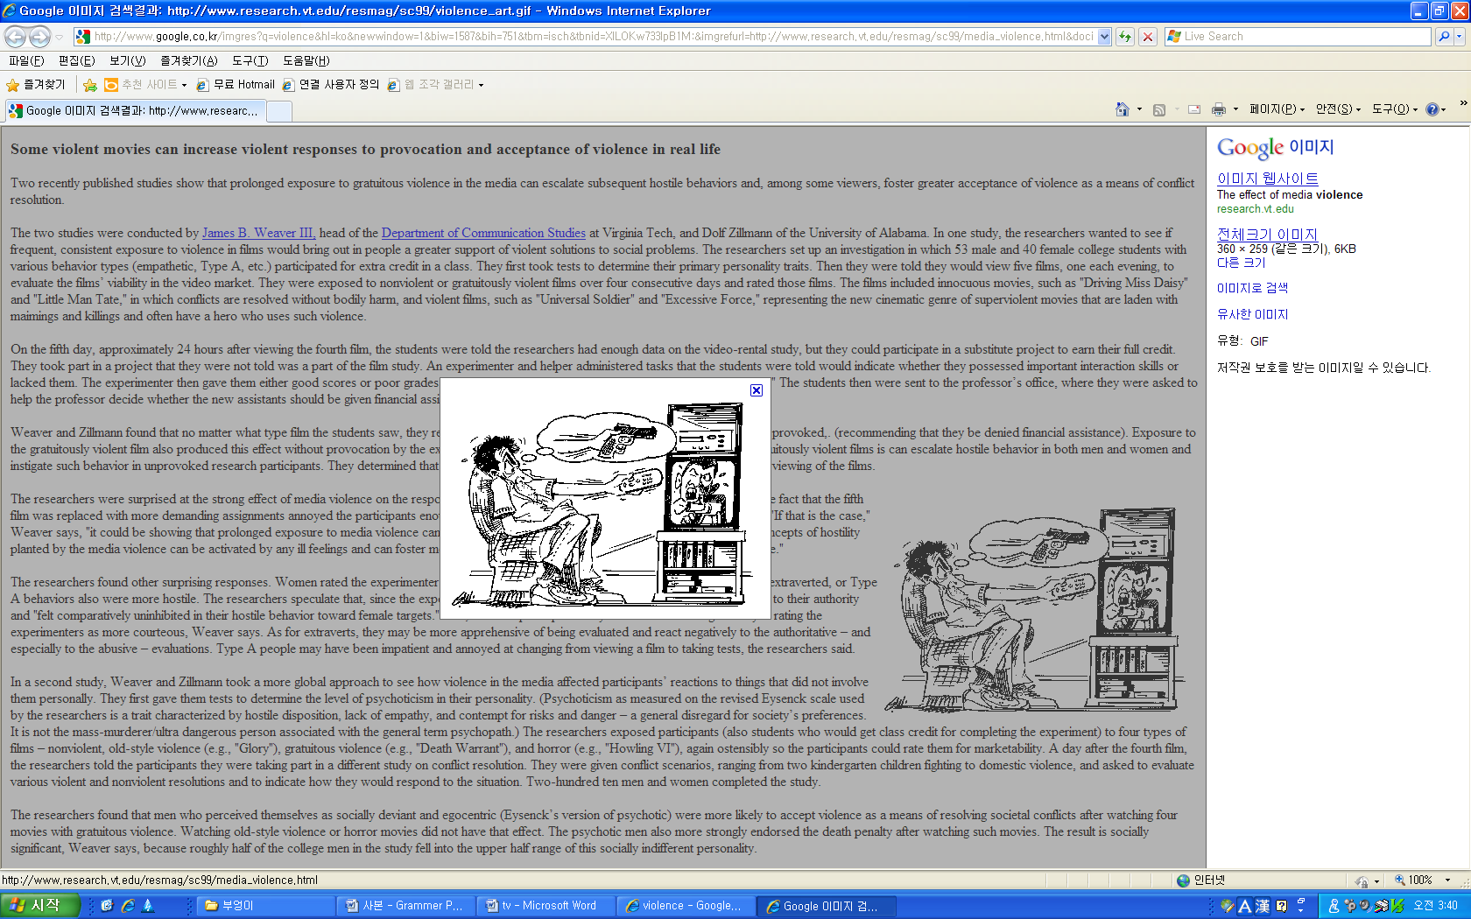
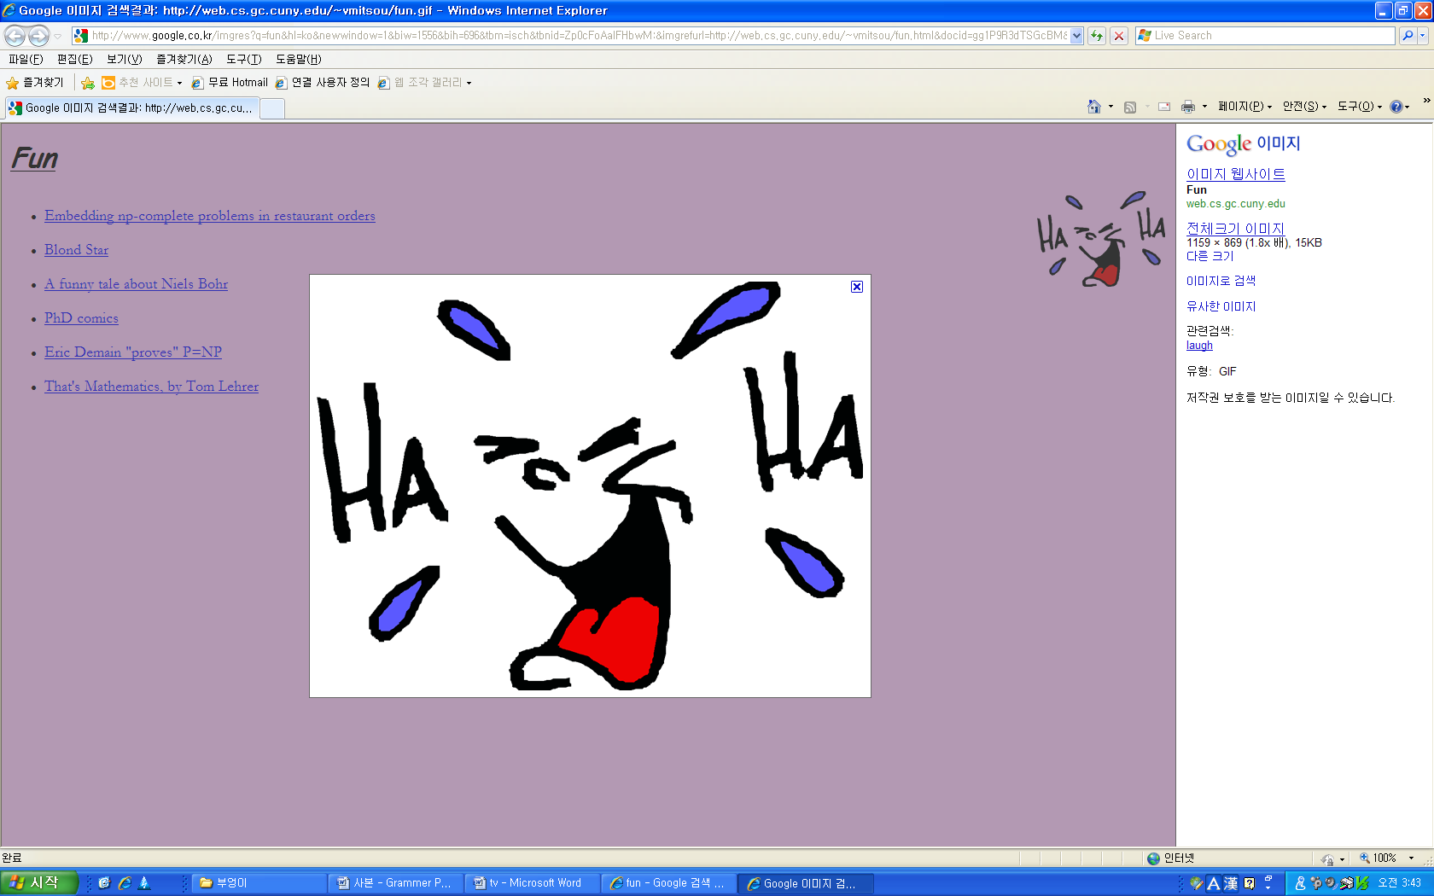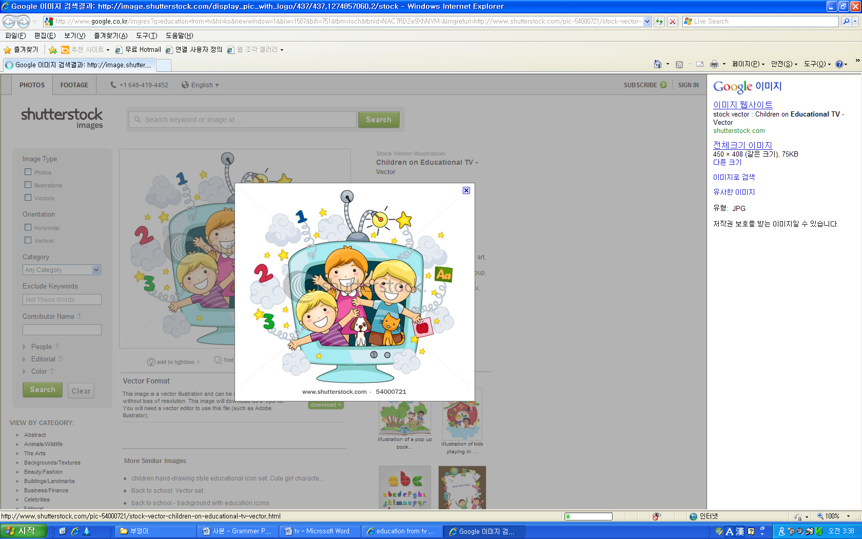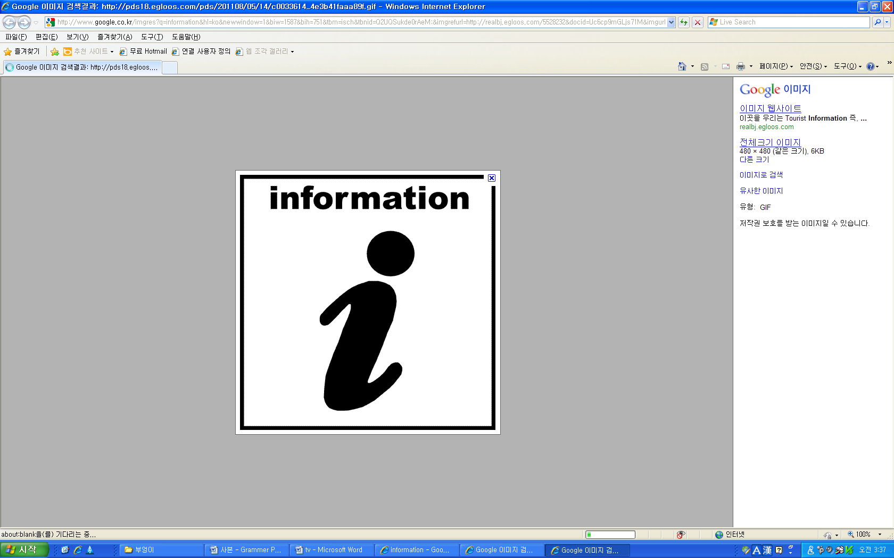
Worksheet #1
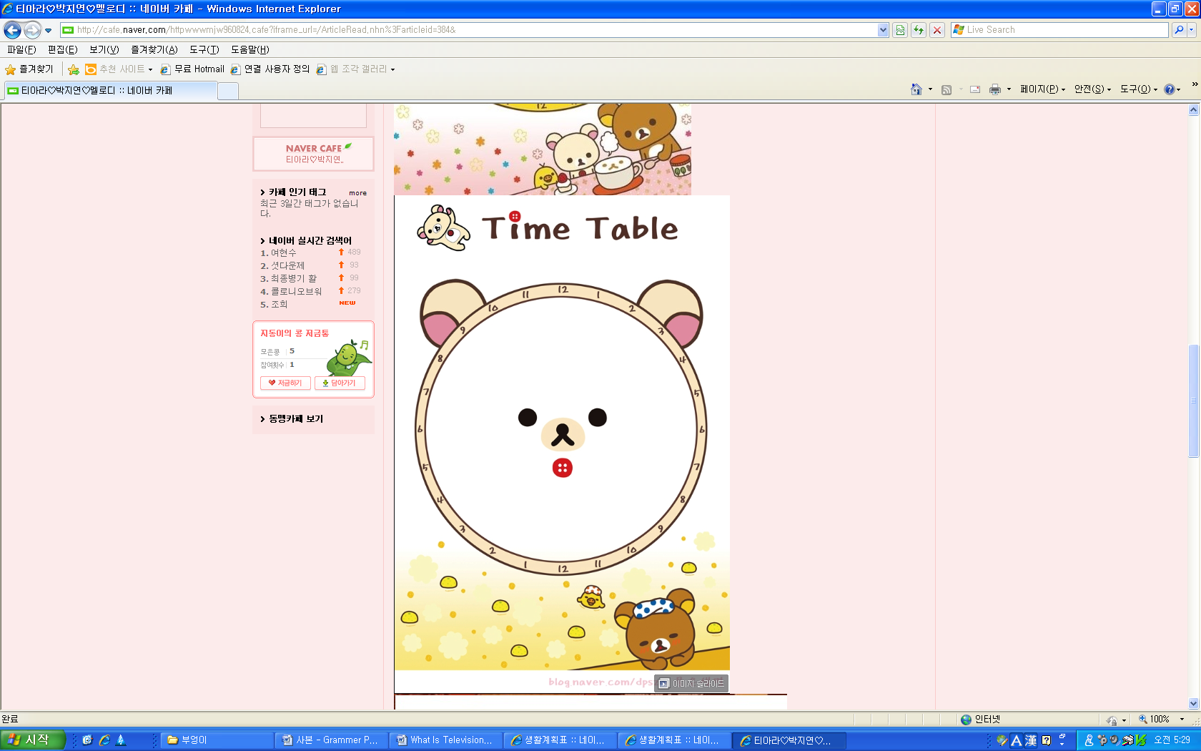

- Sleep 5. Go to the movies
- Play computer games 6. _______________
- Watch TV 7.________________
- Take a walk 8.________________

Worksheet #2

What Is Television?

A television is a device that sends images and sound by electric or electromagnetic signals. Tele means far in Greek and vision means sight in Latin.
Television is one of the greatest inventions of the 20th century. Unlike most of the world’s major inventions, hardly anyone knows who created television. In fact, it was not invented by a single person. Many people worked over the years to develop the modern television.

Worksheet #3

Good vs. Bad

TV is an unlimited source of information. Through the use of TV, we can bring the finest teachers, artists, scientists, and philosophers into our homes. Preschoolers can get help learning the alphabet on TV. Students can learn about wildlife on nature shows. Parents can keep up with current events on the evening news.
Today, TV has special channels for news, sports, and movies. Simply by pressing buttons, we can find programs that fit our tastes. It is also more convenient and less expensive for a family to sit at home, watching TV.
Why pay for expensive seats at a stadium or a cinema if you can turn on the TV and watch interesting movies, concerts, and soccer matches?

Worksheet #3

Good vs. Bad

However, TV has problems, too. Watching too much TV can waste our valuable time. According to one study, Americans watch about 4hours of TV every day. That is almost 28hours every week. In comparison, parents spend only 40minutes each week in meaningful conversation with their children.
Parents worry that children will learn the wrong things by watching TV. Children are likely to imitate what they watch on TV. For example, if children see violence often, they are more likely to imitate it themselves. TV violence can also lead to problems such as anxiety, depression, and nightmares.
Moreover, according to research, children who watch TV more than 4hours every day are more likely to be overweight. Children usually want food they see on commercials. This food is often high in sugar and fat. Children also tend to snack in front of the TV. Watching TV distracts the brain and stops the children from knowing when they are full. This can lead to overeating.
People may begin to stare like zombies when they are watching TV. They become unfocused and show a lack of attention.
Worksheet #4
What Do You Think?

- Without TV, what would the world be like?

- What do you think are the best and worst things about TV?

- If you made a TV program for teenagers, what kind of program would it be?

Worksheet #5
Organizing Ideas

Complete the diagram below using the help box.

GOOD Things about TV
- TV is 1._____________________________________________________________
- Through the use of TV, we can bring teachers, artists, and scientists into our homes.
- TV 2._______________________________________________________________
- We can enjoy movies, concerts, and sports matches.

VS.
BAD Things about TV
- Watching too much TV can 3._______________________________________
- Children can 4._____________________________________________________
- Children who watch much TV are likely to become overweight.
- TV can get in the way of exploring, learning, and interacting with people.

Help Box 1. Unlimited, source, information
2. enable, keep up with, current events
3. waste, time
4. imitate, violence, on

