Worksheet 1. Brain storming

Think about how global warming would relate to dandruff:

Think of words that could be connected with global warming. Use following diagram to complete brain storming. Share ideas with other classmates.

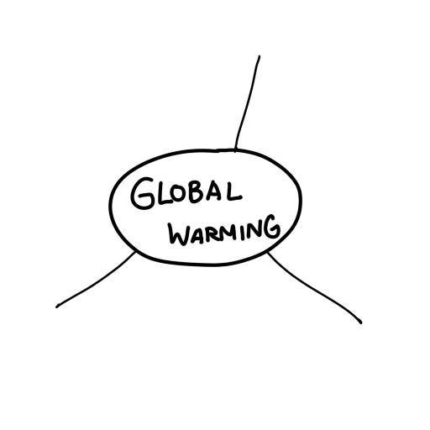

Worksheet 2. Reading

Dandruff linked to global warming

The next time you brush away some dandruff from your shoulder, stop and think: you may be contributing to global warming. This is a conclusion reached by German researchers, who report that unexpectedly large amounts of dandruff, skin flakes and fur are causing air pollution. Ruprecht Jaenicke and his team, from Mainz University, conducted an extensive fifteen-year study of air samples from all over the world. He found that biological materials make up twenty-five per cent of air pollutants, known as aerosols. Other biological pollutants, also called bio-aerosols, include bacteria, fungi, pollen and particles from plants and trees.

Mr. Jaenicke says these bio-aerosols play an important role in regulating the earth’s climate and have been underestimated in analyzing weather patterns and global warming. He says scientists should consider bio-aerosols more when predicting climate change. Bio-aerosols can absorb heat from the sun to warm the air and reflect sunlight to cool it; they also affect how rain and snow are formed. Jaenicke’s paper, “Abundance of Cellular Material and Proteins in the Atmosphere”, is available in this month’s issue of the journal Science. He does not tell us which shampoos to use to reduce dandruff and global warming.

True or False?
- Dandruff is one thing that causes global warming. T/F
- Global warming is one reason for people to suffer dandruff. T/F
- Biological materials in air samples were 2.5% of all pollutant. T/F
- The scientists recommended certain brand of shampoo
to reduce global warming. T/F
- Only carbon dioxides can absorb heat and reflect light. T/F
- Bio-aerosol is a chemical to kill animals. T/F
- Mr Jaenicke is from France. T/F
Worksheet 3. Writing letter

As a team, write a short letter to the government to reduce dandruff in order to stop global warming. Persuade the government, and tell what action they have to take.

