Lesson Plan – Listening/ Speaking/ Grammar/ Reading

Title – Travel to New York City

Instructor:  Hyun ju, Lee  (Hyun) | Level:  Upper Intermediate | Students:  11 Students | Length:  30 Minutes

Materials:

- Pictures
- Pre-Activity Worksheet #1 (11 copies)
- Main-Activity Worksheet #2
- Post-Activity Worksheet #3(11 copies)
- Wall Chart (New York City Map)
- Students Name Card
- White board and Board markers

Aims:

- Main: To enable Ss to improve their speaking and listening skills
by working in pair about travel to New York City

-Secondary: Ss will know about New York attractions
by sharing their own ideas and experiences

- Personal: I want to practice speaking lesson skill
I want to increase my confidence

Language Skills

- Listening: Ss will listen to teacher’s instructions and classmates’ speaking.
- Speaking: Ss will practice their speaking by sharing their ideas and experiences
- Reading: Ss will read the information about New York City attractions
- Writing: Ss will make sentences

Language Systems:

- Lexis: vocabulary of travel items and attractions of New York City
- Grammar: future tense “be going to”
- Function: how to describe attractions and to know about New York City
- Phonology: none to discuss
- Discourse: none to discuss

Assumptions:

Students already know:
- how the class is set up and run
- the teacher’s style of teaching and the pace of the course
- they are all adults
- where is New York City
- most students know about New York City

Anticipated Problems: Solutions:

- Ss may not know about attractions → Give Ss information pictures

- Ss may need more time the work → Give Ss some more time
on the worksheet and help them

- If time is running out → Cut –off plan

- The lesson finishes early → Give Ss SOS activity

References:

- Times TESOL Workbook
- http://endic.naver.com
-http://www.aviewoncities.com/nyc/statueofliberty.htm
- http://image.search.naver.com

Lead-in
Materials: Board and Board Markers

Time  1 min | Set up  Whole Class | Procedure  Greeting :  Hello everyone.  How are you today?  (Ss: I’m good, tired…)  Good!  Is there anyone who likes traveling?  (Ss: Raise their hands.)  I think everyone likes traveling.

Pre-activity
Materials: Pictures, Worksheet #1, Board, Board Markers

Time  3 min  2 min  3 min  1 min | Set up  Whole Class  Individually  Whole Class  Whole Class | Procedure  1. Eliciting :  What is the name of city? Guess!  This is a big city. It is called “the city that never sleeps and the big apple”  (In case, Empire States, Statue of Liberty…)  (Ss : New York City)  (Put the picture#1 ,2 on the board)  Right! It is New York City.  (Write “Travel to New York” on the board)  Have you ever been to New York before?  (Ss: Yes or No.)  Do you know where New York is?  (Ss: The USA)  Right!  CCQs  1. Is “New York” in the west side of  the USA?  Today, I will give you free ticket for New York so we are going to New York City.  Yeah~  2. Choosing Items  Instructions:  Before we go to New York we will bring some items. I will give you the picture of items.  (Giving Ss worksheets #1)  But you can take only three items.  Choose three items and explain the reason.  Demonstration:  For example, I need a guide book because I can get some information and refer to.  (Write the sentence on the board)  I will give you 2 minutes.  ICQs  1. What are you going to do?  2. Are you working individually?  3. How many minutes do you have?  (Ss do the activity)  Monitor discreetly.  Answer students if they ask questions.  Give time warning: 30 seconds left.  Be flexible with time.  Alright. Are you done? Time is up!  OK. Who want to share your ideas?  Go through the one by one  Students talking time  OK. Everyone did a good job!  Thank you.  3. Prediction  Instructions :  (Put the map of New York on the board)  Look at this. Here is the map of New York.  Now, we are all in New York.  Let’s go to somewhere and enjoy New York!  Are you ready?

Main activity
Materials: Map of New York, Worksheet #2, Name Card, Board

Time  3 min  3min  7 min | Set up  Whole Class  Pair  Whole Class  Pair | Procedure:  1. Explain activity  Instruction:  Now you are going to somewhere with your partner. I make you guys in pair.  (Make the students in pair.)  I will give you a picture of attraction  that you are going to.  (Write “attraction” word on the board)  Do you know what attraction means?  CCQs:  1. Is the attraction food?  2. Does the “Attraction” mean the place  to visit and tour?  (Give Ss pictures)  There is some information about the place.  Get some interesting information about the attraction and make your plan what you are going to do there. You have 3 minutes.  Demonstration:  For example, We’re going to Brooklyn Bridge.  Brooklyn Bridge is one of the most magnificent landmarks in New York.  It connects Manhattan and Brooklyn by spanning the East River.  We’re going to enjoy the beautiful night view and take lots of pictures on Brooklyn ridge. I will give you 3 minutes.  ICQs  1. What are you going to do?  2. Are you working in pair?  3. How many minutes do you have?  (Ss do the activity)  Monitor discreetly.  Answer students if they ask questions.  Give time warning: 30 seconds left.  Be flexible with time.  Give 1more minute if they need it.  2. Pair presentation  Instruction:  OK. Time is up.  Let’s enjoy New York!  Where are we going to first?  Which team wants to be first?  (Ss volunteer)  Students Talking Time
post-Activity
Materials: Worksheet #2

Time  7min | Set-up  Whole Class  Individually  Whole Class | Procedure  1. Free production  Instruction:  Did you enjoy New York? I hope you will enjoy real New York someday.  Now, let’s talk about the place that you want to go in the future. I will give you worksheet.  Please answer the questions.  Where do you want to go and why? What are you going to there, whatever you want. You have 3minutes.  ICQs  1. What are you going to do?  2. Are you working individually?  3. How much time do you have?  Monitor discreetly.  Answer students if they ask questions.  Give time warning: 30 seconds left.  OK. Time is up!  Who wants to tell us first?  Any volunteer?  Share students’ talking time  Can I have your worksheet? I will check your sentences and give you back tomorrow.  2. Conclude lesson  Do you have any questions about today’s lesson? You did a great job today.  Thank you all of you.  You have a great day and see you guys tomorrow. Goodbye!

SOS activities
Materials: n/a

Time  A) | Set up  Whole Class | Procedure  Instructions:  Everyone has visited somewhere.  This time, let’s find out the best place your partner has visited.  (Make pairs)  ICQs  1. What are you going to do?  2. Are you working in pairs?

Pictures for eliciting

#1
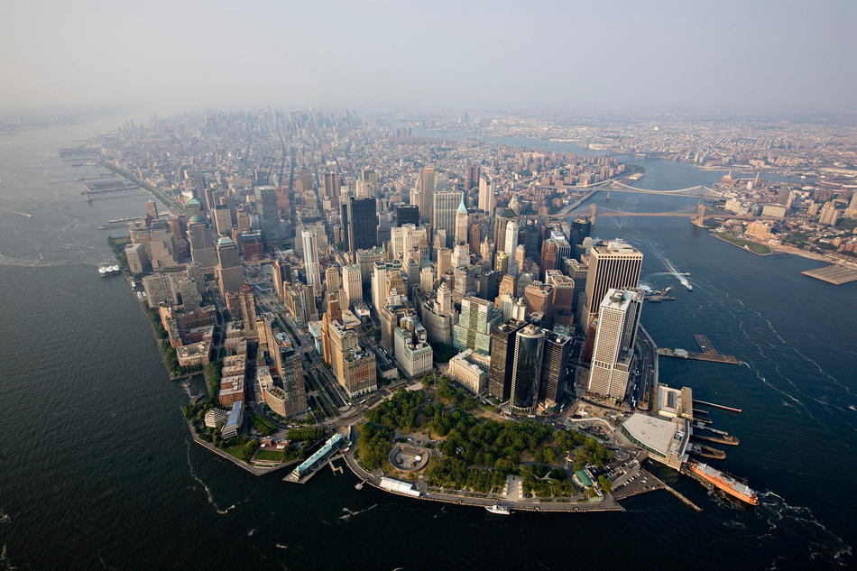

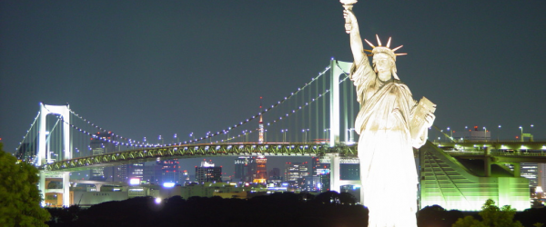

#2

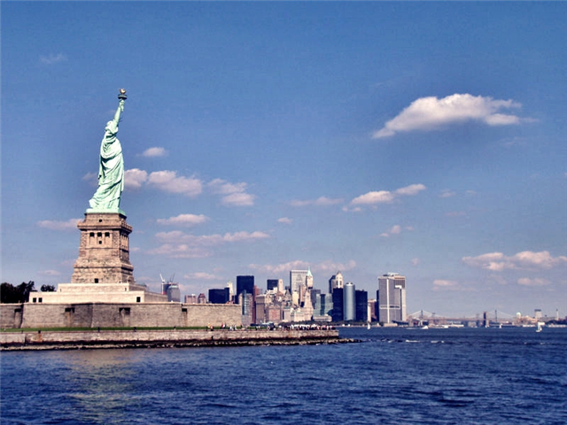

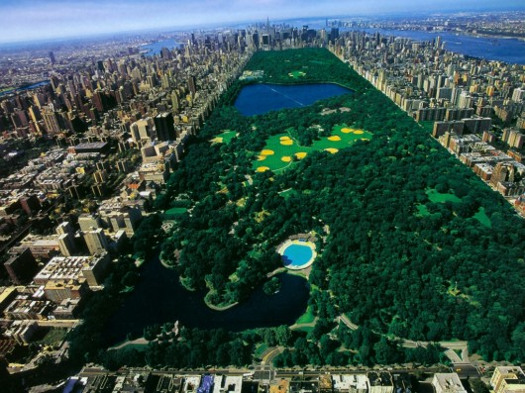
Work sheet #1(Items)
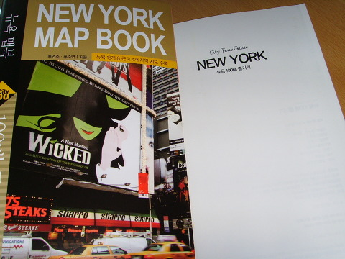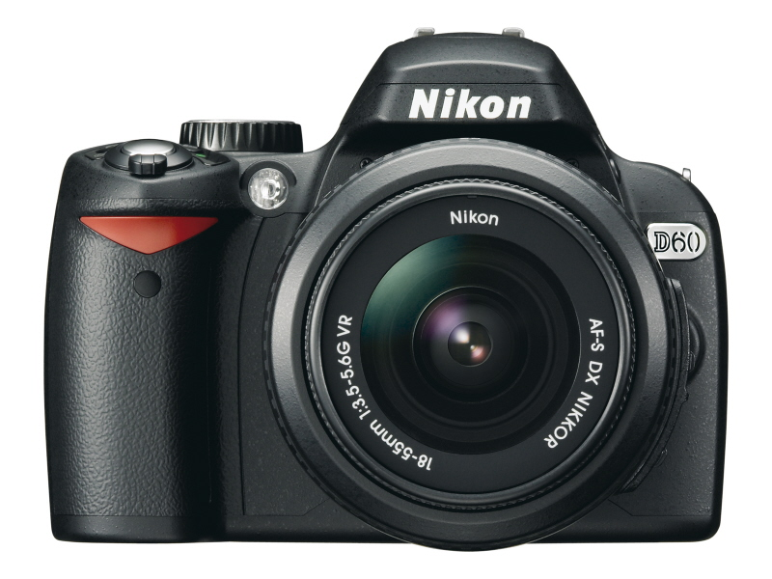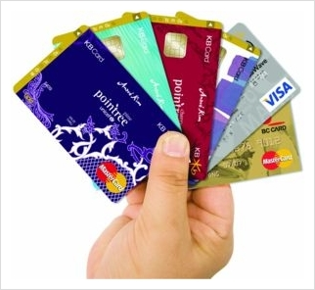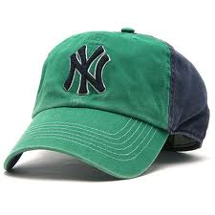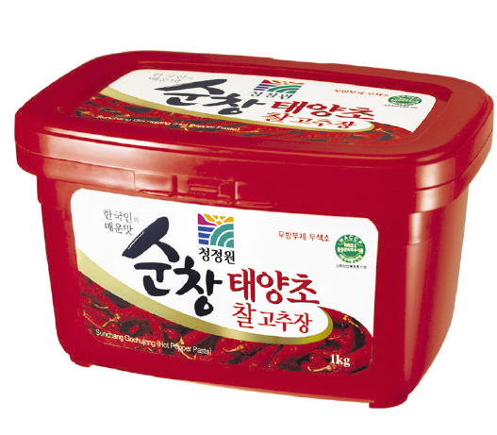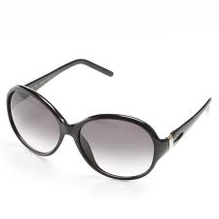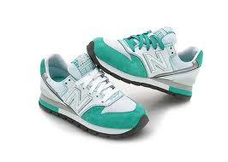
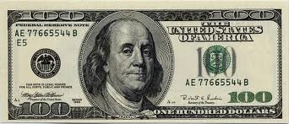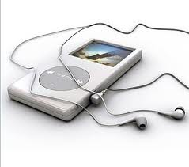

* Choose three items you want to take and explain why you need.

1. I need because

2. 1. I need because

3. 1. I need because

Worksheet #2

Statue of Liberty

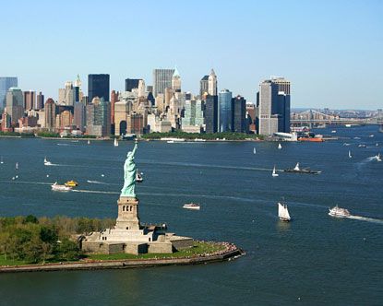
The Statue of Liberty was a gift of friendship from the people of France to the people of the United States and is a universal symbol of freedom and democracy. The Statue of Liberty was dedicated on October 28, 1886, designated as a National Monument in 1924 and restored for her centennial on July 4, 1986. The statue was a gift from the French government for the 100th birthday of America's Independence.
Thousands of people visit daily. All visitors must purchase a ticket for boat transportation through Statue Cruises. Tickets include access to both Liberty Island and Ellis Island. Entrance to the Statue of Liberty National Monument is free, but there is a charge for the ferry service that all visitors must use.
1. Summarize and get some interesting information about your attraction.

2. What are you going to there? (Whatever you want.)

3. And please tell us about #1 and #2
Worksheet #2

Central Park

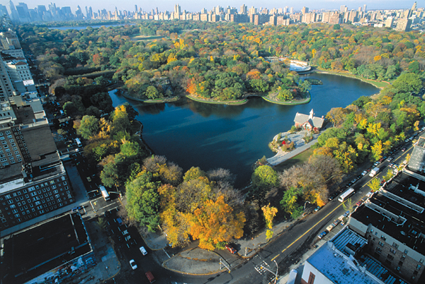

Central Park is a public park in the center of Manhattan in New York City.
Central Park is one of those places that make New York such a great place to live. The huge park, 843 acres large (341 ha), is located in the center of Manhattan. Its design is an example for city parks around the world.

The park boasts several lakes, theaters, ice rinks, fountains, tennis courts, baseball fields, many playgrounds and other facilities. It is also home to the Central Park Zoo and the Metropolitan Museum of Art. Especially during the weekends, when cars are not allowed into the park, Central Park is a welcome oasis in this hectic city.

1. Summarize and get some interesting information about your attraction.

2. What are you going to there? (Whatever you want.)

3. And please tell us about #1 and #2

Worksheet #2

Metropolitan Museum of Arts

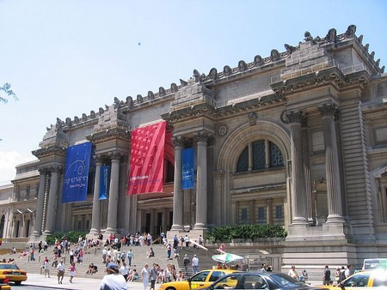

With more than two million works of art spanning thousands of years, the Metropolitan Museum of Art is one of the most expansive and prolific art museums in the world and it should be on everyone's New York to-do list.

There's also a rooftop sculpture garden and the amazing Robert Lehman Collection, often described as one of the most extensive and impressive private art collections in the world.

1. Summarize and get some interesting information about your attraction.

2. What are you going to there? (Whatever you want.)

3. And please tell us about #1 and #2

Worksheet #2(for Main- Activity)

Times Square

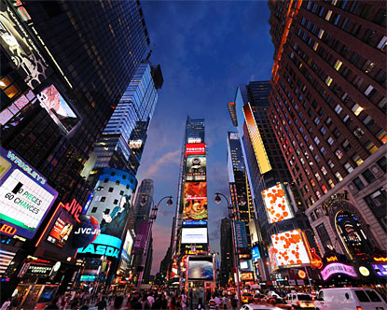

Times Square, the most bustling square of New York is known for its many Broadway theatres, cinemas and super signs.
It is one of those places that make New York a city that never sleeps.
Times Square is a major commercial intersection in the borough of Manhattan in New York City, at the junction of Broadway and Seventh Avenue and stretching from West 42nd to West 47th Streets.
1. Summarize and get some interesting information about your attraction.

2. What are you going to there? (Whatever you want.)

3. And please tell us about #1 and #2

Worksheet #2

5th Ave.

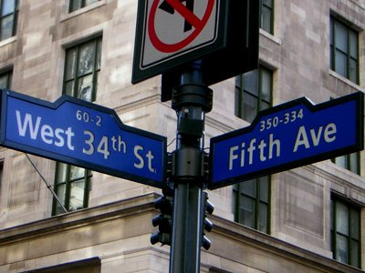

New York's Fifth Avenue is best known as an unrivaled shopping street. Almost any upscale retailer has a prestigious store located at this street. However not all of Fifth Avenue is shopping-centric. Along Central Park Fifth Avenue becomes a more residential street with a large number of interesting museums.

1. Summarize and get some interesting information about your attraction.

2. What are you going to there? (Whatever you want.)

3. And please tell us about #1 and #2

Worksheet #2

BB
Brooklyn Bridge
B
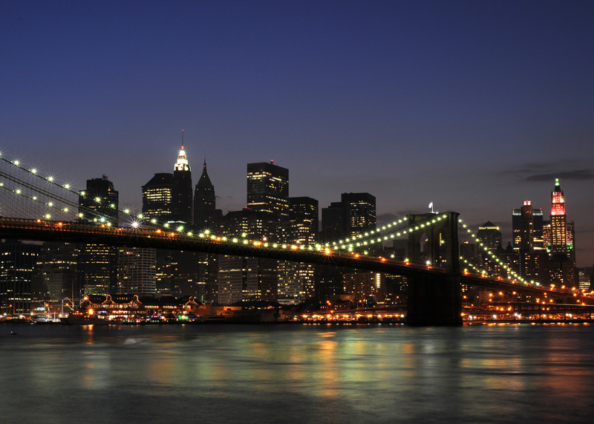

The Brooklyn Bridge, built between 1869 and 1883, connects Manhattan with New York's most populous borough, Brooklyn, at the time one of the country's largest cities. The bridge is one of the most magnificent landmarks in New York.
It connects Manhattan and Brooklyn by spanning the East River.

1. Summarize and get some interesting information about your attraction.

2. What are you going to there? (Whatever you want.)

3. And please tell us about #1 and #2

Worksheet #2

Empire state building

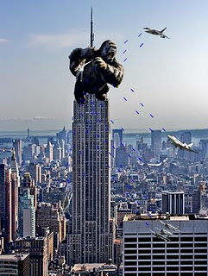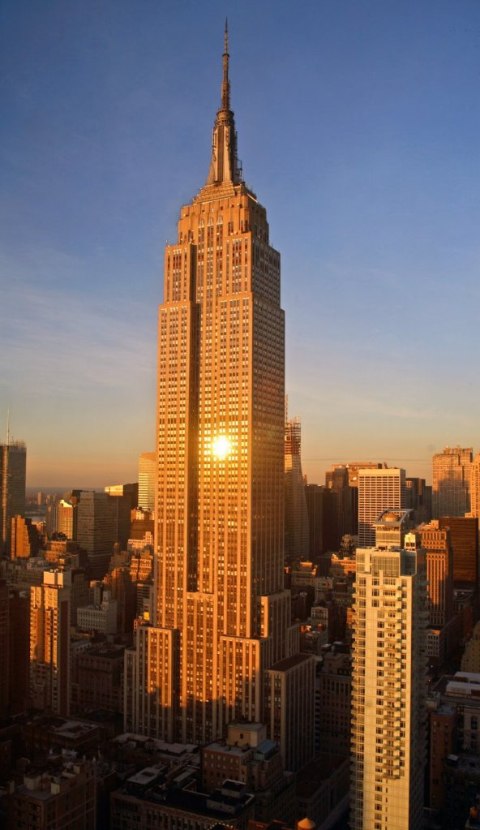

The Empire State Building is a 102-story landmark in New York City, United States, at the intersection of Fifth Avenue and West 34th Street. It is 1,250 ft (381 meters) tall. Its name is derived from the nickname for New York, the Empire State. It stood as the world’s tallest building for 40 years, from its completion in 1931 until construction of the World Trade Center’s North Tower was completed in 1972. Following the destruction of the World Trade Center in 2001, the Empire State Building once again became the tallest building in New York City
The Empire State Building also features in many films, but the film that made it even more famous then it already was, was the classic King Kong in 1933. Even today, though the building has been stripped from its title of the world's tallest building, it is a symbol of New York itself visited by 2 million people each year.

1. Summarize and get some interesting information about your attraction.

2. What are you going to there? (Whatever you want.)

3. And please tell us about #1 and #2
Worksheet #3

★ Let’s talk about the place that you want to go.

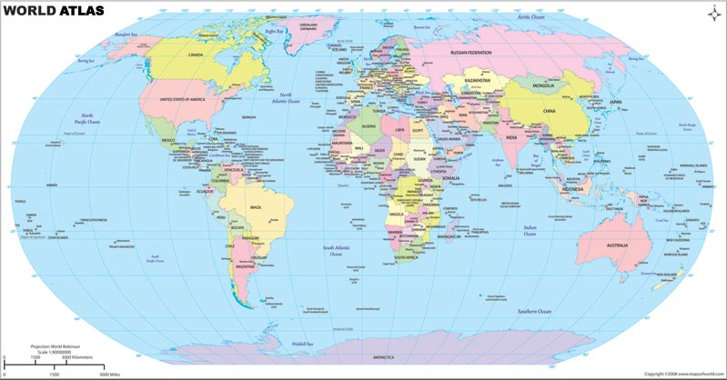

1. Where do you want to go someday in the future?

2. Why do you want to go there? What are you going to do there?

Lesson Plan - Speaking

Title: Travel to New York City

Name: Lee, Hyun-ju (Hyun)
Class: TESOL 70th WD
Instructor: Benjamin Chavez Valencia
Date: Dec. 01. 2011

