Lesson Plan – Listening/ Speaking/ Grammar/ Reading

Title – Fairy tale(The Frog Prince)

Instructor:  Hyun ju, Lee  (Hyun) | Level:  Upper Intermediate | Students:  10 Students | Length:  30 Minutes

Materials:

- Pictures
- Pre-Activity Word Flash Cards #1
- Main-Activity Worksheet #2 (10 copies)
- Post-Activity Worksheet #3(10 copies)
- Wards Cards
- White board and Board markers

Aims:

- Main: To enable Ss to improve their reading and listening skills
by working in pair to read fairy tale(the frog prince)

-Secondary: Ss will know about The New Frog Prince by reading , making sentences
and sharing their own ideas

- Personal: I want to work on(increase) my timing and pacing(a little slowly)
I want to increase my confidence

Language Skills

- Listening: Ss will listen to teacher’s instructions and classmates’ speaking.
- Speaking: Ss will practice their speaking by sharing their ideas
- Reading: Ss will read rewritten the Frog Prince
- Writing: Ss will make their own short story(sentences)

Language Systems:

- Lexis: vocabulary and phrasal verbs of the story
- Grammar: Can read the past and past continuous tense
- Function: Can read and make the new Fairy Tales
- Phonology: Show the word flash cards and repeating
- Discourse: none to discuss

Assumptions:

Students already know:
- how the class is set up and run
- the teacher’s style of teaching and the pace of the course
- they are all adults
- most students know about many fairy tales

Anticipated Problems: Solutions:

- Ss may not know about Fairy Tale → Explain the typical story

- Ss may need more time the work → Give Ss some more time
on the worksheet and help them

- If time is running out → Cut –off plan

- The lesson finishes early → Give Ss SOS activity

References:

- Times TESOL Workbook
- http://endic.naver.com
- http://www.google.co.kr/imghp
- Speed English Engine Ⅲ (Jungchul)

Lead-in
Materials: Board and Board Markers

Time  1 min | Set up  Whole Class | Procedure  Greeting :  Hello everyone.  How are you today?  (Ss: I’m good, tired…)  Good!  We have just ten days left to Christmas.  Do you have any special plan?  I hope something magical things are going to happen to everyone. Today I want introduce about something magical story like Christmas miracle.

Pre-activity
Materials: Pictures, Word Flash Cards, Word Cards, Board, Board Markers

Time  2 min  2 min  2min  3min  1 min | Set up  Whole Class  Whole Class  Whole Class  Whole Class  Whole Class | Procedure  1. Eliciting :  This is the picture about the stories.  Do you know who she is?  (Show and put the picture#1, 2, 3 on the board)  Alright. She is Cinderella.  What about this?  Right. She is Snow White and seven dwarfs.  This one is? Right. She is Sleeping Beauty and she is the little mermaid.  They are all characters in a story.  Do you know what kind of stories?  We are called this kind of stories …  Right. Fairy Tale!!  (Write “Fairy Tale” on the board)  Everyone knows some fairy tales.  I think even you don’t like reading, you have read about the Fairy Tales at least once.  Fairy tales is a kind of imaginary and happy stories like “Cinderella, Snow white and seven dwarfs and Sleeping beauty.  These are not real stories.  CCQ’s  1. Is Fairy Tale a magical and  happy ending story? (Yes)  2. Is Fairy Tale a true story? (No)  Right!  2. Vocabulary  Instructions:  Today, we are going to read one fairy tale.  Before we read, let’s get some words.  I will give you a word paper. Just in case, there is some information. After understanding please make some sentences to explain to everyone. And everyone can guess and answer.  Demonstration:  For example, I have this word.  This person is a female member of a royal family, usually the daughter of a king or queen or the wife of a prince.  (Ss: Princess!)  Right. The word is a princess.  (Put the word card on the board.)  I will give you 2minutes to think about and make some sentences.  Please don’t open the paper  before I say “Go”.  ICQs  1. What are you going to do?  2. Are you working individually?  3. How many minutes do you have?  (Give Ss word cards)  OK. Everyone start!  (Ss do the activity)  Monitor discreetly.  Answer students if they ask questions.  Give time warning: 30 seconds left.  Be flexible with time.  Alright. Time is up!  Who wants to explain first?  Go through the one by one  Students talking time  (Put the words cards on the board.  Explain some more if it needs  and make Ss repeat some words  and make Ss read the definition of word)  Ex) Hyun, please read the definition.  Hyun: wardrobe is kind of cabinets in which you can hang your clothes.  Please repeat after me.  Wardrobe. (Ss: Wardrobe.)  Go through the one by one  OK. Everyone did a good job.  Thank you.  3. Prediction  Instructions :  Now we know about the words.  I think we are ready to read the story.  (Pointing at the words card on the board)  I have a question.  Can you guess What my story is about?  Princess, frog and castle…  Can you guess the title of the story?  (Ss: The Frog Prince?)  Right! The Frog Prince.  Everyone knows about this story.  Alright, my story is “The Frog Prince.”

Main activity
Materials: Worksheet #2(Reading , Comprehension), Board

Time  1 min  3min  2min  3min  3min | Set up  Whole Class  Whole Class  Whole Class  Pair  Whole Class | Procedure:  1. Reading  Instructions:  OK. Now I’ll give you a paper of story.  Let’s read what the story is about.  I’ll give you 3mimutes.  Please, don’t read before I say “Go”.  Ok? Good!  (Give Ss worksheets #1)  ICQs  1. What are you going to do?  2. Are you working individually?  3. How many minutes do you have?  Alright, you can read now. Go!  (Ss do the activity)  Monitor discreetly.  Answer students if they ask questions.  Give time warning: 30 seconds left.  Be flexible with time.  Alright. Time is up!  What about the story, isn’t it fun?  2. Comprehension  Instructions:  OK. Everyone read The Frog Prince.  So now let’s check up your comprehension.  I want you to work in pair.  (Make the Ss in pair)  I will give a worksheet.  There are 10 sentences. Find out each sentence is True of False.  And if the sentence is false, please correct the any mistake.  Demonstration:  For example, “The princess was a man.”  is False. And the correct sentence is  “The princess was a girl”.  I will give you 3 minutes.  Please don’t start before I say “Go”.  ICQs  1. What are you going to do?  2. Are you working in pair?  3. How many minutes do you have?  (Giving Ss worksheets #2)  OK. You can start.  (Ss do the activity)  Monitor discreetly.  Answer students if they ask questions.  Give time warning: 30 seconds left.  Be flexible with time.  Give 1more minute if they need it.  3. Pair presentation  Instruction:  OK. Time is up.  Let’s find out the sentences are True or False. Who wants to be first?  (Ss volunteer or start in order)  OK. Hyun, can you start from No. 1?  Go through the one by one  Students talking time  Alright. Everyone did a really good job.  Thank you.
Post-Activity
Materials: Worksheet #3

Time  7min  3min | Set-up  Whole Class  Individually  Whole Class | Procedure  1. Free production  Instruction:  Alright. I hope you enjoyed “the new frog prince story”. Was it fun? Good!  Now, let’s make a new story this time.  Your own story.  I’ll give you paper.  Please wait until everyone has paper.  (Giving Ss worksheets #3)  OK. Let’s take a look paper quickly.  (Read the instruction on worksheet #3)  When the princess kissed the frog, the frog turned into SOMETHING.  But it was not a prince. Something different!  What did the frog turn into?  Use your imagination.  It could be anything.  Things, food, animals, people, flower, something valuable…  Demonstration:  For example, my story is about…  (Read the examples on the worksheet #3)  You have 3minutes.  ICQs  1. What are you going to do?  2. Are you working individually?  3. How much time do you have?  (Ss do the activity)  Monitor discreetly.  Answer students if they ask questions.  Give time warning: 30 seconds left.  Be flexible with time.  Give 1more minute if they need it.  OK. Time is up!  Who wants to tell us first?  Any volunteer?  Share students’ talking time  2. Error correction  Alright.  What is the magical story?  Unscramble word: lfyastraie  (Ss: fairy tales!!)  And I can’t hear any errors from you.  Alright! Good job!  3. Conclude lesson  OK.  This is all about my story.  Do you have any questions about today’s lesson? You did a great job today.  Thank you all of you.  You have a great day and see you all tomorrow. Goodbye!

SOS activities
Materials: Worksheet #4

Time  A) | Set up  Whole Class | Procedure  Instructions:  This time, let’s make the sentences correct order. Put each group of words in order to make a sentence that tells something. Write each sentence on the lone below the words.  (Make pairs)  (Giving Ss worksheets #4)  ICQs  1. What are you going to do?  2. Are you working in pairs?
Pictures for eliciting

#1
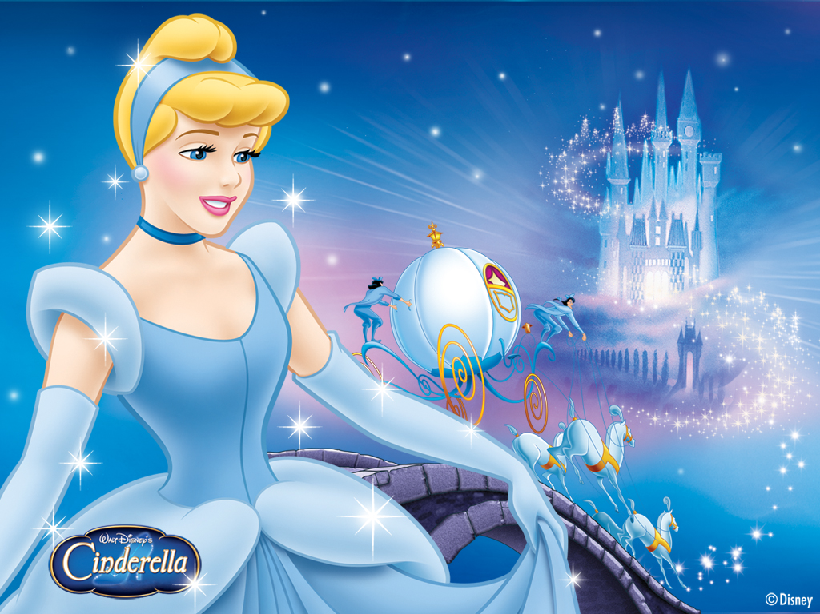

#2

Pictures for eliciting

#3
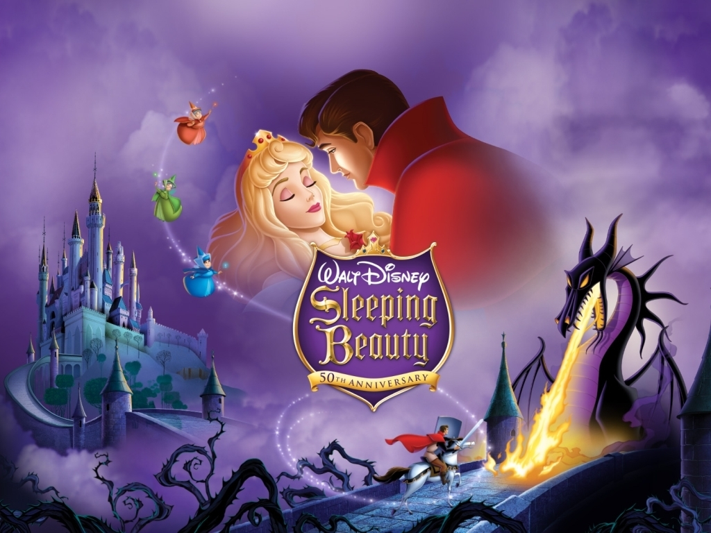

#4

Worksheet #1 (for pre - activity) – Word Cards

Bookworm Wardrobe
[|bʊkw3:rm] [|wɔ:rdroʊb]
A bookworm is someone A wardrobe is a tall cupboard
who loves books for their content, or cabinet in which
or who otherwise loves reading. You can hang your clothes.
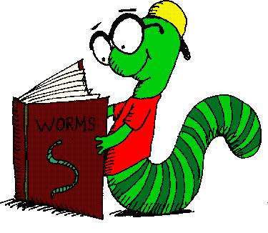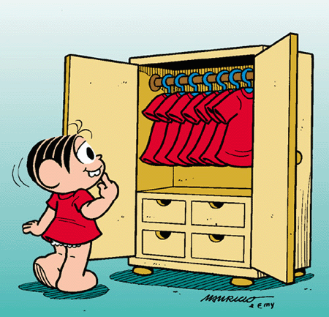

Croak Clatter
[kroʊk] [|klӕtə(r)]
It is a deep low sound If hard objects clatter,
like the sound a Frog makes. they make a loud unpleasant noise
when they hit against each other.
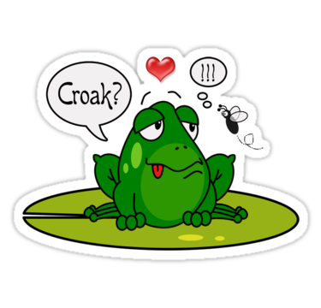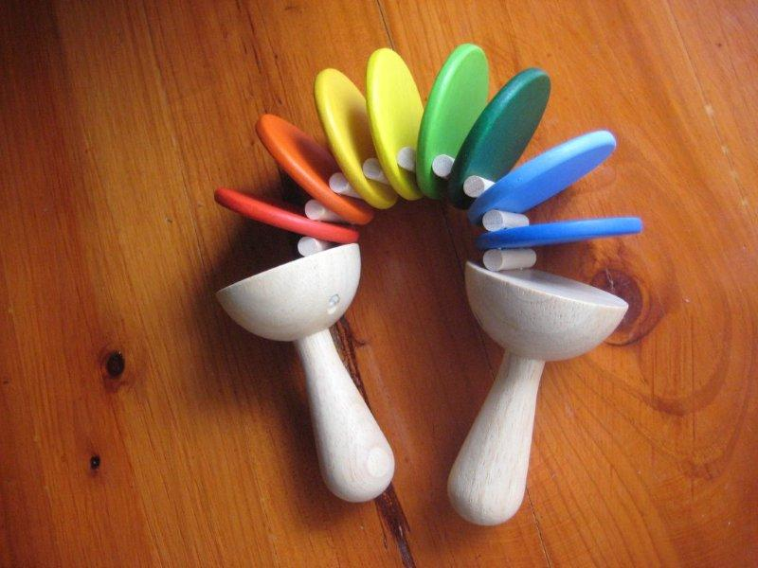
Worksheet #1 (for pre - activity) – Word Cards

Hide-and-seek castle
[|haɪd n |si:k] [|kӕsl]
A children’s game in which A castle is a large with thick,
a child tries to find other high walls.
children who are hiding.
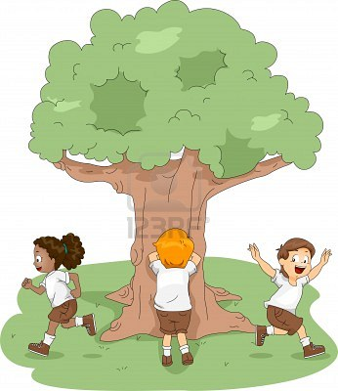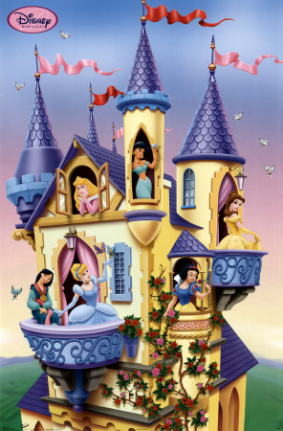

Frog lightning
[frɔ(ɑ):g] [|laɪtnɪŋ]
A frog is a small creature A bright flash of light in the sky
that lives near water and that happen during thunderstorms.
has long legs for jumping.
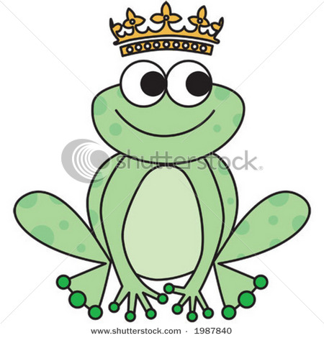
Worksheet #1 (for pre - activity) – Word Cards

Turn into Slip into

To change, or to make something To go in somewhere secretly.
change, into something different. Steal into

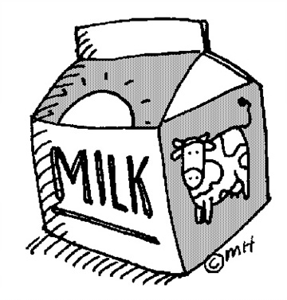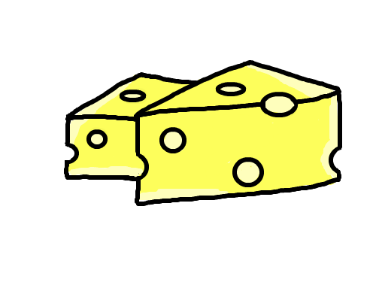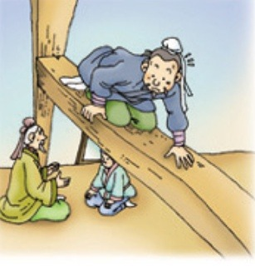

Bookworm [|bʊkw3:rm]
Wardrobe [|wɔ:rdroʊb]
Crock [kroʊk] – It is a kind of sound a frog makes.
Clatter [|klӕtə(r)] - a noise/sound
Hide-and-seek
Castle
Turn into Grubs turn into butterflies.
Slip into
Frog
Lightning
Princess

* Please read this story and remember as much as you can. Enjoy the story!

The Frog Prince

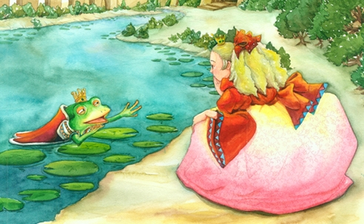

Not very long ago, there was a princess. She was so pretty that everyone loved her. Though she was a young girl, she was such a bookworm that on one knew more stories than her.
One day, when she was talking a walk outside, she found a golden frog. She talked to herself, ‘It must be the Frog Prince.’ “Oh, I know you. Once I kiss you, you’ll turn into a handsome prince and marry me.” She brought the frog home and kissed him. But nothing happened. “As I told you, you should change now. While I’m so beautiful, you’re too ugly this way.” She kissed again, but the frog was just croaking. “OK, I’ll wait.” After that, she treated him as if it was a prince. No matter who told her it was just a frog, she didn’t listen.
Several days passed. Since it was raining, they were playing hide-and-seek inside. “While I’m counting to ten, you hide. Don’t move until I find you.” The frog hid under the wardrobe. Suddenly, there was a flash of lighting. Hearing the clatter in the wardrobe, she opened it up. You know what was there? A handsome prince! “Oh, if you’re a real prince, please say anything but croaking.” “Uh… hi…” That evening, they got married and moved to the prince’s castle.
But, do you remember that the frog hid UNDER the wardrobe? In fact, he was still there. Having been told not to move, he kept waiting for the princess to find him. The prince? He might have slipped into the room to see a beautiful girl!

Worksheet #2

True or False

* Please mark the sentence is true or false.
If it is false, please correct the mistake.

1. The princess was very pretty and everyone loved her. T / F

2. The princess didn’t like reading books. T / F

3. The princess found the frog inside the castle. T / F

4. The princess didn’t know anything about the Frog Prince story. T / F

5. When the princess kissed the frog, he didn’t change into a prince. T / F

6. All the people in the castle thought the frog was a prince. T / F

7. On a rainy day, the princess and the frog played outside. T / F

8. While the princess was counting to ten, the frog hid under the wardrobe. T / F

9. When the princess opened the wardrobe, there was a prince. T / F

10. The frog was the prince. T / F

Worksheet #3

Now, let’s make your own story!

The story is about…

When the princess kissed the frog, the frog turned into SOMETHING.
But it was not a prince. Something different!
What did the frog turn into? Use your imagination.
It could be anything.
Things, food, animals, people, flower, something valuable…

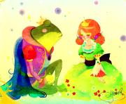

EX)
My story is about…
When the princess kissed the frog, the frog turned into seven dwarfs.
The seven dwarfs brought Snow White so we had a party all night.

Please, make short your own story.

When the princess kissed the frog,

Worksheet #4

* Please make correct sentences.

playing
were
they
inside
1.
hide- and-seek

→ .

2.
move
until
Don’t
I
find
you

→ .

3.
you
will
a
handsome

turn
into
prince

→ .

the
hid
4.
under
wardrobe
the
frog

→ .

Lesson Plan - Reading

Title: Fairy Tale (The Frog Prince)

Name: Lee, Hyun-ju (Hyun)
Class: TESOL 70th WD
Instructor: Benjamin Chavez Valencia
Date: Dec. 15. 2011

