Speaking Lesson Plan
Shopping Spree: Stick to Your Budget!

Instructor:  Anne | Level:  Upper Intermediate | Students:  11 |  | Length:  30 minutes
Materials:
- Pictures of Paris Hilton (11 copies)
- Expression lists (11)
- Dialogue worksheet (11)
- Blank sheets of paper (11)
- White board, board markers

Aims
-Main
: To enable Ss improve to their speaking skills through discussions on shopping styles.
-Secondary
: Ss will learn various shopping expressions through worksheets and dialogues.
-Personal
: I want to manage my teaching pace by speaking more slowly.

Language Skills:
- Reading: Ss will read dialogues
- Listening: Ss will listen to others say about their experiences
- Speaking: Ss will talk about their experience of shopping
- Writing: Ss will make their own dialogues

Language Systems:
- Lexis: impulse, spree, remorse, bulimic, hangover
- Function: sharing personal experiences
- Structure: none to discuss
- Phonology: none to discuss
- Discourse: none to discuss

Assumptions:

Students already know:
- How the class is set up and run
- Ss are older than 20 and some of them like shopping
- Every Ss has experiences of shopping and some of them have experience shopping spree

Anticipated Problems:  - Ss may not know a lot expressions  - If time is short  - If students finish their tasks earlier than anticipated |  |  | Solutions:  - Give them friendly explanations with examples  - Cut post-activity discussion short and only ask 2~3 Ss to share their experiences.  - Do SOS activity
References:
- http://blog.naver.com/homemaker33
- http://blog.naver.com/jmischelle/
- www.google.com
- http://en.wikipedia.org/wiki/

Lead-in
Materials: Board
Time  1 min | Set Up  Whole class | Procedure:  Hey everyone. How was your day yesterday?  Okay, is there anyone who recognizes this person?  (Show Ss the pictures)  Yes! She is Paris Hilton. What is she doing? (shopping)  Does anyone hate shopping?

Pre- Activity
Materials: Pictures, Board, Expression lists
Time  2 min  5 min |  | Set Up  Whole Class  Whole Class | Procedure:  I. Eliciting  T: Now, guess what this word is.  It’s shopping ______, and the word starts with the “s” and it rhymes with “glee” or “free.” (spree)  Have you heard of this term, “shopping spree”?  Shopping spree is a shopping trip that involves buying many items and spending lots of money.  CCQ  Does a shopping spree mean when you save money? (N)  Does a shopping spree mean buying a lot of things in one day (Y)  Today, we are going to talk about different shopping styles and share our experiences.  II. Expression  T: First, let’s look at some of the expressions that we might use when we go shopping.  (give Ss handout #1)  Instruction  Read a sentence by turns. After done reading, name one person and ask the person if she/he knows the meaning of any expression on the sheet. The person who was called the last time names another person and continues.  Demonstration  _____, do you know the meaning of #6?  - If the Ss has the right answer, let her point out another Ss  - If the Ss doesn’t know, give explanations  Do the activity until more than half of the Ss have spoken.
Main Activity
Materials: Dialogue work sheet, Board
Time  2 min  5 min  4 min |  | Set Up  Whole Class  Pair Work  Whole Class | Procedure:  I. Make Dialogues & Role Play  T: Are you guys ready to move on to the main activity? We are going to practice making dialogues using various expressions.  (Give Ss Dialogue worksheets)  Do you see the girl right there? What is she saying? (I’m broke)  What does that mean? (That she doesn’t have money at all)  Right! Let’s see what happened to her. _______, can you be “A” and _______, can you read “B”?  (Ss read the dialogue)  Great job!  Instruction  Make a dialogue using various expressions. Work in pairs. Write down the dialogue on the back of the sheet. You have 5 minutes.  CCQ  When you are broke, do you have a lot of money? (No)  When you are broke, do you have no money at all? (Yes)  ICQ  What are you doing?  How many minutes do you have?  Are you working individually?  Monitor discreetly. Give time warning.  T: Okay, now let’s see what everyone did. From this group right here, could you do a role play out of your dialogue?  (Everyone does a role play)
 | Post- Activity
Materials: Blank sheets of paper
Time  2 min  2 min  5 min  2 min |  | Set up  Whole Class  Individual  Whole Class  Whole Class | Procedure  I. Free Production  T: Have you ever been in trouble for going on a shopping spree?  Are there special occasions that you just want to buy things without worrying too much about money?  (Give Ss blank sheets of paper)  Instruction  Write down your experience of buying a lot of things. You have 2 minutes.  CCQ  Does impulse buying include shopping plan? (N)  Does impulse buying mean buying something without plan? (Y)  ICQ  What are you writing?  Are you working individually?  How many minutes do you have?  T: Now, let’s talk about our personal experiences. In my case, when I lose confidence, I tend to go on a shopping spree. ______? How about you?  II. Conclude Lesson  Error Correction  T: I didn’t hear any mistakes today. You guys did a great job.  Feedback  How was today’s class? Did you have any difficulties?  See you guys tomorrow!

SOS Activity
Materials: n/a
Time  5 min | Set Up  Individual | Procedure:  1.Paris Hilton  If you are Paris Hilton, how is your life going to be? Talk about it.

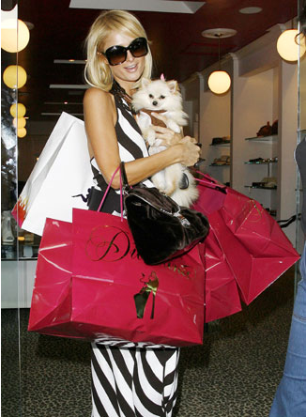
#1 Expression

- I bought it on impulse because it was a great price.
- You are a shopping addict and an impulse buyer.
- You are such a shopaholic.
- Because of my impulsive buying, I’m short of money.
- I went on a shopping spree.
- Impulse shopping inevitably causes regrets.
- It’s too late for buyer’s remorse.
- You’re always spending money right and left.
- I did it because it was on sale.
- I did it because I was afraid it would not be there on my next visit.
- Is it worth the money?
- I’ve tried to cut back, but it never works.
- Don’t go to the mall.
- You only get the urge to buy on impulse if you’re in a shopping area.
- I’ll just feast my eyes on them.
- Think before you swipe your card.
- Ask yourself if you need this.
- Stick to your budget.
- To beat impulse buying, you must live within your means and save.
- I was hit with the biggest shopping hangover.
- She is such a shopping bulimic.
- I’m broke.

Stick To your Budget!

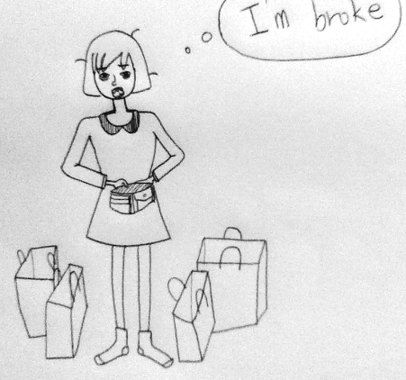

A: I went on a shopping spree and now I’m totally broke.

B: You always spend money right and left.

A: I know. What should I do?

B: Make a plan before shopping and stick to your budget!

Think about your experience of shopping spree and share your experience with your partner. Then make a dialogue using various expressions.

Be prepared for a brief role-play.

