Speaking Lesson Plan

Who’s your ideal person?

Instructor:
JEHAK LEE
Level:
Upper-Intermediate
Students:
20 students
Length:
20 minutes

Materials:
- Board and markers
- Six pictures
- Cards for activity (20)
- Papers (10)

Aims:
- Main aim: to enable Ss to improve speaking skills by doing a role play on finding an ideal person.
- Secondary aim: Ss will improve their speaking skills by doing a role play and making their own stories.
- Personal aim: I want to improve on my ICQ/ CCQ delivery.
I want to improve on my time management.

Language Skills:
- Speaking : Ss will present their new profiles and short stories with partners
- Writing : Ss will make short stories
- Listening : Ss will listen to each other’s presentations
- Reading : Ss will read their own sentences for profile and short stories

Language Systems:
- Phonology : other people’s presentation
- Lexis : ideal, some vocabularies on the cards
- Grammar : none to discuss
- Function : none to discuss
- Discourse : conversation when Ss make a pair and a short story

Assumptions:
Students already know:
- The teacher’s style of teaching and pace of the course.
- Ss are able to vary language form to suit the situation.
- Ss are able to express their ideas with occasional errors.

Anticipated problems and Solutions:

problems | solutions
When eliciting, Ss probably can’t answer the word of ‘ideal’ | I’ll give some hints : it starts with I and the sounds like the word of ordeal
Ss could be absent. Then the number of Ss will be odd. | I’ll be the partner with a Student who doesn’t have a partner. But I’ll be just a partner.

References:
www.naver.com (pictures)

Lead-In
Materials:
Time  1minutes | Set Up  Whole class | Procedure:  Hello, everyone. How are you today?  It’s really freezing out there. Right?  I really hate winter.

Pre-Activity
Materials: Board, Markers, 6 Pictures
Time  1minutes  1minute  4 minutes | Set Up  Whole class  Whole class  individually | Procedure:  Eliciting  (attaching a picture of couple on the board)  Of course you guys know this couple. They are hot issued couple in Korea last year. So what’s another meaning of a compatible person?  (Ss say the some words that they think right. But if there are no answer, I’ll give some hints)  the word starts with ‘I’ and sounds like the word of ‘ordeal’  (have Ss say the word Ideal)  Yes, that’s right. Ideal (person)  CCQ  Is an ideal person who you dislike? (NO)  Is an ideal person who is in your heart? (YES)  (attaching 4 pictures on the board)  (point at the first picture)  As you know, he is very rich.  (point at the second picture)  And she has a good looking.  (point at the third picture)  He has talent of talking and very funny.  (point at the forth picture)  And she is my ideal person. She has a hot body.  (point at the question mark which I attached before class on the board)  Imagine your ideal person. What is the most important quality when you are looking for an ideal person?  (drawing a circle on the board and write ‘qualities of an ideal person’ in the middle of circle)  Instruction  Now, I will give you 1and half minutes. All you guys come to the board and draw a line. And then, please write down in your own word of your ideal person.  For example,  Demonstration  (drawing a line from the circle and write ‘good looking’)  Like this. It can also be money, personality or religion. .  So,  ICQ  What are you going to do? Write quality on the board.  How much time do you have? 1and half minutes  Is it an individual work? yes  Now, everybody stand up! Let’s begin.  (everybody come to the board and write things.)  (I write on the board during Ss doing activity:  My ideal person is someone who is(has)_________because_____________________________.)  Time warning : 1 minute left  30 seconds left  10 seconds left  Alright done, go back to your seats please.  (I read this sentence using my own word.)  My ideal person is(has) good looking because I don’t care about money.)  (I’ll choose three to six Ss to speak by using this form)  So, (S’s name)  (when I gesture (point that sentence) S naturally follow the sentence)  (about 15 seconds to answer each person)  Good job.
Main Activity
Materials: Cards for activity, board and markers
Time  1minute  7minutes  2 minutes | Set Up  Whole class  individually  Whole class | Procedure:  Instruction  Now, I’ll give you a card randomly. In this card, I wrote down certain characteristics. Once you get your card, please introduce yourselves according to the card. Each person will have 15 seconds. After that, you guys will make a pair to find an ideal person. So please listen carefully.  For example,  Demonstration  (pick a card)  I’m going to introduce myself.  I’m a woman. I’m 28 years old. I don’t have a job. I have optimistic personality. My hobby is riding a motorcycle. And I have many piercings on my body. Etc.  ICQ  What are you going to do? introduce  How much time do you have? 15sec.  Is it group work? no  (distribute cards)  So, from ______goes first.  (Ss introduce themselves.)  (After a S spends their 15 seconds, if time’s up, I’ll say “(beep), next please.”)  (After finishing their introduce)  Did you listen carefully?  So now, you have 2 minutes. You are going to make a pair. And then, sit together with your partner.  ICQ  What are you going to do? Find a partner  How much time do you have? 2 minutes  If you find a partner, then what should you do? Sit  Now, please stand up. And find your ideal person.  Begin!  Time warning : 1minute left  30seconds  10seconds  Time’s up.  Let’s sit down, please.  (Ss move and make a pair)  (If a S doesn’t have a partner, then I’ll be a partner.)

Post-Activity
Materials: Papers, Board and markers.
Time  2 minutes  30 seconds  40 seconds | Set Up  Pair work  Whole class  Whole class | Procedure:  Instruction  From now, imagine yourselves as a couple in five years. And make a short story in pair. For example, we married, broke up, bore 5 children or whatever you want. Just make 3 or 4 sentences. I’ll give you 1 minute.  ICQ  What are you going to do? Making a story  How much time do you have? 1 minute  Who are you working with? Partner  Good, now begin.  (Monitor discreetly)  Time warning : 30 seconds left  10 seconds left  Alright, let’s time to listen to someone’s story.  (I’ll choose one couple. If I have more time, then choose another couple. I’ll give a S about 20 seconds.)  What’s you guy’s story?  (Ss answer theirs)  Great. It was really nice story!  Conclude  Feedback  Today, I can’t find any mistake, guys.  Error correction  (write down ‘deali nosper’ on the board)  I unscrambled. Guess what?  (Ss answer ‘ideal person’)  Right! Ideal person.  Good job today. This conclude today’s lesson. See you tomorrow and have a great day.

S.O.S Activity
Materials:
Time  2-4minutes | Set Up  Whole class | Procedure:  Instruction  Today we talked about ideal person. Then, let’s talk individually more specific. Who is your ideal person? I’ll give you 1minute.  For example,  Demonstration  For me, my ideal person is Jennifer Love Hewitt. She has a good looking. And she has a hot body too. I love her voice when she sings a song.  ICQ  What are you going to do? Talk about own ideal person  How much time do you have? 1minute  Are you working individually? Yes  (I’ll ask them individually, and if the class time finish then I’ll make class conclude.)

My profile
Gender : Male

Age : 60

Job : Body builder

Personality : Easily lose one’s temper

Hobby : dancing in a club

- Looks like Arnold Schwarzenegger
My profile
Gender : Male

Age : 30

Job : Businessman

Personality : easy-going

Hobby : travelling

- Religion : Unification church
My profile
Gender : Male

Age : 39

Job : Soccer player

Personality : tough

Hobby : reading a book

- Looks like alien (like a Ronaldinho)
My profile
Gender : Male

Age : 28

Job : movie star

Personality : arrogant

Hobby : taking a picture

- He can’t read a letter
My profile
Gender : Male

Age : 45

Job : archeologist

Personality : optimistic

Hobby : volunteering

- Looks like Tom cruise
My profile
Gender : Male

Age : 18

Job : millionaire

Personality : selfish

Hobby : playing the computer game

- Many girlfriends
My profile
Gender : Male

Age : 22

Job : cook

Personality : shy

Hobby : drinking

- Has no friend
My profile
Gender : Male

Age : 34

Job : student

Personality : romantic

Hobby : cooking

- Has no experience of love
My profile
Gender : Male

Age : 24

Job : pro-gamer

Personality : humble

Hobby : shopping

- Very fat
My profile
Gender : Male

Age : 42

Job : CEO

Personality : naive

Hobby : working out

- Very talkative
My profile
Gender : Female

Age : 18

Job : model

Personality : gloomy

Hobby : shopping

- Throw money away
My profile
Gender : Female

Age : 22

Job : designer

Personality : selfish

Hobby : taking a picture

- Religion : Unification church
My profile
Gender : Female

Age : 28

Job : None

Personality : optimistic

Hobby : ride a motorcycle

- Has many piercings on her body
My profile
Gender : Female

Age : 30

Job : flight attendant

Personality : easily lose one’s temper

Hobby : dancing in a club

- Beautiful, has a blue eye
My profile
Gender : Female

Age : 34

Job : teacher

Personality : naive

Hobby : reading a book

- Religion : Catholic
My profile
Gender : Female

Age : 39

Job : CEO

Personality : arrogant

Hobby : volunteer

- Divorced, has 2 babies
My profile
Gender : Female

Age : 45

Job : movie star

Personality : easy-going

Hobby : working out

- beautiful
My profile
Gender : Female

Age : 60

Job : millionaire

Personality : romantic

Hobby : travelling

- heavy smoker
My profile
Gender : Female

Age : 24

Job : figure skater

Personality : shy

Hobby : drinking

- ugly
My profile
Gender : Female

Age : 42

Job : president

Personality : tough

Hobby : playing the computer game

- Religion : Islam





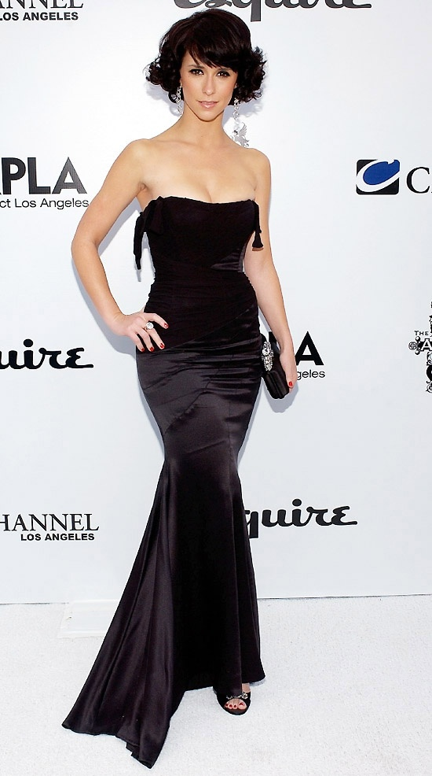

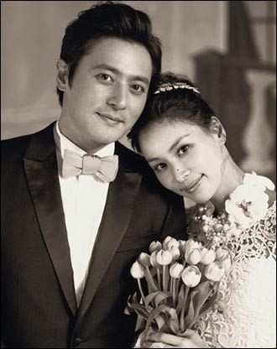

Please write couple’s story in five years.
(it should be 4 to 5 sentences)

