Topic : Days &School subjects

Instructor:  Sarah | Level: pre-Intermediate  (10~11 years old) | Students:  20 | Length:  30 minutes

Target Vocabulary:
English, math, science, music, art, P.E., Korean, social studies

Target Sentences:
What day is it today? Today is ___________. (Days of the week)
Do you have __________ class on Monday? ( school subject expression )
I have _______ class on Monday.

Materials: 1. O X board (days & school subject)
2. Pictures of school subjects
3. Worksheet
4. Song – “days of the week”, “Today is Monday”

Aims/Objectives:
Students will learn vocabulary and expressions relating to school subjects.
Students will be able to ask and answer the question using the expression
“What day is it today?” “What class do you have?”

Assumptions:
Students can ask and answer some simple questions.
Students have learned previously about the days of the week
Students already knew some words.(English, math, class, days of the week)
Students can follow the song.
Students can make short sentences with vocabulary used in the lesson.
Students have ever seen the weather forecast.

Anticipated Errors and Solutions:

When making sentence if some students make a mistake, encourage them to speak out. Let them do again. Or give some tip
When the class goes quickly, Ts ask more questions and play some game using the flash cards.

References:
http://kizclub.com http://www.eric-carle.com www.youtube.com

Lead-In
Materials: Song – days of the week
Time | Set Up | Student Activity | Teacher Talk
2 | Whole class | Saying hello to each other  Ss sing “days of the week” song. | Hello, everyone?  How are you today? Today is cold, isn’t it? What day is it today? What day was it yesterday? What day is it tomorrow?  Sing a song with Ss

Pre-Activity
Materials: pictures of school subjects ( English, math, science, music, art, P.E., Korean)
OX board
Time | Set Up | Student Activity | Teacher Talk
3 | Whole class | Listen & learn | Activity 1 – Ask and Answer  : Show the picture cards  Ask questions.  What day is it today?  What class do you have?  I have English class.
5 | Group  works | What day is it today ?(together)  It is *Monday. (S pick a day)  Do you have *English class today? (together)  Yes, I have _____ class today.  No, I don’t have _____ class today. | Activity 2- OX board game  Demonstrate how to play the OX board game.  Choose a day and pick a subject picture on that day. Ask “Do you have English on Monday? and flip over the picture. If you see an “O” you say “Yes, I have~~. And get some points.

Main Activity
Materials: “Today is Monday” song board
Time | Set Up | Student Activity | Teacher Talk
5 | Whole class | Sing a song  Look at the song board  Sing aloud with motions  “Today is Monday, Today is Monday. Monday, English  All you happy children Come and study hard.” | Activity 1 – sing a song  Sing a song  “Today is Monday.”  Sing after me.  Change the lyric.
5 | Pair work | Ask and answer the question.  And fill in the blank | Survey  : work sheet  Explain the worksheet and give it to Ss  Let’s survey.

Post Activity
Materials: Days & school subject flash cards
Time | Set Up | Student Activity | Teacher Talk
8 | Pair work | Play a game  Ss review today’s lesson  Ss receive the worksheet. | Activity 1 – snap game  Explain the snap game  Ss ask: What day is it? What class do you have?  T answer Today is ___.  I have _____class.  Review today’s lesson.
Wrap-Up
Materials: song
Time | Set Up | Student Activity | Teacher Talk
2 | Whole class | Sing a subject song.  Assign homework | Let’s sing a subject song.  Now, I’d like to give your assignment.  Make your own time table.  Did you have fun? See you tomorrow.

Days of the week

What are the days of the week?
____________ ____________ ____________ ____________

____________ ____________ ____________

What is your favorite day of the week?

_____________________________

Let’s talk

Ask your friends

What is your favorite day of the week?’ What is your favorite subject?’
And then write the answers in the table.
What is your favorite day of the week?

Name | day | subject
Saturday

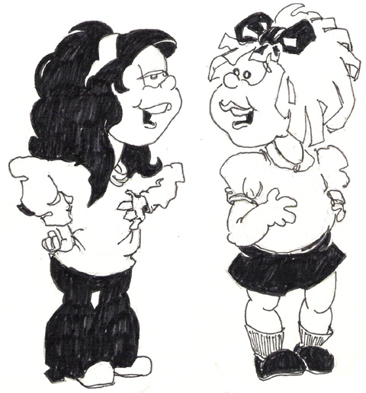

Songboard


