Topic: comparatives – I am taller than you.

Instructor:  Sarah | Level: pre-Intermediate  (11~12 years old) | Students:  20 | Length:  30 minutes

Target Vocabulary:
taller, shorter, younger, older, stronger, weaker, faster, slower, bigger, smaller

Target Sentences:
Which one (Who) is _______er?
I am _______er than you.( comparatives expression )

Materials:
adjectives picture cards, word cards

Aims/Objectives:
Students will be able to use expressions of comparison.
Students will be able to read words and sentences used for comparing things.
Students will be able to apply comparative expressions in life.

Assumptions:
Students already knew adjectives words.(tall, short, big, small, fast, slow)
Students are able to complete the simple sentences.
Students can make short sentences with vocabulary used in the lesson.

Anticipated Errors and Solutions:
Students may not have enough time to complete the activity.
• Give more time.( 1~2 minutes)
• Let them know that they don’t have enough time.
Students may not spell the word correctly. For example “bigger”
• Let them do again. Or give some tip.
When making sentence if some students make a mistake, encourage them to speak out.

References:
www.mes-english.com
www.teacherplus.co.kr

Lead-In
Materials:

Time | Set Up | Student Activity | Teacher Talk
2 | Whole class | Saying hello to each other | Hello, everyone?  How are you today?  Today is cold, isn’t it?

Pre-Activity
Materials: picture cards( adjectives ), word cards

Time | Set Up | Student Activity | Teacher Talk
3 | Make groups of 4 | Discuss and divide the cards in 2 categories. | Activity 1 – Categories  : Grouping Pictures  Divide 2 categories with these cards.  I want you to make two groups.
3 | Whole class | Match the word to the right picture.  It is *slow (one student)  It is *fast. (other student)  She is tall.  * slow, fast, strong, weak, tall, short,  Ss can answer. | Activity 2- Categories  : Matching word cards to pictures  I will give you word cards. Can you match the words to the right picture?  Very good.  Check answers  As the students guess, write the words on the board.  Could you write the word under the picture?

Main Activity
Materials: worksheet

Time | Set Up | Student Activity | Teacher Talk
7 | Whole class | Make a sentence using the cards.  Call out the words  Writing activity  Fill in the blank. | Activity 1 – making sentence  Ok, Let’s split the cards in a different way.  Can you make a sentence using your cards. Add er + than  Checking answers  After someone calls out the correct answer, write the word next to the sentence that you have written on the board.  As the matches are made, students can respond “ I am ____er than you.  Give them worksheet.
8 | Make groups of 2 | Do the mission  Make a sentence. | Activity 2 – Do the mission game  One student from each team will come up here. Pick a card.  Let’s read the question together.  “Who is stronger?”  Let’s do arm wrestling.  Who is winner?  ____ is stronger than ___.  Winner will get some points.

Post Activity
Materials: picture cards
Time | Set Up | Student Activity | Teacher Talk
5 | Make groups of 4 | Play the game.  Say the sentence together. | Activity 1 – Snap game  Work in pairs  CCQ : How much time do you have?  Put the cards in the middle of the desk.  When I say a sentence pick up the card quickly.
Wrap-Up
Materials:

Time | Set Up | Student Activity | Teacher Talk
2 | Whole class | Good bye. | Did you have fun?  You did a great job. See you next time.
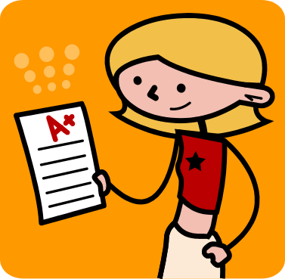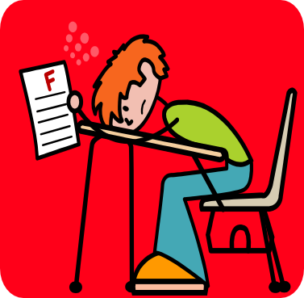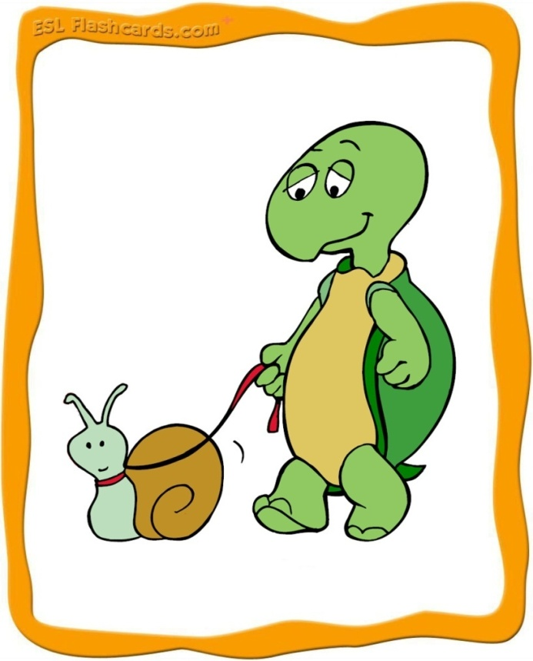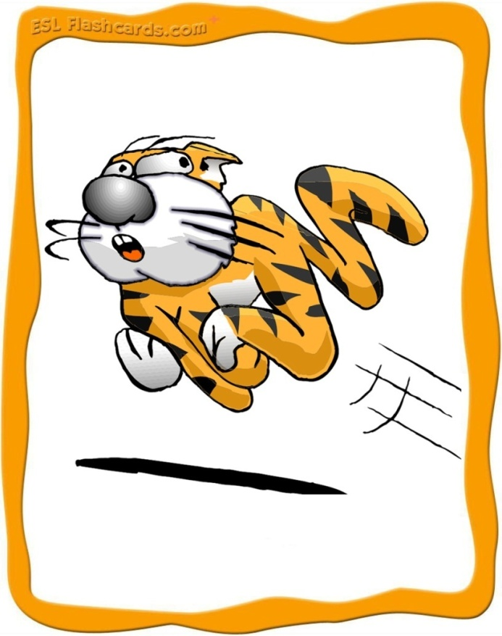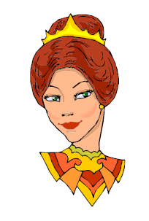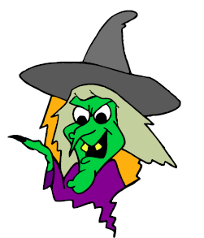
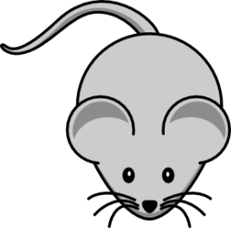
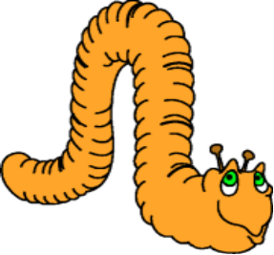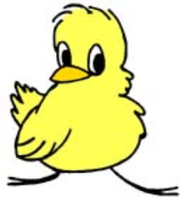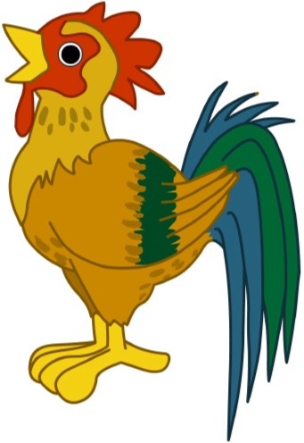
Name________________ Date______________
Make a sentence using the word below.

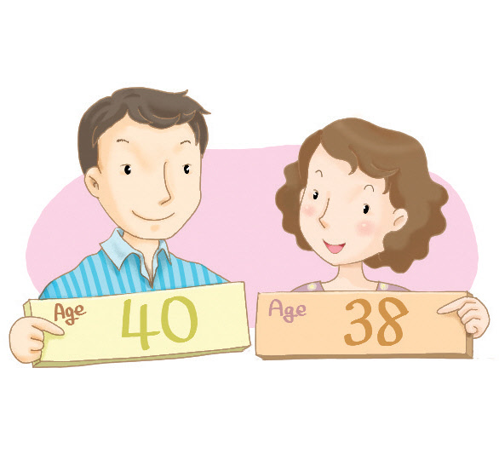 | 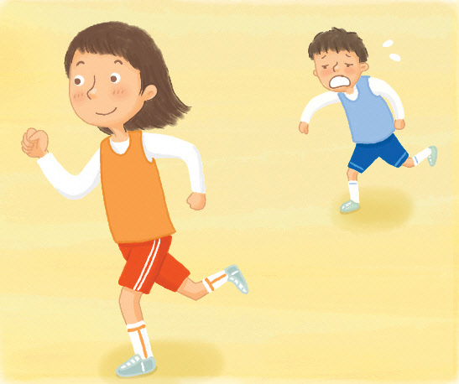
He is __________ than me. | She is __________ than me.
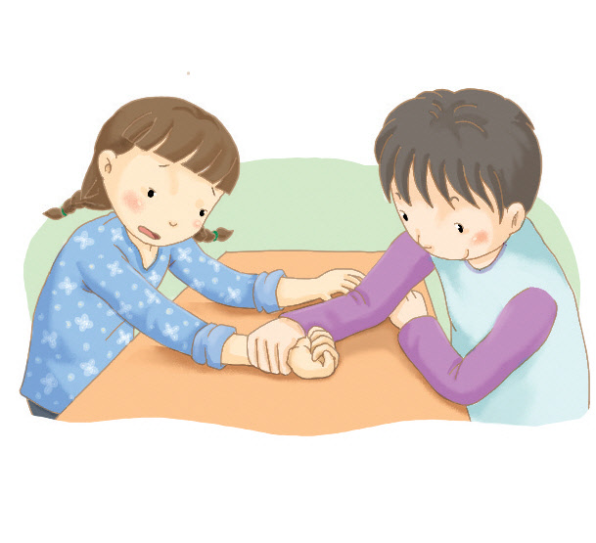 | 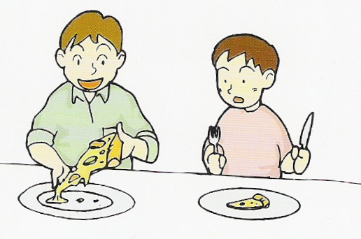
She is __________ than me. | His pizza is __________ than mine.
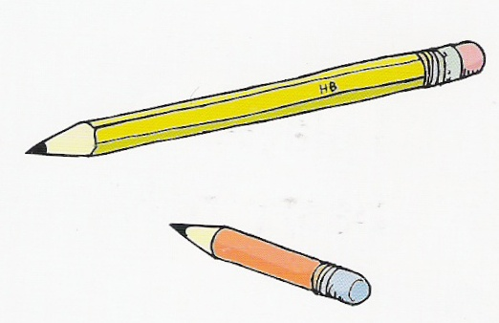 | 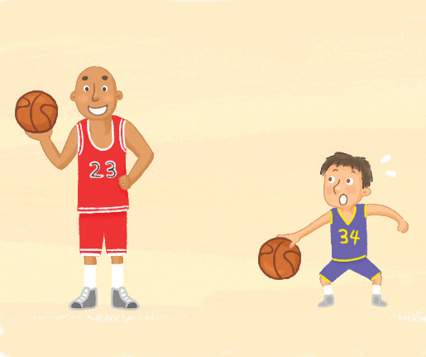
Your pencil is __________ than mine. | He is __________ than me.
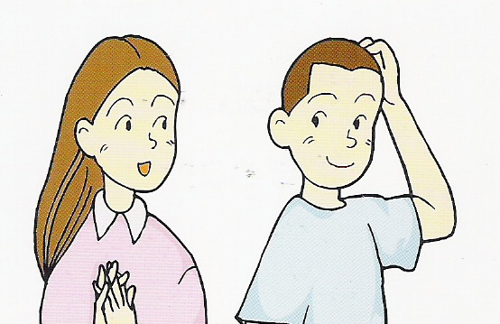 | 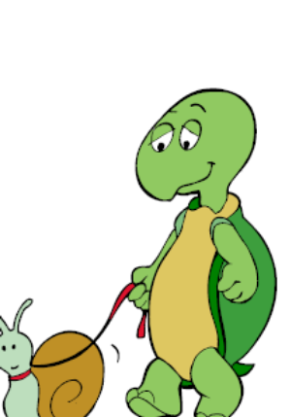
Her hair is __________ than me. | The tiger is __________ than the turtle.
Older younger shorter longer faster slower taller bigger smaller stronger weaker

I’m Stronger than You Name _____________Number______

Fill in the blank with the appropriate sentence to compare the two pictures.
Example
 The snake is longer than the worm. 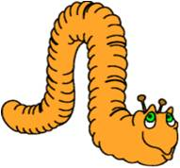

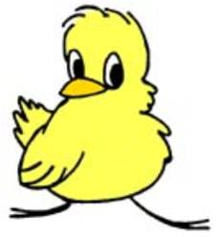 The chick is ___________________ than the chicken. 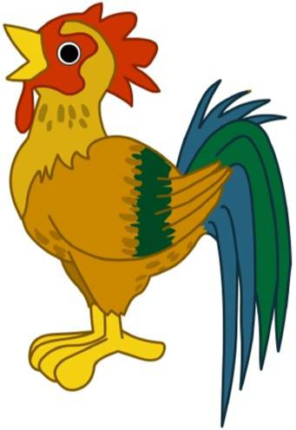

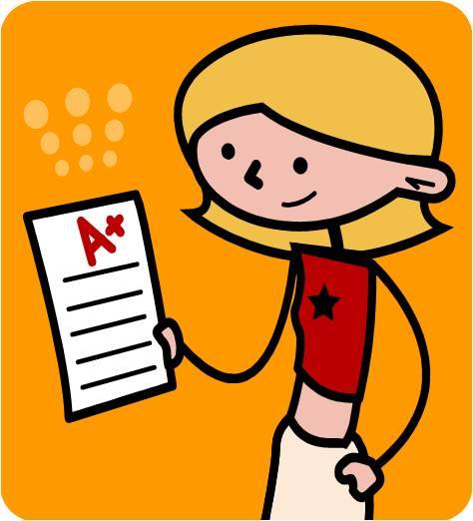 She is __________ than me.

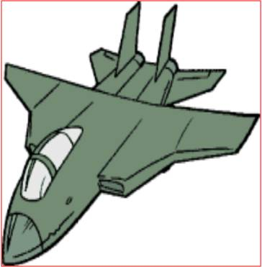 The jet is ________ than the car. 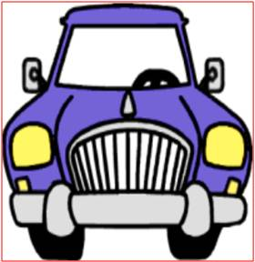

 He is ___________ than me.

In our class:

______________ is taller than ______________.

_____________ is stronger than _____________.

_____________ is shorter than _____________.

_____________ is older than ______________.

_____________ is faster than _____________.

