Topic: Let’s paint!

Instructor:  Sandy, Kim | Level:  the 5 to 6 year olds | Students:  14 | Length:  30 min

Target Vocabulary: hat, gloves, scarf, coat, socks, trousers,
red, orange, pink, brown, yellow, black

Target Sentences: - What color is this?
- It is ‘ ’.
- What is he wearing?
- He is wearing ‘ ’.

Materials: ppt, whiteboard, marker, 14 worksheets of picture
Color pencils/crayons: red, orange, pink, brown, yellow, black

Aims/Objectives:
- Ss will be able to pronounce the names of each garment and colors.
- Ss will be able to make use of the pattern sentence they learned in the class.

Assumptions:
- Ss may have difficulty pronouncing certain words
- Ss may already know all the colors they use in class.
- Ss may feel the task is too easy.

Anticipated Errors and Solutions:
- Ss may make mistakes using the pattern sentence at first.
→ Give them a great deal of time to practice.

References:
http://learnenglishkids.britishcouncil.org/en/language-games/paint-it/winter-clothes
www.google.com
Teaching English to Children by Wendy A. Scott and Lisbeth H. Ytreberg
Five-Minute Activities for Young Learners by Penny McKay and Jenni Guse

Lead-In
Materials: whiteboard, marker

Time | Set Up | Student Activity | Teacher Talk
2min | Whole  class | Greetings  - Hello, teacher?  - I am good! Thank you!  - Yes! | Greetings  - Hello?  - How are you everyone?  - It is great today, isn’t it?

Pre-Activity
Materials:

Time | Set Up | Student Activity | Teacher Talk
3min | Whole  class | Activity 1  - Yes!  - It is a skate!  - Yes, I like.  - No, I don’t. | Activity 1  - Draw a skate on the board  - Do you know what this is?  - Do you like skating?  - Do you often go skating?
5min | Whole  class | Activity 2  - It is pink!  - It is brown!  - It is black!  - It is red!  - It is yellow!  - It is orange! | Activity 2  - Show Ss all the colors they are using.  - What color is this?  - What color is this?  - What color is this?  - What color is this?  - What color is this?  - What color is this?

Main Activity
Materials:

Time | Set Up | Student Activity | Teacher Talk
7 min | Whole  Class  Pair  work | Activity 1  - Ss paint the scarf pink.  - Ss paint the hat red.  - Ss paint the socks yellow.  - Ss paint the coat brown.  - Ss paint the trousers black.  - Ss paint the gloves orange.  - Ss ask each other  ‘What color is this?’  ‘It is ( )’. | Activity 1  - After making sure they all know the color correctly & grouping  - Please everyone, paint the scarf pink.  - Please everyone, paint the hat red.  - Please paint the socks yellow.  - Please paint the coat brown.  - Please paint the trousers black.  - Please paint the gloves orange.  - After grouping  - Now ask your partner:  ‘What color is this?’  ‘It is ( ).’
7min | Whole  class | Activity 2  - He is wearing trousers.  - They are black.  - He is wearing gloves.  - They are orange.  - He is wearing a coat.  - It is brown.  - He is wearing socks.  - They are yellow.  - He is wearing a scarf.  - It is pink.  - He is wearing a hat.  - It is red. | Activity 2  - After finish coloring & grouping  - What is he wearing?  - What color are they?  - What is he wearing?  - What color are they?  - What is he wearing?  - What color is it?  - What is he wearing?  - What color are they?  - What is he wearing?  - What color is it?  - What is he wearing?  - What color is it?

Post Activity
Materials: whiteboard, marker

Time | Set Up | Student Activity | Teacher Talk
4min | Whole  class | - He is wearing a scarf.  - It is pink. | - Ask the Ss using pattern sentences  - What is he wearing?  - What color is it?
Wrap-Up
Materials: whiteboard, marker
Time | Set Up | Student Activity | Teacher Talk
2min | Whole  class | - Yes!  - Have a good time!]  - Bye! | - Do you like the work you did today?  - That is all for today!  - Have a good time!  - Bye!

WORKSHEET 1

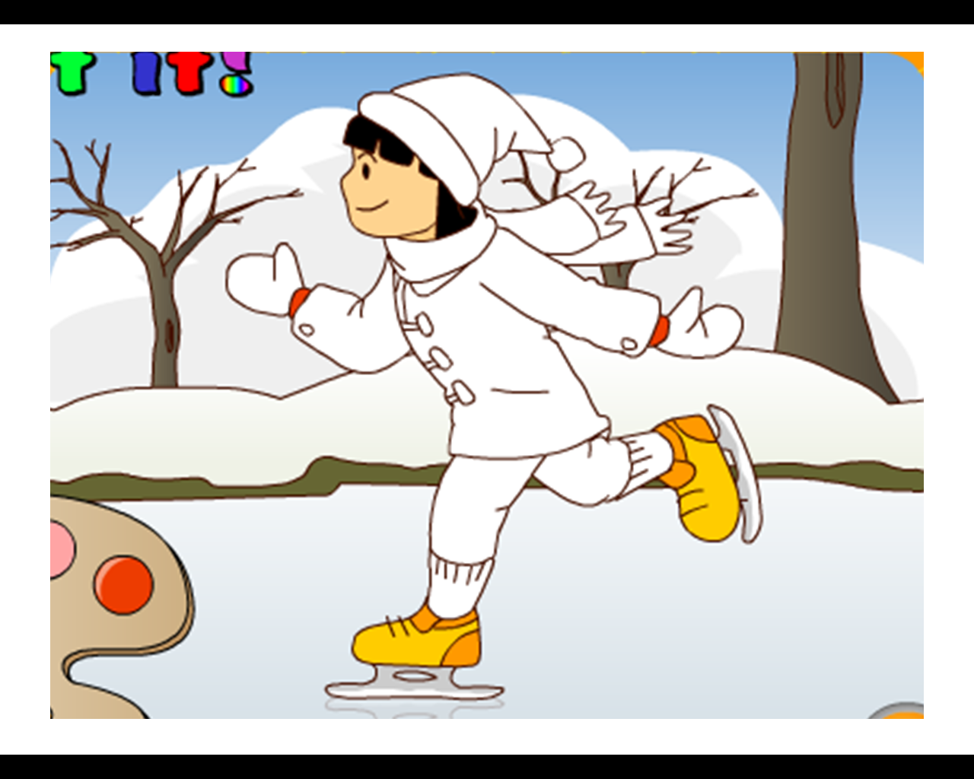

WORKSHEET

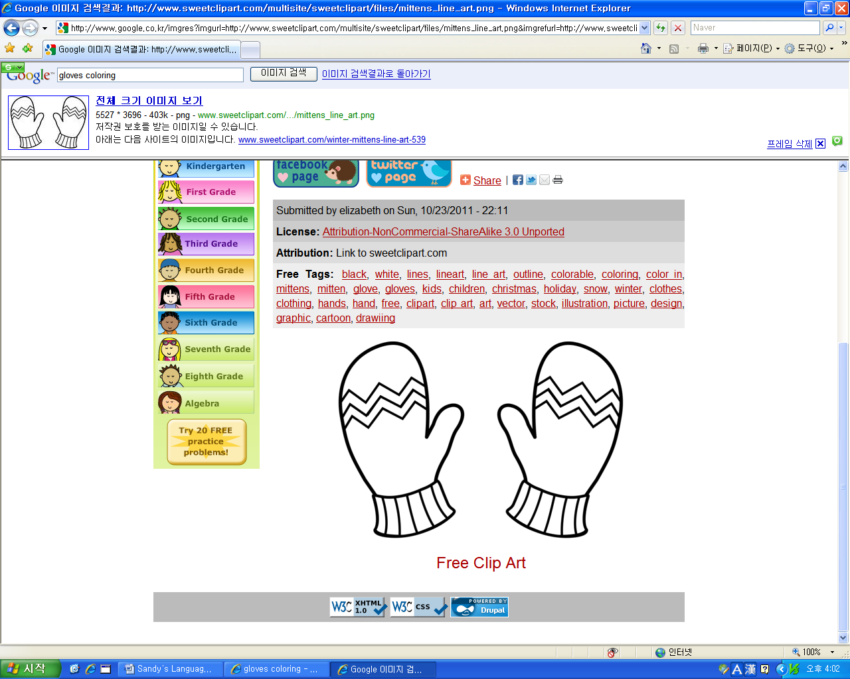

WORKSHEET

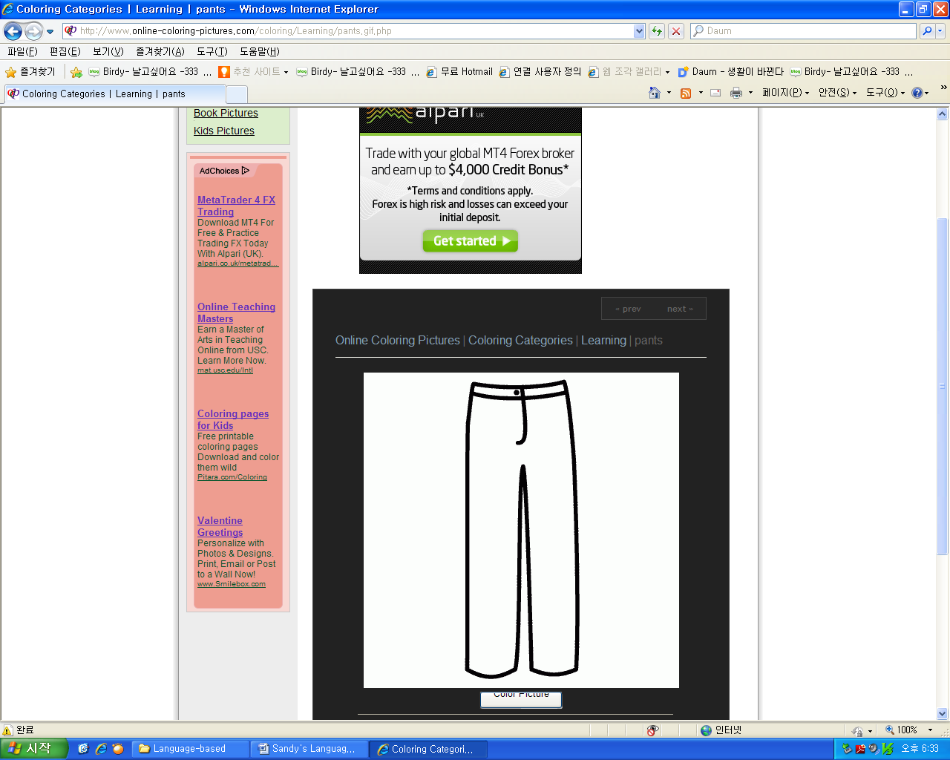

WORKSHEET

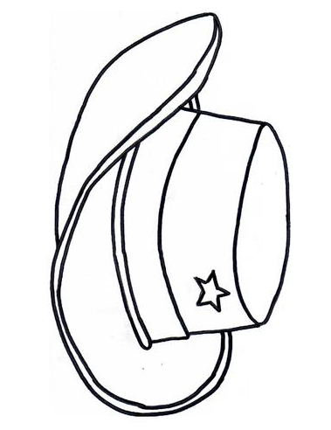

WORKSHEET

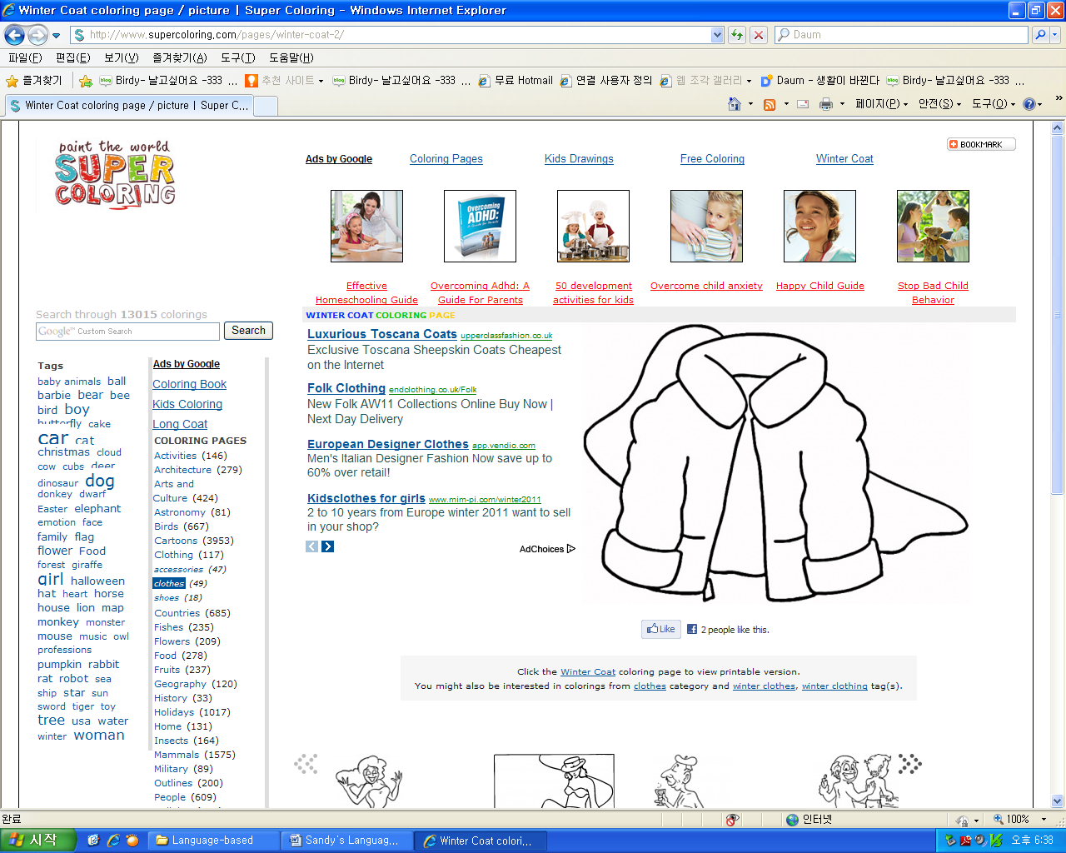

WORKSHEET

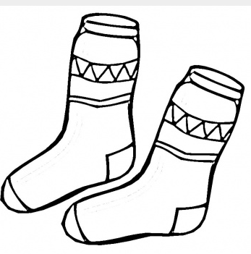

WORKSHEET



