Lesson Plan
 |  | Speaking Lesson Plan
 |  | Social Networking in today’s world
Instructors | Tina |  |  | Level | Intermediate |  | # of Ss: | 14 |  |  | Length: | 40
Materials
- White-board & Marker
- Pictures of SNS sites (original + 1 extra-copy)
- SNS word sheet(original + 1extra-copy)
- Worksheet#1-1,2,3,4 for explanation (6 copies per each sheet )
- Worksheet#2 for discussion (15copies and 1 extra copy)
- Worksheet#3 for creating a story (3 copies and 1 extra-copy)
- Worksheet#3 for Article script (15copies and 1 extra copy)
- Worksheet#4-1,2,3,4,5,6,7 for making a poster (3 copies per each sheet)

Aims
- To practice speaking by doing worksheet and activities
- To improve on skimming and scanning for information related to the topic.
- To practice listening and speaking through talking time with class mates.
- To practice the pronunciation by eliciting and talking using expression points.

Language Skills
- Listening : listening to the presentation and what the teacher says to the student and listening Ss saying through activities.
- Reading : Reading worksheets and information.
- Speaking : Discussion in group, answering to T ‘s questions, presentation to class
- Writing : Making sentences to do worksheets

Language Systems
- Lexis: Vocabulary in the worksheet and information related to the topic.
- Function: . The use of words in common expressions
- Phonology: Practicing new words related SNS
-Discourse : Group work and talking each other about their topic (SNS)

Assumptions
Students already know:
- How the class is set up and run ( Ss are sitting in pairs)
- They are intermediate level
- The teacher’s style of teaching and pace of the course
- Ss are familiar with pair work and discussion
- Ss have experience to use SNS
Anticipated Errors and Solutions
- Ss may not use any social networking sites.
→ Give Ss explain it to Ss, If most Ss don’t know how to explain it, T will explain more.
- Ss may not be able to make sentences for activity within limited time
→ Give hands to them and examples for Ss not to be embarrassed
- If the Ss cannot finish the task in time,
→ Give hands to them and make the question simply.
- If the Ss do their works earlier than planned,
→ Let Ss to share their idea to a different person other than their partner.

References
- TIMES TESOL Workbook, Long Beach USA
- http://www.google.co.kr/images?hl=ko&newwindow=1&gbv=2&tbm=isch&sa=3&q=kakaotalk+icon
- http://www.helium.com/items/757605-the-negative-side-of-facebook
- http://www.scribd.com/doc/12682789/Pros-and-Cons-of-Social-Networks

Lead-In
Materials |  | Picture sheet of SNS sites , White-board
Time |  |  |  | Set up |  | Teacher Activity
2 min |  |  | Whole class |  | Procedure:  - Hello, everyone. How are you today?  - is there anyone who is using a kakaotalk with smart phone  now?  [Eliciting]  <Instruction>  ( Showing the picture sheet to Ss and ask)  - Look at this picture. What do you think about these pictures?  (Ss may say that facebook, SNS , youtube)  Do you know what the “SNS”means ?  (Ss answer but T doesn’t need to give answer )  - OK, Today, We are going to talk about social networking services. But first, we will learn some famous SNS sites at the next step.
Pre-Activity
Materials |  | White-board, Marker, SNS world sheet ,Worksheet #1 -1,-2,-3,-4
Time |  |  | Set up |  | Teacher Activity
10 min |  |  | Whole class  Group  Individually  Group  Whole class |  | Procedure:  New Vocabulary –Reading and Explanation (Pre-Activity1)  <Instruction>  T post the words (SNS),  -Guys Who knows what SNS means ?  (Ss answer and then T post the word (Social network Service)  T shows “Worksheet #1 Let’s Look at SNS sites Pictures” (Facebook, skype, facebook, kakaotalk,)  - Ok guys, Pls look at this pitcure, we need to explain each of them in detail. First of all Let’s take a seat as 4 groups!  You 3, you 3, and you 4 and you 4.  And I will give some information of each social network site to each group .After reviewing an information sheet with your group members. All the members of each group need to explain the site to class mates.  -You will have 4 minutes  -And Presentation time will be given 1 minute to each group  [CCQ]  - How much time do you have??  - What do you have to do with your group members?  - How much time will you have to do presentation?  (Distribute worksheet #1 -1,-2,-3,-4 )  -Walk around and monitor the Ss. Answer if they ask question.  -Let them know the time limit by saying “You have minute left.”  -If Ss need more time, give 1 or 2 minutes to finish. If every Ss are struggling, T should explain the meaning.  Ok guys times up  Who is willing to volunteer?  Group A, Pls do a presentation about what your group’s SNS site  (All group and group members are involved for presentation)  <Feedback>  - How was it ?  - Do you understand what SNS mean ?  - Was it difficult to explain it in English ?
Main Activity #1
Materials | White board, board marker, worksheet #2, Note, Pencil or Pen
Time |  |  | Set up |  | Teacher Activity
Main Activity #1
9 min |  |  | Whole class  Group  Individually  Whole Class |  | Procedure:  Let’s talk about negative and positive of social networks  <Instruction>  It’s time for playing game.  Before starting game, we need to make 3 groups .  You 5 , you 5 and you 4.  -As you know, lots of people are using more than one social network sites by using computer or mobile phone. Let’s think what are the negative or positive effects of social network sites?  Now each group talks and finds what the negative and positive effects of SNS.  Guys, Don’t forget that, before doing brainstorming, each Ss should talk about their habit of using SNS site with pair.  Each group has 4 minutes.  And The presentation time is limited within 1 minute to each group.  <Demonstration>  Look at this Worksheet #2, there are common 2 questions.  You can make answers for the Question 1, 2 based on your experiences with your class mates sitting next of you.  And the Question 3, We need to ask and answer your group members.  For example, One person asks his partner Question No1 “Which SNS sites do you use?”, then the partner can answer that “I use facebook as my SNS site”.  And to find the positive and negative things of SNS sites, I need to talk with our group members.  Then someone in your group is required to do a presentation  [CCQ]  - What are you doing now?  - Do you work as a pair, group or case by case?  - For what, do you have to talk with your group members?  (Distribute the Worksheet #2 -1,-2,-3,-4 to each group)  -T moves around classroom and check that Ss need to talk with their partner for the questions 1 ~3 in pair.  - Let them know the limited time by saying  “You have minute left.”  -Let’s check the Ss Answer on by one.  - A group who will be the volunteer to do presentation.  (Ss answer what they prepared )  <Feedback>  - How was the presentation?  - Was it easy? Or Difficult for you to do activity?  - Do you have enough time to think about your SNS?
Main Activity #2
Materials |  | White board, board marker, worksheet #3, Note, Pencil or Pen
Time |  |  | Set up |  | Teacher Activity
9 min |  |  | Whole class  Group  Individually  Group  Whole Class |  | -O.K. Let’s move to the next activity  Procedure:  <Instruction>  (T shows several pictures of the Worksheet # 3.)  -Guys look at these pictures, what can you guess from these pictures?  -Those pictures are related with one article which is not a fiction but reality.  -Before doing activity, we need to make 4 groups  -You 3, and 3, and you 4 and you 4.  - Using these pictures, each group needs to create a story freely.  -Ok guys, you will have 4 minutes.  -And the presentation time for each group will be given  just 1 minute.  [CCQ]  - What are you doing now?  - Do you work as a pair or group?  - How many time do you have?  (Distribute the Worksheet #3 to each group)  (T moves around classroom and if Ss ask something, T helps Ss understand)  (Let them know the time limit by saying  “You have minute left.”)  - Ok guys, Let’s check answer for each group.  - Who will be the volunteer ?  -Ok _____ Pls speak aloud what your group created  <Feedback>  - How was it?  - Was this story interesting?  - To prevent any unexpected problem from SNS what you have to do?

Post-Activity
Materials | Worksheet # 4 , Note, Pencil or Pen
Time |  | Set up | Teacher Activity
8 min  2 min |  | Whole Class  In pair  Whole Class  Individually  Whole class  Whole class | 1.Procedure:  <Instruction>  -Guys, for this activity, we are going to do with your partner. Not a group.  You 2, you 2,,,and you 2.  I will give you a worksheet, There is a image related Facebook, With your partner, find out what the image means.  (T shows worksheet #4)  Each team will have 3minutes  Then Each pairs needs to do a presentation shortly in front of class with your partner within 30 seconds.  <Demonstration>  For example, Look at this picture (Facebook drug )  With this image, I can say that Many people are addicted to Facebook these days, because it is easy to access to facebook by mobile phone.  [CCQ]  - How much time do you have??  - Do you work in pair ?  - What will you do with this worksheet ?  (Distribute worksheet#4 -1, 2,3,4,5,6,7 to each pairs)  (T moving around classroom. If Ss asks something then T gives Kind explanation to Ss)  (Let them know the time limit by saying  “You have minute left.”)  -Let’s listen to what the other teams made with image.  - Who will be the volunteer to make presentation.  (Ss give a presentation freely )  <Feedback>  - How was it?  - Do you learn about SNS well?  - Do you want to have more SNS site?  2.Conclude lesson  (Give a homework)  Did you enjoy today’s speaking class?  I hope you enjoyed practicing speaking english through  the activities .  Today, there is not tomorrow’s assignment .  Good job today. See you tomorrow!
Title : Social network in our world
- Picture sheet of SNS sites (Lead in)



Title : Social network in our world
-SNS word sheet (Pre-Activity)
SNS
Social Networking
Service

Title : Social network in our world
Title :Social networking in today’s world
Worksheet #1: Let’s look at SNS sites (picture)
- Facebook - Skype


- Kakaotalk - Cyworld


Title : Social network in our world
Title :Social networking in today’s world
Worksheet #1: Let’s look at SNS sites- 1
(for Explanation with group)

- Facebook :
- 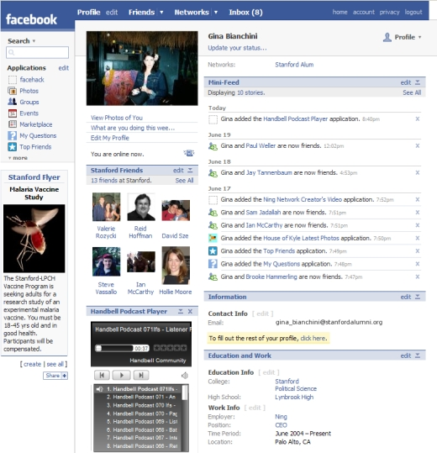

Facebook is now the largest social network in the world,—with 132 million unique visitors, it is also still the fastest growing.
(At least among the major social networks)..Facebook’s visitor growth is up 153 percent on an annual basis. The strongest point of facebook is that it can automatically add your friends easily without efforts. Sometimes it can find not only your old friends but also the people who you don’t even know. If you do business, facebook will be helpful for owners to interact and communicate with customers by increasing website traffics

Title : Social network in our world
Title :Social networking in today’s world
Worksheet #1: Let’s look at SNS sites -2
(for Explanation with group)

- Skype
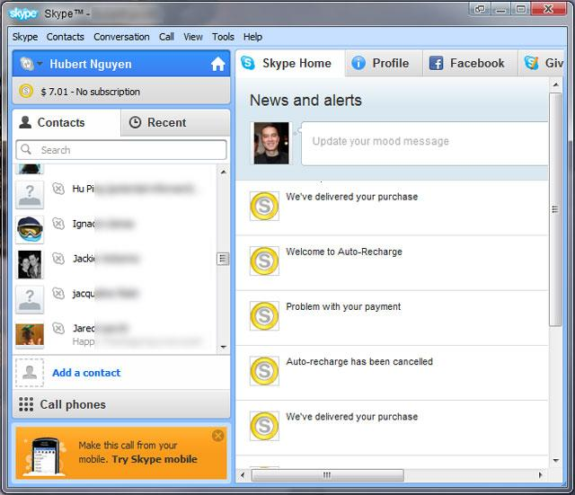
Skype allows users to telephone each other for free – if using another computer or wireless mobile phone or smart phone. It allows people to phone each other in different countries at a greatly reduced rate – the cost of a local landline call, Of course the users within skype service are free of charge. Other similar networks allow one to telephone to far off countries at an even lower telephone rate than Skype charges. It is popular for business who need to call to their customer within the skype service

Title : Social network in our world
Title :Social networking in today’s world
Worksheet #1: Let’s look at SNS sites -3
(for Explanation with group)

- Kakaotalk
- 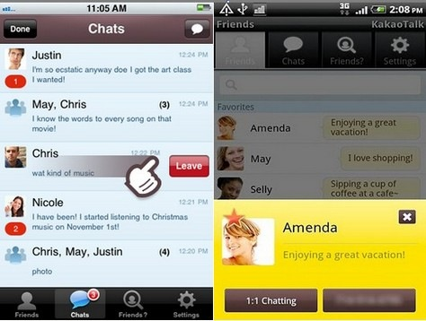
KakaoTalk is a free mobile messenger application. It allows Android and iPhone users to chat one-to-one or in a group anywhere in the world. Besides texting, it supports sharing of pictures, videos or contact information. KakaoTalk is a phone number based service. So, you only need to enter your phone number to use this service. No registration or logging-in required. KakaoTalk mobile application is currently available in English, Japanese and Korean.

Title : Social network in our world
Worksheet #1: Let’s look at SNS sites -4
(for Explanation with group)

- Cyworld
- 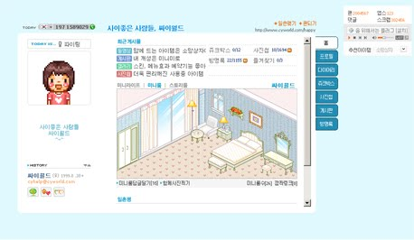
In Korea, even though Twitter and Facebook are getting famous, Cyworld (www.cyworld.com) is still the most popular social network service. Cyworld provides an individual virtual space called “Minihompy” where people can manage their diary, photos, notes, and visitor .This service started to get popular about 5 years ago. Today, most Koreans have their “Minihompy” just like their homes in the web.
Like the other Social Networking sites, Cyword has their specific terms too. For example, ll-chon, which means your friends (www.facebook.com) or followers (www.twitter.com). Il-chon is a Korean term which means the degree of blood relationship in the family. Those terms are now being used in daily conversation among Koreans who have accessed to this Social Networking Site.

Title : Social network in our world
Worksheet #2: Let’s Talk
-(write down sentences you think out)
1. Which SNS site do you use?

2. How often do you use them ?

3. Based on your experience, think of positive and negative points about social networks
Negative
Positive
Title : Social network in our world

Worksheet #3:Let’s Making a story
Title : What ruined her 16th birthday party ?
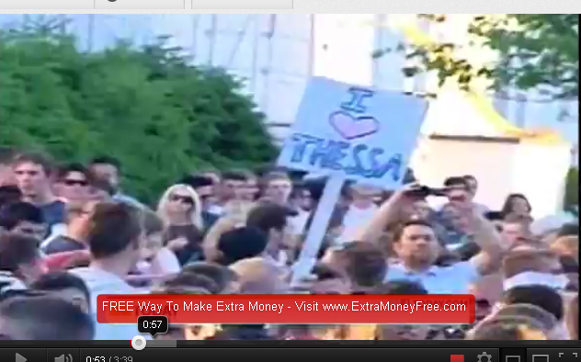
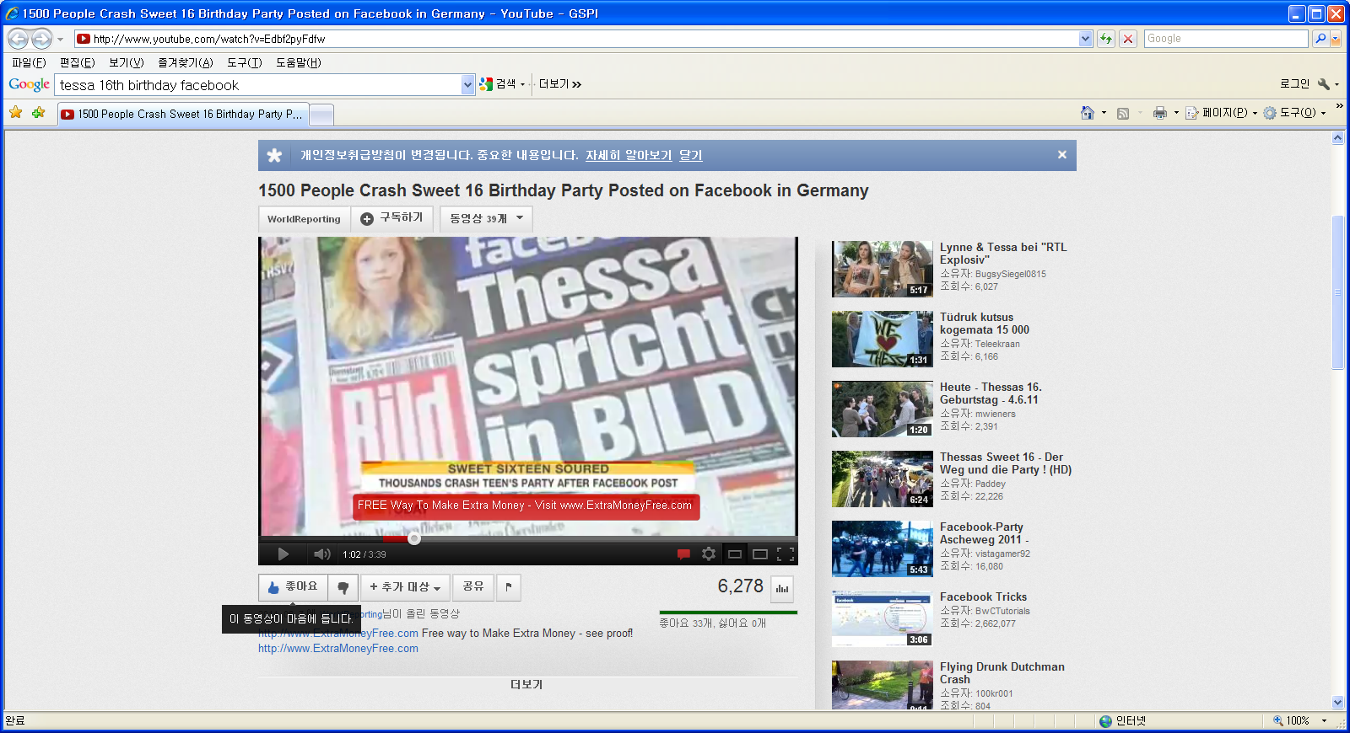

Title : Social network in our world

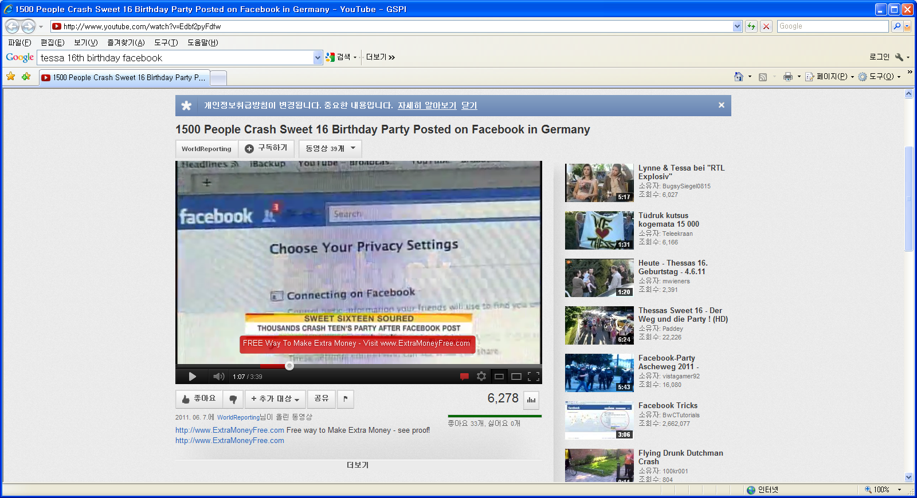
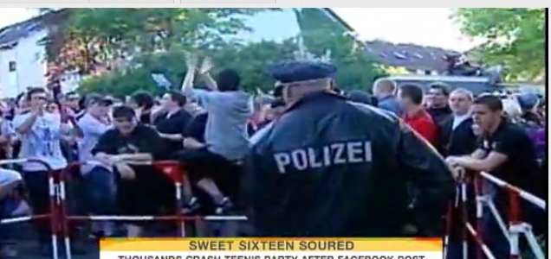

Title : Social network in our world
Worksheet #3:Let’s Making a story - Answer
Title : What ruined her 16th birthday party ?
Script
One girl’s Sweet 16 party ended in tears after she forgot to change a little privacy setting on Facebook, resulting in more than 1,500 people showing up for the party in Hamburg-Bramfeld, Germany.
The girl quickly left the party, but it took more than a hundred police officers to control the crowd. Eleven people were detained, two small fires broke and one cop was injured. All of this happened because the birthday girl, identified as Thessa, forgot to change her party’s status from public to private on Facebook.
Besides the injuries and fire, there were quite a lot of people ready to be entertained and enjoy the gathering.
Perhaps parents need to stress the importance of Facebook privacy to their kids. We can’t stress enough how important is to check your privacy settings, but maybe this story will act as a cautionary tale for others to tell and spread the word.

Title : Social network in our world
Worksheet #4 Let’s make a poster -1
Let’s think and talk with the picture


Title : Social network in our world
Worksheet #4 Let’s make a poster -2
Let’s think and talk with the picture


Title : Social network in our world
Worksheet #4 Let’s make a poster -3
Let’s think and talk with the picture


Title : Social network in our world
Worksheet #4 Let’s make a poster -4
Let’s think and talk with the picture


Title : Social network in our world
Worksheet #4 Let’s make a poster -5
Let’s think and talk with the picture



Title : Social network in our world
Worksheet #4 Let’s make a poster -6
Let’s think and talk with the picture



Title : Social network in our world
Worksheet #4 Let’s make a poster -7
Let’s think and talk with the picture



