Creating Advertisements
I. Analyze your product and consumer
1. Product:
- Find out WHAT is so special and unique about your product
Ex> Pencils: Do they need to be sharpened or be lead replaced? Are they easy to grip, should they be smooth and stylish, and come in many attractive colors, etc.?
- Highlight the product benefits. Make a list of your product benefits and then rank them in the order of importance to your consumer (not to you). Concentrate on the top most benefits.
- Make sure you focus on only one compelling reason otherwise you will confuse your reader/consumer.
- Identify relevant unique product offerings. By relevant it should be something that the consumer needs or likes, and not that's unique for the sake of it.
Ex> An example of something unique to your product but not relevant is a colorful garbage bag.
2. Customer:
- Think of target audience, who are interested in buying the product or using the service. Understand WHO will buy or use your product/service. Search for as much information about them as possible.
Ex> If you are selling a pencil, your target audience may be kids, students, women, men or teachers.
- Are they the users, buyers or influencers? In the case of pencils, users may be students, buyers are parents and influencers are friends.
- Understand WHY will they buy or how will they use your product. Why consumers buy this product category, your brand or the competitor's brand. Consumer can buy a product because they “need” it; or because they “want” it; or because they “need and want” it.

II. Create your product message
- Decide HOW to effectively convey the Product message.
- Think of your target audience’s needs and wants
- Normally the product benefit is highlighted in the ad by using catchy headlines/slogans and attention grabbing visuals. There’s no second chance at making a good first impression. If the advertisements don’t catch consumers’ attention within seconds, they are considered failed.
- Headlines/slogans: Use rhyming, alliteration, key words, enthusiasm for slogans.
Ex> Nike “Just Do it”, Volkswagen “Think Small”, Marlboro “The Marlboro Man”, Absolut Vodka “The Absolut Bottle”, Chanel “Share the fantasy”
- Visuals: eye-catching pictures, unconventional and entertaining images
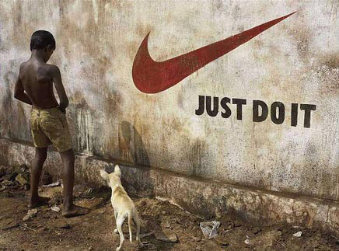 Nike (Just Do It)
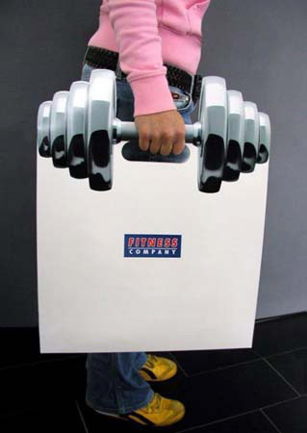
Fitness Company
Mr. Hot Pepper

- The product claim you make should be credible and trustworthy - don't make incredulous claims that your product cannot deliver.
- For the tone and style of the advertisement, you need to keep your target audience in mind. Use imperative voice for clarity. It should get their attention, be easy to understand, informative, correct in tone and manner and above all entertaining.
- Engage the consumer to make your ad ''stand out'' in clutter and be different from competitors. Words such as “Free”, “Extra”, “Best”, “New” or “Now” are the traditional favorites. For an instant response, action words such as “Call Now”, “Hurry”, “Rush”, work well.
- Don't forget to include all the information that is required, but at the same time don't overload. Keep it simple and short.
- Is there an unmet desire or need, any frustration in the mind of your consumer? Assess the need gap that exists for the product or service. Think about how you will please your customers having those unmet desires.

