Worksheet_1 [Eliciting-funnier]
Worksheet_1 [Eliciting-slower]

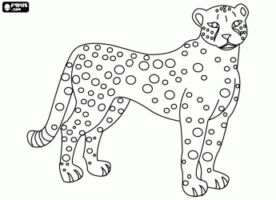

Worksheet_1 [Eliciting-more delicious]
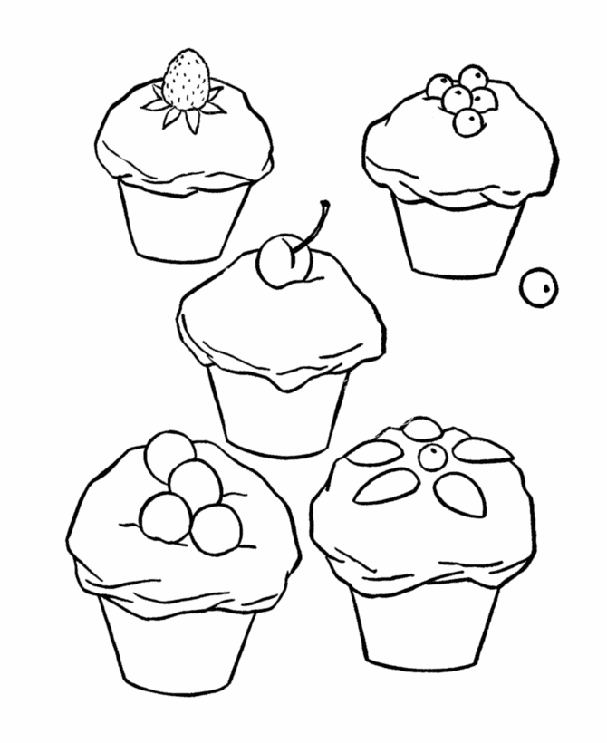

Worksheet_2 [Pre activity]-Hand out after the activity

♧Comparative Adjective♧

Adjectives are words that descries noun. Adjectives can also be Comparative- this means that they mean “adjective + - er” or “more + adjective.”

With most short adjectives (1 or 2 syllable), you add “-er.”
- Big -> Bigger
- Funny -> Funnier
- Fast -> Faster

With longer adjectives, you add the word “more.”
- Important -> more important
- Interesting -> more interesting
- Beautiful -> more beautiful

*If an adjective ends in “consonant-y,” you have to change the y to I , then add –er. (Eg. funnier / easier)
*If an adjective ends in “vowel-consonant,” you have to double the consonant, then add –er. (Eg. bigger, thinner)

Write the Comparative form of the adjectives below;

1.Slow _______________ 11.Handsome _______________
2.Comfortable _________________ 12.Fast _________________
3.Fat _________________ 13.Beautiful _________________
4.Big _________________ 14.Tall ___________________
5.Short _________________ 15.Smart __________________
6.Delicious__________________ 16.Cheap ___________________
7.Hard ____________________ 17.Expensive __________________
8.Rich ____________________ 18.Famous ___________________
9.Complicated __________________ 19.Cold ___________________
10.Ugly ____________________ 20.Hot ____________________

Worksheet_3 [Main activity]-Eliciting

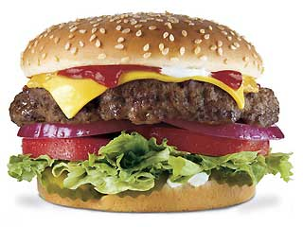

Worksheet_3 [Main activity]-Pair work

“Their burgers are bigger than ours,
Their French fries are juicier than ours,
Their staffs are friendlier than ours,
So I go to Burger King”

Cosmetic Brand | Food and Beverage Brand
 | 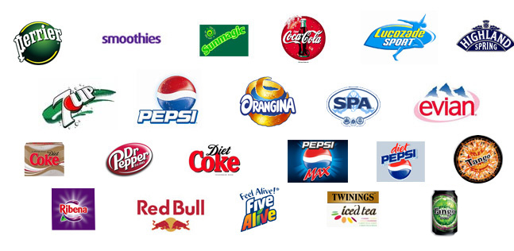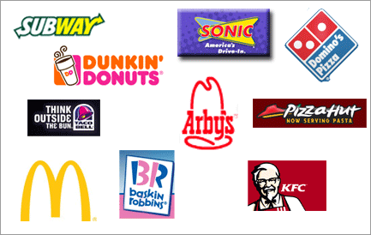
Car Brand | Airline Brand
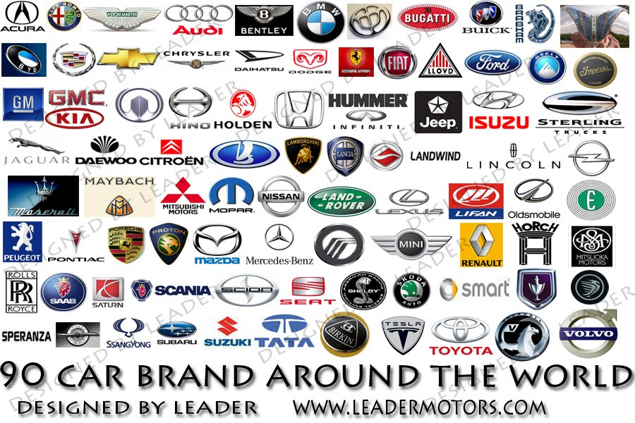 | 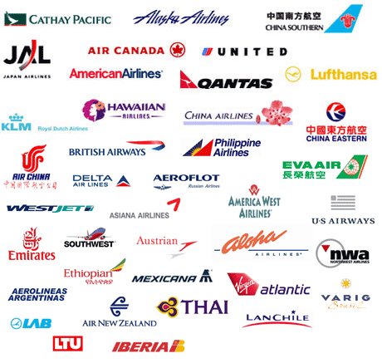

Choose one brand from one category, and create 5 Comparative sentences.

Eg) TONYMOLY has better facial cream than MISSHA.

1)
2)
3)
4)
5)
Worksheet_3 [Main activity]-Cosmetic Brand

Worksheet_3 [Main activity]-Food & Beverage Brand

Worksheet_3 [Main activity]-Car Brand

Worksheet_3 [Main activity]-Airline Brand
Worksheet_4 [Post activity]-Use your gesture

“Cats are scarier than dogs.”

