Listening Speaking Reading Grammar Writing

Topic: The Passive voice

Instructor:  Judy Kwon | Level:  Intermediate | Students:  8 | Length:  30 Minutes

Materials:
- White board, board markers and eraser
- Pictures
- Worksheet 1 – piece of papers
- Worksheet 2 – Mix and Match/Complete the sentences (8 copies each)
- Worksheet 3 – The Mary Celeste (8 copies each)

Aims:
- Main Aim: To enable Ss to improve their grammar skills by having Ss practice the active and passive voices.
- Secondary Aim: Ss will practice the passive voices by completing the worksheets.
- Personal Aim: I want to increase STT and improve my ICQs and CCQs.

Language Skills:
- Reading: Ss will read the worksheets.
- Listening: Ss will listen to the teacher’s instruction and what others say.
- Speaking: Ss will present their answers each other.
- Writing: Ss will complete the worksheets.

Language Systems:
- Lexis: A variety of verbs and vocabularies to change the sentences
- Function: How to write sentences with the passive forms
- Grammar: Error correction through the worksheets
- Phonology: Pronunciation by representing answers
- Discourse: By matching the sentences in the worksheets

Assumptions:
- Ss are intermediate level.
- Ss know they speak only English in the class.
- Ss are mostly active. The class will work in pairs.
- Ss are familiar with subject, object and complement.

Anticipated Problems and Solutions:
- If Ss don’t understand key vocabularies, teacher tells Ss synonyms and antonyms or explains.
- If Ss make grammar mistakes in their speeches, error correction is needed.
- If time is running out, shorten the discussion time. (cut-off plan)
- If there is more time than expected, give Ss more examples. (SOS activity)

References:
- www.google.com
- http://www.englishgrammarsecrets.com
- http://www.usingenglish.com/handouts/
- http://www.english-grammar-lessons.com/passive/

Lead-In
Materials:
White board, board markers and eraser

Time | Set Up | Teacher Talk (Student Activity)
1 min | Whole class | Greeting  Hello, everyone!  How are you today?  (Pick a student and ask.)  Did you have good weekdays or have you had tough days?  [SS answer the question.]  (Sounds like you had a good weekend. Or Sounds like you were busy!)

Pre-Activity
Materials:
White board, board markers and eraser
Pictures
Worksheet #1 – piece of papers

Time | Set Up | Teacher Talk (Student Activity)
10min | Whole class | - Guessing about the subject  Eliciting  (Show Ss pictures)  Now, look at this picture.  (Show picture #1 – Gustave Eiffel) Do you know who it is?  (Show picture #2 – the Eiffel Tower) Do you know what it is?  (Show picture #3 – Do you know who built the Eiffel Tower?  [Ss answer and guess the topic.]  Yes, well done.  “A French engineer Gustave Eiffel built the Eiffel Tower in 1889.”  Subject verb object  If you make the Eiffel Tower the subject in this sentence, how can you change the sentence?  [Ss answer.]  Yes, excellent!  It should be…  “The Eiffel Tower was built by a French engineer Gustave Eiffel in  Object verb preposition Subject  1889.”  - Introduce the topic  CCQs  Can we use the active form to say what the subject does? (Yes)  Can we use the active form to say what happens to the subject? (No)  Can we use the passive form to say what happens to the subject? (Yes)  “The hamster can be kept in a cage.”  - Is it an active sentence? (No)  - Is it a passive sentence? (Yes)  Instruction  Please pick the piece of paper each.  There is one sentence using the active form.  I give you 1 minute to change the sentence to the passive form.  But, I don’t want you to start until I say go.  Demonstrate  First, I will pick one paper.  OK. My sentence is “----------------------“  If I rewrite this sentence using the passive form,  it should be “------------------------“  ICQs  So, what are you going to do?  How many minutes do you have? [Ss: only 1 minute]  Are you working individually? – [Ss: Yes]  Can you start before I say go? – [Ss: No]  OK, begin!  Timing  (1 minute, 30 seconds, 10 seconds … time’s up!)  From ooo, please read your sentence first and then re-speak using the passive form.  [Ss read their sentence and then re-speak using the passive form.]  Well done, everyone.

Main Activity
Materials:
White board, board markers and eraser
Worksheet 2 – Mix and Match/Complete the sentences

Time | Set Up | Teacher Talk (Student Activity)
12min | 2groups | Grouping  Have Ss speak “active” “passive” in order.  Please speak “active” “passive”…  OK, “active” group is here and “passive” group is there.  [Ss change their seats.]  Instruction  Now, I am going to give you the worksheet.  At the front page, you can see the mix and match and the other side has the activity about completing the sentences with these words.  I want you to complete both sides and then share your answers with your members.  Please correct if you find any mistakes from your members.  I give you 5 minutes.  ICQs  So, what are you going to do?  How much time do you have? [Ss: 5 minutes]  Are you working with your members together? [Ss: Yes]  OK, start!  Timing  (1 minute, 30 seconds, 10 seconds … time’s up!)  Good job, guys!  From ooo, could you read the completed sentence one by one, please?  [Ss read their completed sentence.]  Please go back to your seat.

Post Activity
Materials:
White board, board markers and eraser
Worksheet 3 – The Mary Celeste

Time | Set Up | Teacher Talk (Student Activity)
7min | In pairs | - Wrap-up the lesson  Grouping  Please work together. (make Ss in pairs)  Instruction  Here’s a story about the mysterious ship – the Mary Celeste.  Please work together to fill in the blanks with the appropriate passive forms below.  You have 3 minutes and I don’t want you to turn the paper before I can say ‘begin’.  ICQs  So, what are we going to do?  How many minutes do you have? [Ss: 3 minutes]  Are you working individually? [Ss: No]  Are you working in pairs? [Ss: Yes]  Can you start before I say go? [Ss: No]  (Distribute the Worksheet 3 – The Mary Celeste)  OK, begin!  Timing  (1 minute, 30 seconds, 10 seconds … time’s up!)  (Check answers with Ss.)  From ooo, could you read the completed sentence one by one?  [Ss read their completed sentence.]  - Conclude lesson  Did you enjoy the class today?  Well done, everyone.  Since I didn’t hear any mistakes, why don’t we unscramble this sentence?  (Write down on the board.)  “ was / by / King Sejong. / invented / Hangeul ”  - Hangeul was invented by King Sejong.  [Ss answer.]  Do you have any questions?  If not, I conclude my lesson today and will be followed by Ben.

Pre-Activity (Eliciting)

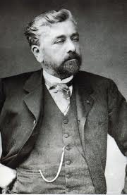


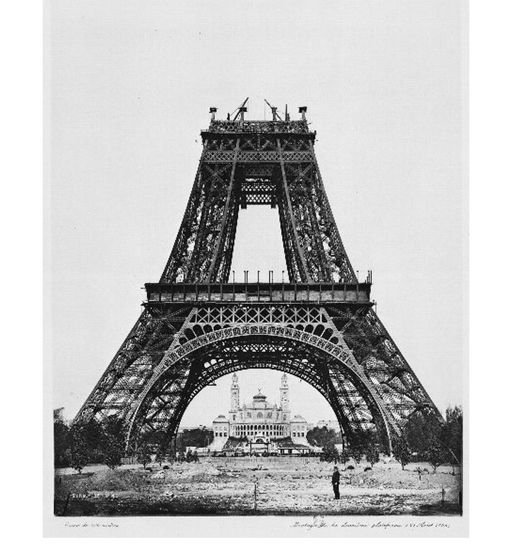

A French engineer Gustave Eiffel built the Eiffel Tower in 1889.
Worksheet #1 : Pre-Activity

Please rewrite these sentences using the passive form.

You are not allowed to smoke in here.
- Smoking _____ _______ ________________ in here.

People speak hundreds of languages in India.
- Hundreds of languages ______ ______________ in India.

Trucks deliver the goods to the warehouse.
- The goods _______ ________________ to the warehouse in trucks.

Da Vinci painted the Mona Lisa.
- The Mona Lisa _____ __________ _____ Da Vinci.

Somebody has stolen my car.
- My car ______ _________ ____________.

Nobody invited me to the party.
- I _________ _____________ to the party.

Our manager took the decision.
- The decision _______ ___________ by our manager.

We will finish everything tomorrow.
- Everything _______ ______ _________ tomorrow.

Worksheet #2 : Main-Activity
- Mix and Match -

- Has everyone been informed (a) done to find the children.

- Everything possible is being (b) village near here.

- The project was completed (c) by a subcontractor.

- Have all the rooms been (d) the company made a huge loss.

- The bottles are filled before the labels (e) you more than a week ago

- The car was stolen (f) booked yet?

- He was forced to resign after (g) on time.

- The tickets were posted to (h) from the car park.

- The books are printed (i) are put on.

- It was filmed in an old (j) of the latest changes?

- Complete the sentences -

- The road ____________________. We had to take a detour.

- The building ___________________ on schedule. It was three months late.

- These parts ________________ in Korea and simply assembled here.

- We ______________ $500 in cash to do the job.

- ___________________ for an interview?

- The new research center _________________ by the President.

- Goggles and safety shoes __________________ in the factory.

- She __________________ yet. She doesn’t know if she has the job or not.

- ______ your car ________________ after the accident?

hasn’t been told
Has
are made
were paid
was’t completed
was opened
must be worn
was closed
Have you been invited
been repaired

Worksheet #3 : Post-Activity

The Mary Celeste: An Unsolved Mystery from History



The Mary Celeste _____________ in 1861. At first it ___________ ‘The Amazon’. On it’s first voyage, it __________ in a collision. Then it caught fire while it _______________ after the collision. The ship ______ almost completely ___________ when it ran aground off the Canadian coast. After it had been rebuilt, it ___________ and the name _____________ to ‘Mary Celeste’. In November 1872, it sailed from New York. One month later, the ship ___________ between the Azores and Portugal. The ship ________________. The ship ____________ back to Portugal. There was a long investigation but an explanation _______________. There have been many ideas about what happened to the ship but none of them ___________________.

was sold wrecked was have been proved
was found was changed was called
was built was damaged
was never found had been abandoned
was taken was being repaired

