Pre-Activity- Eliciting

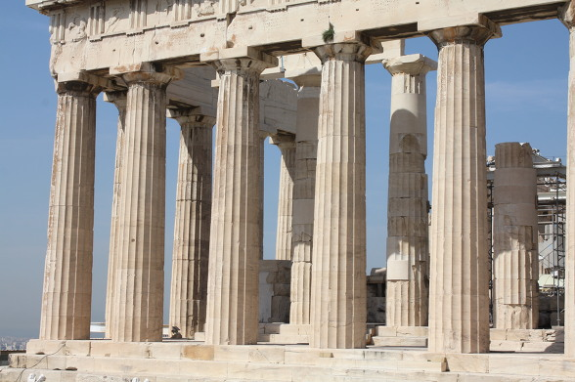

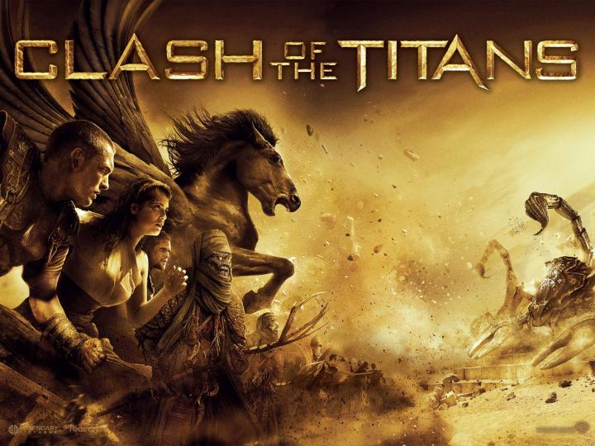

Pre-Activity- (print as blown up pictures.)
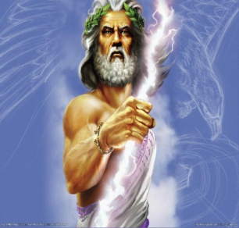 | 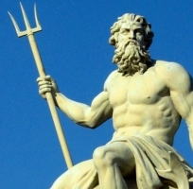 | 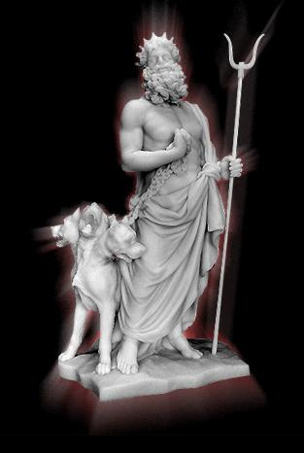
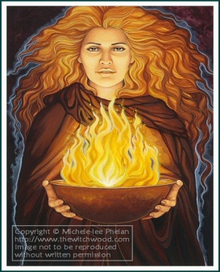 | 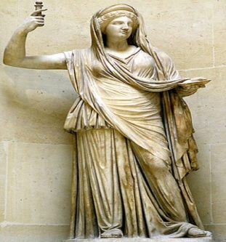 | 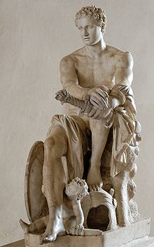
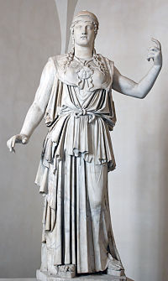 | 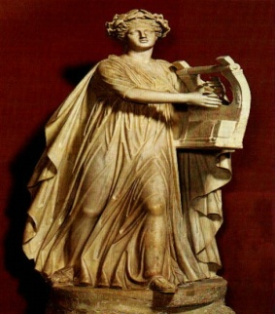 | 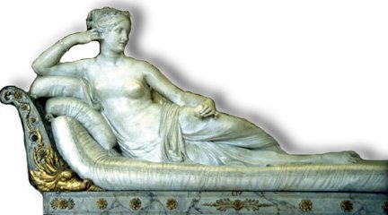
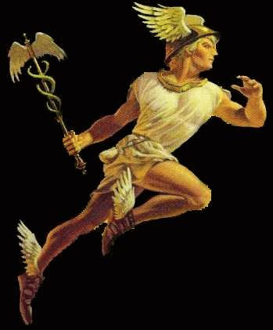 | 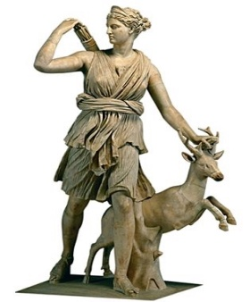 | 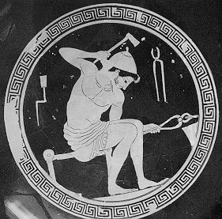

ZEUS  (=JUPITER) | POSEIDON  (=NEPTUNE) | HERMES  (=MERCURY)
HADES  (=PLUTO) | HESTIA  (=VESTA) | ARTEMIS  (=DIANA)
HERA  (=JUNO) | HEPHAESTUS  (=VULCAN) | APOLLO  (=PHOEBUS)
ARES  (=MARS) | ATHENA  (=MINERVA) | APHRODITE  (=VENUS)

Pre-Activity
 | 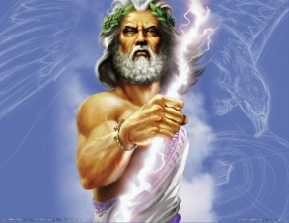
 |  |  | 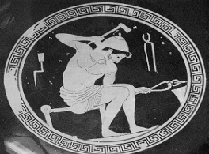
 | 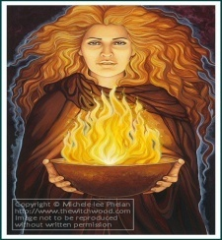 |  | 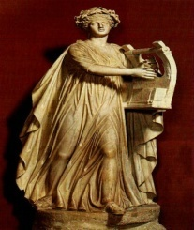
 | 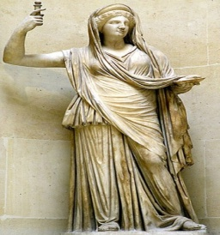 |  | 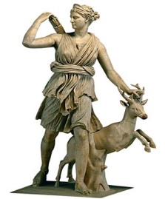
- Artemis (goddess of the huntsman) b. Hermes (god of messenger)

- Aphrodite (goddess of love & beauty) d. Apollo (god of music)
- Athena (goddess of war & agriculture) f. Ares (god of war)
- Hephaestus (god of the smiths) h. Hera (ruler of goddess)
- Hestia (goddess of fire) j. Hades ( god of the underworld)
- Zeus (ruler of gods) l. Poseidon (god of the sea)
Names

Main Activity
Zeus won the draw and became the supreme ruler of the gods.
He is lord of the sky, the rain god. His weapon is a thunderbolt which he hurls at those who displease him. He is married to Hera but, is famous for his many affairs.
He is also known to punish those that lie or break oaths.

Poseidon is the brother of Zeus. His prize was to become lord of the sea.
He was widely worshiped by seamen. His weapon is a trident, which can shake the earth, and shatter any object. He is second only to Zeus in power amongst the gods.
He has a difficult quarrelsome personality. He was greedy. He had a series of disputes with other gods when he tried to take over their cities.

Hades is the brother of Zeus. He had the worst draw and was made lord of the underworld, ruling over the dead. He is a greedy god who is greatly concerned with increasing his subjects.
He is also the god of wealth, due to the precious metals mined from the earth.
He has a helmet that makes him invisible. He rarely leaves the underworld.
He is unpitying and terrible, but not capricious.

Hestia is Zeus sister. She is a virgin goddess. She does not have a distinct personality.
She plays no part in myths. She is the Goddess of the Hearth, the symbol of the house around which a new born child is carried before it is received into the family. Each city had a public hearth sacred to Hestia, where the fire was never allowed to go out.

Hera is Zeus wife and sister. She was raised by the Titans Ocean and Tethys.
She is the protector of marriage and takes special care of married women.
Most stories concerning Hera have to do with her jealous revenge for Zeus's infidelities.

Ares is the son of Zeus and Hera. He was disliked by both parents.
He is the god of war. He is considered murderous and bloodstained but, also a coward.

Athena is the daughter of Zeus. She is fierce and brave in battle but, only wars to define the state and home from outside enemies. She is the goddess of the city, handicrafts, and agriculture. She invented the bridle, which permitted man to tame horses, the trumpet, the flute, the pot, the rake, the plow, the yoke, the ship, and the chariot. She is the embodiment of wisdom, reason, and purity.

Apollo is the son of Zeus and Leto. His twin sister is Artemis.
He is the god of music, playing a golden lyre. The Archer, far shooting with a silver bow. The god of healing who taught man medicine. The god of light. The god of truth, who can not speak a lie. One of Apollo's more important daily tasks is to harness his chariot with four horses and drive the Sun across the sky. He is famous for his oracle at Delphi. People traveled to it from all over the Greek world to Devine the future.

Aphrodite is the goddess of love, desire and beauty.
In addition to her natural gifts she has a magical girdle that compels anyone she wishes to desire her. Aphrodite arose from the sea foam on a giant scallop and walked to shore in Cyprus.

Hermes is the son of Zeus and Maia. He is Zeus messenger. He is the fastest of the gods.
He wears winged sandals, a winged hat, and carries a magic wand.
He is the god of thieves and god of commerce. He is the guide for the dead to go to the underworld. He invented the lyre, the pipes, the musical scale, astronomy , weights and measures, boxing, gymnastics, and the care of olive trees.

Artemis is the daughter of Zeus and Leto.
Her twin brother is Apollo. She is the lady of the wild things.
She is the huntsman of the gods. She is the protector of the young.
Like Apollo she hunts with silver arrows. She became associated with the moon.

Hephaestus is the son of Zeus and Hera. .
He is the only god to be physically ugly. He is also lame.
Some say that Hera, upset by having an ugly child, flung him from Mount Olympus into the sea, breaking his legs.
He is the god of fire and the forge. He is the smith and armored of the gods. He uses a volcano as his forge. He is the patron god of both smiths and weavers. He is kind and peace loving.

Main activity questions
Who are the two brother’s of Zeus? | Who is Hera married to?
Which god or goddess represents love, desire, and beauty? | What is the role of Apollo?
Who does he weapon “trident” belong to? | Who is the son of Zeus and Hera?
Who is the supreme ruler of the gods? | What tool does Artemis use when hunting?

Ss will choose a god/goddess and give a solution to these problems.
Earthquake | Tsunami
Famine | Drought

