Listening Speaking Reading Grammar Writing

Topic: the Second Conditionals

Instructor:  Sylvia | Level:  Upper Intermediate | Students:  8 | Length:  30 Minutes

Materials:
- Pictures about hypothetical situations
- Sentence cards- worksheet #1
- Situation cards-Worksheet #2, Worksheet #6
- Fill in the blank sheet-Worksheet #3
- Underline sentences-Worksheet #4
- Answer sheet- Worksheet #5
- White board, board markers

Aims:
Main: To enable Ss to improve their grammar skills by hypothetical situations.
Secondary: Ss learn the second conditionals by making sentences and worksheets.
Personal: I want to improve my CCQ , ICQ delivery and grouping techniques

Language Skills:
- Listening: Ss will listen to teacher’s instructions and classmates’ speaking.
- Speaking: Ss will practice their speaking by discussing their friends’ problems.
- Reading: Ss will read the situation cards and short stories.
- Writing: Ss will fill in the blank and make the second conditionals.

Language Systems:
- Phonology: None to discuss
- Lexis: new words used on the worksheets
- Grammar: the second conditionals
- Function: Stating what you would do
- Discourse: sharing opinions

Assumptions:
Students already know
- how the class is set up and run.
- the teacher’s style of teaching and the pace of the course.
- the second conditionals.
- All students are already familiar with doing activities with worksheet.

Anticipated Problems and Solutions:
-Ss don’t understand key vocabularies.
→ T tells Ss synonyms and antonyms or explains if needed
- Ss may need more time the work on the worksheet
→ Give Ss some more time and help them
- If Ss finish their task earlier than anticipated
→ Do SOS activity

References:
- Timesaver grammar activity
- About.com. English as 2 nd Language
- http://iteslj.org/questions/friends.html

Lead-In
Materials: n/a
Time | Set Up |  |  |  |  | Procedure
1min | Whole class |  |  |  |  | T: Hello, everyone. Did you have nice weekdays?  S: Yes, I did.  T: What are you going to do after class?  Do you like watching movies?  What kind of movies do you like?  (talking about it with a few students)  T: I like movies about “A Hero”.
Pre-Activity
Materials: Pictures, , Board, Board Markers, Worksheet #1
Time |  |  | Set Up |  |  | Procedure
8min |  |  | Whole class  Pair work  Individually |  |  | 1.Eliciting  (Put the picture on the board)  T: OK, guys. Look at this picture. Who is he?  (Ss say “a superman”)  What is he doing?  (Ss say “He is flying.)  T: Is it possible? Is it real?  (Ss probably say “no”)  T: Right, it’s impossible.  But sometimes I really want to be a superman because I want to fly.  I want to be strong.  (T writes “hypothetical” on the board.)  T: These are hypothetical situations, which means it may or may not be real  In the future. It isn’t true and real in this moment.  CCQs  When the situation is hypothetical,  - Does it mean real in this moment?  - Does it mean unreal in this moment?  (Modeling: If I were a superman, I would fly.)  T: This means “I can’t fly as I’m not a superman”.  This is called the second conditional.  (T writes “the second conditional” on the board.)  T: Today we are going to learn about the second conditional which is unreal  in the present time.  (Second conditional : if+S+verb (past tense) , S+would + infinitive form)  The second if conditional refers to an unreal (or very unlikely) situation  In the present time.  (T writes a few examples on the board.)  (“If I were a doctor, I could heal people.”)  (“If I were a firefighter, I could put out fires.”)  T: These are not real now. I am not a doctor or firefighter. So I can’t heal  People or can’t put out fires.  2. Making sentences  T: Now, I’ll give you sentence cards. Connect two sentences.  It must be grammatically correct and logical. Pay attention to punctuation.  You have 3 minutes. And it’s a pair work.  ICQs  - What are you going to do?  - Are you working individually?  - How many minutes do you have?  (Distribute sentence cards.)  (monitor discreetly)  T: 30 seconds left. Time’s up.  Let’s have a time to share the answer.  Very nice, good job.
Main Activity
Materials: Worksheet #2, Worksheet #3,Board, Board Markers
Time |  | Set Up |  |  | Procedure
14min |  | Individually  Individually  Group work  Whole class |  |  | 1. Choosing the correct answer  T: Now, I’ll give you worksheets.  You have 2 minutes to do a worksheet. Choosing the correct answer.  And it’s an individual work.  ICQs  - What are you going to do?  - Are you working individually?  - How many minutes do you have?  (Distribute worksheets)  (monitor discreetly)  T: 30 seconds left, 10 seconds left. Time’s up.  Let’s check the answer.  (Let Ss read the sentences.)  Very nice, good job  2. Counselor  T: Now, let’s work in two groups. There are situation cards here.  Each group will choose the cards. So you have to read the story and come up with some solutions by using “If I were you or If S did~~, I would~”, “Because~~~~~~~~~~~~.”  I’ll give you 5 minutes.  (Modeling: If I were you ~, I would ~. Because~.)  ICQs  - What are you going to do?  - Are you working individually?  - How many minutes do you have?  (Ss do the activity)  (Monitor discreetly.)  T: 30 seconds left. Alright. Time’s up.  Let’s share your suggestion. Now group A. Read your card and tell your  solutions by using “If I were you, I would~”, “Because~~~~~~~~~~~~.”  Let’s start with group A.  (Ss say their solution.)
Post Activity
Materials: Worksheet #6, Board, Board Markers
Time | Set Up |  |  |  | Procedure
7min | Whole class  Whole class |  |  |  | 1. What would you do if…?  T: I have picture cards in my hand. Let me choose one card.  And I will show it to you. Tell me what you would do.  ICQs  - What are you going to do?  - Are you working in group?  (T reads the card.)  T: What would you do if there was a fly in your soup?  (Ss say their opinions.)  T: Good job. Now Leo, pick one card and read it please.  (Leo reads the card.)  (The other Ss answer.)  T: Good job. You did well today.  (If the time remains, do this activity again.)  2. Conclude lesson  (error correction: unscramble the sentence)  I/YOU/IF/WERE/ MARRY/HIM /WOULD/  T: Do you have any questions about today’s lesson? If there are no further questions, I’ll conclude this class. You did a great job today. Thank you all of you. You have a great day and see you guys tomorrow.
SOS Activities
Materials: Worksheet #4, Board, Board Markers
Time | Set Up |  |  | Procedure
 | Individually |  |  |  | 1. Emergency procedures  T: I am going to give you worksheets. There are short stories on the worksheets.  You have to underline all the second conditional sentences.  You have 2 minutes. This is an Individual work.  ICQs  - What are you going to do?  - Are you working individually?  - How many minutes do you have?  T: Time’s up. Now let’s read your sentence one by one.

Worksheet #1(Sample Lesson)
If it were New Year’s Eve,
I would be at a party.
If I got a pet,
it would have to be a cat.
I wouldn’t do that
if I were you.
If you won the lottery,
what would you do with the money?
How would your life be different
if you spoke English perfectly?
If we studied all night,
we still wouldn’t pass the test.
If our teacher were absent,
we wouldn’t be doing this activity.
If we went to the beach,
would you go swimming?
If I invited you to dinner,
would you expect me to pay?
We wouldn’t have cars
if it were 1700.
Worksheet #2(Sample Lesson)

I’m sixteen years old and my parents are ruining my life. They never let me do anything. All my friends’ parents let them stay out late and go to clubs and parties. My parents always insist I’m back home by nine o’clock and they usually come to pick me up. It’s so embarrassing. What can I do? Please help me.
I’m unhappy about the way look. My friends always look great because they wear fashionable clothes and make-up. My parents don’t have much money so I often have to wear my sister’s old clothes. When I do get new clothes, my mom usually chooses them for me and she doesn’t let me wear make-up. I’m so depressed. What can I do? Please help me.
I met a wonderful boy while I was on holiday last month. He worked in a restaurant on the beach. It was love at first sight. Now I’m back home. We email and text each other everyday. A few days ago, he suddenly stopped writing and he doesn’t answered his phone when I rung him. How can I find out if he is okay? I really worried. What can I do? Please help me.
My best friend recently broke up with her boyfriend. She was very upset because she really liked him. Now my friend’s ex-boyfriend has asked me out. He says he is always liked me. He’s gorgeous and I’d love to go out with him. But I don’t hurt my friend. What can I do? Please help me.
A few days ago, I found a wallet in the street with 500.000won in it. There wasn’t a name or address. So I spent the money on a computer game I’d wanted for ages. Now I found out that the wallet belonged to an elderly neighbor. I feel really bad. I haven’t got a job so I can’t repay the money. What can I do? Please help me.
Last term, we had biology exam at school. I knew I wasn’t going to do very well. So I cheated(I found out the answers on the teacher’s computer. I got best mark in my class and my parents were really proud of me. Now I’m in a new biology class. Everyone’s really clever and I don’t understand the work. I hate this class but I’m too embarrassed to admit I cheated and I don’t want to disappoint my parents. What can I do? Please help me.
Last week, I found my girlfriend’s diary. I read some of the diary and found out that she kissed another boy while she was going out with me. I’ve really angry and upset. I want to tell my girlfriend how I feel. But I don’t want her to know I read her diary. What can I do? Please help me.

Worksheet #3(Sample Lesson)
Put the verbs in brackets into the gaps. Form a Conditional sentence - type II.
Example: If I __ (to go) to the cinema, I ________ (to watch) an interesting film.
Answer: If I went to the cinema, I would watch an interesting film.

1) If I (to come) home earlier, I (to prepare) dinner.
2) If we (to live) in Rome, Francesco (to visit) us.
3) If Tim and Tom (to be) older, they (to play) in our hockey team.
4) If he (to be) my friend, I (to invite) him to my birthday party.
5) If Susan (to study) harder, she (to be) better at school.
6) If they (to have) enough money, they (to buy) a new car.
7) If you (to do) a paper round, you (to earn) a little extra money.
8) If Michael (to get) more pocket money, he (to ask) Doris out for dinner.
9) If we (to hurry), we (to catch) the bus.
10) If it (to rain), Nina (to take) an umbrella with her.

Worksheet #3(Sample Lesson)
Put the verbs in brackets into the gaps. Form a Conditional sentence - type II. Mind the negations in the sentences.
Example: If I __ (to go) to the café, I ________ (not/to drink) milk.
Answer: If I went to the café, I would not drink milk.

1) If Oliver (to find) money, he (not/to keep) it.
2) If they (not/to wear) pullovers in the mountains, it (to be) too cold during the night.
3) If Tony (to know) her phone number, he (not/to give) it to Frank.
4) If we (not/to visit) this museum, you (not/to write) a good report.
5) If it (not/to be) so late, we (to play) a game of chess.
6) If Jeff (not/to like) Jessica, he (not/to buy) her an ice-cream.
7) If I (to be) you, I (not/to go) to Eric's party.
8) If you (to drop) this bottle, it (not/to break).
9) If she (not/to bully) her classmates, she (to have) more friends.
10) If he (not/to print) the document, I (not/to correct) it.

Answer sheet #5(Sample Lesson)
1) If I came home earlier, I would prepare dinner.
2) If we lived in Rome, Francesco would visit us.
3) If Tim and Tom were older, they would play in our hockey team.
4) If he was my friend, I would invite him to my birthday party.
5) If Susan studied harder, she would be better at school.
6) If they had enough money, they would buy a new car.
7) If you did a paper round, you would earn a little extra money.
8) If Michael got more pocket money, he would ask Doris out for dinner.
9) If we hurried, we would catch the bus.
10) If it rained, Nina would take an umbrella with her.

) If Oliver found money, he would not keep it.
2) If they did not wear pullovers in the mountains, it would be too cold during the night.
3) If Tony knew her phone number, he would not give it to Frank.
4) If we did not visit this museum, you would not write a good report.
5) If it was not so late, we would play a game of chess.
6) If Jeff did not like Jessica, he would not buy her an ice-cream.
7) If I were you, I would not go to Eric's party.
8) If you dropped this bottle, it would not break.
9) If she did not bully her classmates, she would have more friends.
10) If he did not print the document, I would not correct it.

Worksheet #4(Sample Lesson)
Underline all second conditional structures.
If you take a look at handout, you’ll find all the telephone numbers, addresses and other necessary information. If Tom were here, he’d help me with this presentation. Unfortunately, he couldn’t make it today. OK, let’s get started: Today’s subject is helping guests with emergency situations well. That’s why we like to review these procedures every year.

If a guest looses his passport, call the consulate immediately. If the consulate isn’t nearby, you’ll have to help the guest get to the appropriate consulate. It would be great if we had some more consulates here. However, there are also a few in Boston. Next, if a guest has an accident which is not so serious, you’ll find the first-aid kit under the reception desk. If the accident is serious, call an ambulance.

Sometimes guests need to return home unexpectedly. If this happens, the guest might need your help making travel arrangements, re-scheduling appointments, etc. Do everything you can to make this situation as easy to cope with as possible. If there is a problem, the guest will expect us to be able to handle any situation. It’s our responsibility to make sure ahead of time that we can.

Worksheet #6(Sample Lesson)

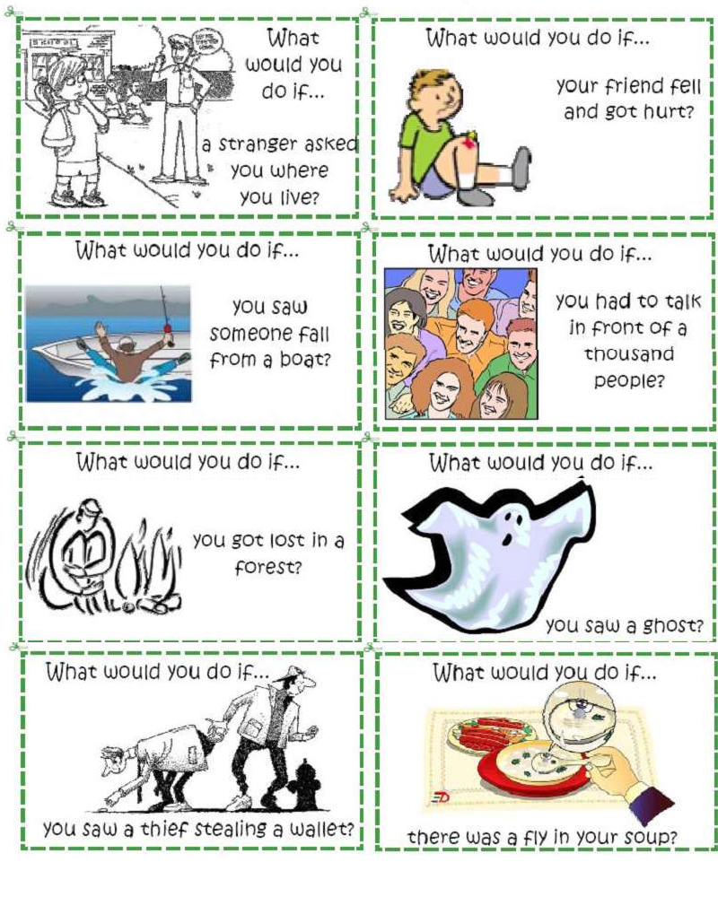

Assignment
There are three types of the if-clauses.
type | condition
I | condition possible to fulfill
II | condition in theory possible to fulfill
III | condition not possible to fulfill (too late)

Form
type | if clause | main clause
I | Simple Present | will-future (or Modal + infinitive)
II | Simple Past | would + infinitive *
III | Past Perfect | would + have + past participle *

Examples (if-clause at the beginning)
type | if clause | main clause
I | If I study, | I will pass the exam.
II | If I studied, | I would pass the exam.
III | If I had studied, | I would have passed the exam.

Examples (if-clause at the end)
type | main clause | if-clause
I | I will pass the exam | if I study.
II | I would pass the exam | if I studied.
III | I would have passed the exam | if I had studied.

Examples (affirmative and negative sentences)
type |  | Examples
 |  | long forms | short/contracted forms
I | + | If I study, I will pass the exam. | If I study, I'll pass the exam.
 | - | If I study, I will not fail the exam.  If I do not study, I will fail the exam. | If I study, I won't fail the exam.  If I don't study, I'll fail the exam.
II | + | If I studied, I would pass the exam. | If I studied, I'd pass the exam.
 | - | If I studied, I would not fail the exam.  If I did not study, I would fail the exam. | If I studied, I wouldn't fail the exam.  If I didn't study, I'd fail the exam.
III | + | If I had studied, I would have passed the exam. | If I'd studied, I'd have passed the exam.
 | - | If I had studied, I would not have failed the exam.  If I had not studied, I would have failed the exam. | If I'd studied, I wouldn't have failed the exam.  If I hadn't studied, I'd have failed the exam.
* We can substitute could or might for would (should, may or must are sometimes possible, too).
I would pass the exam.
I could pass the exam.
I might pass the exam.
I may pass the exam.
I should pass the exam.
I must pass the exam.

