Listening Speaking Reading Grammar Writing

Topic: The Cultural Lifestyle of “Han”

Instructor:  Young Seo | Level:  Intermediate | Students:  8 | Length:  30 Minutes

Materials:

- Photos of Han Style
- Paper cups & 10 words of six cultural symbols related “Han Style”
- 18 pieces of striped papers which are the meaning of the “Han Style”
- Worksheet #1 – Role Play (8 copies)
- Blank Papers and color pencils
- Paper cup and scraps of paper
- White board and board markers

Aims:

- Main Aims :
To enable to students to practice and improve their reading skills by having students
study and practice the “Han Style” of culture.

- Secondary Aims :
Students will learn about the six cultural symbols related to “Han style” by having students
do a worksheet and a role play.

- Personal Aims :
I want to improve on my skill ‘ICQ & CCQ delivery’ to students correctly.
I want to improve on my confidence of teaching.

Language Skills:

- Reading: Students will read a worksheet.
- Listening: Students will listen to their group member’s answers and opinions.
- Speaking: Students will speak their ideas with group members.
- Writing: Students will write what their members in the group talk.

Language Systems:

- Phonology: None to discuss
- Lexis: Learn the word of “Han Style” meaning.
- Function: Introduce “Han Style” to use own sentences.
- Discourse: None to discuss
- Grammatical: None to discuss.

Assumptions:

Students already know:
- Teacher’s style of teaching and the pace of the course.
- How the class is set up and run.
Most students do not know:
- The word “Han Style means

Anticipated Problems and Solutions:

- Students may not be able to follow the passage easily.
→ Follow the task-feedback circle: let them listen to the tracks again until they get the
list of the content
- Students may need more time to work on the idioms.
→ If it takes longer than 5 minutes, cut answer-checking short by verbally sharing
the answers instead of having students write them on the board.
- If time is short.
→ Cut post-activity discussion short and only ask 2~3 students to share their opinions

References:
- Han Style
http://www.google.co.kr/imghp?hl=ko&tab=wi
http://english.visitkorea.or.kr/enu/CU/CU_EN_8_1.jsp
http://www.han-style.com/english/hanstyle/site.jsp
http://tour-eng.jeonju.go.kr/index.sko?menuCd=AB03003000000

Lead-In
Materials:

Time | Set Up | Student Activity | Teacher Talk
2min. | Whole  Class | Greeting & Answer  Students speak about lunch &  favorite food. | Greeting  Hello, everyone. How’s everything?  Did you have a delicious lunch?  What did you have?  What is your favorite food?

Pre-Activity
Materials: Photos of Han Style, Paper Cup, 10 words of six cultural symbols related “Han Style”,
and 18 pieces of striped papers which are the meaning of the “Han Style”

Time | Set Up | Student Activity | Teacher Talk
2min  5min | Whole Class  Individual work | Listen teacher’s instruction.  Guess what the photo is about.  Answer teacher’s questions.  Pick up one of the six symbols from the cup.  Find the meaning of it. | Eliciting  Look at these photos.  What is this? (Show each photo)  “Hanbok”(Traditional Korean Clothing),  “Hangeul” (Korean Alphabet),  “Hanok” (Traditional Korean Houses),  “Hanji” (Traditional Korean Paper),  “Hanguk Eumak”(Korean Music),  “Hansik” (Korean Food)  Those six cultural symbols are called “Han Style”  Today, we are going to learn about “Han Style” which represents the source of Korean culture and symbolizing Korea. Those six things are core parts of Korean traditional culture.  CCQ  Does “Han Style” represent Chinese culture? → No.  Does “Han Style” represent Korean culture? → Yes.  1. Find the meaning of the Six Cultural Symbols in Korea  Instruction  Work in individual. Choose one of the six cultural symbols from paper cup.  Find the meaning of the word which you picked up from the classroom wall.  Will give 2 min. and start when I say “go”  Demonstration  I picked up “Hansik”  Try to find the meaning of the striped paper that “Continue to gain popularity throughout the world for its incredible health benefits.”  ICQ  What are you going to do with the word you picked up from paper cup?  →Find the meaning of the word on the wall.  Are you working in pairs?  →Work individually.  How many minutes do you have? →2min.  Will you start when you get the paper? →No  Will you start when I say go? →Yes  (Distribute the words)  Monitor discreetly. Answer students if they ask questions.  Give time warning: 1minute left and  30 seconds left.  Say “Time is up” loudly.  If the students still work, will make a noise to get student’s attention.  Check answers  Ask Students who found the meaning and share what they have.

Main Activity
Materials: Worksheet #1 – Role Play, the Articles of “Han Style”, blank papers, Paper cups, and scraps of paper
Time | Set Up | Student Activity | Teacher Talk
12min | Group work | Listen the teacher’s instruction.  Divide to 2 groups.  Read the article of “Han Style”  Create 3 questions and answers about the topic. | 2. Role Play  Instruction  Work in groups. Divide to 2 groups.  (One group is “Han” and the other is “Style”)  All “Han” seats here & all “Style” seat there.  Choose one of the following topics.  Play the rock-paper-scissors game and the winner pick a topic first.  Pretend that you are an English tour guide or foreign visitors in South Korea.  Pick who is going to be the tour guide and rest of the group members will be foreign visitors.  Read one of the articles about “Han Style”.  Make three questions for foreign visitors and answers for an English tour guide in each group with one of “Han Style” (Six Cultural Symbols in Korea). After discussion, you will present it in 1 minute. Will give 6minutes and start when I say “go”.  Demonstration  Pretend that you are one of the foreign visitors and ask a question about “Hanji”.  What does Hanji make more special than other paper?  →It is not only used drawing, but also used multi ways such as window covers, wrapping paper, and furniture.  If I have some beautiful color Hanji, what can I use them for?  →They could make clothing like Hanji dress.  ICQ  What are you going to do? → Role Play with the topics of “Han Style”  How many questions and answers do you create? →3 questions and answers  Will you work in individually? → Group  How many minutes do you have? → 6 min.  Are you going to start when I give you papers? →No  Are you going to start when I say “go”?  →Yes  (Distribute the topics and blank papers)  Monitor discreetly. Answer students if they ask questions.  Give time warning: 3 minutes, 1 minutes, & 30 seconds left.  Check answers  Each group presents the topic as role play.  After the presentations, the foreign visitors vote which group is more interesting.

Post Activity
Materials: Blank papers and color pencils
Time | Set Up | Student Activity | Teacher Talk
8 min | Pair Work | Listen teacher’s instruction.  Answer teacher’s questions.  Set in pairs.  Create the seven symbol of Han style from your own mind. | 3. Create the Seventh Symbol of Han Style  Instruction  Work in pairs.  Now you know what the six symbols of Han Style are well.  Create the seven symbol of Han style from your own mind. Tell us why you made it.  Will give 3min. and start when I say “go”  Demonstration  I create the seventh symbol is Hanbang which is Korean traditional medicine.  ICQ  What are you going to do?  Will you work in individually?  How many minutes do you have?  Are you going to start when I give a paper?  Are you going to start when I say “go”?  (Distribute blank papers & color pencils)  Monitor discreetly.  Answer students if they ask questions.  Give time warning: 1 minutes & 30 seconds left.  Check answers  Share answers with other students.  If time is short, cut answers shortly.  If more time, share all students answer.  Feedback/ Error correction  I didn’t hear any mistake today.  Do you have any question?  (Boarding scrambled words)  “H/N/A” “Y/S/L/T/E”  →HAN STYLE  Closing  Awesome job today.  See you guy’s next week!!
SOS Activities
Materials:
Time | Set Up | Student Activity | Teacher Talk

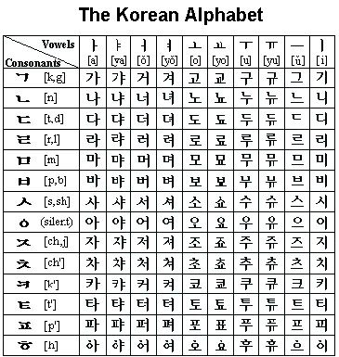

Hangeul (Korean Alphabet)

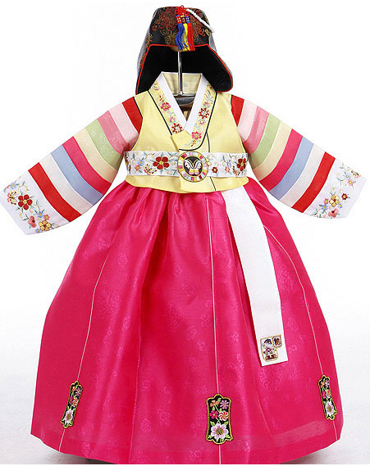

Hanbok (Traditional Korean Clothing)

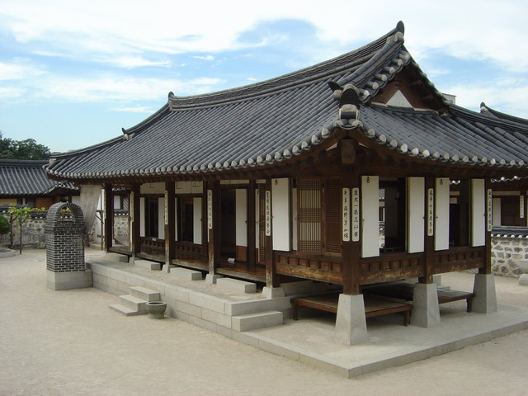

Hanok (Traditional Korean Houses)

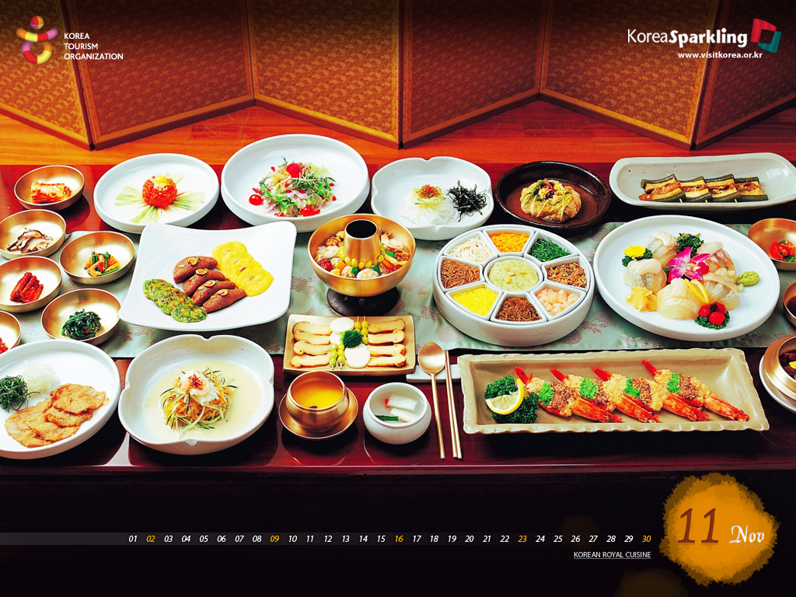

Hansik (Korea Food)

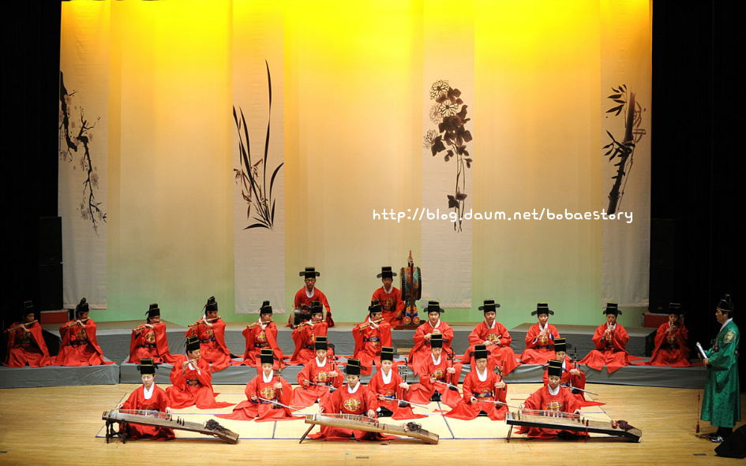

Hanguk Eumak (Korea Music)

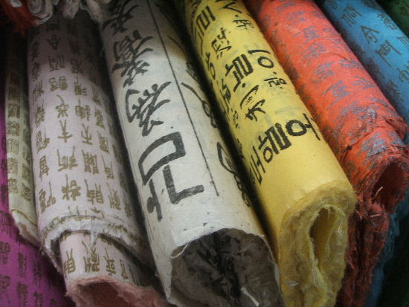

Hanji (Traditional Korean Paper)

Worksheet #1 – Role Play

Directions: Pretend that you are an English tour guide or foreign visitors in South Korea. Pick who is going to be the tour guide and rest of the group members will be foreign visitors. Make three questions for foreign visitors and answers for an English tour guide in each group with one of “Han Style” (Six Cultural Symbols in Korea).
Hanbok (Traditional Korean Clothing)  Hangeul (Korean Alphabet)  Hanguk Eumak (Korea Music) | Hanok (Traditional Korean Houses)  Hanji (Traditional Korean Paper)  Hansik (Korea Food)

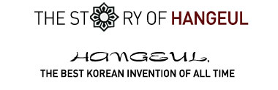
Hangeul, the Korean alphabet, refers to the series of letters that form syllables with which the Korean language is written. The most unique aspect of Hangeul is that it was intentionally created by the government as a written means of expressing the Korean language. History states that King Sejong, who was the 4th king of the Joseon Dynasty, sponsored and helped in the scientific creation of the alphabet with the help of a team of scholars, making it the most significant invention in Korean history.
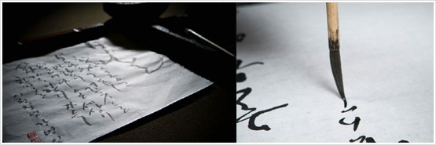
Koreans take pride in their alphabet. They believe that Hangeul best demonstrates the creativity of Koreans during the past 5000 years of Korean civilization. Koreans mark the 9th of every October as a national celebration to commemorate the creation of Hangeul. As the only national celebration for an alphabet in the world, this day reflects the uniqueness of an alphabet created and systematized by a government to reflect the unique sounds of a language.
King Sejong, the creator of Hangeul, is regarded as a national hero in Korea. There are in fact only two kings commemorated as truly great kings of Korean history. One is Gwanggaetodaewang of Goguryeo, who ruled over the largest territory in Korean history, and the other is King Sejong, who created hangeul and many other significant inventions. King Sejong appears on the 10,000 won note and a statue of him stands at Gwanghwamun Square, which is a symbol of Seoul.
Hangeul is a series of creative and scientifically created characters. The alphabet was originally composed of 17 consonants and 11 vowels when it was first conceived however, now only 14 consonants and 10 vowels are used. The 5 main consonants (ㄱ, ㄴ, ㅅ, ㅁ, ㅇ) imitate the shape lips and tongue make when making that particular sound and reflect the five core elements of Oriental philosophy. The 3 main vowels (ㆍ, ㅡ, ㅣ) symbolize the sky, the earth and mankind, which are thought to be the origins of the universe. This achievement came through the brainstorming of the best scholars of the time.

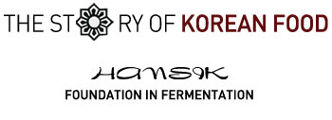
Korean food is referred to in Korean as Hansik. While many other Asian ethnic foods such as Chinese or Japanese food have become popular throughout the world, Korean food has yet to reach its peak. The Korean government is crusading for the globalization of hansik in cooperation with companies, civic groups and the mass media. As the people of the world gain a better understanding of Korean food, its flavors, and its roots, Korean food will undoubtedly become a global commodity like the food of Korea’s neighbors.
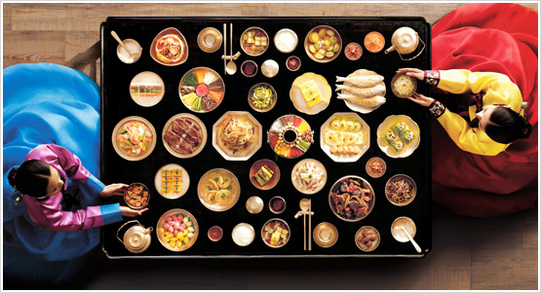
The key to Hansik is fermentation. Every nation has their unique fermented foods such as cheese, yogurt or natto. There are many kinds of fermented foods in Korean cuisine. The purpose of fermentation is to purposely break down foods into more digestible components through the natural use of the bacteria that exists all around us. Unlike food simply going bad, fermentation represents a useful and practical change. So the Korean says not sseokhinda (to be spoiled) but “sakhinda” (to be fermented). The expression is based on the concept of in-depth understanding on fermentation. The quintessential fermented food of hansik is kimchi, and although there are hundreds of different kinds, the most internationally well known is spicy fermented cabbage. When meeting someone who has never encountered kimchi before, Koreans may introduce its as a type of salad, a kind of salad made using spices, red peppers, salt, garlic and oriental cabbage, sauerkraut with a kick, if you will. But this simple explanation leaves out the most important variable, that of fermentation, which is the entire key to how a particular batch of kimchi might taste. The kimchi that is preferred most by Korean people contains salted shrimp or anchovies and has aged underground for at least a year in a jangdokdae (large clay jar). Like a fine wine, the process of aging gives kimchi its deep taste.
Koreans express a well-aged kimchi as being "ripe". The verb of "ripe' is often used for fruits. However, the Korean use it also for many kinds of fermented food. As with fruit, edible after the process of blooming, growing and ripening on the tree, in the same way, kimchi is allowed to develop its own complexities of taste over a long period of time. The very idea of kimchi embodies the notion of extended waiting.
Some of the other typical fermented food found Korean table are jang (sauces) of all kinds including ganjang (soybean sauce), gochujang (red pepper paste) and doenjang (soybean paste) are known collectively as jang (sauces). The old saying that the taste of food is the taste of sauce is highly applicable in hansik because these sauces are the basis of Korean food. Sauces are added to most Korean dishes and foods are classified depending on the kinds and quantity of the sauces they contain
Koreans make their supply of kimchi once a year before winter to ensure they get the nutrients they need during the winter. This tradition is known as gimjang. The ‘jang’ in gimjang and ‘jang’ in ganjang, gochujang and doenjang are the same word and reflects the same basic principle of fermentation.
Another feature of hansik is that it is strongly based on vegetables. The basic composition of a table serving is steamed rice, soup and a variety of side dishes. All of them are traditionally vegetable based; in fact, a side dish of meat was typically a rare sight on the dining table of common people. The cow in Korea, which has long been an agricultural society, was regarded as a tool of labor rather than mere food.
Hansik is fundamentally a slow food, a cuisine well suited to health and well being, because it is mostly based on vegetables grown locally and aged and fermented sauces. One of the best opportunities for visitors to Korea is 'the temple stay'. The most popular type of temple stay is one that includes the true temple dining experience, which prohibits the use of meat and of artificial flavors.
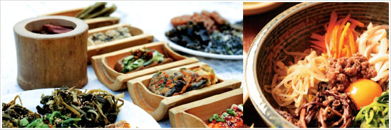
As the unique taste and undeniable health benefits of hansik are becoming more widely known, the day is surely not far off where everyone will be able to enjoy hansik at home or at their neighborhood Korean restaurant.

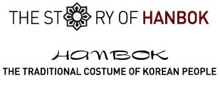
The Hanbok is the traditional outfit of the Korean people. Koreans nowadays wear this outfit only on festive days or special anniversaries, however it was worn daily up until just 100 years ago. It is a kind of traditional formal dress and most Koreans keep a hanbok for these special times. Children wear hanbok on their first birthday and adults wear it for their wedding ceremony and on their 60th birthday. The hanbok is also worn for funerals or religious services, and is still used as casual wear in villages or districts where the traditional ways of life are still maintained such as Chunghak-dong on Mount Jirisan.
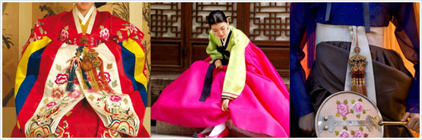
One way to refer to Korea is 'the people in white’, which refers to the fact that the Korean people often wear white or similar tones. Koreans have long worn white clothing made of hemp or cotton regardless of their status. The case of formal dress was different, however. Color and design were typically luxurious and the hanbok was particularly highly valued for its gracious and subtle colors. Modern designers have presented the traditional Korean costume at renowned cities of fashion such as Paris and New York.
The hanbok is colored using natural dyes. The colors of nature are imbued in the cloth. For example, red dye is obtained from the petals of red flowers. The color pigment is extracted by grounding the petals in a mortar, putting them in a jar and rinsing them with hot caustic soda. It is a very slow, complicated, precise process. The colors obtained in this way differ greatly from artificial dyes in their color and depth. The Hanbok is creative and emotional in its design. One Korean phrase regarding the shape of the outfit is the 'upper is narrow, lower is wide'. The jacket must be tightened and the skirt relaxed, as was the silhouette of the women’s hanbok in Joseon times. The tightly fitting jacket attractively reflects the shape of the upper body. The wide sleeves and flexible skirts enhance the wearer’s gracefulness by hiding the physical features of the lower body.
The principles behind the creation of the hanbok can be explained by the movement from 2 dimensions to 3 dimensions. The flat cloth is patterned, cut, and sewn in 2 dimensions but the subject wearing the hanbok is a 3 dimensional being. The hanbok is frilled or fastened with string to enhance the 3D affect. The unique line of the hanbok is created from this process. The lines of the hanbok costume are as smooth as the curves of the eaves of tiled roof house and as sharp. An old adage says that you can tell the man by his clothes.
Koreans have traditionally lived as one with nature, and obtained all material from natural sources for making cloth and coloring it. Koreans favor smooth curves rather than straight lines and that has added a gracious line to the hanbok. A common comment that every hanbok designer gets is that the outfit is more beautiful when it is worn than when it is on the hanger, and more beautiful when moving than when standing. Indeed, the unique lines of the hanbok appear at their greatest when the wearer is in motion.
Although hanbok have become the ritual dress of choice worn only on traditional holidays, Koreans' love for hanbok is tremendous. The popularity of Korean classic dramas is causing many foreigners to take a keener interest in traditional Korean attire as well.
[Hanbok in the 16th Century]
1. Men's hanbok | 2. Women's hanbok
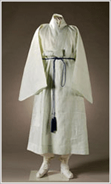 | 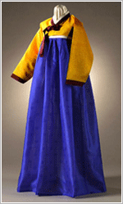
3. Children's hanbok | 4. Ceremonial hanbok
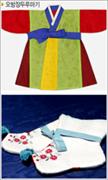 | 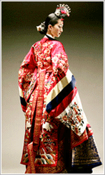

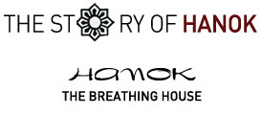
Hanok refers to Korean traditional architecture style with various roof types including thatches, shingles and tiles. With the vanishing of thatch-roofed and shingle-roofed houses, Hanok today is generally understood as the tile-roofed house. There are many tile-roofed houses not only occupied as private residences, but also maintained as national cultural heritages.
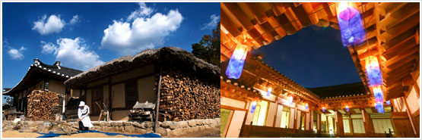
The Korean style Hanok house is not only the tradition of the past but also an effective architectural style in modern times. Hanok’s charm is twofold: scientific excellence and environmental friendliness. The scientific excellence is demonstrated by a heating system called the “ondol.” Ondol helps residents endure the cold of winter by heating the floors of the home. The word ‘ondol,’ now registered in the Oxford Dictionary, literally means “warming the stone.” When heat coming from the fire in the kitchen is connected to the other rooms, the layer of stone in the floor of the target room becomes heated. The warm air at floor level rises, keeping the temperature of the whole room comfortable.
As much of Korean daily life utilizes the floor surfaces, the ondol culture, the core of the family’s indoor temperature control, is always mentioned when discussing Korea. In the West, the cold floor is often avoided, while chairs and beds are preferred. However, the comfort of the ondol means that Korean people, rather than avoiding the floor, make full use of it. In fact, the reason that it is necessary to take off shoes before entering a house is to keep the floor as clean as possible. This is because the floor is used for both dining and sleeping; short folding tables are brought out when dining, and bedclothes are placed on the heated floor at night for sleeping.
The words ‘downside’ and ‘upside’ are both derived from ondol. The floor near the fireplace is heated and is the hottest area when the fire is burning hot. The Korean people are always aware of the need to show respect to the elderly and therefore this area, the downside, is usually reserved for elders of the family. Fires are less necessary during the summer and Korean homes kept cool by utilizing natures cooling system, the movement of air. The Hanok house has fewer walls and more doors. When the door is closed, it becomes a wall and when it is open, it brings in the breeze to keep air circulating throughout the living spaces. That is why the Hanok keeps cool in the heat of summer.
Ondol is also used for medicinal purposes. The Korean language has the phrase “sizzling the body,” which refers to a kind of fomentation effect that is created when somebody lies on the hot floor in the cold winter. Such fomenting is known as being effective for tired or sick people, pregnant women and the elderly. To this day, Koreans prefer to forment on a toasty ondol floor when they get a cold or other such illness.
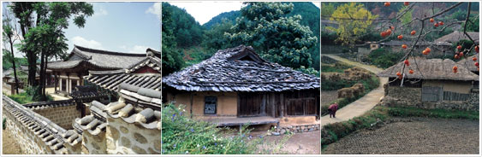
Another attraction of Hanok is its environmental friendliness. The earth, stone, wood and paper which make up the Hanok are obtained directly from natural sources. Wood is used in pillars, rafters, doors, windows, and flooring. Walls are a mixture of straw and earth. The Korean paper used throughout the house is made from natural wood pulp and is glued to the frame of the sliding doors and the cross ribs of the windows. The floor is polished with bean oil after covering it with Korean paper, making the flooring waterproof. The Hanok breathes on its own because every material is from nature. The wood and earth breath when it is humid indoors and exhale when it is dry.
Koreans built their homes in accordance to geomancy. Houses were positioned after considering the distance and direction in line with mountains and fields as well as the location of water. The direction and structure of the position of the house were decided by this principle. The theory of geomancy is not just a simple superstition. Koreans regard a house built against the background of a mountain and facing the south as being in the most ideal location, and certain points have to be taken into consideration when constructing a residential structure, such as limiting the effects of wind off the mountain, adequate ventilation and exposure to sunlight. When considering these points, Hanok is a very practical residential form.
Finally, the best experience of Hanok comes from the inside. With its scientific excellence and environmental friendliness, Hanok and its aesthetics may be appreciated the most from exploring it from its interior.

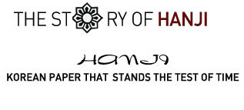
Hanji literally means “the paper of Korea”. The main material is the fibrous skin of the mulberry. Hanji is not simply paper. It is used in a variety of ways, and has a different name according to its use. If it is glued on a door it is called a window paper It is copy paper if it is used for a family registry book, Buddhist sutra or old books, while it becomes drawing paper. if four gracious plants or birds are drawn upon it.
The strong vitality of Korean paper is the reason it can be used in a multitude of ways. There is an old saying that paper lasts a thousand years and textiles (such as silk or hemp) last five hundred, reflecting the superior strength of paper over cloth. Koreans even used Korean paper as a suit of armor after varnishing the lacquer. It is known that the life span of Korean paper is 1,000 years. In the West, products made of paper more than 300∼400 years old are rare. But Korea has preserved quite a few books and drawings which are almost 1000 years old. The most typical example is the , which is the oldest printed material in the world. The year the was created was 751.
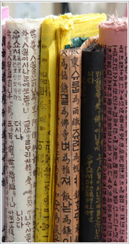 | Korean paper was also very famous as much as Sodongpa, a famous Chinese poet in the 11th century Chinese poet said that he would like to publish his anthology with paper produced from Goryeo (The name of the Korean dynasty at that time), which was one of Korea’s main export good at that time. Koreans use Korean paper made by traditional methods for government documents or other documents.  The superiority of Korean paper comes from the material with which it is made. The bark of the mulberry is strong and can endure without decomposition when it is immersed in the water for 1 year. It allows both air and light through as the fibers are wide. High-quality Korean paper can be produced with trees that are only 1 year old, while cheaper modern paper must use the pulp from trees 20~30 years old.
The manufacturing process of Korean paper is complicated, slow and laborious. The dry mulberry is cut after the frost has arrived and is peeled off after steaming. It is immersed in water for one day and, after being dried under the sunlight, the bark is peeled off, steamed again inside an iron pot and immersed in caustic soda. The steamed bark is smashed inside a stone mortar after the water has been squeezed out. Then it is rinsed in flowing water after being placed inside a wrapper. The washed mulberry is mixed with water and a natural adhesive. Next, the fibers are strained through a bamboo screen, which is shaken back and forth to create a crisscross pattern of fibers. The pulp is then dried by stacking it on a wooden panel and placed in the sun, completing the process. Learn more about the manufacturing procedure of traditional Korean paper through a visit to the Korean paper museum in Jeonju (www.hanjimuseum.co.kr), Jeollabuk-do.
The traditional methods for making Korean paper are not being passed down as greatly as before, making the manufacturing process quite challenging these days. It is such a difficult job that traditional masters of hanji say, “I will not let my son be a container man (the person who strains the fiber through a bamboo screen) even if I am driven to the worst”.

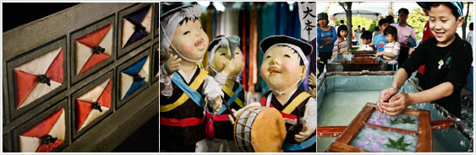
The small quantities, a long production process and distribution limited to specialty markets make it difficult for traditional Korean paper to compete with the mass distribution of cheap easily produced modern paper. The Korean government has therefore appointed the masters of Korean papermaking as intangible cultural assets and protects the industry with special care.
The superiority of hanji has endured despite historical and global changes. There is a trend toward using hanji for another purpose, like for artwork. Artists for calligraphy and dyeing insist on using Korean paper. Black Chinese ink spreads evenly because the paper is strong and lacks impurities despite being thin. Korean paper is used widely in various art industries. Fashion shows for clothing made of hanji have been held on the Champs Elysee in Paris. A study on potential protective properties of hanji paper for space shuttles is currently underway in a joint study by Korea and the USA. Korean paper has been developed for use as a substitute for styrofoam as internal packing material.

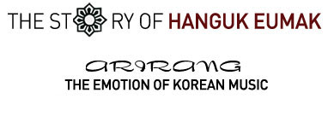
The burning of the heart is implicit in the sound of the voice. This is the first step of being able to understand traditional Korean music. Within traditional Korean music listeners can find the history of the Koreans, a history memorable for its sorrow and pain. Much of the music that has been passed down from previous generations deals with feeling of separation. Koreans sang songs when they could not hold their sadness in.
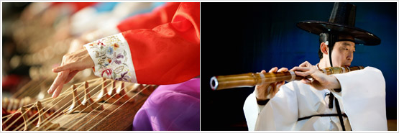
Of course, not all Korean music is sad. For example, royal court music is a kind of music used for ceremonies or rituals. Music played during religious services or events belongs to this category. Consequently, formal music often focuses on lauding 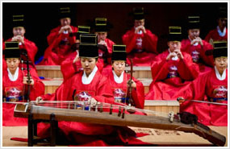the achievements of past kings. The strict format is more important than the content in the case of music played for official events. The display and playing of every instrument is also symbolic. One typical example of formal Korean music is the Jongmyo Shrine ritual music. It is the music that is played for the ritual services for former kings and has been appointed a world intangible heritage by UNESCO.
If formal music is for the ruling class then 'folk music' is the song of those being ruled. This genre includes the pansori, a traditional Korean narrative song, which has been named a UNESCO world intangible heritage. The pansori is a kind of music presented to audiences by skilled vocal singers and drummers.
But even the unskilled could sing these songs. They sang when they worked in the rice paddy or fields, sang when they went off their lover and sang when their life was troubled and weighing them down. The 'folk song' literally means the song of folklore. Therefore, the folk song is the traditional music sung most frequently by Koreans.
Folk songs contain the bittersweet emotion of Koreans. The quintessential Korean folk song is Arirang. Arirang is the title of a particular song that is now used as a symbol of Korea and Korean culture. There are many variations of Arirang in Korea. Arirang can vary independently depending on the region. The Jeongseon Arirang is found in Jeongseon, a remote mountain of Gangwon-do. Jindo, an island of Jeollanam-do, is home to the Jindo Arirang. The number of traditional Arirangs passed down throughout the nation can be counted in the hundreds if modified rhythms are included. The refrain is the same even though the songs may differ by region: 'Arirang Arirang Arario'. Arirang is in essence a song of farewell. The origin of the word of 'Arirang' is ‘the hill’. With 70% of its land being mountainous, there are also many foothills throughout the country. Most Koreans had partings on a number of such hills. An emotion of deep regret is imbued in the rhythm of Arirang and its very pronunciation--'Arirang’evokes the feeling of the tears shed by Koreans and the remembrance of their sad stories.
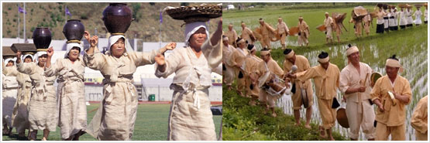
Traditional Korean music Is significantly different from that of other places. In Western music for instance, one note equals one beat. In the meter of Korean music, however, is one that phrase gets one breath. Basically, the unit of times for rhythm is different between Korea and other countries. More interestingly, there is no conductor for Korean music. The individual musicians of a group must play his or her instrument in tune with his breath and with the breath of his or her colleague's. The breath of Korean musical rhythm unites with movement. The traditional Korean music is always accompanied by dance and song. For a greater depth of view of Korean music, focus must be given to the breath of the musicians. The Korean expression 'tuning the breath' originates from the concept of rhythm in Korean music.

