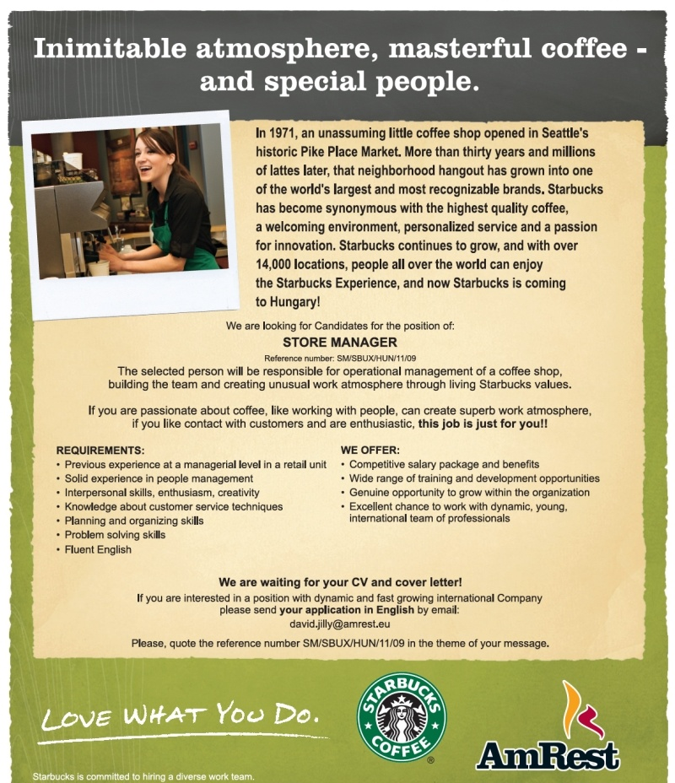

|  |  |
| --- | --- |
| **Interviewer’s Role** | Starbucks is coming to your town and you, as an owner, are recruiting people for a store manager position. You’ll be interviewing the applicant. Read the post, then do the interview based on the questions below. |
| **Interviewee’s Role** | You heard that Starbucks is coming to your town and is hiring, so you apply for a store manager position. Give some thought to the common interview questions below before doing the interview. |



to your town!

**< Questions to prepare for >**

**1. Tell me about yourself.**

TIP: The most often asked question in interviews. Talk about things you have done and jobs you have held that relate to the position you are interviewing for.

**2. Why did you leave your last job?**

Never complain of supervisors, co-workers or the organization. Keep smiling and talk about leaving for a positive reason such as a great opportunity.

**3. What experience do you have in this field?**

Talk about specifics that are relevant to the position. In case of little relevant experience, get as close as you can.

**4. What do you know about this organization?**

Do some research on the organization before the interview. What are the current issues and who are the major players?

**5. Why do you want to work for this organization?**

This should be based on the research you have done on the organization. Sincerity is extremely

important here.

**6. What have you done to improve your knowledge in the last year?**

Have some positive self-improvement activities handy to mention.

**7. What kind of salary are you looking to get?**

A nasty little game that you will probably lose if you answer first. So, do not answer it. Instead, say something like, “That’s a tough question. Can you tell me the range for this position?” If there’s no way out of showing your cards, say that it depends on the details of the job, and give a wide range.

**8. Are you a team player?**

Of course, you are a team player. Be sure to have examples ready to give good evidence of your team attitude.

**9. Have you ever had to fire anyone? How did you feel about that?**

You will do it when it is the right thing to do. You will protect the organization when an individual has created a harmful situation.

**10. Tell me about your ability to work under pressure.**

You thrive under certain types of pressure. Give an example.

**11. Explain how you would be an asset (=a useful tool) to this organization**

Highlight your best points as they relate to the position being discussed.

**12. Why should we hire you?**

Point out how your assets meet what the organization needs.



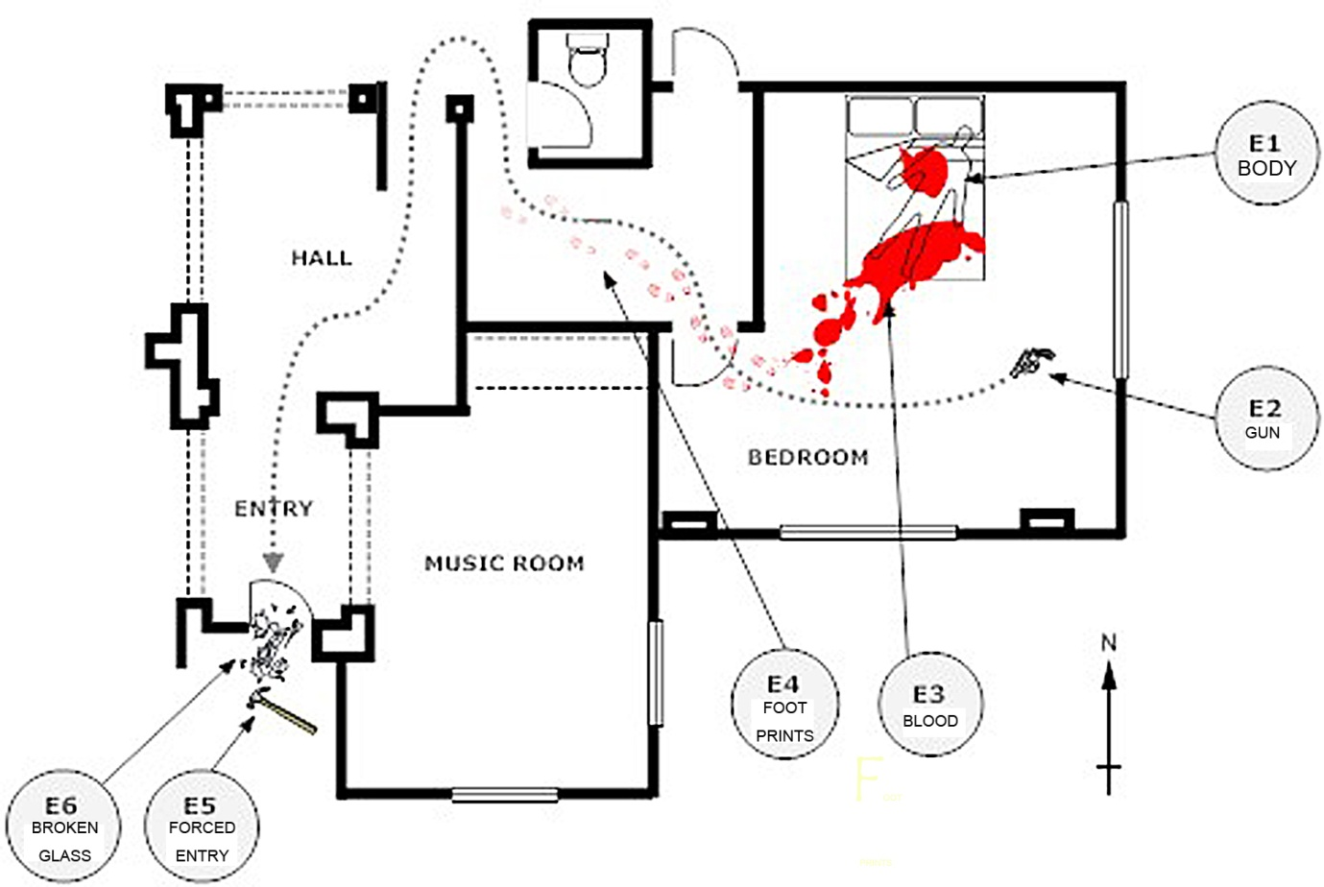

You are the CSI agent now. You are investigating a murder.

B must interview A to obtain the crime scene evidence.

B needs to re-create the crime scene diagram without looking at A’s paper.

B can use the sample question on the worksheet.

A should give B a detailed description of the evidence.

**GENERAL QUESTIONS:**

1. Can you describe the house? (small/large, how many rooms, etc.)
2. What path did the murderer take through the house? (Which rooms did they walk through?)

**EVIDENCE QUESTIONS:**

E1. Where was the BODY found? What position was it in?

E2. Where was the GUN (murder weapon) found?

E3. Where was the BLOOD found?

E4. Where were the murderer’s FOOT PRINTS found?

E5. Where was the FORCED ENTRY made?

E6. Where was the BROKEN GLASS found?



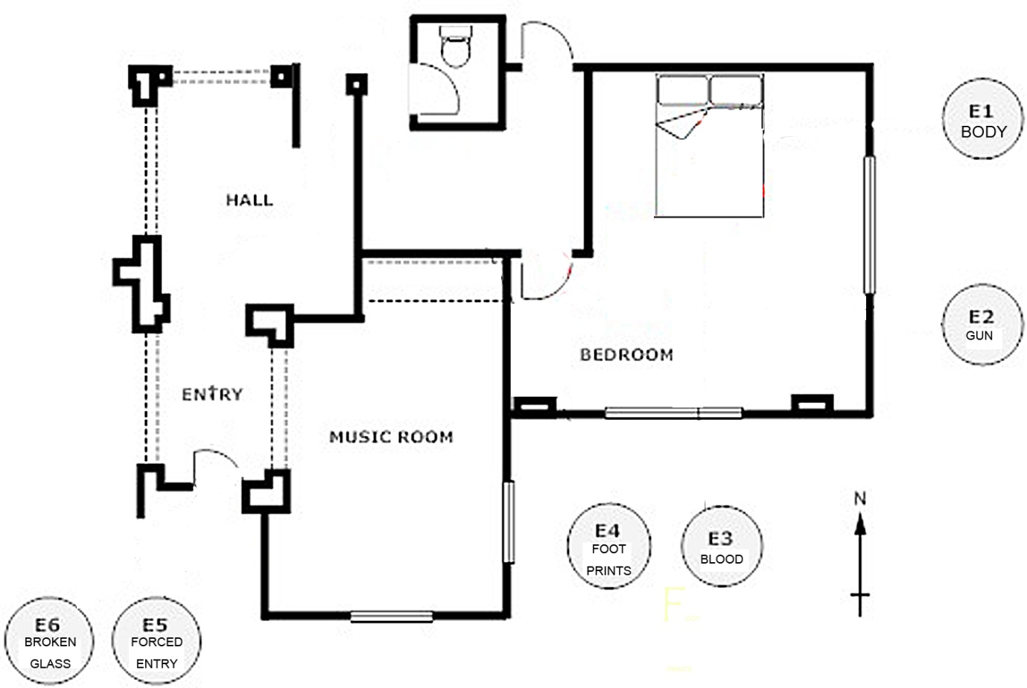

You are the CSI agent now. You are investigating a murder.

B must interview A to obtain the crime scene evidence.

B needs to re-create the crime scene diagram without looking at A’s paper.

B can use the sample question on the worksheet.

A should give B a detailed description of the evidence.

**GENERAL QUESTIONS:**

1. Can you describe the house? (small/large, how many rooms, etc.)
2. What path did the murderer take through the house? (Which rooms did they walk through?)

**EVIDENCE QUESTIONS:**

E1. Where was the BODY found? What position was it in?

E2. Where was the GUN (murder weapon) found?

E3. Where was the BLOOD found?

E4. Where were the murderer’s FOOT PRINTS found?

E5. Where was the FORCED ENTRY made?

E6. Where was the BROKEN GLASS found?

**C:\Documents and Settings\혜연\Local Settings\Temporary Internet Files\Content.IE5\7BF9BT67\MC900078748[1].wmfC:\Documents and Settings\혜연\Local Settings\Temporary Internet Files\Content.IE5\ZEX9MK7Y\MC900293476[1].wmfMost weird jobs around the world**

Each person earns the living on his own ways to support himself as well as the family. If you are employed and bored with your career, take a look at most **weird jobs** below to know that you are still luckier than many people. Those who are not well educated or have **strange hobbies** take over the following jobs to make ends meet in their life.

|  |  |
| --- | --- |
| Golf Ball Diver | Dog Food Tester |
| **Golf Ball Diver** When a golf ball is hit into the water, your task is to pick it up. In modern golf courts, professional **golf ball** divers can become a millionaire with picking up 3000 balls a day. The most dangerous thing is that the lake is full of glass, iron pieces and even crocodiles | **Dog Food Tester** Like any dishes we eat, dog food needs to be inspected too. Dogs cannot tell you what their favorite kinds of food are, so it is required to have a profession taste such as **delicious cuisines**. It can be seen that you need a special stomach to taste dog food every day. |
| Smell Tester | Hair Boiler |
| **Smell Tester** Although technology and science are more and more developing, **cosmetic companies** still need professional staff to smell their products. A smell tester has to smell 60 different odors three times per an hour. | **Hair Boiler** Hair boiler is considered to be the worst job. You must stand beside a big pan which is used to boil different kinds of animal hair until it becomes soft enough to make **false hair**. |
| Bat Cave Scavenger | Bad Breath Smeller |
| **Bat Cave Scavenger** Bat waste can be used as a medicine, but its smell is so terrifying that you may be poisoned. Besides, scavengers have to seek bats in remote regions where there are many caves and crustacean carnivores | **Bad Breath Smeller** As a bad breath smeller, you must have an excellent nose to make sure that chewing gums and mouthwashes are good at keeping the users free of smell. If a person has just eaten dinner, drunk wine or had unpleasant odor, the tester will smell that mouth from level 1 to level 9 to record whether that smell makes you vomit or not. Then the tester smells again after that person use chewing gums or **mouthwashes** |

**Cover Letter Writing Assignment**

I didn't have time to write a short letter, so I wrote a long one instead. *- Mark Twain*

A properly written job application letter, or a cover letter, is an effective way to get a potential employer's attention and to convince him or her to read your CV. 당신이 직업에 적합한 후보 이유를 분명하게 설명합니다. It clearly explains why you are a suitable candidate for the job.

**Features of a Good Cover Letter**

1.1.1. , 건설적인 긍정적이고 낙천. Constructive, positive and optimistic. 2.

2. 잠재적인 고용주의 필요에 초점을 맞추고 있습니다 - 분명 자격증, 기술 및 광고 게재 순위에 대한 경험을 연결합니다. Focuses on the potential employer's needs - clearly connects qualifications, skills and experience

to the advertised position. 3.

3. 첫 번째 문단은 독자의 관심과 주목을 일으 킵니다. The first paragraph causes reader's interest and attention. 4.

4. 사람이 신청되는 위치를 참조하기 : 제목 라인 또는 "RE"를 가지고 있습니다. Has subject line or “RE:” to refer to the position a person is applying for. 5.

5. 일관된 글꼴 크기 (예를 들어 타임즈 새로운 로마 12이 Arial 9). Consistent font size (eg Times New Roman 12 or Arial 9). 6.

6. 아무 이탤릭체 없음 (이탤릭체는 읽기 힘들다), 아니 굵은 텍스트 (일부 특수 단어 제외)없이 열. No italics (italics is hard to read), no bold text (except some special words) and no columns. 7.

7. 아니오 계약 양식 없음 (이건 아니면 할 수없는 등), 아니 느낌표, 이모티콘이나 감정을 표현하는 다른 기호. No contracted forms (such as it's or can't), no exclamation marks, emoticons or other symbols

expressing emotions. 8.

8. 짧은 단락. Short paragraphs. 9.

9. 않음 이력서의 요약 혹은 재개하라. Not a summary of CV or Resume. 10.

10. 진실을 알려줍니다. Tells the truth. 11.

11. "는 관계자 분께"이 없습니다. Does not have “To Whom it May Concern”. 12.

12. 일관성을 유지하고 라인과 단락 사이에 적절한 공간을 포함하고 있습니다. Maintains consistency and contains appropriate spaces between lines and paragraphs. 13.

13. 인쇄상의 또는 문법 오류가 없습니다. No typographic or grammar errors. 14.

14. 길이 더 이상 아닌 페이지 (3-6 단락). No more than one page long (3-6 paragraphs).

**A Sample Cover Letter**

|  |
| --- |
| Dear Dr. Hiring,   RE : 연구 조교 Re: Research Assistant   당신은 서면 및 구두 기술과 연구 조교에 대한 검색의 컴퓨터 지식과 관련된 요구 사항의 조합을 강조. You emphasize a combination of requirements involving written and verbal skills and computer expertise in your search for a research assistant. 염두에이 프로필을 통해, 당신의 검토를 위해 내 자격 증명을 제공합니다. With this profile in mind, I offer my credentials for your review.  영문학 전공 및 부전공 컴퓨터로서, 사업의 양적 및 질적 측면을 연결하는 기회를 추구합니다. As English major and Computers minor, I seek opportunities to connect the quantitative and qualitative aspects of business. 위치에서 나는 커뮤니케이 션과 교육과 과외를 통해 개발된 교정 기술과 함께 컴퓨터 응용 프로그램에 내 능력을 제공할 수있는 가능성을 참조하십시오. In your position, I see the possibility to offer my proficiency with computer applications along with communication and proofreading skills developed through teaching and tutoring.  내 배경의 다음 측면의 입장과 가장 관련이 있다고 생각 : I believe that the following aspects of my background are most relevant to your position:  클라이언트 개발, 조직의 커뮤니케이 션과 컴퓨터 응용 프로그램에 대한 노출과 관련된 실질적인 비즈니스 운영에 대한 • 소개. • Introduction to practical business operations involving exposure to client development,  organizational communication and computer applications.  작문 동료 개인 교습으로 문법 문제 및 교정 과제 등 • 체험. • Experience as a writing fellow tutoring grammar issues and proofing assignments.  교육 기관에서 교육 및 강연을 통해 개발된 연설 기술을 포함한 언어적 의사 소통 • 전문. • Expertise in verbal communication including public speaking skills developed through teaching  and lecturing at educational institutions.  나는 위치를 논의 귀하의 비즈니스에 대해 자세히 알아보고 자신의 필요와 나의 재능 간의 경기를 보여주는 기뻐할 것입니다. I would be happy to discuss your position, learn more about your business and demonstrate the match between your needs and my talents.  감사합니다, Yours sincerely,    양 성공적인 지원자 Ms. Successful Applicant |