**C:\Documents and Settings\혜연\Local Settings\Temporary Internet Files\Content.IE5\YI8110CC\MC900217178[1].wmfC:\Documents and Settings\혜연\Local Settings\Temporary Internet Files\Content.IE5\ZEX9MK7Y\MC900217434[1].wmfHealth Matters**

**A. Look at the form below, and write the word that matches each definition.**

**Use the words from the form.**

|  |  |
| --- | --- |
| **Patient Information Form** | |
| **Name:** | **Date of visit:** |
| **Date of your last checkup:** | |
| **Please check all of your symptoms:** |  |
| 1. **Are you…**  * dizzy? * short of breath? * nauseous? * weak? * other: | **3. Have you been…**  ○ wheezing?  ○ coughing?  ○ sneezing?  ○ vomiting?  ○ other: |
| 1. **Do you have any pain in your…**  * abdomen? * ribs? * hips? * chest? * other: | **4. Please give a brief description**  **of your illness.** |

1. not strong, without energy
2. feeling that you’re going to vomit
3. making a noise by air suddenly coming out of the nose
4. suddenly pushing air out of the throat with a short sound
5. C:\Documents and Settings\혜연\Local Settings\Temporary Internet Files\Content.IE5\ZEX9MK7Y\MC900290887[1].wmf part of the body below the chest and above the legs
6. relating to breathing with a whistling sound

**B. Look at these health problems. Match the problem with the advice.**

## ADVICE

**a. Take some aspirin.**

**b. Go to bed and rest.**

c. Put some ointment on it.

**d. See the dentist.**

**e. Drink lots of liquids.**

**f. Take some vitamin C.**

g. Put it under cold water.

**h. Put heating pad on it.**

**i. See the doctor.**

## PROBLEMS

**1. A toothache**

**2. A burn**

**3. A backache**

**4. A sore throat**

**5. A headache**

**6. A cold**

**7. A cough**

**8. A fever**

C:\Documents and Settings\혜연\Local Settings\Temporary Internet Files\Content.IE5\YI8110CC\MC900429315[1].wmf

**C. According to your match write sentences using “should” and invent one with “shouldn’t”.**

1. *When you have a toothache you* ***should*** *see the dentist and you* ***shouldn’t*** *eat any candies.*











C:\Documents and Settings\혜연\Local Settings\Temporary Internet Files\Content.IE5\ZEX9MK7Y\MC900343293[1].wmf

**D. Role playing Being a doctor and patient! The patient can tell the doctor about the symptoms, and the doctor can give advice with should/shouldn’t. Work on it in your group.**

Ex) Doctor: Is anything bothering you today? Tell me about your symptoms.  
 Patient: I’ve been sneezing and coughing for three days. And I’m dizzy.  
 Doctor: Let’s have a look. You should take some Vitamin C and….

**JUST FOR FUN!**

**WORD GAME. Look at the words below. How many new words can you make with letters? Use only the letters in these words.**

**h e a l t h m a t t e r s**

**Ex) heat, real**

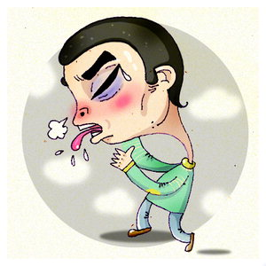

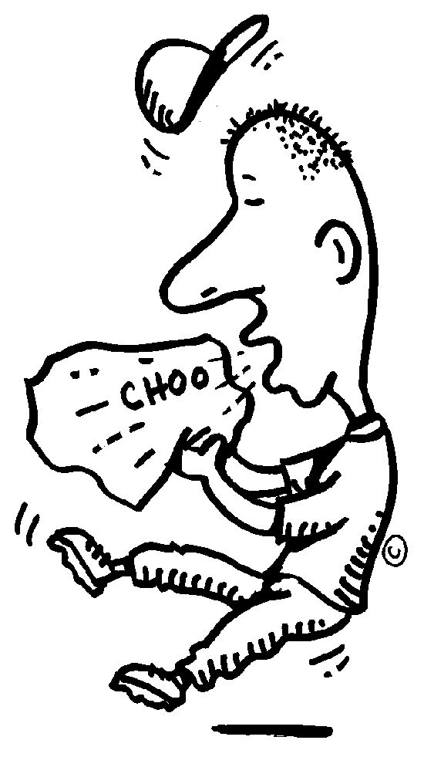



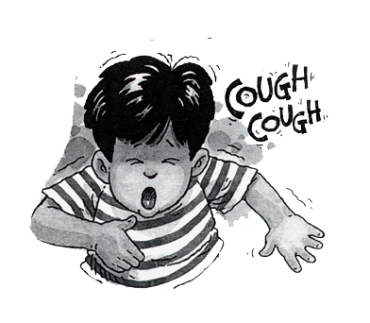



**WHEEZING**

**SNEEZING**

**COUGHING**

**VOMITING**

**DIZZY**