It’s called the "broken windows" theory and it says that in a neighborhood where buildings have broken windows, people are more likely to engage in bad behavior. Maybe because they ( )no one will care. Or there’s little chance they’ll get caught. The idea has been ( d)by people in law enforcement—crack down on ( )crime and you’ll also put a halt to more serious ( )s. New York City, for example, used the logic to justify a “zero tolerance” approach to things like the squeegeeing of car windows. But the theory has been hard to prove. Crime did go down in New York, but was it directly related to the ( ) decline?
Now Dutch scientists say that there may be something to the whole “broken windows” thing, after all. For example, they found that cyclists who parked their bikes near a wall covered in ( ) were twice as likely to litter than people who parked near the same wall after it was painted clean. The results were published online by the journal Science on November 20th. I guess we should be thankful that the cyclists’ bad behavior stopped at littering. And they didn’t decide to, say, ( ) a better set of wheels for the ride home.
—Karen Hopkin

figure swipe graffiti squeegee

petty embrace offense

Kees Keizer and his colleagues at the University of Groningen deliberately created such settings as a part of a series of experiments designed to discover if signs of vandalism, litter and low-level lawbreaking could change the way people behave.
…
The most dramatic result, though, was the one that showed a doubling in the number of people who were prepared to steal in a condition of disorder. In this case an envelope with a €5 ($6) note inside (and the note clearly visible through the address window) was left sticking out of a post box. In a condition of order, 13% of those passing took the envelope0- (instead of leaving it or pushing it into the box). But if the post box was covered in graffiti, 27% did. Even if the post box had no graffiti on it, but the area around it was littered with paper, orange peel, cigarette butts and empty cans,25% still took the envelope.
The researchers’ conclusion is that one example of disorder, like graffiti or littering, can indeed encourage another, like stealing. Dr Kelling was right. The message for policymakers and police officers is that clearing up graffiti or littering promptly could help fight the spread of crime.

Embrace

Petty
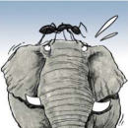

Offense
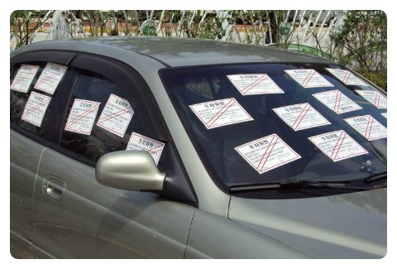
graffiti

Swipe
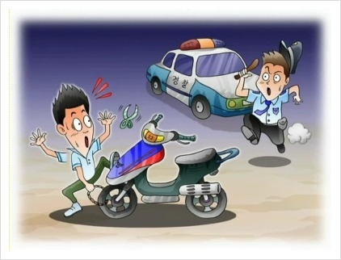
Squeegee
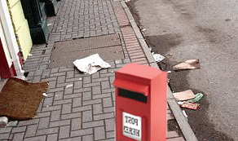
#3

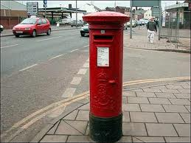
#1

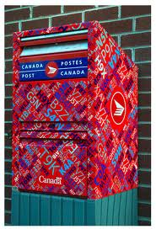
#2

It’s called the "broken windows" theory and it says that in a neighborhood where buildings have broken windows, people are more likely to engage in bad behavior. Maybe because they (figure )no one will care. Or there’s little chance they’ll get caught. The idea has been (embraced )by people in law enforcement—crack down on (petty )crime and you’ll also put a halt to more serious (offense)s. New York City, for example, used the logic to justify a “zero tolerance” approach to things like the squeegeeing of car windows. But the theory has been hard to prove. Crime did go down in New York, but was it directly related to the (squeegee) decline?
Now Dutch scientists say that there may be something to the whole “broken windows” thing, after all. For example, they found that cyclists who parked their bikes near a wall covered in (graffiti) were twice as likely to litter than people who parked near the same wall after it was painted clean. The results were published online by the journal Science on November 20th. I guess we should be thankful that the cyclists’ bad behavior stopped at littering. And they didn’t decide to, say, (swipe) a better set of wheels for the ride home.
—Karen Hopkin

In the mid-1970s The State of New Jersey announced a "Safe and Clean Neighborhoods Program," designed to improve the quality of community life in twenty-eight cities. As part of that program, the state provided money to help cities take police officers out of their patrol cars and assign them to walking beats. The governor and other state officials were enthusiastic about using foot patrol as a way of cutting crime, but many police chiefs were skeptical. Foot patrol, in their eyes, had been pretty much discredited. It reduced the mobility of the police, who thus had difficulty responding to citizen calls for service, and it weakened headquarters control over patrol officers.
Many police officers also disliked foot patrol, but for different reasons: it was hard work, it kept them outside on cold, rainy nights, and it reduced their chances for making a "good pinch." In some departments, assigning officers to foot patrol had been used as a form of punishment. And academic experts on policing doubted that foot patrol would have any impact on crime rates; it was, in the opinion of most, little more than a sop to public opinion. But since the state was paying for it, the local authorities were willing to go along.
Five years after the program started, the Police Foundation, in Washington, D.C., published an evaluation of the foot-patrol project. Based on its analysis of a carefully controlled experiment carried out chiefly in Newark, the foundation concluded, to the surprise of hardly anyone, that foot patrol had not reduced crime rates. But residents of the foot patrolled neighborhoods seemed to feel more secure than persons in other areas, tended to believe that crime had been reduced, and seemed to take fewer steps to protect themselves from crime (staying at home with the doors locked, for example).
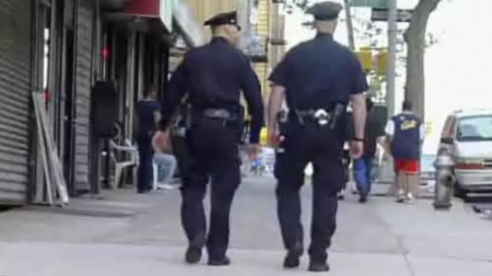
Walking beats
Skeptical

Pinch

Questions
- Answer the question using Yes/No.
This program was announced in the mid-1970s the state of New Jersey.
A .Yes B. No
2. What is the purpose of this program?

3. Who was skeptical about using foot patrol as a way of cutting crime?

4. What did Foot Patrol reduce?

5. Did many police officers have difficulty patrolling on foot?

6. Did the Police Foundation published that foot patrol had reduced crime rates?

7. How did the residents of the foot patrolled neighborhoods seem to feel?

Answer
- Yes
- To improve the quality of community life in 28 cities.
- Many police chiefs.
- The mobility of the police/their chances for making a “good pinch”
- Yes
- No
- They seem to feel more secure than persons in other areas.

