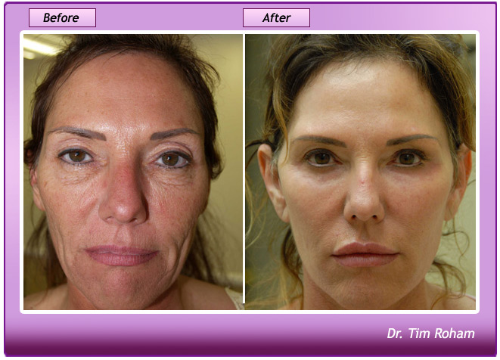

Face lift

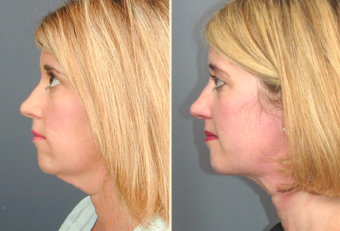

Lipo suction
Cat lady

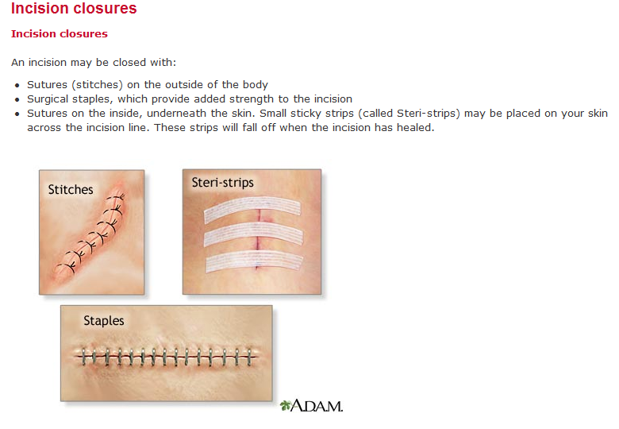

Incision

- A cut into a body tissue or organ, especially one made during surgery.

b. The scar resulting from such a cut.

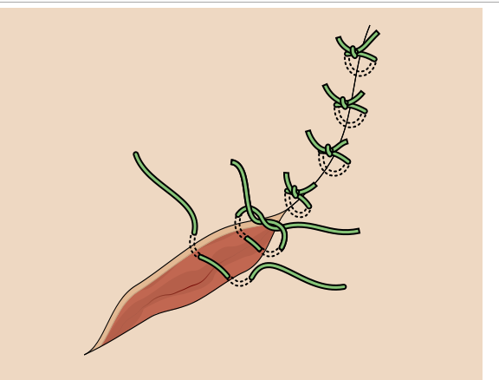

- The fine thread or other material used surgically to close a wound or join tissues.

b. The stitch so formed.

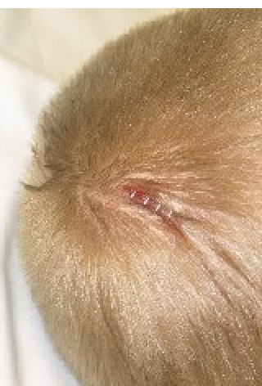

3.Staple an instrument for stapling papers etc.

Many of you might not be aware of this material used to hold the structure especially

when facelift and check bone surgeon uses

Staple to hold the cheekbone while healing.

4.Site in this article site doesn’t mean
Internet site. It is means place, part

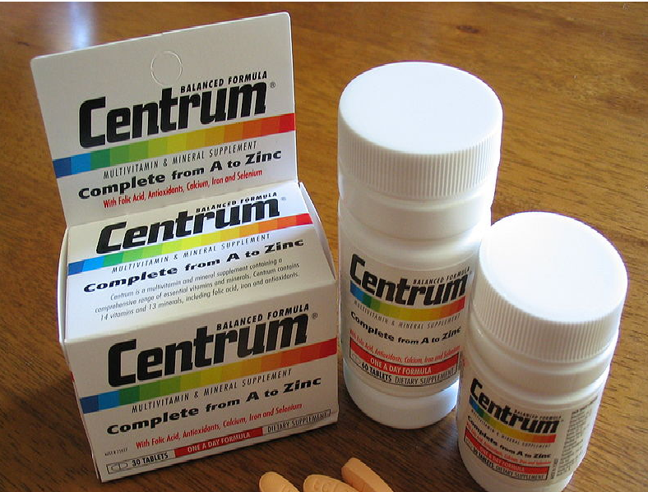

5.Over-the-counter
Medication that can be bought by patient without doctor’s prescription

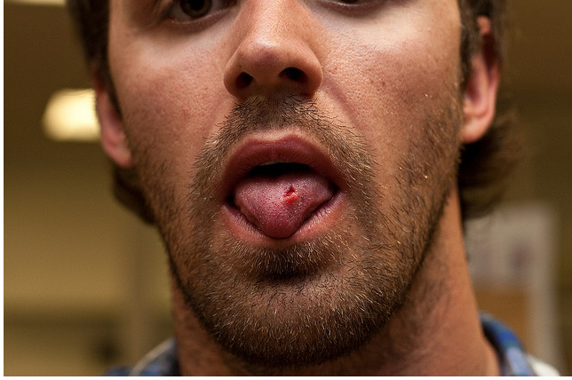

6.Nick b. To cut into and wound slightly: A sliver of glass nicked my hand

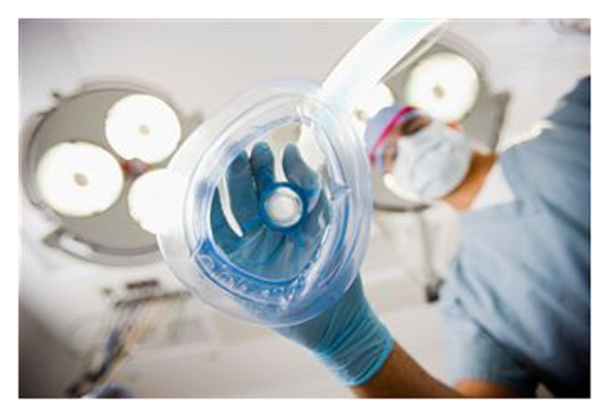

7.Anesthesia 1. Total or partial loss of sensation, especially tactile sensibility, induced by disease, injury, acupuncture, or an anesthetic, such as chloroform or nitrous oxide.
2. Local or general insensibility to pain with or without the loss of consciousness, induced by an anesthetic.
3. A drug, administered for medical or surgical purposes, that induces partial or total loss of sensation and may be topical, local, regional, or general, depending on the method of administration and area of the body affected.

