The 5 Diet Mistakes
Women Make Most
New Work City nutritionist Stephanie Middleberg, R.D., has seen and heard some doozies from women trying to lose weight. Avoiding these diets that don’t work can help you ditch the unwanted pounds, easy.

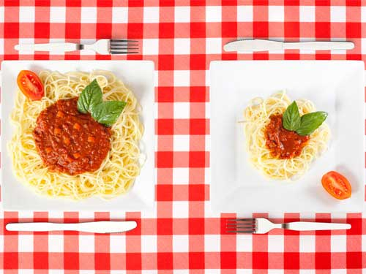
Eating Large Portions
A lot of women I see trying to lose weight and being unsuccessful at it aren’t sitting in their cubicles eating junk food-instead, they are dieting their way up the scale, devouring huge chopped salads for lunch (it takes a lot of dressing to cover a trough of veggies) or eating multiple 100-calorie snacks packs. Even overeating “healthy” foods can sabotage your weight-loss goals. Large portions not only leave you feeling tired and bloated but also expand your stomach, so it takes more and more food to keep you feeling feel full. That’s why the “leave a little food on your plate” rule is an oldie but a goodie, especially when you’re eating out.
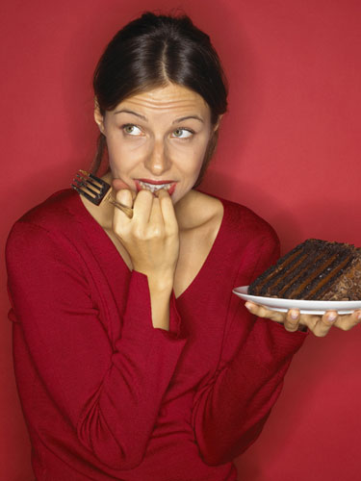
Giving Up After One Splurge
Too many people think, “Well, I messed up on one meal, so what’s the point of sticking to my diet?” Then they attack the refrigerator or keep on indulging all day, all week, all month. One indulgent meal isn’t a problem-it’s regularly eating that way that is. In fact, I encourage all my clients to have at least one splurge weekly. The idea is to get comfortable having a slice or two of pizza at a work event or with your kids on Friday night and realize that it isn’t reason to throw in the towel.

Eating “Diet” Foods
When I first start working with clients, many of them tell me they raid the supermarket looking for labels that say low-fat, low-carb, and low-sugar because they are trying to cut calories. Then when I ask how that’s working for them, they tell me: They’re never full. That’s because diet foods leave you unsatisfied and craving more. While they might trick your taste buds, they can’t fool your body – so you end up having the sugar-free candy and then a real dessert after.

Obsessing Over Calories
Of course calories matter, but I’ve seen clients be the most successful when they stop the obsessive number-crunching and start looking at the foods they are eating, the portions they put on their plates, and where their food is coming from (for example, the produce aisle vs. plastic wrappers). Another problem with counting calories is that the majority of us tend to underestimate how many calories we consume by as much as 30 percent. And it’s easy to lose sight of personal hunger cues: Say, for example, that you’re aiming to stay at 1,800 calories a day. You might be full after dinner but when you know you have 200 calories left in your “budget”, you may feel compelled to eat more when your body doesn’t really need it.

Skipping Breakfast
In fact, many women skip a morning meal because they “aren’t hungry” – which usually means they either overate the night before or they want to start the day in a calorie deficit so they can eat more later in the day. The problem with that is that it could backfire, causing you to pack more food into your body later on. While most people tend to eat the majority of our food between 4pm and 11pm, a better approach would be to front – load your calories so your body can burn them for fuel throughout the day.

