Full script for listening

Hello everyone. My name is Luca. On behalf of Suntan Tours I'd like to welcome you all to Los Cabos. The bus ride to your hotel will take about fifteen minutes. Right now I'd like to take a minute to familiarize you with the area and discuss some brief safety precautions. Firstly, I ask that you remain seated until we reach our destination and that you not eat or drink while on the bus. Secondly, please realize that it is against the law to get drunk in public. Enjoy your vacation, but do drink responsibly and do not drink and drive.

I promise you are going to enjoy your stay here in San Jose, Los Cabos. This is a beautiful, quiet city where you can relax, sit by the beach, enjoy great meals and feel very safe. You can walk into town and enjoy the fountains or take a moonlit walk along the water. Please do not swim here. This is not a safe place to swim because there is a strong undertow. Cabos San Lucas is the place to go if you want to enjoy swimming in the ocean. You can take a short bus ride from your hotel. There you will also enjoy entertainment and dancing.

Suntan tours offers a variety of special discounts depending on your travel plans. We have golf packages, as well as guided whale boat tours, and fishing charters. There will be a short information session at 1pm in the lobby of the hotel tomorrow where you can learn all about these offers. We recommend that you do not purchase packages from street vendors as they are not always 100 percent reliable. They also may charge you more than what they say. Please take my advice and allow Suntan tours to book all of your day trips and activities while you are here.

If you need to exchange your dollars into pesos, please use a bank or money exchange. We don't recommend exchanging your money at the hotel because you won't get a fair rate. Some restaurants will accept American or Canadian money, but you are better off to exchange your money and pay with pesos. Or, if you prefer, you can always use your credit cards. Also, if you want to get around the city, or travel to Cabos San Lucas, we recommend that you take the local bus rather than a taxi. The bus costs about one American dollar, and the driver can give you change if you don't have the exact amount. If you do decide to take a taxi make sure that you negotiate a price before you go.

We're going to be pulling up to the hotel in just a few minutes. Please sit back and enjoy the view of the ocean on the left hand side of the bus as we enter the city. I ask that you remain in your seats until we have come to a complete stop. Javier will be meeting us at the bus to help you with your bags. Please double check to make sure your bag has been taken off the bus. On behalf of Suntan Tours, have a wonderful vacation in San Jose and I hope to see you tomorrow at the information session.
Worksheet for dictation

Hello everyone. My name is Luca. On behalf of Suntan Tours I'd like to welcome you all to Los Cabos. The bus ride to your hotel will take about fifteen minutes. Right now I'd like to take a minute to familiarize you with the area and discuss some brief safety precautions. Firstly, I ask that you r until we reach our destination and that you not eat or drink while on the bus. Secondly, please realize that it is against the law to g . Enjoy your vacation, but do drink responsibly and do not drink and drive.

I promise you are going to enjoy your stay here in San Jose, Los Cabos. This is a beautiful, quiet city where you can relax, sit by the beach, enjoy great meals and feel very safe. You can walk into town and enjoy the fountains or t . Please do not swim here. This is not a safe place to swim because there is a s . Cabos San Lucas is the place to go if you want to enjoy swimming in the ocean. You can take a short bus ride from your hotel. There you will also enjoy entertainment and dancing.

Suntan tours offers a v depending on your travel plans. We have golf packages, as well as guided whale boat tours, and fishing charters. There will be a short information session at 1pm in the lobby of the hotel tomorrow where you can learn all about these offers. We recommend that you do not purchase packages from street vendors as they are not always . They also may charge you more than what they say. Please take my advice and allow Suntan tours to book all of your day trips and activities while you are here.

If you need to exchange your dollars into pesos, please use a bank or money exchange. We don't recommend exchanging your money at the hotel because y Some restaurants will accept American or Canadian money, but you are better off to exchange your money and pay with pesos. Or, if you prefer, you can always use your credit cards. Also, if you want to get around the city, or travel to Cabos San Lucas, we recommend that you take the local bus rather than a taxi. The bus costs about one American dollar, and the driver can give you change if you don't have the exact amount. If you do decide to take a taxi make sure that you n .

We're g the hotel in just a few minutes. Please sit back and enjoy the view of the ocean on the left hand side of the bus as we enter the city. I ask that you remain in your seats until we have come to a complete stop. Javier will be meeting us at the bus to help you with your bags. P your bag has been taken off the bus. On behalf of Suntan Tours, have a wonderful vacation in San Jose and I hope to see you tomorrow at the information session.
Worksheet for listening details

Name:

* Find the answer while listening.

- Where is the speaker?
- What is her name?
- How long does it take to hotel?
- Is it okay to stand up on the bus?
- Is it allowed to drink while on the bus?
- Where are speakers and listener?
- Is San Jose good place for swimming?
- Where does the tour guide recommend for swimming?
- There are many activities Suntan tours offer.
-
-
-
10. What currency is used in Los Cabos?
11. Do restaurants accept any money from any country?
12. Can tourists use their credit cards?
13. Which does the tour guide recommend, take a bus or take a taxi?
14. Why does tour guide recommend it?
15. What do tourists have to check when they are off the bus?

Vocabulary & Comprehension Question

* Match the vocabulary with the definition.
word | definition
on behalf of | - an action that is intended to prevent something dangerous or unpleasant from happening.
charter | - an undercurrent
undertow | - A charter plane or boat is one which is hired for use by a particular person or group and which is not part of a regular service
fountain | - If you familiarize yourself with something, or if someone familiarizes you with it, you learn about it and start to understand it.
precaution | - an ornamental feature in a pool or lake which consists of a long narrow stream of water that is forced up into the air by a pump.
familiarize | - as a representative of

* Choose the one right answer.

- What does the tour guide say is illegal in Los Cabos?
- Drinking alcohol.
- Renting cars.
- Being drunk in public.
- Standing on buses.

- What advice does the tour guide give about transportation?
- Have the correct change.
- Don’t travel at night.
- Tip the taxi drivers.
- Use public transit.

- Where are tourists recommended to exchange their money?
- At the hotel.
- On the bus.
- At a bank.
- At the tour agency.

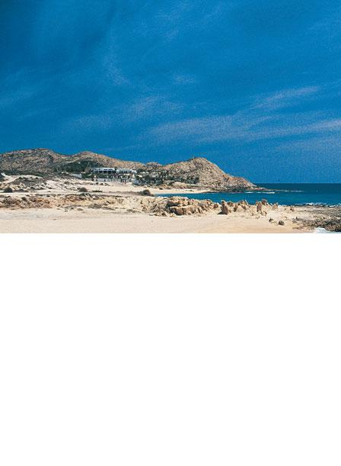
4 nights 5 days

Only $799 now!
Fantastic place for you!

Cabos San Lucas beach
Golf package
Whale boat tour
Fishing charter

Dreams come true!

You can leave now!!

Suntan Tours
Welcome to Los Cabos!!
(070) 527-3516
www.suntantours.com

