Lesson Plan
Reading Lesson Plan
City Tour Bus

Instructor :  Kevin | Level :  Intermediate | # of Ss :  7 | Length :  40 minutes

Materials
- An air ticket
- Worksheets
- City tour bus brochures
- Schedule planners
Aims
- Ss can understand future expressions and can use it.
- Ss to improve listening by listen teacher and classmates speaking.
- Ss to improve speaking by say their experiences and plans.
- Ss to improve reading and writing by read the worksheets and take notes about their plan.
Language Skills
- Listening : Listen teachers instruction and classmates speaking.
- Speaking : Speak the article’s main idea and say their future plan.
- Reading : Read Tomas’s 2 days city tour plan and understand use of future plan.
- Writing : Ss take a small notes about their future plan.
Language Systems
- Phonology : Ss speak English by correct pronunciation.
- Grammar : Ss can use past and future structures.
- Function : Ss chose correct words depend on the situations.
Assumptions
- Ss experienced their trip. For example, field trips or study abroad.
- Ss have enough ability to skim and scan the paragraph.
- Ss have their own plan for this summer vacation.
- Ss have enough logical intelligence to make an order of the paragraph.
Anticipated Errors and Solutions
- Ss think that warm-up is a fake : Teacher prepare an air ticket which is not a real, so Ss can think teacher is lying. However this is not an important thing in this lesson. Thus if Ss talk about this, teacher can explain it.
- There is a student who do not have an experience tour : The student can think about his/her wish, and can say this with his/her partner.
- Ss do not understand some words in the paragraph : Teacher can explain those or can give instruction of peer tutoring.
- Some Ss can not plan their vacation : Teacher can hive he/she directly. If it is impossible (if the student is shy or something other reasons), teacher can make groups and help as a group.
References
- Times media Student’s workbook, module 07, Teaching Grammar
- http://www.google.com/ for images
- http://en.seoulcitybus.com/
- http://www.citytourbusan.com/citytour_2010/

Lead-In
Materials |  | An air ticket
Time |  | Set up |  |  | Procedure
2 min |  | Whole class |  |  | ◎ Greeting  ○ Greeting with Ss some easy questions and give a good atmosphere. Then involve Ss into the class.  - How are you felling today?  - How is the weather outside?  - What did you do yesterday?  ◎ Eliciting  ○ Teacher show an air ticket and ask Ss some questions. It can make Ss feel low-anxious and involve Ss in to the topic.  - Do you know what it is?  - Can you see this ticket to where?  - Where can I buy this?  ◎ Motivation  ○ Teacher say a story – why I bought this ticket- to the Ss. After this story, teacher can ask Ss some questions that check students’ understand.  - Where did I see the advertisement?  - When do I go Je-ju island?  ○ Let Ss find the today’s learning point. Teacher can give some guide questions.  - Through our conversation, can you guess what will we learn today?  - Focus on time. Were we talk past events?
Pre-Activity
Materials | Worksheet
Time |  |  | Set up | Procedure
3 min |  |  | Whole Class  Individual work | ◎ Introduce learning point and activities  ○ Introduce today’s learning point and activities to the Ss and let them expect what we will learn.  Learning Point  Understand future expressions and can use it  Activities  Activity 1. Tour experiences  Activity 2. Tomas’s tour plan  Activity 3. My summer vacation  ◎ Introduce Key Expressions  ○ Introduce new expressions that Ss must study in this class. Teacher read one by one, Ss repeat after teacher. Teacher should explain them.  Going to = Gonna  If I have a chance, I will ~~.  What will happen if ~~.  ◎ Do an exercise  ○ Demonstrate before give worksheets.  ○ Teacher gives Ss a “Quick Check” worksheet. Let them expect how is the key expressions work on sentences.  ◎ CCQs  - What is the name of worksheet?  - Is this multi-choice questions?  - Is this an individual work?  ◎ Quick check the answers  - What is the answer?

Main Activity
Materials | Worksheet
Time |  | Set up | Procedure
10 min  10 min |  | Group work  Individual work | Activity 1. Tour experiences  ◎ Instruction  ○ Before teacher gives handouts, teacher should do enough explain to avoid Ss confusing.  - There are some questions that ask your travel experiences. Discuss with your partner.  ◎ Demonstration  ○ Before teacher gives handouts, teacher take one questions as an example.  - Q : Did you ever go abroad? Where? If not, where do you want to go?  - Teacher’s answer : If I have a chance, I will go Canada. (Key expression)  ◎ CCQs  - How many questions in this worksheet?  - How many times does it takes you think?  - Are you talk with me or your classmates?  ◎ Discussion  ○ Ss talk their experiences with their partners and teacher walk around the classroom observe the Ss.  ◎ Quick answers  ○ Teacher ask questions which are on the paper and check Ss’ grammar.  ◎ Feedback  ○ Teacher listen Ss speaking and feedback. For example, correct grammar or give a good feedback. (Good, awesome)  Activity 2. Tomas’s tour plan  ◎ Instruction  ○ Teacher prepare a City Tour Brochure and show to Ss.  - Tomas is traveling the world. He is going to come to South Korea for 2 days. Here is a City Tour Brochure that Tomas will visit.  ◎ Before give handouts  ○ Teacher gives a guide that Ss need to find main ideas in a short time.  ○ Demonstration : Teacher need to take one question for an example.  - I will ask you 2 questions about Tomas’s tour.  ◎ CCQs  - What do you do with this worksheet?  - How many questions will I ask?  - Ask for what?  ◎ Reading the brochure for main idea  ○ Teacher let Ss read the brochure and find the main idea. Teacher gives Ss a short time.  - Where does Tomas will go in Seoul?  - Where does Tomas will go in Busan?  ◎ Reading the brochure for detail idea  ○ Teacher instruct Ss read the brochure detail and find some information. And let them fill in the schedule blanks.  ◎ Demonstration  ○ The schedule blank is let Ss help Tomas’s tour easily. So teacher must take a blank in the worksheet and show it to the Ss.  ◎ CCQs  - How many blanks on the paper?  - Why do you fill Tomas’s schedule?  - How much time do you have?  ○ Teacher gives Ss running time.  - 1 minute left.  ◎ After activity  ○ Teacher can ask Ss some questions.  - What will Tomas will go on Monday?

Post-Activity
Materials | Worksheet
Time |  | Set up | Procedure
5 min |  | Group work | Activity 3. My summer vacation  ◎ Instruction  ○ Before teacher gives handouts, teacher explain the work for Ss to avoid students’ confusing.  ◎ Demonstration  ○ Teacher take one question on the paper and do it. Let Ss must use the key expressions.  - Do you have any schedule in this summer vacation?  ◎ CCQs  - Is this group work?  - Are there questions ask Tomas’s schedule?  - How much time do you have?  ◎ After the group work  ○ Teacher asks some questions about Ss vacation. And understand Ss and correct their grammar problems.  - Do you have any schedule in this summer vacation?  - Follow on questions.  ◎ Give feedback  ○ Teacher gives good feedback for Ss and make closing atmosphere.  ◎ Conclusion  ○ Use PMI (Plus, Minus, Interesting) questions review today’s lesson.  - What do you learn today?  - Is there anything want to improve today’s class?  - What part of the class do you interested?  ◎ Rap up and preview  - Let’s rap up the class here. Next time we will study Funny situations. Thanks for your time.

Quick Check
Name : ( )

☞ Choose one correct answer with this Key Expressions!

Going to = Gonna
If I have a chance, I will …
What will happen if …

- Diana ( ) see a dentist now because of her teeth.

- If she has a chance to
- Going to
- What will happen if she

- ( ) teacher gives me an extra homework?

- If I have a chance that
- Gonna
- What will happen if

- ( ) go abroad, I want to visit Canada.

- If I have a chance to
- Going to
- What will happen if I

☞ Answer those questions!

- If you have a chance to go Pop Art Museum, what day do you want to go?

- What will happen if you attend this English class?

Worksheet 1
Name : ( )

☞ Discuss this questions with your partner!

- Did you ever travel in Korea? Where? How was it?

- Did you ever do abroad? Where? How were you got the chance?
(If not, please tell me. If you have a chance to go abroad, where do you want to go?)

- Where was the best place you visited?

- Have you ever traveling with your family? Where? What happened?
(If not, please tell me. If you have a chance travel with your parents, where do you want to go?)

- Have you ever traveling with your family? Where? What happened?
(If not, please tell me. If you have a chance travel with your parents, where do you want to go?)

☞ If your group done, please talk about your last vacation!

City Tour Bus Schedule
Name : ( )

Seoul
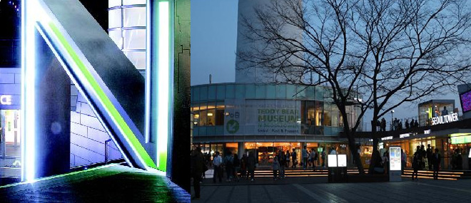
N Seoul Tower
Walking through the city streets of Seoul at night one will more than likely spy a large lit structure atop a mountain

looking down over the city. This structure is N Seoul Tower.
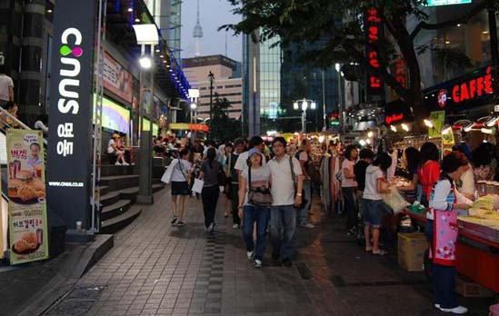
Myeongdong

Myeongdong is a mid-priced shopping district in Seoul, well known for offering mid to high-priced trendy fashions

and accessories. Fashion boutiques and name brand clothing chains abound in this area.

Busan
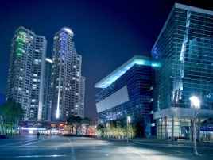
BEXCO is an exhibition and convention ceter which shows techniques and traditions of Korea.
They hosted worldcup soccer draw set in 2002, ITU Telecom Asia in 2004, and annual APEC summit in 2005.
Bexco was also used as main press center during Busan Asian Games back in 2002.
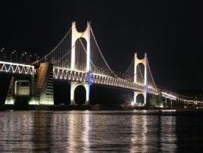
It is on the sea with beautiful scenery. It was designed as the best road of 100 beautiful ways by the Ministry of Construction and

transportation and the association of Korea Road in 2006.

☞ Here is Tomas’s schedule.

2012. 7. 2 | 2012. 7. 3 | 2012. 7. 4 | 2012. 7. 5
8 : 00 p.m  Arrive at Incheon International airport. | 9 : 00 a.m  Travel Seoul with City Tour Bus.  8 : 00 p.m  Take KTX from Seoul to Busan. | 9 : 00 a.m  Travel Busan with City Tour Bus  3 : 00 p.m  Free time in Busan. | 12 : 30 p.m  Take JAL airline to Tyoko.

☞ Take easy to look at the City Tour schedule.

2012. 7. 3 | 2012. 7. 4
Bus Time :  Places :  1.  2.  What is the view points :  1.  2.  KTX Time : | Bus Time :  Places :  1.  2.  What is the view points :  1.  2.  Free Time From :

☞ Please introduce some good places to visit when Tomas’s free time.

My Summer Vacation
Name : ( )

☞ Discuss this questions with your partner!

Please use this Key Expressions.
Please say full sentences.

Going to = Gonna
If I have a chance, I will ~~.
What will happen if ~~.

- Do you have any plans this summer vacation?

- If someone gives you an air ticket, where do you want to go?

- What are you going to do after this class?

- If you have a chance study in Canada, what do you want to major in?

- What will happen if you travel Japan?

- If you have a chance to get a world travel ticket, where do you really want to go?

- What will happen if you live in USA?

- Make some follow on questions!

